EMPLOYMENT OF PEOPLE WITH DISABILITIES IN MALAYSIA:
DRIVERS AND INHIBITORS

Melissa Ng Lee Yen Abdullah
See Ching Mey
Universiti Sains Malaysia

This study attempts to identify the drivers and inhibitors of employment for people with disabilities in Malaysia. It explores the skills and psychological traits needed by people with disabilities in order to get jobs and the barriers to their employment. Data include interviews detailing the viewpoints of 24 teachers with visual impairments. These teachers are registered and classified as either legally blind or partially sighted by the Malaysian Social Welfare Department. The majority of them are male, Malay, between 30-40 years old and have diploma qualification from Teachers Training College. The interviews were transcribed verbatim. Keywords or phrases were extracted, clustered, and interpreted into themes. Analyzed data were confirmed with the participants to ensure trustworthiness and reliability. The findings provide interesting insights into the specific employment issues faced by people with visual impairments and also shed lights on the issues encountered by people with other types of disability. It also discusses measures that can be taken to improve the employment rate of people with disabilities in the country. A discussion of the research findings is also provided.

Education for People with Disabilities
The official number of registered people with disabilities in Malaysia has increased steadily over the last five years, as shown in Table 1 (Social Welfare Department, 2009a; Ministry of Education, 2009). By mid-2009, there were already 258,918 people with disabilities registered in the country compared to a mere 69,753 registrations recorded by the Social Welfare Department in 1997 (Ministry of Education Malaysia, 2009; Salleh, Abdullah, & Buang, 2001). However, the trend may not reflect an actual increase in the disabled population because the registration of people with disabilities in the country is not a compulsory practice. This increase could have resulted from greater public awareness about the importance of registration, a step that enables people with disabilities to access special education, healthcare benefits, financial assistance, job-placement services and so on.

Table 1
Registered People with Disabilities in Malaysia
Type of Disability | 2004 | 2005 | 2006 | 2007 | 2008 |  | 2009  (until May 2009)
Blind/Visually Impaired | 15,364 | 16,211 | 18,258 | 20,039 | 21,204 | 23,738
Deaf/Hearing Impaired | 24,712 | 26,470 | 29,522 | 31,715 | 32,850 | 35,368
Physically Disabled | 51,090 | 58,371 | 66,250 | 73,559 | 78,036 | 86,485
Learning Disabilities | 57,483 | 66,906 | 76,619 | 85,812 | 91,303 | 100,180
Cerebral Palsy | 34 | 623 | 887 | 1,787 | 2,382 | 3,250
Others | 1,934 | 4,335 | 5,983 | 7,338 | 8,164 | 9,897
Total | 150,617 | 172,916 | 197,519 | 220,250 | 233,939 | 258,918
(Source: Social Welfare Department, 2009a; Shamsiah Abdul Rahman, 2008)

Table 1 shows that out of the total number of registrations recorded in 2009, 23,738 (9.20%) are blind/visually impaired, 35,368 (13.65%) are deaf/hearing impaired, 86,485 (33.39%) are physically disabled, 100,180 (38.69%) have learning disabilities, 3,250 (1.25%) have cerebral palsy, and the remaining 9,897 (3.82%) have other disabilities.

The World Health Organization (WHO) estimated that 10% of any population has some form of disability; one third of which are children younger than 15 years old. Translating this into the Malaysian context, it is estimated that about 900,000 children suffer from various disabilities (Ministry of Education, 2009). The Malaysian government is committed to ensuring that people with disabilities are given their due rights in formal education. The philosophy behind this educational system was based on The Education Act of 1996 (Part 11, 3.2), which states that all children with special needs are educable if they are able to manage themselves without help and are confirmed by officials as capable of undergoing the national educational program (Special Education Department, 2006, p.55). The Act was amended in 2002, making it compulsory for children with disabilities to have at least six years of primary education. In conjunction with this change, the Department of Education has also established early intervention programs for children (aged five and above) with hearing, visual, or learning disabilities (Ibrahim, 2006). As shown in Figure 1, admission into early intervention programs marks the beginning of special education for children with disabilities. With assistance from the Ministry of Health, these special needs children could be identified and enrolled in the formal school system by the Ministry of Education. However, placement in preschool, or in any level of formal education, requires endorsement and certification from medical doctor. For the severely disabled, who are not recommended for placement in government-run preschools, the Social Welfare Department under the Ministry of Women, Family, and Community (MWFC) will provide special education. Consequently, a total of 388 centers for Community-Based Rehabilitation (CBR) have been established all over the country to cater to the educational needs of children with severe disabilities (Social Welfare Department, 2009b).

In Malaysia, Non-Governmental Organizations (NGOs) also play vital roles in providing academic education for individuals who failed to gain admission into government-run schools, such as those individuals with mental retardation or severe physical disabilities. These individuals will most likely be given vocational training and will later work at sheltered workshops, depending on their ability to comprehend and execute the required tasks (Figure 1). It is competitive for people with severe disabilities to secure jobs in the open employment; sheltered workshops therefore are designed to give them opportunities leading to dignity, self-worth and socialization amongst their peers. These workshops often employ people with disabilities in a variety of subcontracting work such as packaging, mailing and sorting services for companies and also producing food and crafts (Bakti-Mind, 2008).
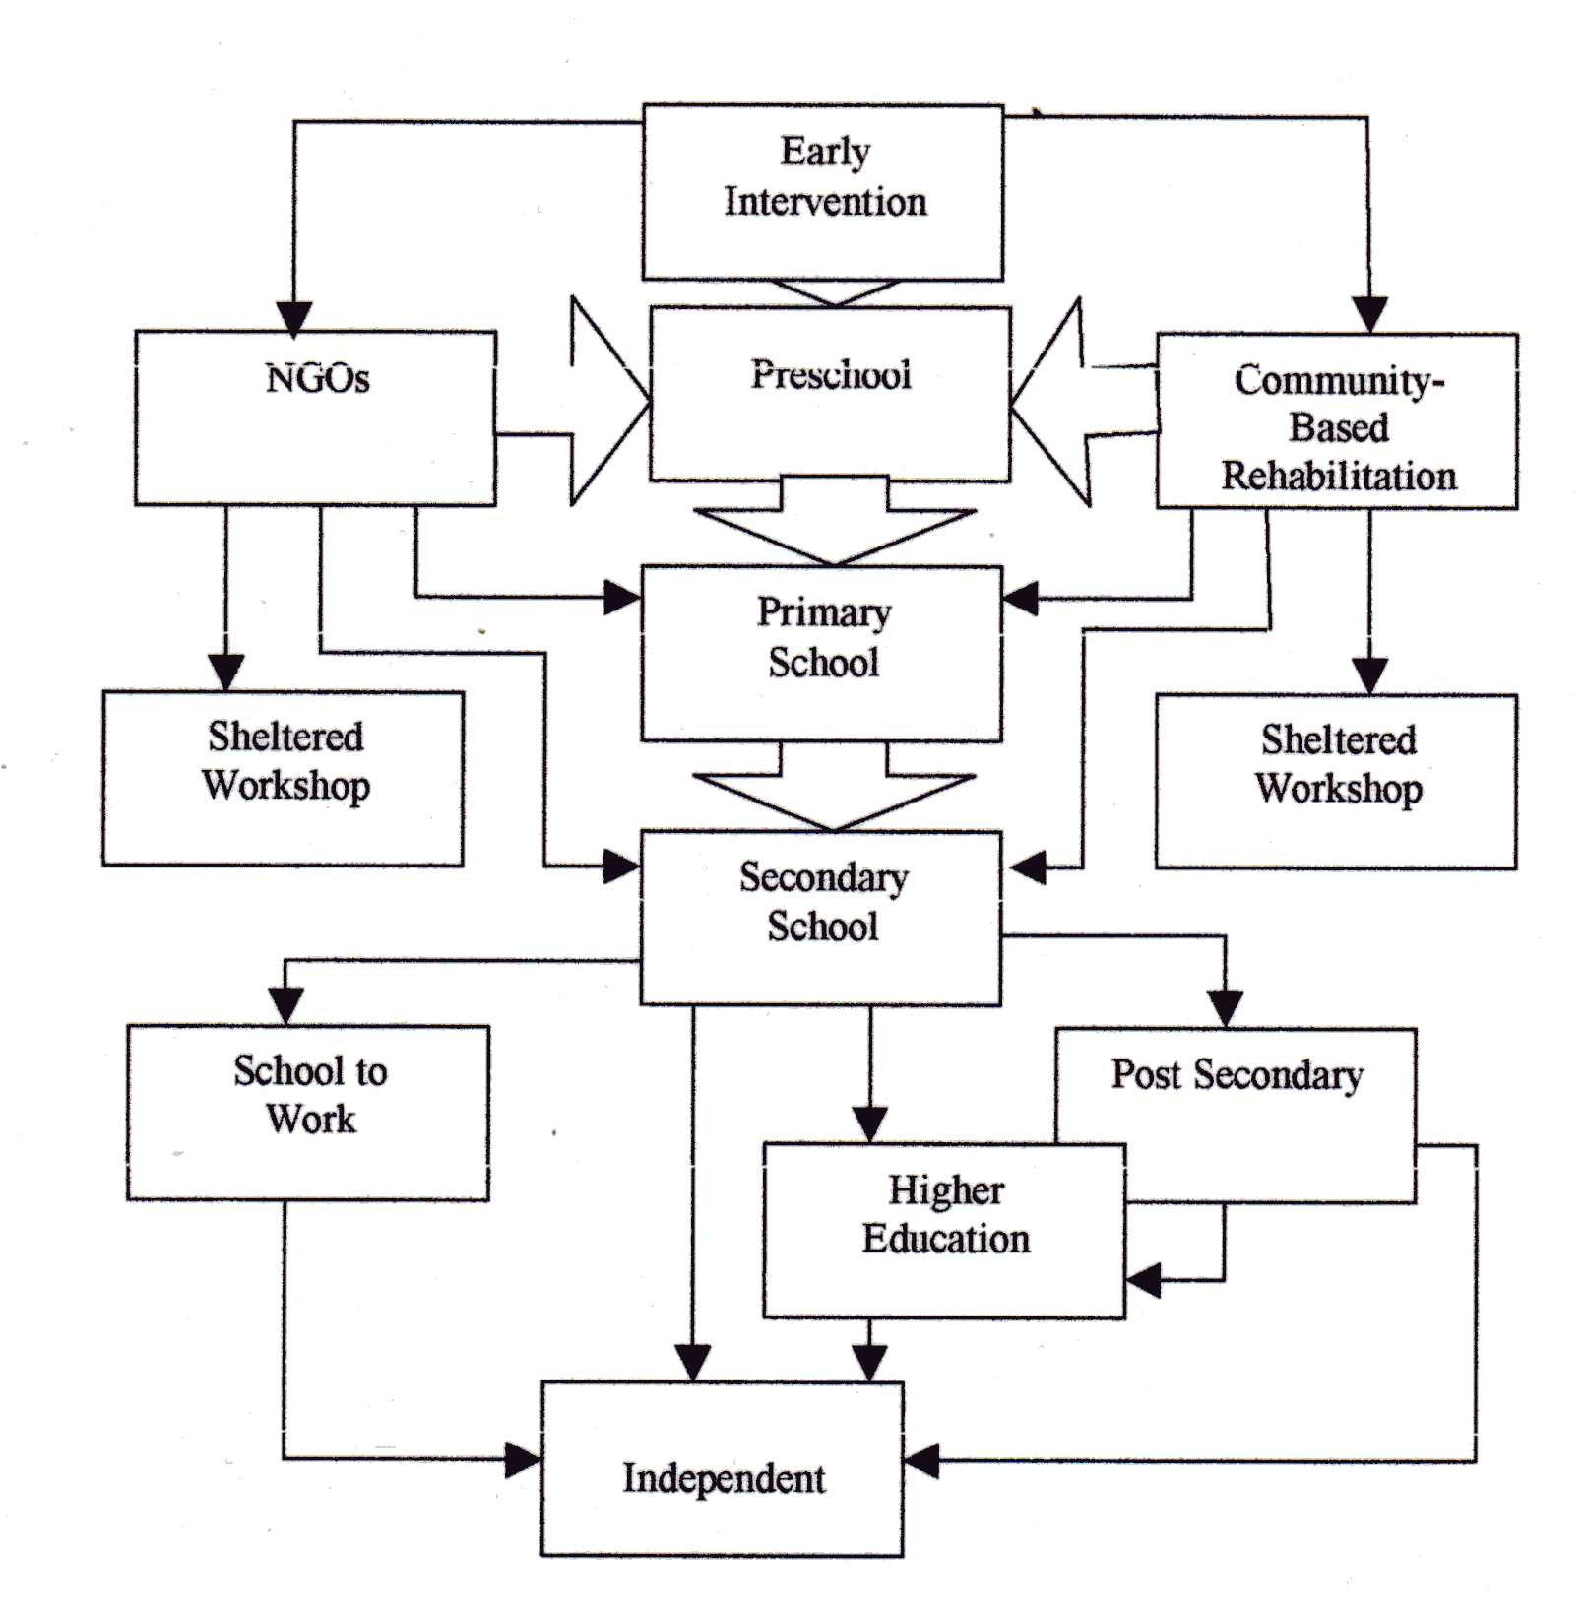
Figure 1: Adapted from Educational System for the Special Needs
(source: Special Education Department 2006, p57)
Those with less-severe disabilities, through special schools and integration programs, are able to acquire academic, computer, living, social, and prevocational skills. The educational system is now moving toward inclusive programs where children with disabilities are fully integrated into mainstream classes (Biwako Millennium, 2007; Ali, Mustapha, & Jelas, 2006). This initiative started in the ‘90s after a series of seminars, workshops, and field work that catalyzed the development of inclusive education in Malaysia (Jelas, 1995a, 1995b, 1997; Ministry of Education, 1995). Inclusive education is now strongly encouraged, though not mandatory, in Malaysia (Ministry of Education Malaysia, 2009). Nevertheless, the move toward more inclusive programs indicates that children with disabilities are being given the opportunity to learn in the mainstream schools and to integrate with their able-bodied peers. It is important that children with disabilities are not segregated from the community.

The flowchart in Figure 1 demonstrates that education, as a whole, is accessible to individuals with disabilities in Malaysia from preschool to the tertiary level. At the end of the formal education system, they are expected to begin living independently, join the workforce, and contribute to society and country, just like other citizens.

Vocational Training and Employment
Vocational training centers for people with disabilities have mushroomed in Malaysia, particularly in the last 20 years. Both government- and NGO-run centers hope to provide self-employable skills to people with disabilities so that these individuals can fulfill the manpower needs of the country. For the blind or visually impaired, vocational training focuses on woodwork, massage, telephony, piano tuning, agriculture, arts, and craft, as well as information communication (Malaysian Association for the Blind, 2007; Salleh, 2002). On the other hand, those who are deaf or have hearing impairments are given training in general mechanics, refrigeration, air-conditioning mechanics, electrical repair, dressmaking, furniture making, plumbing, welding, catering, and graphic design (Malaysian Federation of the Deaf, 2007). People with learning disabilities have the opportunities to obtain prevocational training, which places emphasis on handicrafts, carpentry, sewing, cooking, and farming skills (Welfare Department, 2008). Those with physical disabilities, but who are able to manage themselves without assistance, may receive training at the Bangi Industrial and Rehabilitation Center, which provides courses on computers, information systems, electrical repair, dressmaking, electronics, and prosthetics and orthotics (Social Welfare Department, 2008).

The government hopes that the vocational and academic training provided to people with disabilities will enable them to enter the workforce. Congruent with this vision, the Malaysian government has announced that at least 1% of the job opportunities in the public sector will be allocated for people with disabilities, and teaching is one of these sectors identified. This policy was implemented since 1989. In 1990, the private sector was encouraged to follow suit. The Ministry of Human Resources has since assisted in the job placement of people with disabilities (Memorandum on Disability Issues, 2005). Moreover, to encourage more people with disabilities to enter the workforce, the Department of Social Welfare gives an incentive allowance of RM 300 to those earning less than RM 1,200 (Ministry of Women, Family & Community Development, 2008). Furthermore, grants, with a maximum amount of RM 2,700, are also awarded by the department to help them launch their own businesses (Social Welfare Department, 2008). Other benefits and facilities provided by the government to people with special needs include tax deductions and rebates, housing rental facilities, public transportation discounts, free medical treatment at all government hospitals, 50% deduction of the excise duty on the purchase of the national cars and motorcycles. In addition, Telecommunication Malaysia (TELEKOM) provides incentives and facilities to people with disabilities, such as free monthly phone rental and free operator services.

Unfortunately, despite the various measures taken, the unemployment rate among people with disabilities in Malaysia is still persistently high. In fact, the recent available statistics taken from the Labor Department of Peninsular Malaysia revealed that currently only about 6,750 people with disabilities are employed in the private sector and less than 1% of the total disabled population are employed in the public sector (United Nations Development Program, 2007). Securing jobs in Malaysia is still very challenging for these people. Literature reviews show that the path to stable employment for people with disabilities is fraught with barriers (Khor, 2002). The changing nature of the workplace and the increasing demand for employees who possess both strong academic and job-related skills may make it more difficult for people with disabilities to find employment. Heron and Murray (2003) stated that the obstacles faced by people with disabilities include inaccessible transportation, inaccessible buildings, and negative attitudes by employers, low self-esteem and overprotective families.

Lack of accessible transportation appears to be the greatest problem faced by people with disabilities (Khor, 2002; Memorandum on Disability Issues, 2005). Without a customized transportation system, many people who might otherwise be able to join the workforce will be confined to their homes, particularly those with physical disabilities (Vasoo, 2004). Physical barriers such as inaccessible buildings and non-disabled-friendly facilities at the workplace can also hinder the employment of people with disabilities.

People with disabilities are also vulnerable to psychological problems, such as poor self-concept and self-esteem that further prevent them from seeking employment (Facchini, 1986; Long, 1997; Khor, 2002; Masi, et al, 1999). Studies have indicated that people with disabilities have been aware of the potential discrimination in education, training, and employment from a young age (Khor, 2002; Watson, et., al, 1999). Such insecure feelings foster a sense of self-limiting conservatism, which, in the long run, may negatively influence their career aspirations and employment (Hendey & Pascall, 2001).

Finally, family plays the most influential role in one’s occupational development and achievement (White, Cox, & Cooper, 1992). Unfortunately, people with disabilities are often subjected to the lowered expectations of their parents, particularly if they were placed in special schools (Watson, Shakespearre, Cunningham-Burley, Barnes, Corker, Davis, & Priestley, 1999; Shah, Arnold, & Travers, 2004). The lack of a comprehensive database on the specific problems faced by people with disabilities in Malaysia poses a great challenge for increasing their employment rate. In order to better understand their problems, the views and personal experiences of people with disabilities must be taken into account. This study aims to fill the literature gap by examining the views of teachers with visual impairments. In 1998, the Ministry of Education announced that people with visual impairments who are qualified would be accepted for teacher training at both university and Teachers Training College. Since then, they have made progress in the teaching profession (Wong, 2007). In the present study, visually impaired teachers are classified either as legally blind or partially sighted individuals by the Malaysian Social Welfare Department. This particular population was chosen because they have successfully overcome the barriers to employment and are currently employed in one of the most respected professions for people with disabilities in Malaysia. These teachers offer valuable insights into the important skills that students with disabilities need to possess to enhance their employability. In other words, factors that drive the employment of people with disabilities may be identified. In addition, the inhibitors or barriers to employment for people with disabilities, particularly for those with visual impairments, may also be uncovered based on these teachers’ personal experiences.

Research Questions
To explore the views of teachers with visual impairments, three research questions were formulated to guide the investigation:
- What skills and psychological traits drive the employment of people with disabilities?
- What barriers inhibit the employment of people with disabilities?
- What measures can be taken to increase the employment of people with disabilities?

Method
This study employed qualitative method to achieve its research objectives. This method of research is based on the collection and analysis of non-numerical data, such as interviews and transcripts, to obtain understanding of a particular issue. This approach permits the researchers to gather rich, in-depth perspectives that could not be gathered through quantitative methods such as questionnaires survey, particularly when the targeted population is people with special needs. Pinter, Eisenson and Staton (1980) found that people with visual impairments prefer to be interviewed because they have good listening skills. Furthermore, interview techniques can generate detailed data that leave the participants’ perspectives intact and provide a context through which to understand the problem. Interviewing is thus a well-establish academic tradition in sociological and educational studies (Denzin & Lincoln, 1994).

Semi-structured interviews design was employed in this study to gather the necessary data. This design allows the researchers to obtain the relevant information and at the same time encourage the participants to freely express their ideas and opinions. An interview protocol was employed to guide the interview sessions, and subsequent questions were formed based on the participants’ responses. With this flexibility, the researchers can gather unexpected significant information as well as answers for predetermined questions. Keywords or phrases were extracted, clustered, and interpreted into themes. Codes in Malay were translated into English. Analyzed data were confirmed with the participants for trustworthiness and reliability. To enhance the validity and to reduce biases in interpreting the collected data, the researchers acknowledged their own preconceived ideas about the research problems and engaged in self-reflection during the data-interpretation processes.

Participants
The employment databank of the National Council for the Blind Malaysia (NCBM) shows that there are about 50 teachers with visual impairment in the country. In order to identify these teachers, a list of special schools was obtained from the Ministry of Education and the schools were contacted to confirm the number of teachers with visual impairment. Twenty-four teachers were randomly selected to participate in this study. The majorities of them are male, Malay, between 30-40 years old and have diploma qualification from Teachers Training College (Table 2). Before the study began, a written approval was obtained from the Ministry of Education, the State Education Department, the Welfare Department, and the schools involved. Verbal consent was obtained from the teachers before they were interviewed.
table 2
Participants’ Demographic Profiles
Demographic | f (n=24) | %
Gender  Male  Female | 19  5 | 79.17  20.83
Ethnicity  Malay  Chinese  Indian  Other | 15  3  2  4 | 62.50  12.50  8.33  16.67
Age  25-29  30-40  > 40 | 4  15  5 | 16.67  62.50  20.83
Academic Qualifications  Diploma  Degree | 18  6 | 75.00  25.00

Data Collection
The researchers initiated the interview sessions by explaining the purpose of the study to the participants and proceed with general questions on the participants’ background. This was followed by predetermined questions which were structured based on the three research questions. The interview sessions were conducted in Malay and English, depending on the participants’ preferences. The length of the sessions ranged from 45 minutes to over an hour. All of the participants were able to express their views without much prompting. Participants from Peninsular Malaysia were interviewed during face-to-face meetings, which were held at the schools’ visitor’s area. Prior arrangements were made with each participant to conduct the interviews during their free time to avoid interrupting the normal school schedule. Telephone interviews were conducted for participants from the state of Sabah and Sarawak due to logistic constraints. Nevertheless, past research has shown that telephone interviews are equally valid for participants who are visually impaired (Hermens, et al., 2006). The telephone interviews were recorded using the built-in recording function in the phone.

Results
The results of the semi-structured interviews are discussed according to three major themes; (1) drivers for employment, (2) inhibitors for employment and (3) measures to enhance employment. The findings provide insights into the skills and psychological traits needed to drive the employment of people with disabilities, particularly among people with visual impairments. It also reveals the barriers encountered by them and measures that can be taken to improve their employment rate.

Drivers for Employment
Table 3 shows the skills and psychological traits needed for people with disabilities to get jobs. Eleven sub-themes emerged. These subthemes can be grouped into three themes: academic skills, job-related skills, and psychological traits.
Table 3
Themes and Subthemes for Skills and Psychological Traits
Theme | Sub themes | Selected Statements
Academic Skills | - Reading skills  - Writing skills  - Language skills  - Mathematical skills  - Computer skills  (particularly for people with visual impairments) | - Normal people [non-disabled] also must know how to read, write and count, right… the basic skills to find jobs, these skills are even more important for people with disabilities (T15, Female)  - To become an operator also requires certification. This shows that academic skills are very important] (T17, Male)  - Computer skills to me are very important [in getting jobs], if a visually impaired person is able to master the JAWS system, then he can explore the Internet on his own…to find jobs…even though he is blind (T3, Male)
Job-related Skills | - Vocational skills  - Problem-solving skills  - Community living skills (Orientation and mobility skills, particularly for the blind) | - [Vocational skills are] very important, because not all [people with disabilities] are academically inclined (T1, Female).  - If the bus is late… have to think of other solutions fast, for an example, get a taxi,..just don’t use disability as an excuse and hopes that the boss will understand (T9, Male)  - …must be independent, especially...for the blind and physically disabled, they must make sure that they can go to work on their own (T22, Male)
Positive Psychological Traits | - Optimism  - Confidence  - Honesty and Openness (about their disabilities)  - Resilience | - … in my opinion,… we [people with disabilities] must not look down on ourselves, … must think positive and believe that we can be successful too (T23, Female)  - We [people with disabilities] need to write in the application form that we have a disability…if not, during the interview the potential employer will feel cheated and reject us straight away (T3, Male).  - …don’t give up easily, try and try again, work harder until we achieve our goals. This is an important quality that every person with a disability must have (T8, Male)

Inhibitors for Employment
The interview findings regarding the inhibitors or barriers of employment for people with disabilities are shown in Table 4. Seven sub-themes emerged, which can be grouped into three themes: employers’ negative perceptions and treatment, weaknesses of people with disabilities and negative parental attitudes.

Table 4
Themes and Subthemes for Inhibitors of Employment
Theme | Sub themes | Selected Statements
Employers’ Negative perception and treatment | - Employers’ negative perceptions and treatment  - Employers’ lack of confidence | - They [the employers] don’t see your face so never mind, the day of the interview comes, they see your face, buta ke, tak boleh (terima) [Oh, blind person, cannot accept](T1, Female)  - I once asked a man, why? [my application is rejected] … he said that we [the employer] don’t have the facilities, you have to go to luar bandar [rural areas], you cannot cope with everything. (T1, Female).  - I was once told directly by an employer that he doesn’t believe that people with disabilities can perform the job equally well as non-disabled people (T18, Male).
Own Weaknesses | - Lack of Academic Skills  - Negative self-concept  - Lack of confidence | - Many [people with disabilities] can’t read or write…like those with mental retardation…or never go to school because parents have kept them at home… how to compete with normal people in the job market… (T13, Male)  - In my opinion, the low self-concept among people with disabilities are quite obvious, you can see that they are afraid when talking to people (T2, Male).  - Sometimes, people with disabilities may ask themselves, can we do this or not? We’re not like other people (T4, Male).
Negative Parental Attitude | - Imparting false hopes  - Overprotective | - Sometimes the parents don’t want to accept [the child’s disability]… they keep taking the child to one bomoh [village doctor] to another, they just won’t accept, so actually the feelings transfer onto the child, because if the parents are insecure, still have hopes, the child says that suatu hari nanti saya boleh nampak [one day, I will regain my sight], why bother to learn…(T1, Female).  - Perhaps they [the parents] want to protect their children [who have disabilities], do not allow them to mix with other people… afraid that they might get bullied. Thus, keeping them away from society… this is not good for them (T23, Female).  - Overprotective parents caused people with disabilities to feel scared, ashamed, the worst part is that they will be afraid to try new things…(T3, Male).

Measures to Enhance Employment
Table 5 shows the interview findings regarding suggestions to enhance the employment of people with disabilities. A total of eight subthemes were identified and later grouped into six themes. These themes reflect the roles played by various parties, including people with disabilities, parents, employers, the media, school and government.
Table 5
Suggestions to Enhance Employment
Theme | Sub themes | Selected Statements
Roles of People with Disabilities | - Change negative attitudes | - People with disabilities who are unemployed must change their attitudes, should not rely on public sympathy to find jobs, … (T11, Male).  - …in order to stay in a job, one (people with disability) must always do his or her best at work.., be good role models…change, if [one] feels that it is not good enough (T14, Male).
Parents’ Roles | - Instill confidence | - Parents must treat children with disabilities like normal kids, don’t be too protective to instill confidence in them (T3, Male).  - [In the past, my parents always force me to find job on my own (T4, Male).
Employers’ Initiatives | - Give people with disabilities a chance to work | - Employers should give people with disabilities a chance to work, try to employ them first, focus on their strength, don’t simply reject them (T9, Male).  - The boss can try to give more responsibilities to the disabled workers so that they can prove that they can do work as well T4, Male).
Media Involvement | - Create public awareness  - Highlight government policies | - The government is already giving some incentives for the employees, maybe some employers are not aware of it..from time to time the media has to highlight what the government does (T1, Female).  - The media should tell people that the disabled workers also could contribute to society (T4, Male).
Role of Government Agencies | - Support and practice inclusive education | - Schools, especially secondary schools, should practice inclusive education because it encourages people with disabilities to socialize with society so that they can mix with them without feeling scared (T3, Male).

Discussion
The drivers and inhibitors of employment for people with disabilities in Malaysia were revealed through the collected qualitative data. Specifically, interviews with the 24 participants yielded a number of views regarding the skills and psychological traits needed by people with disabilities in order to get jobs and also regarding barriers to employment. In addition, the study gathered views regarding the measures that should be taken by various parties to enhance the employment rate of people with disabilities in the country (Figure 2). Within each of these topics, subthemes emerged. Findings show that academic and job-related skills were perceived as prerequisites for people with disabilities to find employment. Academic skills refer to basic literacy (reading, writing, and language skills), numeracy and basic computer skills. In Malaysia, people with disabilities could acquire academic skills through the special education system that is accessible from preschool up to the tertiary level. However, those with severe physical and mental disabilities are usually not recommended by medical personnel for placement into government-run schools. These individuals are placed in centers for Community-Based Rehabilitation (CBR) run by the Ministry of Women, Family, and Community (MWFC). Alternatively, people with disabilities can also receive education from various special education institutions managed by the NGOs in the country.
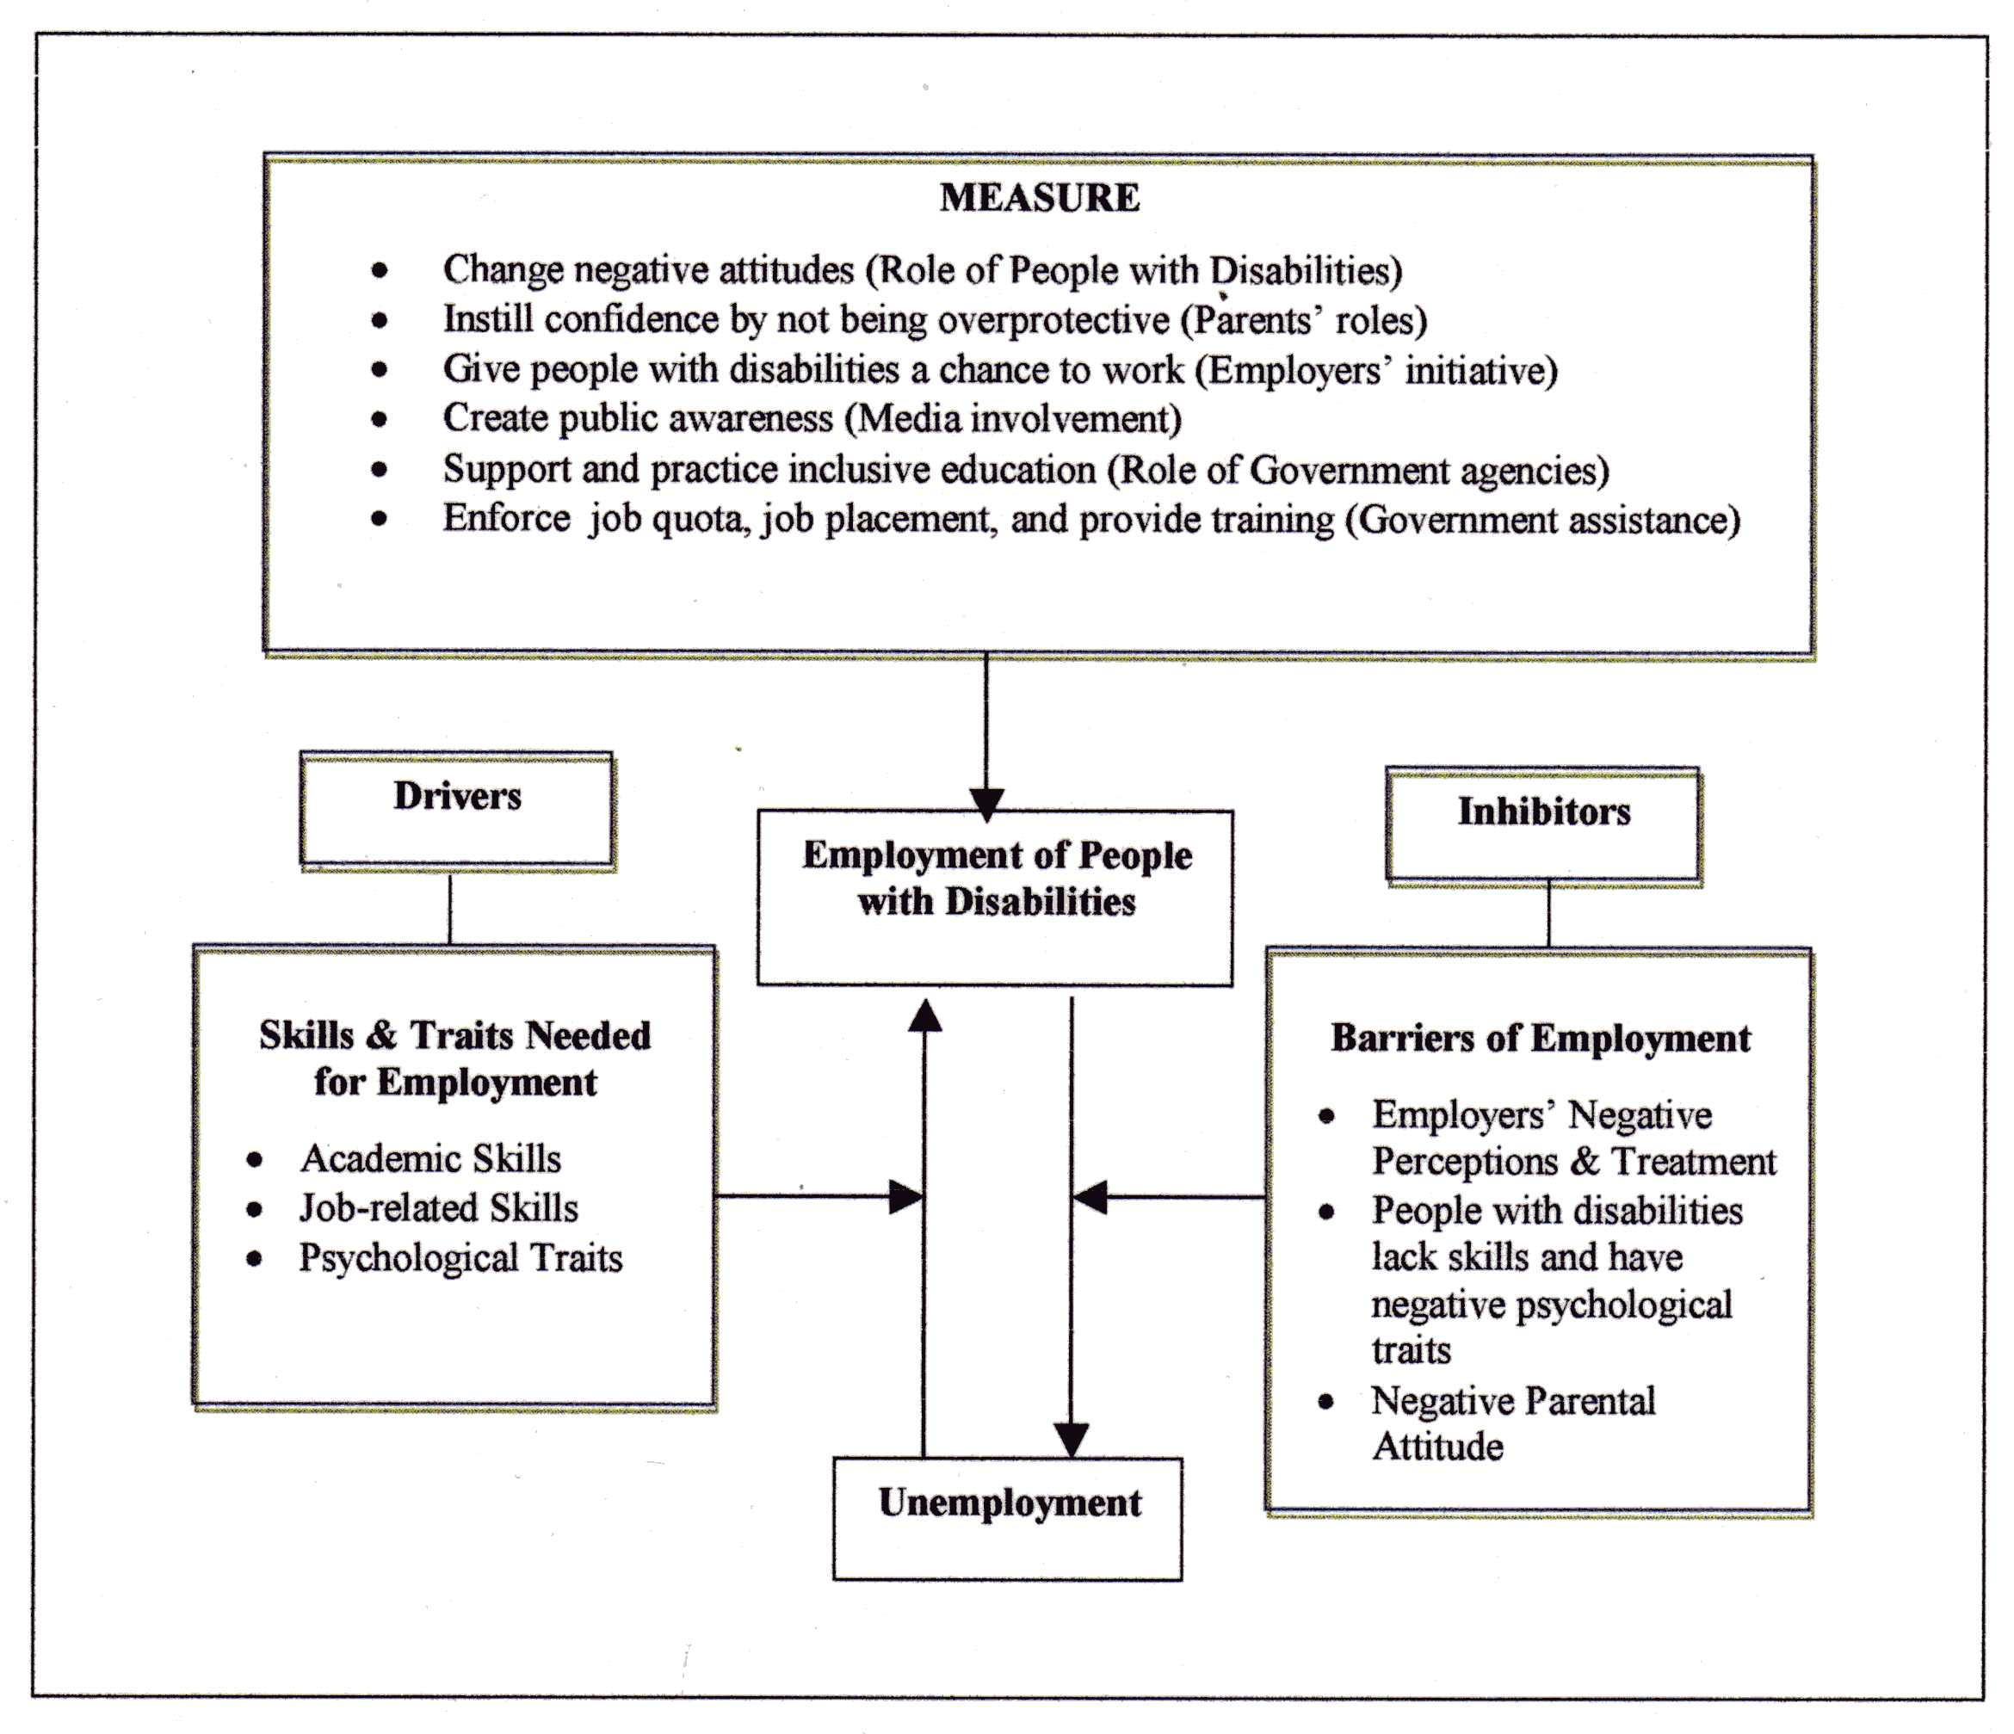
Figure 2: Conceptual Framework for the Findings

The participants believed that people with disabilities should possess vocational skills if they want to find employment, particularly those who are not academically inclined. Prevocational and vocational skills can be obtained through various paths, such as mainstream schools, special education schools, vocational schools, Community-Based Rehabilitation (CBR), sheltered workshops, rehabilitation centers, welfare and NGO institutions, depending on the individual’s age and type of disability. The majority of the participants agreed that it is important to provide vocational skills to people with disabilities. Vocational skills in woodwork, massage, agriculture, mechanics, electrical repair, tailoring, farming, and so on provide greater opportunities for people with disabilities to find jobs in the relevant job field. Other than these vocational programs, people with disabilities should also receive vocational training in information system and computer skills to keep them abreast of the rapid development in Information and Communication Technology (ICT) and to meet the current demands for skilled workers.

In addition to these vocational skills, people with disabilities should also be equipped with other job-related skills such problem-solving and community living skills. The respondents have highlighted that orientation and mobility skills are particularly crucial for people with visual impairments. Without such skills, traveling to the work place itself may be an overwhelming task and potentially limiting one’s ability to engage into the community. Apart from the academic, vocational and job-related skills, people with disabilities should also have positive psychological traits. Optimism, confidence, honesty, openness (about their disabilities) and resilience were perceived as traits that could drive the employment of people with disabilities. Individuals with such traits are psychologically empowered and have high level of self-awareness and self-acceptance. They are also more resilient in the face of challenges and are determined to achieve success in life. All of the aforementioned skills and traits not only help people with disabilities to compete in a job market that does not favor them, but also enable them to carry out their jobs efficiently so that they can remain employed.
Nevertheless, a number of barriers that could inhibit the employment of people with disabilities in Malaysia were also identified in this study. Employers’ negative perceptions and treatment, the shortcomings of people with disabilities and the negative parental attitudes were perceived by the visually impaired participants as some of the major barriers of employment for people with disabilities in the country. The majority of the participants felt that employers are reluctant to hire people with disabilities because they usually lack confidence in them and may not have the facilities to accommodate their needs in the workplace. This belief is supported by Heron and Murray’s (2003) study, which found that employers frequently regard people with disabilities as unsuitable for employment and are thus reluctant to employ them.

Literature reviews also revealed that society usually holds negative perceptions toward people with disabilities, to the extent that they are seen as different, less-capable, incompetent, inferior, and their success is perceived as due to luck or effort rather than capability (Morgon & Wisely, 1996; Millington, Strohmer, Rei, & Spengler, 1996; United for Intercultural Action, 2000). Such prejudicial thinking is clearly demonstrated in Bowman’s (1987) study in which 85% of the respondents have higher confidence in people who abuse alcohol than people with mental retardation in terms of job performance. This result reflects society’s negative perceptions toward the competency of people with disabilities, even when compared to alcoholics who might have less obvious cognitive limitation.

Interestingly, the participants also mentioned that people with disabilities are equally responsible for their inability to obtain employment because they may lack the basic skills required to perform a job, as demonstrated by one of the interviewees: Many [people with disabilities] can’t read or write…like those with mental retardation…or never go to school because parents have kept them at home… how to compete with normal people in the job market… (T13, Male). In addition to fewer academic skills, some people with disabilities also have a negative self-concept and lack self-confidence. These traits may have caused them to lose the battle for employment even before it was begun.

Moreover, overprotective parents who shield their children with disabilities from the outside world could do more harm than good to their children. Parents who are unwilling or unable to accept the condition of their children often believe that there is a cure for their children’s disability and take them to see one bomoh [village doctor] after another. They hope that their children will become normal through spiritual healing. Indirectly, these parents not only impart false hopes on their children but also neglect the children’s immediate need for special intervention, which could enhance their employability in future. As a result, some people with disabilities end up staying at home, totally dependent on their family and isolated from society.

In short, employers’ negative perception, a lack of skills among people with disabilities, their negative psychological traits, and the negative attitude of parents were identified by the participants as barriers to employment. These barriers may explain the persistently high unemployment rate among people with disabilities. In Malaysia, less than one percent of the disabled population is employed (Ministry of Human Resource, 2002). Measures must be taken to overcome this problem.

Some measures were proposed by the participants to enhance the employment rate of people with disabilities in the country. These suggestions can be grouped into six main themes and involve various stakeholders. First and foremost, people with disabilities need to be positive about their own capabilities and potential. This entails parents’ roles in instilling confidence in their children. The employer is another stakeholder that plays crucial roles in providing people with disabilities a chance to work in the organizations. In addition to wider job opportunities, there are also needs to have policies that support people with disabilities in education, community engagement, and employment. Hence, the government should establish clear policies on inclusion education, job quota, and provision of supported employment services such as job placement and skills training. These policies must be highlighted in the media to enhance public awareness. With these efforts in place, the employment rate of people with disabilities in the country may improve.

Conclusion
Securing employment has a certain degree of positive impact on people with disabilities in terms of financial stability and psychological empowerment. Employment not only provides a source of income for independent living but also increases one’s sense of recognition and self-respect (Sarkees & Scott, 1986). Most people with disabilities are trainable and employable. If given job opportunities, they can contribute to the country’s development and become taxpayers. It fact, it is estimated that people with disabilities could contribute about USD 1.68 billion to the Malaysian gross domestic product (Metts, 2000). Hence, they should not be perceived and treated as a liability to society.

The drivers and inhibitors of their employment have been identified in this study. Future studies ought to assess the actual impact of these factors on the employability of people with disabilities. For instance, job-related skills, particularly vocational skills, are prerequisites for people with disabilities to get employment. It is therefore crucial to determine the extent to which the present vocational training meets the market demands and helps people with disabilities get jobs. This implies that the government and NGOs involved in the training of people with disabilities must update and revise their vocational curriculum to ensure that the training provided is in line with the market needs.

Apart from job-related skills, positive psychological trait is another factor that may enhance the employability of people with disabilities. These traits include optimistic, confidence, honesty, openness and resilience, which fall within the parameters of self-determination. Individuals with high level of self-determination are empowered to make decisions about own carrier path and are able to self-advocate as well as engage in community living (Campbell-Whatley, 2008; Wehmeyer, Argan, & Hughes, 2000; Shogren, Wehmeyer, Buchanan, & Lopez, 2006). It enables them to get employment and acquire independent living more successfully. Hence, there are needs to examine the degree to which positive psychological traits is addressed and nurtured in schools, particularly in inclusive education by educators and counselors. The effects of parenting styles on psychological well-being and employability of people with disabilities also warrant further investigations.

Future studies should also unlock the reasons behind employers’ negative perceptions toward hiring people with disabilities and identify measures to create more job opportunities. There are needs to strengthen the legislation on job quota and establish policy on supported employment in the country to ensure people with disabilities have wider employment opportunities and are provided with job readiness training, transition support services, job search, and placement assistance. These policies must be highlighted in the media to enhance public awareness about it. With the establishment of supported employment system, job coaches will be available to assist people with disabilities find job, train for the job and maintain employment. Support services that may be provided include job placement, on-site job coaching and individually tailored supervision. These services can help people with disabilities meet the expectation of the employers and increase their employability.

In summary, the unemployment issue face by people with disabilities is a multi-faceted problem attributed by various factors. A holistic approach that involves various stakeholders, such as people with disabilities, parents, educators, counselors, job coaches, employers, government agencies, and media is needed to enhance the employment rate of people with disabilities in Malaysia.

Acknowledgement
This research project was funded by the Research University Grant, Universiti Sains Malaysia. Account No: 1001/PGURU/816047.

References
Ali, M. M., Mustapa, R., & Jelas, Z. M. (2006). An empirical study on teachers’ perceptions towards inclusive education in Malaysia. International Journal of Special Education, 21 (3), 36-44.
Bakti-Mind.(2008). Sheltered Workshop. Retrieved 4th March 2010 from
http://www.mind.org.my/index.php?page=26
Biwako Millennium. (2007). Malaysian Statement on the Mid-Point Review of the Biwako Millennium Framework for Action, Retrieved on January 15th , 2008 from
http://www.wordenable.et/bmf5/speech
Bowman, J. (1987). Attitudes toward disabled persons: Social distance and work competence. Journal of Rehabilitation, 53(1) 41-44.
Campbell-Whatley, G. D. (2008). Teaching students about their disabilities: Increasing self-determination skills and self-concept. International Journal of Special Education, 23(2), 137-144.
Denzin, N. K. and Y. S. Lincoln. (1994). Handbook of Qualitative Research. London: New Delhi, Sage.
Faccini, R. L. (1986). Self-esteem in young adults with mild mental retardation. Dissertation Abstract International: Section B: The Science and Engineering, 56, 5793.
Hendey, N., & Pascall, G. (2001). Disability and Transition to Adulthood: Achieving Independent Living. Pavilion Publishing: Nottingham.
Hermens, M. L., Adèr, H. J., van Hout, H. P., Terluin, B., van Dyck, R., & de Haan, M. (2006). Administering the MADRS by telephone or face-to-face: a validity study. Annals of General Psychiatry, 5, Art no 3
Heron, R., & Murray, b. (2003). Assisting Disabled Persons in Finding Employment: A Practical Guide. Uruguay: International Labor Organization.
Ibrahim, H. (2006). Parents, Practitioners, and Policy Makers in Positive Partnership. Proceedings in 1st National Early Childhood Intervention Conference, 18th to 20th November 2006, Copthorne Orchid Hotel, Penang. Retrieved December 2008, from
http://www.asiacommunityservice.org/NECIC/CD/Plenary%20Session%204/PS%204A%20-%20Haniz%20Ibrahim.pdf
Jelas, Z. M. (1995a). Strategi bagi pelaksanaan pendidikan inklusif. [Implementation strategies for inclusive education]. Paper presented at Inclusive Education Seminar, Kuala Lumpur: Regional Education Department.
Jelas, Z. M (1995b). Perkembangan kini dan peningkatan pelaksanaan pendidikan khas.[ Development and improvement on special education implementation]. Paper presented at National Special Education Seminar. Terengganu: Ministry of Education Malaysia.
Jelas, Z. M. (1997). Ke-arah pendidikan inklusif di Malaysia melalui kerjasama antarabangsa.[Towards inclusive education in Malaysia through international collaboratio]. Paper presented at National Teachers Education Seminar. Serdang: Universiti Pertanian Malaysia.
Khor, H. T.(2002). Employment of persons with disabilities in Malaysia. Paper presented at the Economic Briefing to the Penang State Government. Retrieved on April 2nd, 2008 from http://job4disabled.jobstreet.com/resources1.htm
Long, C. A. (1997). The development of self-esteem in young adolescents with mild mental retardation. Dissertation Abstracts International Section A: Humanities and Social Sciences, 57(9-A), 3892.
Malaysian Association for the Blind. (2007). The Gurney Training Center for the blind. Retrieved May 3rd, 2008 from http://www.mab.org.my/services/educational.html
Malaysian Federation of the Deaf. (2007). History of the deaf education in Malaysia. Retrieved April 21st, 2008 from http://www.mfd.org.my
Masi, G., Mucci, M., Favilla, L., & Poli, P. (1999). Dysthymic disorder in adolescents with intellectual disability. Journal of Intellectual Disability Research, 43, 80-87.
Memorandum on Disability Issues for the 9th Malaysian Plan. (2005). New Strait Times-Malaysia News Online. Retrieved January 5th, 2008 from http:// http://www.pocam.org/DOWNLOAD/ 050601_memo3.htm
Metts, R. L.(2000). Disability issues, trends, and recommendations for the World Bank. Retrieved July 3rd 2007 from http://siteresources. Worldbank.org/DISABILITY/
Resources/280658-11726907476/DisabilittyIssuesMetts.pdf.
Millington, M. J., Strohmer, D. C., Reid, C. A., & Spengler, P. M. (1996). A preliminary investigation of the role of differential complexity and response style in measuring attitudes towards people with disabilities. Rehabilitation Psychology, 41, 243-254.
Ministry of Education Malaysia. (2009). The development of Education: National report of Malaysia. International Conference on Education at Geneva. Retrieved May 10th 2010 from http://www.ibe.unesco.org/National_Reports/ICE_2008/malaysia_NR08.pdf
Ministry of Education. (1995). Perancangan Strategik Pendidikan Khas 2020. [Special education strategic planning 2020]. Kuala Lumpur: Jabatan Pendidikan Khas.
Ministry of Education. (1995). Perancangan Strategik Pendidikan Khas 2020. [Special education strategic planning 2020]. Kuala Lumpur: Jabatan Pendidikan Khas.
Ministry of Women, Family & Community Development. (2008). Budget 2009. Retrieved March 11th 2010 from http://www.kpwkm.gov.my
Morgan, S. B., & Wisely, D. W. (1996). Children’s attitudes and behavioral intentions toward a peer presented as physically handicapped: A more positive view. Journal of Developmental and Physical Disabilities, 8, 29-42.
Pinter, R., Eisenson, J., & Stanton, M. (1980). The Psychology of the Physically Handicapped. Ayer Co. Pub: Manchester, US.
Rahman. S. A. (2008). An inclusive, barrier-free and rights-based society for people with disabilities (PWDs) in Malaysia. Proceedings in the 2nd Malaysian Conference on Rehabilitation, November 7, 2008, Ministry of Women, Family, and Community Development, Malaysia. Retrieved 22nd September 2009 from http://www.mind.org.my/index.php?page=565
Salleh, N. M., Abdullah, K. & Buang, N. A. (2001). Job opportunities for special needs population in Malaysia, Education Journal, 27, 77-85.
Salleh, N. M. (2002). Our Vocational School: From the eyes of visually impaired children in Malaysia. International Journal of Learning, 9, 1398-1402.
Sarkees, M.D., & Scott, J. L. (1986). Vocational Special Needs. Homewood, IL: American Technical Publishers, Inc.
Shah, S., Arnold, J., & Travers , C. (2004). The impact of childhood on disabled professionals. Children & Society, 18, 194-206
Shamsiah A. R. (2008). An inclusive, barrier-free, and rights-based society for people with disabilities (PWDs) in Malaysia. Paper presented at the Second Malaysian Conference on Rehabilitation, November 7 - 9, 2008, Bangi Industrial Training and Rehabilitation Center, Selangor, Malaysia.
Shogren, K. A., Wehmeyer, M., Buchanan, C., & Lopez, S. J. (2006). The application of positive psychology and self-determination to research in intellectual disability: A content analysis of 30 years of literature. Research and Practice for Persons with Disabilities, 31(4), 338-345.
Social Welfare Department. (2008). Pemulihan, perkhidmatan dan pembangunan OKU. [Rehabilitation, services and development of disabled people]. Retrieved April 15th 2008 from http://www.jkm.gov.my/
Social Welfare Department. (2009a). Statistik Orang Kurang Upaya. [Statistics on disabled person].Retrieved January15th 2009 from http://www.jkm.gov.my/
Social Welfare Department. (2009b). Program Pemulihan dalam Komuniti [Community-Based Rehabilitation]. Retrieved May 17th 2010 from http://www.jkm.gov.my/
Special Education Department (2006). Collaboration Based on Partnership towards realization of Principle, Equity and Social Cohesion: Malaysian Perspective. Proceedings in the 26th Pacific International Seminar on Special Education Japan, 4th to 7th December 2006, The National Institute of Special Education Japan, Japan.
United for Intercultural Action. (2000). Equal rights for people with disabilities. Paper presented at A Mobility International seminar, April 12-16, Brussels, Belgium. Retrieved January 17th 2009 from http://www.unitedagainstracism.org/pages/repssbruen.htm
United Nations Development Program. (2007). Encouraging increased participation by Persons with Disabilities in the workforce in the State of Johor. Retrieved 10th May 2009 from http://www.undp.org.my/uploads/PWD-Johor_prodoc.pdf
Vasoo, S. (2004). Singapore: Employment opportunities for disabled people. Retrieved January 3rd from http://www.disabilityworld.org/01-03_04/employment/singapore.shtml
Watson, N., Shakespearre, T., Cunningham-Burley, S., Barnes, C., Corker, M., Davis, J., & Priestley, M. (1999). Life as a Disabled Child: A quantitative Study of Young’s People’s Experiences and Perspectives. Edinburgh and Leeds: University of Edinburgh and Leeds.
Wehmeyer, Argan, & Hughes, 2000). A national survey of teacher's promotion of self-determination and student-directed learning. The Journal of Special Education, 34 (2), 58-68.
White, B., Cox, C., & Cooper, C. (1992). Women’s Career Development. Blackwell Publishers: Oxford.
Wong, H. S. (2007). Blind Teachers in Malaysia and the Related Issues. The National Council for the Blind, Malaysia (NCBM), 47, 20-21.

