PERCEPTIONS OF VOCATIONAL TRAINING WITH ELEMENTARY SPECIAL EDUCATION STUDENTS: A CASE STUDY

Beth A. Jones
and
Kashunda L. Williams
Texas A&M University-Commerce

The present study sought to determine the perceived utility of initiating vocational training in primary education by implementing a student-operated restaurant. Specifically, this study examined the extent to which vocational education training affected school professionals’, parents’, and elementary special education students’ perceptions of knowledge, performance, and self variables. Participants included 32 school professionals, 19 parents, and 16 students.
At the conclusion of the vocational training, researcher constructed surveys were distributed to school faculty and parents. Additionally, students participated in a semi-structured interview conducted by the researchers. Findings suggest that parents and school professionals perceived the intervention as producing a very significant effect on students’ knowledge, performance, and self variables. School professionals, as well as parents, perceived the training as worthwhile, worthy of continued implementation, and as age appropriate. Non-parametric analyses revealed that school professionals’ and parents’ perceptions of the training’s effect on students’ outcomes were not significantly different. Student surveys suggested the training produced a positive effect on students’ perceptions of knowledge and performance variables.

Transition planning and vocational training for adolescents with disabilities became a national priority with the passage of the Individuals With Disabilities Education Act (IDEA) in 1990 (20 U.S.C. § 1414(d)(1)(A)). This national emphasis on transitioning was reiterated by the Individuals with Disabilities Improvement Act of 2004 (IDEA) which states that the purpose of special education is to, prepare [individuals with disabilities] for further education, employment, and independent living toward the national aim of ensuring equality of opportunity, full participation, independent living, and economic self-sufficiency. ((20 U.S.C. §l400C33)(c)(l)). Since its inception, legislation mandating transition planning and vocational training has resulted in much improved postsecondary outcomes for students with disabilities. For example, the National Longitudinal Transition Study-2 (NLTS2), which began tracking more than 11,000 special education students in 2000, demonstrated a significant rise in employment among exiting students with disabilities (Wagner, Newman, Cameto, & Levine, 2005). Due to the known positive outcomes associated with vocational training and transition planning for adolescents with disabilities, it has been hypothesized that preparation of students in the early grades for entrance into the workforce when they are adults may be critical, potentially making students more likely to be productive members of society (Fabian, 2007; Livelli, 1999).

Benefits of Vocational Training. Studies have demonstrated that vocational education programs yield positive effects on school performance and post-school outcomes. Some elements of school performance include, but are not limited to, school attendance, course failure, and dropout rates. Post-school outcomes are measured by involvement in a post-secondary vocational programs and/or employment. These positive effects offer validation for the utility of vocational training with post-secondary special education students.

The National Longitudinal Transition Study (NLTS), a study conducted by SRI International and sponsored by the Office of Special Education Programs, found that participation in vocational education decreased absenteeism and course failure (Wagner, 1991). One compounding effect of this for students with disabilities who take vocational courses or participate in work experience programs is that they are more likely to graduate (Evers, 1996). Specifically, Wagner found that vocational training resulted in a compounded 8% chance of dropping out, versus 15% for students who had not participated in vocational education. This is supported by a finding by the U. S. Department of Education (1994) that associates a concentration in vocational courses or having taken a survey vocational education class with a dramatically lower probability of dropping out of high school in the 11th and 12th grades.

This reduction in dropout rates is most significant because, according to the National Longitudinal Transition Study-2 (Wagner, Newman, & Cameto,2004), students without a high school diploma do not share in the significant increase in postsecondary education enrollment that occurs among youth with disabilities who complete high school, only about one-fourth of dropouts enroll in a high school completion program, dropouts do not benefit from the increased earnings relative to the federal minimum wage and the shifts in the types of jobs occupied by youth with disabilities who completed high school, and dropouts are less likely than high school graduates to have the support and stability of living with parents.

Post-school employment outcomes for students with disabilities who participated in vocational education programs, compared to those for non-participants, are well documented (Frank, Sillington, & Carson, 1991; Frank, Sitlington, Cooper, & Cool, 1990; Hasazi, Gordon, R. & Roe 1985; Hasazi, Johnson, Hasazi, Gordon, & Hull, 1989; Shapiro & Lentz, 1991; Sitlington & Frank, 1990; Wagner, 1991). Of these studies, most reported higher percentages of employment for students who participated in vocational education. Furthermore, Hasazi et al. (1985), Hasazi et al. (1989), and Wagner (1991) reported that students with disabilities who participated in vocational education had significantly higher levels (+13% - 48%) of post-school employment compared to students with disabilities who did not take vocational education. In fact, students who had taken vocational education in their most recent school year, and, thus, had the associated likelihood of school completion, had an estimated probability of finding employment at 78%, compared to 55% for similar students who had not taken vocational education courses or participated in work experience in their most recent school year (Wagner, 1991). Additionally, several studies have demonstrated that secondary vocational education is consistent with a positive labor market advantage (Fourqurean & LaCourt, 1990; Harvey, 1998; Hasazi et al., 1985; Hasazi et al., 1989; Mithaug, Horiuchi, & Fanning, 1985; Schalock, Holl, Elliott, & Ross, 1992).

Implementation of Vocational Education. Accessibility of vocational training programs directly impacts how vocational education is delivered, and, in order to better prepare students for transitions, special educators should be apprised of this issue (Evers, 1996). For example, students’ participation in vocational training occurs solely in the upper grades, with continual increases approaching 11th and 12th grade (Cobb & Neubert, 1992; Wagner, 1991). Specifically, the NLTS found that 38% of students in 7th and 8th grade were enrolled in vocational education, versus 82% of 11th and 12th graders. What is more, just as the number of students enrolled in vocational education increased in the upper grades, so did the time spent in training (i.e., ten hours a week in upper grades versus seven hours a week for 9th and 10th graders). Wagner points out that this data is especially troubling given that over half of students with disabilities (57%) dropped out in the 10th grade or earlier, before students could benefit from participation in the upper school grades that are associated with higher rates of vocational education and the experiences gained from vocational training. Furthermore, a review of existing literature revealed a majority of research targeted at the implementation of vocational training with secondary students with disabilities and an apparent absence of implementation of such trainings with younger populations. In 1973, Bender did propose a framework for enhancing occupational guidance programs for elementary schools which focused on broadening students' knowledge of work and careers, career expectations, relation of education to work, and self-concepts. The framework was to be implemented by school counselors and a model of implementation procedures was discussed. Since the Bender (1973) study, however, there has been an apparent absence of implementation of such trainings with younger populations. This conclusion was drawn after conducting a literature search using Ebsco ERIC and vocational model + elementary; vocational model; vocational model + learning disabilities; and vocational model + special education as the search terms, as well as a search using PsycINFO with the terms vocational model + elementary.

Given that vocational training occurs primarily in the upper grades (Wagner, 1991) and an increased accountability for post-school outcomes in recent years which have made effective vocational training even more relevant (Bassett & Kochhar-Bryanr, 2006; Carter, et. al., 2010; Wagner, 1991), this study sought to serve as a primary investigation into the utility of vocational education for primary special education students. Pertinent to this objective is determining the effects of elementary vocational training on student outcome variables. Particularly, the authors wanted to examine the impact that such training would have on school professionals’, parents’, and students’ perceptions of students’ outcomes related to knowledge, performance, and self variables.

Knowledge, Performance, and Self. Previous efforts to assess the utility of vocational training have investigated school performance and post-school outcomes. Because the targeted population of the present study involved elementary students, measures of school dropout rate and post-school outcomes were not warranted. Therefore, the principal investigators adapted factors presented by Wentling and Barnard (1984), Occupational Survival Skills and Affective Job Skills, in order to establish categories by which to measure student outcomes.

Wentling and Barnard use the term Occupational Survival Skills to encompasses generalizable skills necessary for maintaining a job, including: ability to follow directions, being dependable, respecting authority, effectively managing time and materials, an understanding of the steps necessary to do a job, and how to present a good image to the employer. Therefore, for the purposes of assessing outcome measures, the present study divided occupational job skills into two categories: knowledge and performance. First, knowledge was used to code participants’ mentions of anything learned, whether inferred or implicitly stated. The performance variable was coded when participants mentioned or described any action that did not include future behavior. According to Wentling and Barnard (1984), Affective Job Skills refer to whether a vocational program has allowed students to develop an understanding of their own abilities and interests. Thus, a third variable, associated with affective job skills, was termed self. Self-outcomes included any reference to emotional states, self-reflections, and/or feelings.

The purpose of this research was to implement vocational training with elementary special education students in order to: (a) document school professionals’ and parents’ perceptions of student outcomes following participation in the vocational training. Specifically, do school professionals and parents perceive the vocational training as producing significant student outcomes in the areas of knowledge, performance, and self? (b) Document school professionals’ and parents’ perceptions of the worth, need for continued implementation, age appropriateness, and student utilization of skills attained during training. (c) Determine if school professionals and parents differ in their perceptions. (d) Document students’ perceptions of the effects of the training in the areas of knowledge, performance, and self.

Method
Considering the known benefits of vocational training for students with disabilities and the absence of empirical research to support the implementation of vocational training with elementary age students, the present case study sought to investigate the perceived advantages of vocational training on knowledge, performance and self-variables in special education students. The study was conducted in one elementary school (grades PK-four) in the southern United States. This elementary school was the only elementary campus in a district of approximately 1,000 students. The vocational training was implemented as a student-operated restaurant, held on the school campus.

Participants. Participants included school professionals, parents, and students. School professionals who participated (N=32) included all faculty and staff members of the school, school administrators, the speech pathologist, and the campus diagnostician. All parents of participating special education students were given the opportunity to participate. Nineteen parents agreed to take part in the study.

Twenty special education students participated in the vocational training, however due to the fact that four students were nonverbal, only sixteen students completed the student survey. All special education students who were served in the resource classroom for one or more classes or were in the self-contained classroom were included. One participant received inclusion services only. Fourteen of the participants were male (70%) and six of the participants were female (30%). Ten participants were White (50%), eight were Hispanic (40%), one was African-American (.05%), and one was Native-American (.05%). Two students were coded as both White and Hispanic and were included in the Hispanic percentage above.

The represented disability categories were composed primarily of students with learning disabilities (65%) and students with other health impairments (15%). Four students were coded with multiple eligibilities as described as follows: (1) autistic, emotionally disturbed, and speech impaired; (2) autistic, mentally retarded, and speech impaired; (3) mentally retarded and speech impaired; (4) other health impaired, mentally retarded and speech impaired.

Vocational Training. The vocational training utilized in his study was adapted from an unpublished, anecdotal training. This training was implemented, because the first author had used the training in the past and the training was approved be the school campus. The training consisted of three days of opening preparation, three days of actual restaurant operation, three weeks of unit work and a closing ceremony.

Procedures. In preparation for the implementation of the vocational training, the lead special education teacher (also the lead author) solicited local businesses for adequate food donations and restaurant supplies to furnish the student-operated restaurant for three days, with a target of 100 customers each day. During this process, the management of one local restaurant agreed to have all twenty students out to their place of business for a field trip as a kick-off to the opening preparation phase of the training. This allowed the students to see the jobs that they would perform, tour the kitchen, and eat a meal in a restaurant.

At the conclusion of this field trip, students returned to the school campus and were instructed in the correct procedures for filling out a job application. Students were shown correct and incorrect samples, and the strengths and weaknesses of each were discussed. After instruction, the students completed their own job application, which asked them to rank their top three job choices and tell why they would be good at those jobs.

The lead teacher assigned the jobs to the students, attempting to give students their first choices and at least have students perform two different jobs over the three day operation period of the restaurant. The students then proceeded to help set up the restaurant in the teacher’s lounge, rehearse their jobs with teacher modeling and scaffolding, and make posters to advertise their restaurant within the school. The lead teacher sent correspondence to the faculty/staff of the elementary school, to the central office of the district, and to parents for the purpose of inviting adults to attend the restaurant as customers.

During restaurant operation, students served as the hosts/hostesses, waiters/waitresses, cooks (i.e., the students helped fill orders on the plates in lieu of actually cooking), busboys, and cashiers. Customers included the school professionals and students’ parents. School professionals’ surveys were distributed to the faculty and staff of the elementary school at the conclusion of restaurant operation. The surveys were placed in their school mailboxes, and respondents were asked to return the completed form without any identifying information.

On the last day of restaurant operation, all employees of the student-operated restaurant were recognized for their efforts in a school-wide assembly. Students were brought on stage, asked their favorite parts of the experience and presented with a tray of cookies to share. During this time, students were never identified to the student body as special education students.

Following restaurant operation, students began three weeks of academic unit work. The unit work included academic skill building in the areas of language arts and mathematics. As part of the language arts unit, students drafted, edited, and typed thank you notes to send to the contributing local businesses. Students completed a math unit in which they performed mathematical calculations to determine the earnings totals from each day of restaurant operation. Students then translated their earnings findings into table format and graphical representations. Students then answered reflective questions aimed at making projections based on observed patterns of data on the graphs. That is, students projected possible totals earnings if the restaurant had operated a fourth day. Students then transferred graphs to chart paper for the purposes of display in the classroom. Student surveys were completed at the completion of the academic units. That is, the lead author interviewed students and tape recorded their responses.

Approximately three weeks following the completion of restaurant operation and immediately following the academic units, students used part of their earnings to fund a meal at a local restaurant that had contributed greatly to the vocational training. Immediately following the meal, students participated in a closing ceremony to celebrate their successful completion of vocational training. During the ceremony, students and parents viewed a slideshow of photos depicting student participation in the vocational training, ranging from the initial field trip to the local restaurant to student execution of the restaurant. Lastly students presented a portion of their remaining earnings, in the form of a donation check, to an area day camp for students with disabilities. Parent surveys were distributed, completed, and collected during the closing ceremony. Those parents who could not attend were delivered surveys.

Measures. All measures utilized in this study were created by the authors. The following is a description of each measure utilized.

School Professional Surveys. This survey contained seven Likert items, three dichotomous (i.e., yes/no) responses, and two open ended responses. The Likert scale items ranged from 1=insignificant outcomes to 5=very significant outcomes. These items measured school professionals’ perceptions of the significance of student outcomes. The dichotomous items measured perceptions of the training’s worth, need for continued implementation, and age appropriateness. Item 11 on the school professional survey was open ended and measured perceptions of students’ future use of skills learned during the project. The school professional survey also contained a 12th item, which was open ended and measured perceptions of the students’ behavior during the training’s implementation.

Parent Surveys. The parent survey included the same items as the school professional survey, with the omission of the final open ended question (item 12). Additional questions appearing on the parent survey were aimed at obtaining demographic information about their participating child. Specifically, parents were asked to give their child’s age, gender, and ethnicity. Ethnicity choices provided were: Hispanic, African-American, White, Asian, Native American, and other.

Student Surveys. The lead author interviewed the participating students at the conclusion of the academic units. Students responded to five questions during the interview:
1.) what did you learn from being part of the cafe?
2.) What was your favorite part of the café?
3.) What does it take to be a good employee?
4.) What did you learn about filling out a job application? and
5.) How can you use the skills you learned from the café in the future?
Student responses were noted by the researcher, as well as tape recorded for further evaluation. The items on the student survey measured students’ perceptions of the training as they related to the knowledge, performance, and/or self variables.

Inter-rater Agreement. The first two authors independently coded school professionals’ and parents’ responses on their respective surveys, as well as student responses from recordings. IOA was calculated by dividing the number of agreements by the number of agreements plus disagreements, and multiplying by 100%. Agreement was 100% if the researchers had the same results for the variables used (e.g., knowledge, performance, and self). If the scores were not the same, the smaller number was divided by the larger number, and the result was multiplied by 100, following standard agreement computations for rate-based measures (Cooper, Heron, & Heward, 1987). IOA was collected on 31.25% of the school professionals’ surveys. Mean IOA was 94.55% (range, 54.55% to 100%). IOA was collected on 36.84% of the parents’ surveys. Mean IOA was 96.10% (range, 90.91% to 100%). IOA was collected on 37.5% of the total number of the recorded responses to the student survey. Mean IOA was 92.22% (range, 73.33% to 100%).

Analysis
All school professional, parent, and student participants that provided consent were included in the analysis. Responses to survey items, unless otherwise mentioned below, were categorized as either knowledge, performance, or self related. The variables were defined as: (1) Knowledge – mention of anything learned, whether inferred or implicitly stated with questions, (2) Performance – description of any action that does not include future behavior, and (3) Self – reference to any emotional states, self-reflections, and/or feelings.

Responses on the school professionals and parent surveys were coded based on question type. Likert scale items were categorized as being knowledge (i.e., Items 2, 3, & 6), performance (i.e., Items 4 & 5), or self (i.e., Items 1 &7) related. Dichotomous responding was required for items 8-10 on the school professionals and parent surveys. These responses were coded as either 0 (no response) or 1 (yes response). Item 11 on the school professional and parent surveys was open ended and responses to this question were dichotomously categorized (i.e., yes– will use skills learned in the future or no– will not use skills learned in the future) based on response content. The school professional survey contained item 12, which was categorized as being knowledge, performance, and/or self related. That is, each response had the possibility of being coded as all, none, or any combination of the categories depending on its content.

Descriptive statistics were used to determine if there were differences in school professionals’ and parents’ perceived effects of the training. Chi-square and Mann-Whitney analyses were conducted to report differences in parent and school professionals’ perceptions.

Due to the open ended nature of responses on the student surveys, responses were categorized as being knowledge, performance, and/or self related, and each response had the possibility of being coded as all, none, or any combination of the categories depending on its content. Descriptive statistics were utilized to determine students’ perceived effects of the training on their knowledge, performance, and self. Percentages of the overall occurrence of knowledge, performance, and self related statements within student responses were calculated and reported.

Results
School Professionals. The perceived significance of student outcomes presented in Likert items 1-7, as rated by school professionals, can be viewed in Figure 1. Likert items were categorized as being knowledge, performance or self related. Overall, school professionals rated the degree to which perceived student outcomes were related to knowledge as very significant (52.3%), while 30.2% rated them significant, 11.6% neutral, and 5.8% not significant. School professionals also rated their perceived significance of student outcomes as related to performance to be very significant (58.6 %), with 34.5% responding that outcomes were significant, 1.7% neutral, and 5.2% not significant. Lastly, 69.6% of school professionals rated their perceived relationship to self as very significant, while 26.8% responded that the relationship was significant, 3.6% neutral, and 0% not significant. The results indicate that the majority of school professionals perceived the vocational training as producing significant to very significant student outcomes in the areas of knowledge, performance, and self.
Figure 1. Display of perceived significance of student outcomes by school professionals
and parents as reported from Likert items 1-7.
Figure 2 represents the percentage of school professionals who responded affirmatively to items 8-11. Respondents reported the following: 96.9% (n=31) felt the training was a worthwhile project, 96.9% (n=31) felt the training should be implemented in the future, 93.9% (n=31) felt the training was age appropriate and 72% (n=25) felt that students would utilize skills taught as a part of the training in the future. The results indicate that the majority of school professionals perceived the training as worthwhile, as worthy of continued implementation, as age appropriate, and that students would utilize skills attained in the future.
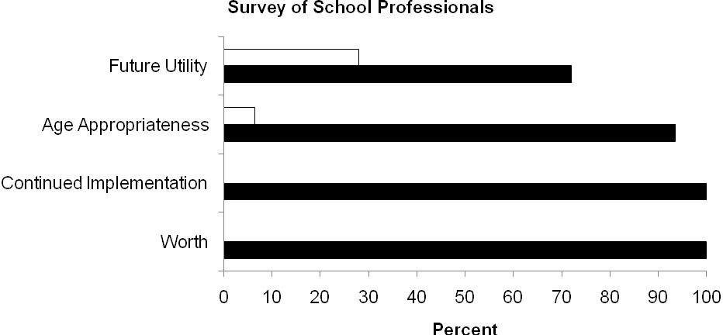

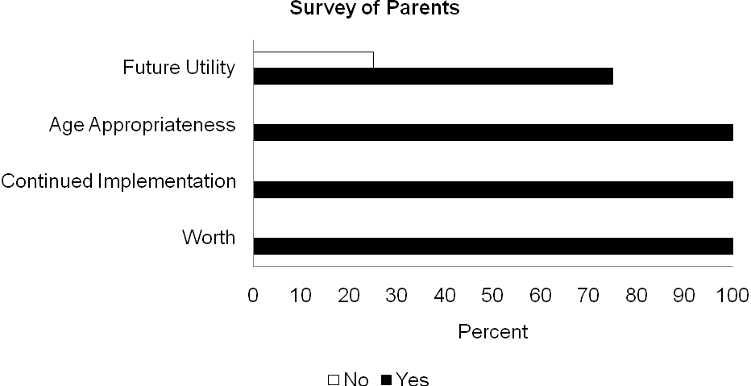
Figure 2. Display of the percentage of school professionals and parents who responded
affirmatively to items 8-11.

Item 12 on the school professionals’ survey allowed respondents to report observed students’ behaviors during the training (see Figure 3 next page). Of the student behaviors reported, 6.7% were related to knowledge, 40% were related to performance, and 93.3% were related to self. The results indicate that the majority of school professionals perceived observed students’ behaviors during the training as self related.

Parents. Parents’ perceived significance of student outcomes with regard to Likert items 1-7 can be viewed in Figure 1. Likert items were categorized as being knowledge, performance, or self related. Nearly half of parents rated their perceptions of student outcomes as having a very significant relationship to knowledge (47.4%). Just over a third of parents (38.6%) reported a significant relationship, 12.3% were neutral, and 1.8% rated the relationship as not significant. Parents’ ratings of their perceived relationship between student outcomes and performance were very similar to those found in relationship to knowledge, with 50% responding very significant, 28.9% significant, 18.4% neutral, and 2.6% not significant. Lastly, a majority of parents rated outcomes as related to self, with 55.3% rating the relationship as very significant, 36.8% significant, 5.3% neutral, and 2.6% not significant. The results indicate that the majority of parents perceived the vocational training as producing significant to very significant student outcomes in the areas of knowledge, performance, and self.
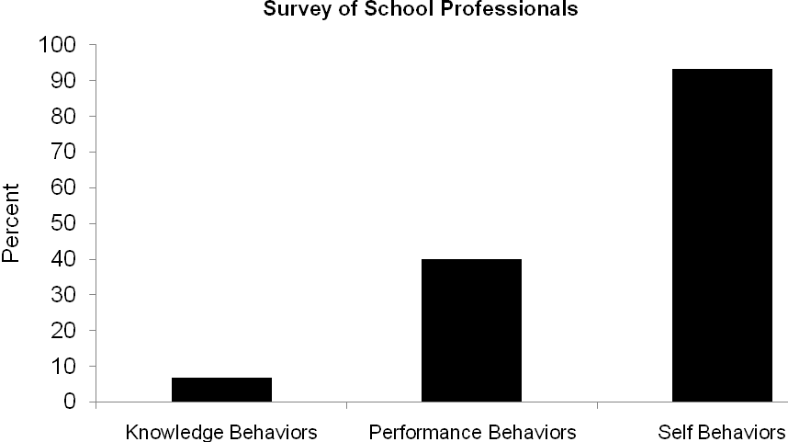

Figure 3. Display of school professionals reported observed students’ behaviors during
the training as the behaviors relate to knowledge, performance and self.

Figure 2 represents the percentage of parents who responded affirmatively to items 8-11. Respondents reported the following: 100% (n=19) felt the training was a worthwhile training, 100% (n=19) felt the training should be implemented in the future, 100% (n=19) felt the training was age appropriate and 63.2% (n=16) felt that students would utilize skills taught as a part of the training in the future. The results indicate that the majority of parents perceived the training as worthwhile, as worthy of continued implementation, as age appropriate, and that students would utilize skills attained in the future. Mann-Whitney U Test analyses were conducted to determine if school professionals and parents differ in terms of their perceived levels of significance. Overall, school professionals’ and parents’ ratings of the perceived relationship between student outcomes and knowledge (z = -.646, p=.518), performance (z = -1.20, p = .230), and self (z = -1.485, p = .137) were not significantly different. It can be concluded that school professionals’ and parents’ perceptions did not significantly differ.
Chi-squared analyses were conducted to determine the proportion of school professionals who perceived the training as: a worthwhile project (chi-squared (1, N=50) = .000, p = 1.0), an activity that should be implemented in the future (chi-squared (1, N=50) = .000, p = 1.0), age appropriate (chi-squared (1, N=50) = .149, p = .699), and teaching skills that students would utilize in the future (chi-squared (1, N=41) = .000, p = 1.0). For each category, no significant differences in the endorsements of school professionals and parents were found. It can be concluded that school professionals’ and parents’ perceptions did not significantly differ.

Students. Students’ perceptions of the effects of the training on their knowledge, performance, and self can be seen in Figure 4.
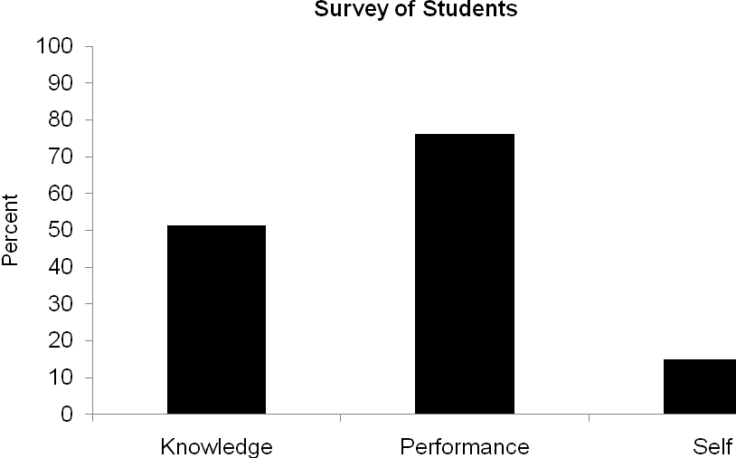
Figure 4. Display of students’ perceptions of the effects of the training on their
knowledge, performance, and self variables.
Overall, student responses reflected outcomes related to knowledge and performance, with 51.3% of student responses containing knowledge related statements, 76.3 % performance related statements, and 15% self related statements. The results indicate that the majority of students perceived the vocational training as producing significant to very significant student outcomes in the areas of knowledge and performance.

Discussion
Training was initiated with the intention of helping students by providing them with an activity that would facilitate learning and personal growth. During the training’s design and development, several questions transpired that were not directly addressed in the literature. Utilizing a systematic methodology and creating measures to address arising questions, the ultimate goal of this study was to contribute to the field of work related to vocational training. That is, this work should be viewed as a case study that initiates investigation exploring the impact of vocational training on elementary school special education students. The purposes of this research were to: (a) document school professionals’ and parents’ perceptions of student outcomes following participation in the vocational training. Specifically, do school professionals and parents perceive the vocational training as producing significant student outcomes in the areas of knowledge, performance, and self?; (b) Document school professionals’ and parents’ perceptions of the worth, need for continued implementation, age appropriateness, and student utilization of skills attained during training.; (c) Determine if school professionals and parents differ in their perceptions.; (d) Document students’ perceptions of the effects of the training in the areas of knowledge, performance, and self.

The results of this study indicate that the majority of school professionals and parents perceived the vocational training as producing significant to very significant student outcomes in the areas of knowledge, performance, and self. Also, the majority of school professionals and parents perceived the training as worthwhile, as worthy of continued implementation, as age appropriate, and that students would utilize skills attained in the future. School professional and parent perceptions did not significantly differ. The majority of students perceived the vocational training as producing outcomes in the area of knowledge and performance, but not in the area of self.

Implications
Perhaps the most far-reaching implication of this investigation is that its findings warrant further study into the affect of vocational training on elementary students in special education. Although exploratory in design, this study provides evidence supporting the notion that vocational training can be implemented with young students, and that the training can affect perceptions of student outcomes. However, the type and degree of the influences of vocational trainings with young students in special education should be addressed in future research, as this study provides merely a foundation for future researchers and practitioners. Researchers can address the limitations of this investigation and design studies that explore other outcomes of vocational training with young students in special education. As a result of this study’s findings and with more research, practitioners should potentially consider changes to the special education curriculum in schools by introducing vocational training in earlier grades.

Another significant impact of this study is related to the fact that adult participants endorsed student outcome variables (i.e., knowledge, performance, and self) at high levels and more consistently than student participants. That is, the majority of participating school professionals and parents perceived the training as having a positive significant impact on students’ abilities. Traditionally, literature supports the idea that adults underestimate the abilities of students in special education. Specifically, researchers have found that teachers overestimate the academic performance of high achievers and underestimate that of low achievers (Coladarci, 1986,; Hoge & Butcher, 1984; Patriarca & Kragt, 1986). Furthermore, Peterson and Barger (1984) found that teachers attributed the success of perceived high achievers to ability, while attributing that of perceived low achievers to luck. Thus, perceived low achievers have difficulty changing their teacher’s expectations through their effort. Early implementation of vocational trainings could potentially serve to change adult perceptions of special education students’ abilities. This potential outcome is supported by Wershing, Gaylord-Ross, C. and Gaylord-Ross, R. (1987) who suggested that a change in adult attitudes and beliefs about students in special education could be a positive result associated with vocational training. Wershing et al., also suggested that vocational training, specifically community-based training, can not only change the behavior of the target students but also the behaviors and attitudes of significant, non-handicapped people in their lives. This study furthers the assertion by Wershing et. al., by suggesting early school-based vocational training can possibly positively influence school professionals’ and parents’ perceptions of special education students.

Limitations and Directs for Future Research
There are, however, potential limitations associated with this research. First, the study’s design could have allowed for rater bias in reporting participants’ perceptions of the vocational training, as the primary investigator was an employee of the school district in which the study was conducted. Therefore, it is possible that prior relationships with the school professionals, parents, and students who participated in the study might have positively impacted their responses. Future research should take measures to mediate relationship history. Second, a more representative sample of the 13 disability categories served under the Individuals with Disabilities Education Act (IDEA) could have been instructive. Given that the sample was predominantly comprised of students with learning disabilities, results may not accurately represent the effects that vocational training would have had for a more severely disabled population. Future research should include a more varied special education population. Third, because the study was conducted in one school district with only 20 participants, there are limitations with regard to the generalization of results. Future research should include a larger sample size. Fourth, the psychometric properties of the surveys used are unknown. Future researchers should utilize measures that have data that demonstrate reliability and validity. Lastly, the study involved indirect assessments (i.e., surveys) of the target variables (i.e., knowledge, performance, and self). The incorporation of direct measures of the target variables (e.g., observations) could strengthen future studies.

Conclusions
It seems logical to consider earlier implementation of vocational training with students in special education, if there is data that reports secondary education students are exiting school before receiving exposure to or completing training programs. The perceptions of school professionals, parents, and students that participated in this study indicate that early implementation of vocational training can result in positive outcomes for students. Our findings further the field, but it is paramount that researchers continue to investigate the impact of vocational training programs with elementary special education students.

References
Bassett D. S. & Kochhar-Bryant, C. A. (2006). Strategies for aligning standards-based education and transition. Focus on Exceptional Children, 39(2), 1.
Bender, R. C. (1973). Vocational development in the elementary school: A framework for implementation. School Counselor, 21(1), 116-120.
Carter, E. W., Ditchman, N., Sun, Y., Trainor, A. A., Swedeen, B., Owens, L. (2010). Summer employment and community experiences of transition-age youth with severe disabilities. Exceptional Children, 76(2), 194-212.
Cobb, R. B., & Neubert, D. A. (1992). Vocational education models. In F. Rusch, L. DeStefano, J. Chadsey-Rusch, L. Phelps, & E. Szymanski (Eds.), Transition from school to adult life (pp. 93-113). Sycamore, IL: Sycamore.
Coladarci, T. (1986). Accuracy of teacher judgments of student responses to standardized test items. Journal of Educational Psychology, 78(2), 141-146.
Cooper, J. O., Heron, T. E., & Heward, W. L. (1987). Applied Behavior Analysis. Columbus, OH: Merrill.
Evers, R. B. (1996). The positive force of vocational education: Transition outcomes for youth with learning disabilities. Journal of Learning Disabilities, 29(1), 69-78.
Fabian, E. S. (2007). Urban youth with disabilities: Factors affecting transition employment. Rehabilitation Counseling Bulletin, 50, 130-138. doi:10.1177/00343552070500030101.
Fourqurean, J., & LaCourt, T. (1990). A follow-up of former special education students: A model for program evaluation. Remedial and Special Education, 12(1), 16-23.
Frank, A., Sitlington, P., & Carson, R. (1991). Transition of adolescents with behavioral disorders-Is it successful? Behavioral Disorders, 16(3) 180-191.
Frank, A., Sitlington, P., Cooper, L., & Cool, V. (1990). Adult adjustment of recent graduates of Iowa mental disabilities programs. Education and Training in Mental Retardation, 25(1) 62-75.
Harvey, M. (1998). The relationship of postsecondary transitional outcomes and participation in secondary vocational technical education among students with disabilities (Doctoral dissertation).Retrieved from UMI: ProQuest Digital Dissertations. (AAT 9836683)
Hasazi, S. B., Gordon, L. R., & Roe, G. A. (1985). Factors associated with the employment status of handicapped youth exiting high school from 1979 to 1983. Exceptional Children, 51, 455-469.
Hasazi, S. B., Johnson, R. E., Hasazi, J. E., Gordon, L. R., & Hull, M. (1989). Employment of youth with and without handicaps following high school: Outcomes and correlates. The Journal of Special Education, 23, 243-255.
Hoge, R. D. & Butcher, R. (1984). Analysis of teacher judgments of pupil achievement level Journal of Educational Psychology, 76(5), 777-781.
Individuals With Disabilities Education Act of 1990, 20 U.S.C. § 1400 et seq. (1990).
Individuals With Disabilities Education Improvement Act of 2004, 20 U.S.C. § 1400 et seq. (2004).
Livelli, P. (1999). Community based vocational training for students with significant disabilities model: leadership and initiation. Journal of Vocational Rehabilitation, 13, 45-49.
Mithaug, D. E., Horiuchi, C. N., & Fanning, P. N. (1985). A report on the Colorado statewide follow-up survey of special education students. Exceptional Children, 51(5), 397-404.
Patriarca, L. A., & Kragt, D. M. (1986). Teacher expectations and student achievement: The ghost of Christmas future. Curriculum Review, 25(5-6), 48-50.
Peterson, P. L. & Barger, S. A. (1984). Attribution theory and teacher expectancy. In J. B. Dusek (Eds.), Teacher expectancies (pp. 159-184). Hillsdale, NJ: Lawrence Erlbaum.
Schalock, R., Holl, C., Elliott, B., & Ross, I. (1992). A longitudinal follow-up of graduates from a rural special education program. Learning Disabilities Quarterly, 15(1), 29-38.
Shapiro, E. S., & Lentz, F. E. (1991). Vocational-technical programs: Follow-up of students with learning disabilities. Exceptional Children, 58(1), 47-59.
Sitlington, P. L., & Frank, A. R. (1990). Are adolescents with learning disabilities successfully crossing the bridge into adult life? Learning Disability Quarterly, 13(2), 97-111.
U.S. Department of Education. (1994). Implementation of the Individuals with Disabilities Education Act: Sixteenth annual report to Congress.(ED 363-058). Retrieved from http://www2.ed.gov/about/reports/annual/osep/index.htmlWagner, M (1991). The benefits of secondary vocational education for young people with disabilities: Findings for the National Longitudinal Transition Study of Special Education Students (300870054). Washington, D. C: Government Printing Office.
Wagner, M., Newman, L., & Cameto, R. (2004). Changes over time in the secondary school experiences of students with disabilities. A report of findings from the National Longitudinal Transition Study (NLTS) and the National Longitudinal Transition Study-2 (NLTS2). Retrieved from http://www.nlts2.org/pdfs/changestimecompreport.pdf
Wagner, M., Newman, L., Cameto, R., & Levine, P. (2005, June). NLTS2: Changes over time in the early postschool outcome of youth with disabilities. Retrieved from http://www.nlts2.org
Wentling, T. L. & Barnard, W. S. (1984). Astudy of state-wide perceptions of vocational education outcomes. Identification and assessment of vocational educational outcomes (R3114D0124487). Washington, D. C: Government Printing Office.
Wershing, A., Gaylord-Ross, C. & Gaylord-Ross, R. (1986). Implementing a community-based vocational training model: A process for systems change. Education and Training of the Mentally Retarded 21(2), 130–137.

