ATTITUDES TOWARDS INCLUSION: GAPS BETWEEN BELIEF AND PRACTICE

Yoon-Suk Hwang
Queensland University of Technology

David Evans
University of Sydney

General education teachers in the Republic of Korea were investigated regarding their participation in programs to include students with disabilities in general education settings. Previous studies have shown that even general education teachers with positive attitudes towards inclusion are reluctant in practice to have students with disabilities in their classrooms. This study examines 33 Korean general education teachers from three primary schools in Seoul regarding their attitudes towards, and willingness to accommodate, the needs of a student with a disability. The results show that 41.37% of general education teachers had positive attitudes towards inclusion programs, while 55.16% were unwilling to actually participate. Quantitative data obtained through a questionnaire was supplemented by qualitative data obtained through interviews. The interviews focused on the positive and negative effects of inclusion, as well as problems in implementing inclusive education programs. The findings will be discussed in the light of previous international research and will highlight links between the age and teaching experience of general education teachers and their negative attitudes towards inclusion.

Inclusion is a global trend in education that requires the involvement of and collaboration between educational professionals. While educational professionals accept the educational rights of children with disabilities and the principle of inclusion - that schools should provide for the needs of all the children in their communities, regardless of ability and disability (Foreman, 2008) - there remain significant barriers to achieving these ideals. This gap entails differences between attitudes towards inclusion (i.e., theory) and a willingness to embrace it (i.e., practice). In this paper attitudes refers to general support for the policy of inclusion, while willingness refers to a specific commitment to the practice of inclusion.

Inclusion entails a restructuring of mainstream schooling to accommodate every child irrespective of ability or disability (Avramidis & Norwich, 2002). Since the main arenas of inclusive education are general classrooms, the attitudes of general education teachers towards inclusion cannot be neglected. For this reason, many studies (e.g.: Avramidis, Bayliss, & Burden 2000, Cornoldi, Terreni, Scruggs, & Mastropieri 1998, Monahan, Marion, & Miller 1996, Reusen, Shoho, & Barker 2001, Snyder 1999, Villa, Thousand, Meyers, & Nevin 1996, and Wood, 1998) have focused on the attitudes of general education teachers towards inclusion.

In a study covering fourteen nations, Bowman (1986) reported that teachers express more favourable views about inclusion where integration is a legal requirement. In the Republic of Korea, the Special Education Promotion Act has mandated free public education for children with disabilities since 1977. The Act has since been amended and extended to cover a range of issues related to inclusion such as the rights of students, the rights of parents/carers, and the range of programs to be made available for students with disabilities (Park, 2002). This legal structure replaced by the Special Education Act for Individuals with Disabilities in 2007. Bowman’s study would imply that general education teachers in the Republic of Korea would be more supportive of inclusion than teachers in countries lacking such a legal framework.

To examine this issue, this study will first briefly review the history of special education in the Republic of Korea prior to the Special Education Promotion Act 1977 (amended in 1987, 1990, 1994, 1997, 2000). This paper will then review studies examining attitudes towards inclusion held by general education teachers in a variety of international contexts.

History of Special Education in the Republic of Korea
The origins of special education in the Republic of Korea have been associated with the work of Christian missionaries in the late 19th century (Park, 2002, Seo, Oakland, Han, & Hu 1993), specifically with Rossetta Sherwood Hall, an American missionary and physician, who in 1894 began teaching Braille to a girl with blindness. Hall went on to establish Pyeung Yang Girls’ School for students with blindness in 1898, and the first special school for students with hearing impairment in 1909 (Park, 2002, Seo, et al., 1993)

This view, however, has been questioned. As early as the Goryeo dynasty (918-1392) people with blindness were employed in Seowoonkwan, the department that dealt with reading natural forces (Im, 1986, Kim, 1999). Seajongsilok, the chronicle of King Seajong of the Chosun dynasty (1392-1910), who ruled in the middle of the 15th century, records that in 1445 Seowoonkwan recruited 10 people with blindness for education in the arts of prediction, as the blind were felt to have special abilities in this regard (Im, 1986). This demonstrates the existence of special education, especially vocational education, in the Republic of Korea from at least 1445, but probably extending back earlier.

Jaesengwon, the first public special education institution to educate students with blindness, was established in 1913. In 1949 the Education Law allowed special education classes in regular primary or middle schools for students with disabilities other than blindness, and mandated the creation of special schools (Kim, 1994). However, the social disruption and poverty that characterised the country after liberation from Japan in 1945 and during the Korean War (1950-1954) resulted in a big gap between the principle of equal educational opportunity on the one hand and the realities of implementation on the other. The enactment of the Special Education Promotion Act (1977), which both mandated education for children with disabilities and the implementation of supporting policies, is considered a landmark in the development of special education.

Since the 1970s special education has undergone rapid development. From one special education classroom located in a general school in 1971, by 2004 there were 4366 special education classrooms, and today 51,386 students eligible to receive special education services are educated in a regular school setting (Kim, 2009). This is about 68.4% of the special education population; the remaining 23,606 students are educated in special schools, with a small number of students with disabilities not enrolled in any education service.

The attitudes held by general education teachers towards the inclusion of students with disabilities are very important for what actually happens in these classrooms. Given the legal structure in the Republic of Korea, where inclusion is mandated by legislation, it would be useful to examine the attitudes of general education teachers there to determine the efficacy of legal intervention in this area.

Teachers’ Attitudes Towards Inclusion
Previous studies of attitudes towards inclusion have yielded contradictory results. While some researchers reported uncertain and even negative attitudes towards inclusion on the part of general education teachers (Hammond, & Ingalls, 2003), most reports (e.g.: Avramadis, et al., 2000, Cornoldi, et al., 1998, D’Alonzo, Gordano,& Vanleeuwen, 1997, Daane, Bierne-Smith, & Latham 2000, Scruggs, & Mastropieri, 1996, Smith, & Smith, 2000, and Vidovich, & Lombard, 1998) indicated positive attitudes, accompanied by a belief in the fundamental value of inclusion.

Using the Heterogeneous Education Teacher Survey and the Regular Education Initiative Teacher Survey-Revised, Villa, et al., (1996) reported that 78.8% of 578 general education teachers in North America showed positive attitudes towards inclusion. As the relationship between general and special education is one of co-equal partnership and mutual support, this study argued that administrative support and collaboration were powerful predictors of favourable attitudes towards full inclusion. Scruggs, and Mastropieri (1996) supported Villa, et al.’s conclusions. They reported that approximately 65.0% of 7,385 general classroom teachers supported the concept of mainstreaming and inclusion, and 53.4% expressed a willingness to accommodate students with disabilities in their classroom.

However, this willingness appears to vary according to the type and severity of disability, and the resources provided to support inclusion. In their survey of 81 primary and secondary teachers in the United Kingdom, Avramidis, et al., (2000) reported that regardless of the positive overall value assigned to the concept of inclusion, students with emotional and behavioural difficulties were seen as creating more concern and stress than those with other types of disabilities. In Uganda, in contrast, students who were deaf or hard of hearing were considered to present more difficulties than students with other disabilities, followed by those with severe intellectual disability (Kristensen, Omagos-Loican, & Onen, 2003).

In a comparative study conducted in Finland and Zambia, Morberg, and Savolainen (2003) stated that Finnish teachers perceived the inclusion of children with speech disorders, specific learning disabilities or physical disabilities to be more successful, while Zambian teachers were reluctant to include students with physical disabilities and visual impairment. The Zambian results appeared to be due to the difficulties inherent in the long distances students must travel to reach the nearest mainstream school.

In a study of attitudes of pre-service physical education teachers, Mousouli, Kokaridas, Angelopoulou-Sakadami, and Aristotelous (2009) reported limited awareness about students with special needs. This study also reported that teachers had a limited understanding of disability and special education, and thought special needs was analogous with mental retardation. Teachers were unfamiliar with the idea of inclusion.

Acceptance of different types of disabilities appears to be influenced by cultural and social backgrounds. This is illustrated by the correlation between the belief among Palestinian and ultra-orthodox Israeli communities that blindness and intellectual disabilities indicate divine punishment, and the reluctance shown by teachers in these communities to accept inclusion of students with these disabilities (Lifshitz, Glaubman, & Issawi, 2004).

Severity of disability and availability of resources consistently influenced teachers’ attitudes towards inclusion, regardless of differences in nationality or culture. Where disability was severe, teachers believed that the regular classroom was not an appropriate educational environment (Morberg, & Savolainen, 2003). A great deal of research highlights the importance of the availability of material and human resources, including appropriate training and technological aids.

Many teachers surveyed indicated an unwillingness to have students with disabilities in their class, despite a consensus regarding the value of inclusion (Vidovich, & Lombard, 1998). General education teachers in Spain, for example, did not perceive instructional adaptations for children with disabilities as feasible, effective or desirable (Molto, 2003); nor did they perceive other teachers to be comfortable with collaboration Daane, et al., 2000). In Italy, Cornoldi, et al., (1998) noted dissatisfaction with the time, training, personnel assistance, and other resources that have been provided for inclusion programs. Westwood and Graham (2003) found that teachers in two Australian states felt they did not have the professional knowledge to work with students with disabilities.

General education teachers tended to agree on the challenges of inclusive programs, but to disagree on the benefits of inclusion (D’Alonzo, et al., 1997). In addition, inclusive programs necessitate collaboration with other teachers, so territorial issues regarding role overlap and role ambiguity appear to constitute a major barrier to inclusion (Wood, 1998).

The level of schooling, whether early childhood, primary, or high school, constitutes another variable in teachers’ attitudes to inclusion. In a study of 900 teachers in the United Arab Emirates, Alahbabi (2009) found that primary school teachers had more positive attitudes than early childhood and high school teachers. High school teachers were found to emphasise teaching curriculum content, and felt that teaching students with disabilities would create problems (p.51).
Years of teaching experience appeared not to be a variable in attitudes towards inclusion Villa et al. 1996), including in the Republic of Korea (Chun 2000). In a recent study, teachers with varying degrees of experience (i.e., 1 – 20+ years of experience) in two Jordanian cities demonstrated little difference in their attitudes towards the inclusion of students with autism in mainstream classes (Muhanna, 2010).

In brief, international studies have indicated that while general education teachers are favourably disposed towards the theory of inclusion, they are concerned about its practical implementation. This study examines the attitudes towards inclusion held by general education teachers in the Republic of Korea through a small-scale project with 33 general education teachers as participants. The purposes of this study are to establish the attitudes of general education teachers towards inclusion, their willingness to teach students with disabilities, their positive and negative attitudes regarding inclusive programs, and the practical problems they encounter in implementing them. Demographic variables such as age, gender, and years of teaching experience are also considered.

Method

Participants and Settings
Participants were general education teachers from three primary schools in Seoul, Republic of Korea. All teachers were in charge of mainstream classrooms that included one student with disabilities. These students with disabilities typically spent up to two hours a day studying with special education teachers in resource rooms outside the mainstream classroom. The rest of the time they were in the mainstream classroom.
Table 1 shows the ages, gender and years of experience of teachers who returned a fully completed questionnaire. Their ages ranged from mid-twenties to sixties. The majority of teachers (i.e., 27 out of 29) were women. In terms of teaching experience, eight teachers had been teaching under five years, seven had taught between five and ten years, six for less than 15 years, and eight teachers had over 15 years teaching experience.

Data Collection
Data collection methods included a teacher questionnaire and interviews. The questionnaire was adapted from the Inclusion Questionnaire for Educators (Salend, 1999) It provided quantitative data about teachers’ attitudes towards inclusion in two parts. Part 1 collected demographic information about participants, such as gender, age, and teaching experience, while Part 2 comprised 25 statements designed to examine teachers’ perceptions towards inclusion, their willingness to teach students with disabilities, the positive and negative results of inclusion for students with disabilities, their attitudes towards collaboration and instructional adaptation, the day-to-day issues they face in implementing an inclusive education program, and implementation problems hampering inclusion. Teachers were asked to respond to each statement using a Likert scale from 1 (strongly disagree) to 5 (strongly agree).
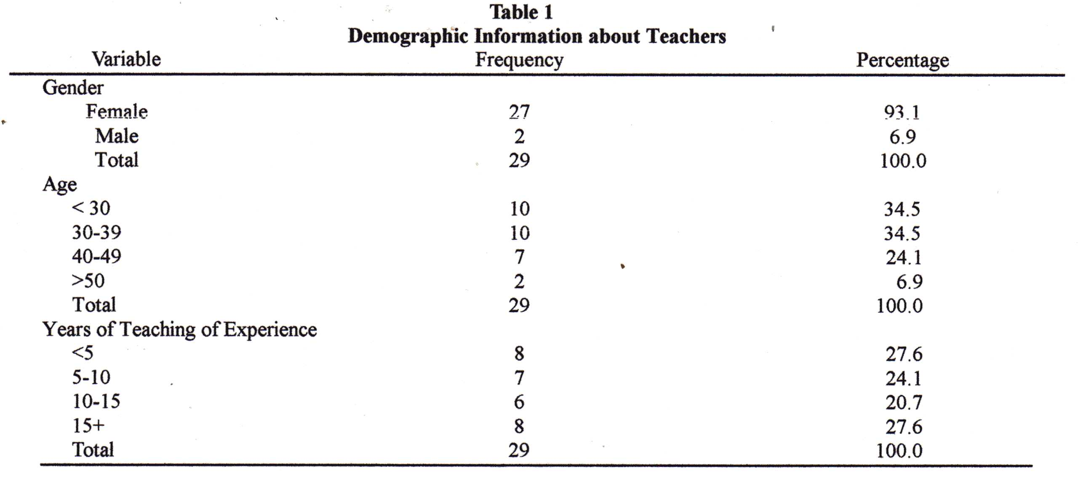
The interview protocol reported by Salend (1999) consisted of 13 questions and was conducted by special education teachers in two out of three schools. In the interview, general education teachers were encouraged to express their personal and professional beliefs about inclusion and collaboration that could not be expressed in a simple questionnaire. Themes addressed in the interview included the issues and problems faced in catering for students with disabilities, professional learning opportunities teacher accessed in regards to inclusion, their personal views on the positive and negative outcomes of inclusion, and the impact of inclusion on students with and without disabilities.

Procedures
The questionnaire was distributed to the general education teachers of three primary schools in Seoul, Republic of Korea, by special education teachers working in those schools. Thirty-three questionnaires were returned, but four were not fully completed and were excluded from the data analysis. However, it is worth noting the questions that teachers were reluctant to respond to (number 7, 8, 9, 10, 11, 16, 19, 21, see Appendix A). They concern the negative effects of inclusion for students with disabilities, the success or failure of inclusion in their classes, the expertise and training required to uphold the beliefs of inclusion, and feelings of subordination to special education teachers.

The special education teachers in two schools conducted the interviews. Nine general education teachers were interviewed, recorded through hand-written notes taken during the interviews.

Results

Questionnaire
General attitudes. General education teachers showed slightly more positive than negative attitudes towards inclusion. As shown in Table 2, 41.37% were in support of the concept of inclusion, while 34.47% perceived it negatively. One fourth were neutral (see Appendix A for results in percent).

With respect to willingness, however, 55.16% of general education teachers indicated they did not wish to teach students with disabilities in their classes. Even teachers who believed in the idea of inclusion were reluctant to accept students with disabilities in their classroom, and only 31.02% showed a stable willingness to teach students with disabilities. Interestingly, eight out of the nine respondents who made up this 31.02% were under forty, and seven had less than ten years of teaching experience.

Positive and negative results of inclusion. The survey indicated that more than half of the teachers believed that inclusion brings social benefits for students with disabilities. Some 58.61% believed that inclusion provides students with positive role models, while only 27.57% of teachers disagreed. On the other hand, only 24.13% saw academic benefits coming from inclusion, while 44.82% believed the opposite. The majority of teachers (75.85%) felt that students with disabilities would receive a better education in a special education classroom. Over a third of teachers thought that students with disabilities may experience feelings of failure and frustration within the general classroom, while 10.34% disagreed. Some 41.37% of general education teachers were concerned that students with disabilities may lose specialised services as a result of inclusion in the mainstream classroom.
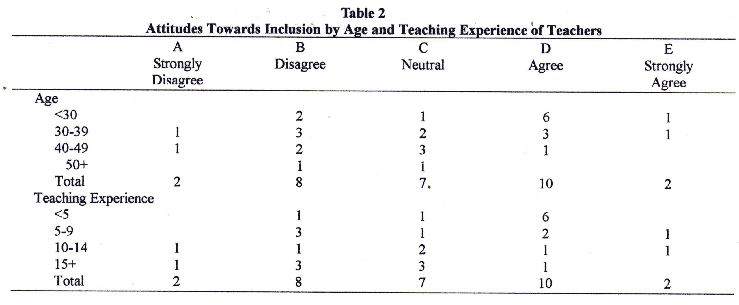Problems in implementing inclusive practices. Over one third of teachers indicated they did not have enough time to effectively meet the needs of students with disabilities, and more than half felt they did not have enough time for students without disabilities. In addition, a large majority of teachers (89.64%) pointed out they lacked the training to implement inclusion successfully. Insufficient support and resources were barriers (75.85%) for them in implementing the principles of inclusion. Furthermore, more than half the teachers agreed that demands for academic results make inclusion of students with disabilities difficult. Adjusting their instruction was problematic (68.96%), and 72. 4% indicated that it was difficult to meet the needs of students with certain disabilities in the general education classroom. Considering that adjustments in curriculum and instruction are a major part of inclusive practices, these results indicate the difficulties involved in establishing an inclusive education environment.

Collaboration and role perceptions. A major factor in the success of inclusion is the degree of collaboration between general and special teachers, and their perceptions of their respective roles. The majority of general education teachers (72.41%) were neutral regarding the effectiveness of their communication with special education teachers. Some 31.03% felt that they played a subordinate role regarding their students with disabilities, and 17.23% reported feeling some degree of intimidation in collaborating with special education teachers. About half of the teachers (51.72%) felt that they were sufficiently involved in the inclusion process.

Age, gender, and years of teaching experience. As this study included only two male respondents, considerations of gender were excluded. Furthermore, as length of teaching experience showed a very similar trend to that shown by age (see Tables 2 and 3), age and teaching experience are examined together.
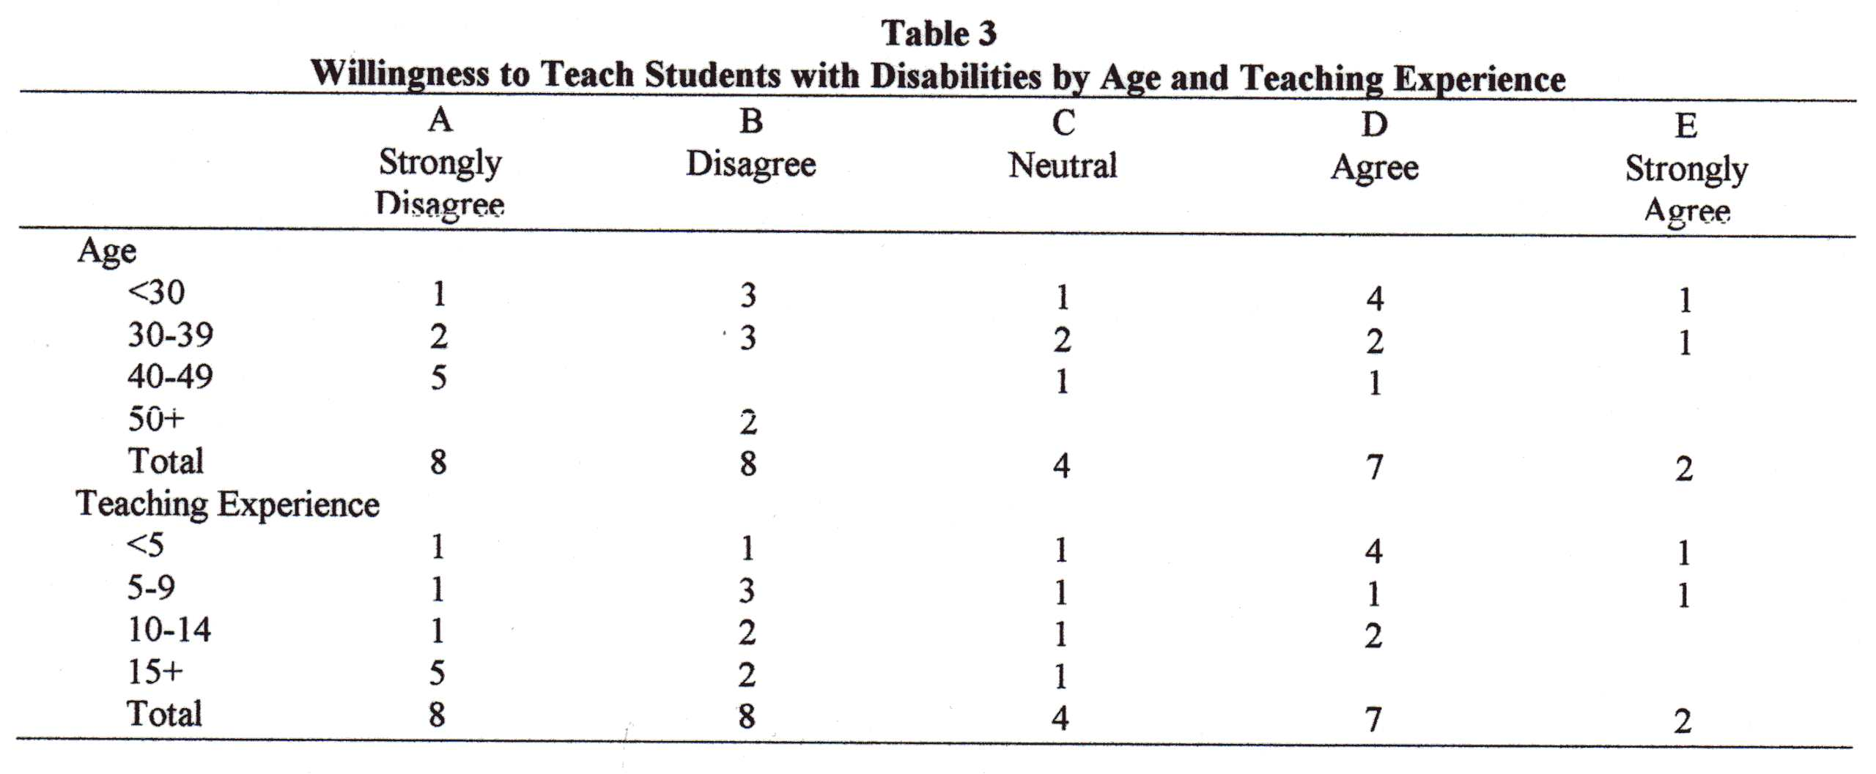The most distinctive feature of Tables 2 and 3 is that the older the respondents, the more negative their attitudes and willingness regarding inclusion. It appears that as teachers gain professional experience their attitudes towards inclusion are dampened, possibly due to the limits in their knowledge they report regarding practices to enhance outcomes for students with disabilities. This indicates the importance of ongoing professional learning opportunities for teachers.

Overall, general education teachers in this questionnaire demonstrated moderately positive attitudes toward inclusion. While 41.37% were in favour of inclusion, when those with neutral attitudes are included, 65.5% of teachers do not reject the concept of inclusion. However, general attitudes towards inclusion do not equate with a specific willingness to teach students with disabilities. Over half the teachers disagreed or strongly disagreed with the question concerning their willingness to teach a student with a disability in an inclusive education environment next year.

Interview
Most general education teachers demonstrated positive attitudes towards inclusion. Some considered it to be a natural development in education and reported mutual benefits for their students with and without disabilities. Teachers demonstrated an understanding of the social function of inclusion by indicating that students without disabilities learned to accept and understand people who were different from them. They also pointed to academic and social achievements of students with disabilities, such as improved handwriting and social skills (e.g., friendship). Teachers indicated that they learned to consider students with disabilities as important members of their class.

Teachers reported they felt inclusion to be successful when they saw all their students playing together, regardless of disabilities. One teacher reported that: As the school year progressed, our experiences with students with disabilities have changed both my own views regarding human rights and educational philosophy, and the views of my students without disabilities. This teacher also said that it was better to accept and implement inclusion rather than feel nervous about it without implementing it. However, she indicated that this new policy of inclusion requires a change in educational philosophy and the building of a consensus to implement it.

On the other hand, most teachers emphasised that for inclusion to be successful, they needed more systematic support and resources such as teaching materials, training, and smaller class sizes. One teacher said: In fact, I did not understand inclusive education very well when I started to teach my student with disabilities and it is still unclear. I hope there are more opportunities to learn what inclusive education is and what disabilities are.

Another teacher spoke of the interlocking roles of principals, general education teachers and students without disabilities regarding attitudes towards inclusion: Principals can encourage general education teachers to be willing to include students with disabilities in their classroom by supporting them, for example by reducing class sizes. And general education teachers can encourage students without disabilities to accept students with disabilities as their friends by demonstrating positive attitudes towards students with disabilities.

Discussion
The purpose of this study is to investigate the attitudes of general education teachers in the Republic of Korea towards inclusion. The study examines the willingness of teachers to teach students with disabilities, their ideas regarding the positive and negative effects of inclusion, and the practical problems experienced by teachers attempting to include students with disabilities in their classroom. The relationships between demographic variables and teachers’ attitudes and willingness are also considered.

The results indicate that Korean general education teachers are divided in their attitudes towards inclusion. While teachers who perceived inclusion positively slightly outnumbered those who perceived it negatively, actual willingness to teach students with disabilities was lower than these favourable attitudes would indicate. Teachers with positive attitudes towards inclusion can be reluctant to teach students with disabilities in their regular classes. These results do not appear to be aligned with the results of previous studies (e.g., Scruggs & Mastropieri, 1996; Vila, et al., 1996). The differences show that in the absence of a general consensus among educational personnel, it would appear difficult to develop an educational system that embraces diversity and inclusion.

The need for changes in the individual attitudes and values of general education teachers was revealed by their feelings on specific issues. For example, while they accepted inclusion as a principle, they felt that time devoted to a single student with a disability was time taken from the rest of the class. Other teachers highlighted a sense of lack in the set of skills and knowledge necessary to teach students with disabilities. Similar issues were found among Australian teachers (Westwood & Graham, 2003).

General education teachers reported that inclusion provides students with and without disabilities with social benefits, such as positive role models. A majority of teachers, however, believed students with disabilities required specialised services in special education classrooms, and were concerned that these specialist services may be lost if they were educated in a regular environment.

These concerns illustrate possible reasons for hesitation in implementing inclusive education practices. Many general education teachers were aware of their limited skills and knowledge regarding inclusion, including the relevant skills and knowledge, and even the very nature of disability and inclusion. This appeared to make teachers fearful of change and hesitant in accepting the new educational agenda of inclusion. Teachers felt supported through the provision of the resources required to carry out their expected roles, including materials, human resources and training. The practical ways in which these resources are utilised to support classrooms and school environments need to be better understood.

This study also revealed the uncertainty and ambiguity felt by general education teachers regarding their membership of a collaborative team. Whereas about half the teachers reported being uncomfortable about having other adults in their classroom (question 18), the large majority reported having some or neutral benefit from their collaborative team (question 22). This outcome appeared to indicate that while teachers were in favour of the concept of inclusion to some extent, and were aware of their limited skills and knowledge about inclusive teaching strategies, they were not comfortable about receiving support from others.

Dettmer, Thurston and Dyck (2005) claimed that the most important element in the implementation of collaboration is the clarification of roles. General education teachers participating in this study, for example, appeared to assume that the role of special education teachers was to be responsible for the academic development of students with disabilities, while their role was merely to provide a social setting in the general classroom. Over time, general education teachers gradually come to accept their educational responsibilities for the academic goals of students with disabilities (Wood, 1998). As roles clarify, the team becomes more cooperative and roles become less rigid. Ebersold (2003), however, warned that coherent functioning cannot be expected to be achieved spontaneously.

Even if there are no generally accepted definitions of the roles of general and special teachers, we can gain a sense of their respective areas of responsibility by understanding the contribution both groups of teachers can make to the classroom program. General education teachers can share their knowledge of content areas, grade level curriculum and effective teaching methods, including large group instruction. Special education teachers, on the other hand, can facilitate individual rather than group learning styles, instructional strategies, clinical teaching, analysis and adjustments of instruction and curriculum, and behaviour management. Special education teachers supplement the work of general education teachers in regard to the specialist, individualised instruction that can improve the quality of outcomes for students with disabilities (Heward, 2003).

Change in educational values and philosophy is another important factor in the successful implementation of inclusion, as evidenced by the responses of teachers during the interviews. If general education teachers retain any educational prejudices and a rigid sense of boundaries in the provision of education programs for all students, including students with disabilities, then the provision of supports and resources may not be enough to maximise outcomes for everyone.

The relationship between the age and experience of the respondents and the negativity of their attitudes was a feature of this study not supported by wider research (e.g.: Chun, 2000, Villa, et al., 1996). The finding that younger and less experienced teachers had more positive attitudes and a greater willingness to include students with disabilities in their classroom may be a result of the philosophy of inclusion being promoted in pre-service teacher education programs. The challenge then for these teachers will be to continue to promote and support these positive attitudes towards meeting the needs of students with disabilities. The other challenge will be to promote more positive attitudes among experienced and older teachers through ongoing professional development and modelling of effective practices, via collaboration and peer partnerships (Pugach, 1995).

As with all studies, interpretation of findings from this study should be framed by its limitations. Firstly, the small number of respondents in Seoul means that demographic variables such as gender and regional factor cannot be examined. Generalisation of the results is limited to teachers who share similar demographic variables and educational culture. Another limitation of this study is that it is focused only on the attitudes of general education teachers. In order for collaboration and inclusion to be successful, the attitudes and problems of special education teachers regarding the implementation of inclusion should also be investigated (Muhanna, 2010).

This paper has reported the results of a small-scale study examining the attitudes of general education teachers in three Korean schools towards including students with disabilities in their classroom. The outcomes of this study provide evidence that the attitudes of these teachers are very similar to those of teachers in other countries. Teachers are unsure of their professional knowledge base and how to cater for students with disabilities in their classroom. The challenge for administrators and those people with expertise (e.g., special educators) will be to break down the barriers between general and special education teachers working together as a normal part of professional development.
The inclusion of students with disabilities in regular classrooms is a goal of many educators and education sectors around the world (Armstrong, Armstrong, & Spandagou, 2010). The same concerns and challenges are shared internationally, including skilling teachers, promoting collaboration among educational professionals, and maintaining positive attitudes towards educating students with disabilities in general education classrooms. This approach, supported through this small study, provides a basis for future research involving all members of the school community (i.e., students, parents, general education teachers, special education teachers, administrators, and therapy staff).

Acknowledgement
We are grateful to Korean special education teachers, Hae-Jin Hwang, Ryoung-Hee Park, and Sun-young Lee who distributed the questionnaire to the participants and interviewed them individually.

References
Alahbabi, A. (2009). K-12 special and general education teachers’ attitudes towards the inclusion of students with special needs in general education classes in the United Arab Emirates (UAE). International Journal of Special Education, 24 (2), 42-54.
Armstrong, A., Armstrong, D., & Spandagou, I. (2010). Inclusive education: International policy and practice. London: Sage.
Avramidis, E., Bayliss, P., & Burden, R. (2000). A survey into mainstream teachers' attitudes towards the inclusion of children with special educational needs in the ordinary school one local education authority. Educational Psychology, 20(2), 191-211.
Avramidis, E., & Norwich, B. (2002). Teachers' attitudes towards integration/inclusion: A review of the literature. European Journal of Special Needs Education, 17, 129-147.
Backman, J. (1984). Acquisition and Use of Spelling-Sound Correspondences in Reading. Journal of Experimental Child Psychology, 38,(1).
Bowman, I. (1986). Teacher training and the integration of handicapped pupils: Some findings from a fourteen nation UNESCO study. European Journal of Special Needs Education, 1, 29-38.
Chun, S. (2000). The study on ordinary school teachers' awareness toward inclusion education.Unpublished manuscript, Taegu University, Korea.
Cornoldi, C., Terreni, A., Scruggs, T., & Mastropieri, M. (1998). Teacher attitudes in Italy after twenty years of inclusion. Remedial and Special Education, 19, 350-356.
D'Alonzo, B., Gordano, G., & Vanleeuwen, D. (1997). Perceptions by teachers about the benefits and liabilities of inclusion. Preventing School Failure, 42, 4-10.
Daane, C., Beirne-Smith, M., & Latham, D. (2000). Administrations' and teachers' perceptions of the collaborative efforts of inclusion in the elementary grades. Education, 121, 331-338.
Dettmer, P., Thurston, L., & Dyck, N. (2005). Consultation, collaboration and teamwork for students with special needs (7th ed.). Needham Heights, MA: Allyn & Bacon.
Eberold, S. (2003). Inclusion and mainstream education: An equal cooperation system. European Journal of Special Needs Education, 18, 89-107.
Foreman. (Ed.) (2008). Inclusion in action (2nd ed.). Sydney: Cengage.
Gaad, E., & Khan, L. (2009). Primary mainstream teachers' attitudes towards inclusion of students with special educational needs in the private sector: A perspective from Dubai. International Journal of Special Education, 22 (1), 96-109.
Hammond, H., & Ingalls, L. (2003). Teachers' attitudes towards inclusion: Survey results from elementary school teachers in three south-western rural school districts. Rural and Special Education Quarterly, 22, 24-30.
Heward, W. (2003). Ten faulty notions about teaching and learning that hinder the effectiveness of special education. The Journal of Special Education, 36, 186-205.
Im, A. (1986). The history of occupations of the blind in Korea. Unpublished PhD, Dankook University, Seoul.
Kim, H. (2009). The role and issues of special classes and inclusive classes in regular school of Korea. Journal of International Special Education in the Asia-Pacific, 5, 12-18.
Kim, J. (1994). Historical implications of one hundred years in Korean special education. Journal of Special Education, 15, 111-128.
Kim, S. (1999). Special education (2nd ed.). Seoul: Yangseowon.
Kristensen, K., Omagos-Loican, M., & Onen, N. (2003). The inclusion of learners with barriers to learning and development into ordinary school settings: A challenge for Uganda. British Journal of Special Education, 30(4), 194-201.
Lifshitz, H., Glaubman, R., & Issawi, R. (2004). Attitudes towards inclusion: The case of Israeli and Palestinian regular and special education teachers. 19, 2(171-190).
Molto, M. (2003). Mainstream teachers' acceptance of instructional adaptations in Spain. European Journal of Special Needs Education, 18, 311-332.
Monahan, R., Marion, S., & Miller, R. (1996). Teacher attitudes towards inclusion: Implications for teacher education in schools 2000. Education, 117, 316-320.
Morberg, S., & Savolainen, H. (2003). Struggling for inclusive education in the North and the South: Educator's perceptions on inclusive education in Finland and Zambia. International Journal of Rehabilitation Research, 26(1), 21-31.
Mousouli, M., Kokaridas, D., Angelopoulou-Sakadami, N., & Aristotelous, M. (2009). Knowledge and attitudes towards children with special needs by physical education students. International Journal of Special Education, 24 (3), 85-89.
Muhanna, M. (2010). Investigation of differences in attitudes, beliefs and knowledge of inclusion of students with Autism between special and general primary teachers in Jordan. Unpublished Master of Education (Research) thesis, Faculty of Education and Social Work, University of Sydney.
Park, J. (2002). Special education in South Korea. Teaching Exceptional Children, 34, 28-33.
Pugach, M., & Johnson, L. (1995). Unlocking expertise among classroom teachers through structured dialogue: Extending research on peer collaboration. Exceptional Children, 62(2), 101-110.
Reusen, A., Shoho, A., & Barker, K. (2001). High school teacher attitudes towards inclusion. The High School Journal, 84, 7-17.
Salend, S. (1999). So what's with our inclusion program? Evaluating educators' experiences and perceptions. Teaching Exceptional Children, 32, 46-54.
Scruggs, T., & Mastropieri, M. (1996). Teacher perceptions of mainstreaming/inclusion 1958-1995: A research synthesis. Exceptional Children, 63, 59-74.
Seo, G., Oakland, T., Han, H., & Hu, S. (1993). Special education in South Korea. Exceptional Children, 58, 213-218.
Shade, R., & Stewart, R. (2001). General education and special education preservice teachers' attitudes towards inclusion. Preventing School Failure, 46, 37-41.
Smith, M., & Smith, K. (2000). "I believe in inclusion, but ...": Regular education early childhood teachers' perceptions of successful inclusion. Journal of Research in Childhood Education, 14, 161-180.
Snyder, R. (1999). Inclusion: A qualitative study of inservice general education teachers' attitudes and concerns. Education, 120, 173-181.
Stoler, R. (1992). Perceptions of regular education teachers towards inclusion of all handicapped students in their classrooms. The Clearing House, 66, 60-62.
Vidovich, D., & Lombard, T. (1998). Parents', teachers' and administrators' perceptions of the process of inclusion. Education Research Quarterly, 21, 41-52.
Villa, R., Thousand, J., Meyers, H., & Nevin, A. (1996). Teacher and administrator perceptions of heterogeneous education. Exceptional Children, 63, 29-45.
Westwood, P., & Graham, L. (2003). Inclusion of students with special needs: Benefits and obstacles perceived by teachers in New South Wales and South Australia. Australian Journal of Learning Disabilities, 8, 3-15.
Wood, M. (1998). Whose job is it anyway? Educational roles in inclusion. Exceptional Children, 64, 181-195.

