MULTI-SENSORY INTERVENTION OBSERVATIONAL RESEARCH

Carla J. Thompson,
University of West Florida
An observational research study based on sensory integration theory was conducted to examine the observed impact of student selected multi-sensory experiences within a multi-sensory intervention center relative to the sustained focus levels of students with special needs. A stratified random sample of 50 students with severe developmental disabilities ages eight to eighteen was selected for observation within a public school environment representing four classifications of students: TMH (Trainable Mentally Handicapped), PMH (Profoundly Mentally Handicapped), students with Autism, and students with Multiple Disabilities. An observation form representing 24 observable behaviors (facial expressions, vocal cues, and body language) defined in the literature was developed and pilot tested for construct validation and reliability purposes. Four trained observers completed inter-rater reliability analysis prior to the study. Observers completed observation forms for individual students for three 20-minute time periods (within the regular classroom, within the multi-sensory center, and after returning to the regular classroom). Sustained focus was measured by combining specific observed types of data reflecting student engagement and on-task behaviors as defined in the literature. Data were analyzed using repeated measures ANOVA. Findings of the study lend strong support for implementing multi-sensory experiences to increase the sustained focus of students with special needs.

Students with developmental disabilities often have overwhelming obstacles to overcome in order to maintain focus in the classroom. Educators of students with special needs are continually challenged in finding ways to assist their students in sustaining focus in the classroom. Using the precepts of Ayres’ theory of sensory integration (Ayres, 1972, 1989, 2005) this study explored the impact of a multisensory environment on the sustained focus levels of students with special needs utilizing an observational quantitative research approach.

Background and Literature Review
Ayres’ theory of sensory integration (Ayres, 1972, 1986, 1989, 2005) provides a conceptual framework for educators grappling with ways to assist special needs students in sustaining focus in the classroom. Sensory integration theory posits that sensory integration is a neurobiological process that organizes sensation from one’s own body and from the environment and makes it possible to use the body effectively within the environment. Sensory integration is information processing (Ayres, 1986, p. 9). The theory of sensory integration is based on five assumptions: (1) Plasticity (the ability of the brain to reorganize neural pathways based on new experiences) exists in the central nervous system; (2) The process of sensory integration occurs in a developmental sequence and is a prerequisite for the development of higher cognitive processes; (3) The brain functions as an integrated whole, but is hierarchically organized; (4) Adaptive interactions are critical to sensory integration; and (5) There exists an inner drive to develop sensory integration through participation in sensory-motor activities (Botts, 2006; Ayres, 1972, 1979, 2002; Bundy, Lane, Fischer, & Murray, 2002). Additionally, sensory integration theory is supported by three postulates: (a) Learning is contingent on the ability of the student to receive sensory information, process the information, and integrate the information into a plan and organized behavior; (b) If the student has a deficit in processing and integrating sensory input, then there will be a deficit in planning and producing behaviors; and (c) Providing students with opportunities for sensory experiences enhances the ability of the central nervous system to process and integrate sensory information (Botts, 2006).

Specific principles and characteristics for delivering interventions using a sensory integration approach designed to assist students with disabilities are provided in the literature as requirements for effective sensory integration intervention techniques: (a) qualified professionals; (b) intervention is family-centered with appropriate assessment procedures; (c) activities are rich in sensation including visual and auditory sensations; (d) the intervention environment is safe and includes equipment that is free from injury; (e) activities that promote appropriate challenges; (f) the intervention environment involves the whole body, moving and interacting with people and things in the three-dimensional space; (g) the sensory environment intervention promotes intrinsic motivation and drive to interact through play; and (h) the activities are their own reward with activities altered to meet the abilities of the student (Parham et al., 2007, p. 219). The multi-sensory environment used for intervention in this study supported each of the principles advocated by the Ayres Sensory Integration Model (Ayres, 1972).

Literature supporting the use of multi-sensory interventions for individuals with special needs identify several areas of positive evidence. Collier and Truman (2008) explored the use of multi-sensory activity for individuals with neurological disabilities as a leisure resource. Their findings indicated that multi-sensory environments when used as a companion for routine daily activities enhanced the sensory awareness of individuals with neurological disabilities and assisted with many of the problems (aggression, agitation, wandering, poor-coordination, and other difficulties) to enhance individual engagement and participation and to reduce environmental barriers. Chan and Chien (2007) reported mixed results from their research efforts to evaluate the clinical effectiveness of multisensory therapy on individuals with severe learning disabilities within a hospital setting. Their findings suggest that multisensory intervention environments have a leisure resource effect of promoting psychological well-being rather than a therapy for reducing problem behaviors (p. 30). However, their study findings also revealed that positive effects of multisensory therapy were evidenced in profound or severely impaired individuals rather than in mildly impaired individuals and the authors suggest that reliability, predictability, relaxation, and freedom from demands rather than sensory input may be key contributors of multisensory therapy (p. 30). Slotnick (2010) suggests that individuals engaged in vision therapy (a therapeutic approach containing a multi-sensory integration activity) will produce results reflecting success toward a learning goal for approximately 85% of individuals. Stadele and Malaney (2001) conducted a single-subject research design using two adolescents ages 17 and 16 (female and male respectively) diagnosed with autism to determine the effects of a multisensory environment on self-injurious behavior, physical aggression, non-compliance, and agitated/disruptive behavior using daily questionnaires completed by facility staff. Results of the Stadele and Malaney (2001) study did not indicate improved behavior after the multisensory environment intervention. However, these researchers indicated that the data collection effort employed in their study using multiple staff members was not a reliable approach for study findings to reflect accurate information.

A meta-analysis of twenty-eight research studies focused on examining the effectiveness of multisensory environments for individuals with intellectual disabilities conducted by Lotan and Gold (2009) concluded that the multisensory approach is effective for improving individuals’ adaptive behaviors in daily life if considered as an individual intervention for use with individuals with intellectual and developmental disabilities. These results parallel earlier studies focused on the effectiveness of multisensory environments used with people with special needs. Houghton, Douglas, Brigg, et al (1998) used a repeated measures design with seventeen students ages 5 years to 18 years who demonstrated improved Foundation Outcome Statement Skills (FOS Skills) after experiencing a multisensory interactive environment. Likewise, Lancioni, Cuvo, and O’Reilly (2002) reported positive effects from twenty out of twenty-one research studies focused on the effectiveness of Snoezelen, a multi-sensory environment intervention approach, involving people with developmental disabilities and people with dementia. However, all of these research reviews identify concerns with research methodologies and sample size considerations.

Inherent in the fidelity of intervention research involving sensory integration is the need for appropriate assessment instrumentation to adequately measure and report outcomes. The use of procedures to evaluate the fidelity of sensory integration intervention approaches was examined by Parham and others (2007) for 34 studies focused with only one study purporting the use of a quantitatively scored fidelity instrument to ensure that the interventions were being delivered as planned and to evaluate the impact of fidelity on study results (p. 221). However, a quantitative study highlighted by Parham and others (2007) as the most well-developed plan for monitoring and evaluating fidelity (Humphries et al, 1992, 1993) did not explicitly discuss fidelity’s impact on the result and provided little attention to the measurement of process features of intervention (Parham et al., 2007, p.222). Shapiro, Sgan-Cohen, Parush, and Melmed (2009) utilized a videotaped observation measurement approach for determining levels of anxious behavior and arousal levels of children ages 6 to 11 before and during a stress-provoking medical situation within a multi-sensory environment and within a regular environment with study findings supporting specific benefits for children with developmental disabilities in sensory environments as compared with regular environments. Videotaping with observer recordings was also used by Smith, Press, Koenig, and Kinnealey (2005) in a before, during, and after implementation of a multisensory integration experience study of seven children ages 8 years to 19 years with developmental disabilities and mental retardation disabilities. Their study findings reported significant reductions in self-injurious behaviors suggesting that the sensory integration approach is effective in reducing self-stimulating behaviors that interfere with functional behaviors.

The present study responded to the need for high quality quantitative research affiliated with measureable outcomes. The study utilized a quantitative observational assessment instrument designed to monitor and assess the sensory integration intervention (multi-sensory environment center) with special attention to the measurement of process features of the intervention as well as impact of the sensory integration intervention.

Statement of the Problem
Despite the widespread acceptance of the sensory integration intervention approach for therapy with children with developmental disabilities the body of research on the effectiveness of this intervention is inconclusive (Parham et al., 2007, p. 216). Two major reasons for the inconclusive evidence regarding sensory integration intervention impact is the indecisiveness in defining learner outcomes and in the methodological challenges of conducting intervention effectiveness research (p. 217).

Evidence supporting the use of sustained focus as the targeted learner outcome for research purposes is documented in the literature. The Southeast Regional Clearinghouse (SERCH) of Charleston College spearheads the NASA’s Science Mission Directorate (SMD) that emphasizes the need to provide appropriate accommodations for students with special needs advocates the need to adjust learning environments for the purpose of sustaining student attention and focus (Runyon, 2007). The SERCH mission includes a strong emphasis on creating educational environments that are conducive to sustaining focus for special needs students as a defined learning outcome. Kaplan, Clopton, Kaplan, Messbauer, and McPherson (2007) examined the impact of multi-sensory environments used in therapy for individuals with autism and found improvement in task engagement time. Ashby et al (1995) and Lindsey et al (1997) identified improved concentration on task for individuals with special needs as an outcome measure of the intervention impact of multi-sensory environments. In addition, Bera (2008) advocates that multi-sensory rooms enhance/increase attention span, thinking and reasoning skills, and concentration (p. 6). Therefore, previous studies support examining learner outcomes that are defined as the student’s sustained focus level.

This study responds to the need for high quality empirical evidence to evaluate the effectiveness of sensory integration intervention by exploring the impact of a sensory integration intervention (multi-sensory center) within an educational environment. The learner outcome measure selected for the investigation is the sustained focus level of the individual student. The purpose of the study was to examine the observed impact of multi-sensory experiences on the sustained focus of students with special needs. The specific problem for investigation sought to answer the following question: Is the use of a multi-sensory environment center an effective intervention for increasing the sustained focus of students with special needs?

Specific research questions investigated by the study include the following focus questions: (1) Is there a difference in the average sustained focus level of students before, during, and after experiencing a multi-sensory environment? (2) Is there a difference in the average self-injurious behaviors before, during, and after experiencing a multi-sensory environment? (3) Is there a difference in the average student relaxation level, happiness level, or engagement level before, during, and after experiencing a multi-sensory environment?

Method
The research design employed for the study is a quantitative observational study with a two-phase research procedures effort: (1) the development, pilot test, reliability analysis, and construct validation study focused on the observation instrument developed for the purpose of this study and (2) the implementation of the observed impact of a multi-sensory center as an intervention on the sustained focus of students with special needs. Each of these two phases is discussed in sequence relative to the development and use of the observational instrument.

Instrumentation Development and Pilot Study
The development and pilot test of the observational instrument for use in the data collection phase was completed in the fall 2006. The instrument was developed using criteria from the literature and focus groups of behavioral experts with teachers of students with severe physical and mental disabilities special needs. The development and refinement of the observational items required considerable discussion and documentation efforts from the literature in preparation for the pilot test of the instrument. Three visual forms selected for observation are included in the instrument: (a) facial expressions; (b) body language; and (c) vocal cues. Hager and Ekman (1995) support the use of these types of visual forms for measurement of behaviors. Behaviors selected for inclusion in the observational instrument were generated from an extensive review of the literature on behaviors of students with severe disabilities (Botts, 2006). Descriptors for the instrument are presented in Figure 1.

Behavior | Facial Expression | Body Language | Vocal Cues
angry/stressed | Clenched/pinched face/reddened face/increased muscle tone | Clenched fists; closed body posture or forceful movements; rocking, pacing, | Increased volume and pitch or withdrawal; screaming forceful tone; negative verbalizations
self-injurious | Clenched face/jaw; reddened face | Movement that causes harm to self | Vocalizations specific to individual known to proceed or accompany self-injury
aggressive | Clenched face/jaw; reddened face | Forceful movement or posture | Vocalizations specific to individual known to proceed or accompany aggression
self-stimulatory | Focus on object of self-stimulatory | Movement that interferes with engagement | Vocalization that interferes with engagement (repetitive)
adaptive | Focus on self-regulatory behavior | Movements or behaviors that self-regulate | Vocalization appropriate to activity from individual known to self-regulate
relaxed | Calm open expression | Languid movements; lowered muscle tone | Softer tones specific to individual
happy | Relaxed face; smiling | Buoyant body posture or movement | Laughing or soft, cheerful tones
engaged/interested | Focused on task or looking toward task, person, or object; joined attention | Actively participating within physical limitations; alert body oriented toward task/person/object | Appropriately responding; quietly listening
Figure 1.
Behavioral Descriptors for the Observation Form

The first four descriptors are indicative of behaviors that are not conducive to sustained focus and may be disruptive while the last four descriptors reflect positive behaviors that support sustained focus in the classroom. The literature defines sustained focus as the combination of two behaviors depicted in the instrument in Figure 1: adaptive and engagement/interested (Botts, 2006).

The use of the descriptors within the instrument for training the observers was a critical component of the development of the data collection phase of the study. However, the descriptors were then replaced with a Likert Scale for use in the formation of the instrument. The resulting final form of the observational instrument is presented in Figure 2.

Facial Expression Body Language Vocal Cues
angry/stressed | 1 2 3 4 5 NA | 1 2 3 4 5 NA | 1 2 3 4 5 NA
self-injurious | 1 2 3 4 5 NA | 1 2 3 4 5 NA | 1 2 3 4 5 NA
aggressive | 1 2 3 4 5 NA | 1 2 3 4 5 NA | 1 2 3 4 5 NA
self-stimulatory | 1 2 3 4 5 NA | 1 2 3 4 5 NA | 1 2 3 4 5 NA
adaptive | 1 2 3 4 5 NA | 1 2 3 4 5 NA | 1 2 3 4 5 NA
relaxed | 1 2 3 4 5 NA | 1 2 3 4 5 NA | 1 2 3 4 5 NA
happy | 1 2 3 4 5 NA | 1 2 3 4 5 NA | 1 2 3 4 5 NA
engaged/interested | 1 2 3 4 5 NA | 1 2 3 4 5 NA | 1 2 3 4 5 NA
Figure 2.
Observational Form Used in the Study

A pilot study of the instrument was conducted using four trained observers and three randomly selected students with severe physical and mental disabilities representing the following disabilities categories: trainable mentally handicapped (TMH), profoundly mentally handicapped (PMH), and educationally mentally handicapped (EMH). The three students selected for the pilot range in age from three to fourteen and represent three categories of disabilities that were subsequently used in the observational study. The pilot study served three purposes: (1) to obtain a reliability coefficient for the observational instrument; (2) to acquire information concerning construct validation of the instrument; and (3) to determine inter-rater reliability information relative to the four trained observers prior to the implementation of the research study. Resulting pilot study information is presented in Figure 3.

Subject Demographics: (N= 3 students observed by four trained observers)
Gender: 1 male and 2 females
Age: 3yrs, 11 yrs, and 14 yrs
Ethnicity: 2 white and 1 black

Reliability Results (Cronbach Alpha Values):
Overall Alpha = .98 with subscales ranging from .89 to .99
Validity Results:
- Lowest loadings on the canonical correlation matrix were for anger and stress
- Highest loadings on canonical correlation were on interested, engaged, and self-stimulatory
- Sustained focus factor of combined variables of engaged, interested, and adaptive loaded on the value of 8.
- Inter-rater Reliability Findings: All 33 rating options resulted in inter-rater reliability coefficients for all four researchers of .64 (p < .05) or higher with only three exceptions between observers # 2 and # 4 only on vocal cues of anger, frustration, and stress.

Figure 3.
Pilot Study Results

Results of the pilot information presented in Figure 3 indicate the viability, consistency, and accuracy of the instrument for the quantitative observational study. Resulting reliability coefficients of internal consistency of the observational instrument (Cronbach Alpha Values) include an overall instrument reliability value of .98 with the eight subscale categories (angry/stressed, self-injurious, aggressive, self-stimulatory, adaptive, relaxed, happy, and engaged/interested) reliability coefficients ranging from .89 to .99. A factor analysis was performed on the observation instrument for construct validation purposes with the following specific validity results: (a) the lowest loadings on the canonical correlation matrix generated from the factor analysis were associated with the subscale of angry/stressed; (b) the highest loadings on the canonical correlation matrix generated from the factor analysis were associated with the subscales of engaged/interested and self-stimulatory; and (c) the sustained focus factor of the combined subscales of interested/engaged and adaptive loaded on the value of eight to reflect the validation of the sustained focus construct. The additional activity of the pilot study of the observation instrument included conducting the inter-rater reliability analysis for the four observers who were the data collectors for the study observations. All four observers completed observation forms for the same three students used on the pilot study generating 33 rating options. All 33 rating options resulted in inter-rater reliability coefficients for all four researchers of .64 (p < .05) or higher with only three exceptions between observers # 2 and # 4 on vocal cues of anger, frustration, and stress. Thus, the pilot study produced a highly reliable observation instrument validated for eight constructs with a strong inter-rater reliability coefficient for conducting the observational study.

Implementation of the Observational Study
Upon completion of the pilot study of the observation form the four specially trained observers were engaged to initiate the observational research study. The four observers were utilized to observe individual students within three types of environments and during three time periods: (1) initial observations were conducted within the regular classroom (before the multi-sensory intervention experience); (2) the second level of observations was conducted while the student was within the multi-sensory center (during the multi-sensory intervention); and (3) the third level of observations was performed after the student returned to the regular classroom (after the multi-sensory intervention). A stratified random sample of 50 students representing four types of disabilities (TMH-Trainable Mentally Handicapped; PMH- Profoundly Mentally Handicapped; students with Autism, and students with multiple handicaps) was used in the observational research study. Observation forms were completed by the trained observers for individual students every other minute for 20 minute time periods at each of the before, during, and after settings (regular classroom, multi-sensory center, and upon returning to the regular classroom). Observers recorded 24 types of data relative to facial expressions, body language, and vocal cues every other minute in a systematic process based on previous research efforts and research literature relative to the conceptual theory of sensory integration and students with special needs. The 50 students were observed individually by trained observers stationed within secluded locations in the regular classrooms and multi-sensory center. Only one observer at a time was present in the secluded classroom or multi-sensory center location during an observational period. The 50 student observations required a five-month time period for completion of the 60-minute observations (20 minutes per each of the before, during, and after time periods) per student.

Measurement of Sustained Focus
Sustained focus, the dependent variable in the study, is measured by combining values of observed types of data as defined in the literature. The data defined as sustained focus consist of facial expressions, body language, and vocal cues that are associated with the combined constructs of engagement and adaptation as defined in the literature and as depicted in Figure 1. Combining the constructs reflects the continuous level of sustained focus of the student within the classroom or within the multi-sensory center. Likewise, non-sustained focus is defined from the literature to be the combined constructs of anger and aggression that are also reflected in the facial expressions, body language, and vocal cues depicted within the classroom or multi-sensory environments and presented in Figure 1.

Research Study Design
The study supported a quantitative observational one-group research design whereby observational measures for the individual students within the group were obtained during three time periods (before the multi-sensory intervention, during the multi-sensory intervention, and after the multi-sensory intervention). The study design aligns with current response-to-intervention research and the utilization of sequential time periods for data acquisition and analysis, especially for the purpose of determining duration of impact or effects of the intervention (Allington, 2008). Observers recorded data every other minute for 20 minutes in each of three time periods (within the regular classroom, within the multi-sensory center, and upon returning to the regular classroom) using the Observation Form developed for the study. Therefore, the research design emulated a repeated measures approach for examining the effects of the multi-sensory intervention on students with special needs.

Sample Description
Students with severe physical and mental disabilities enrolled in a public preK-12 school provided the population for the stratified random selection procedures to select 50 students representing four classifications of students with special needs: TMH (Trainable Mentally Handicapped), PMH (Profoundly Mentally Handicapped), students with Autism, and students with multiple disabilities. The resulting sample for the investigation was comprised of 26 female students and 24 male students with ages ranging from six to seventeen and ethnicity groupings of 26 African American, 23 Caucasian, and one Asian American. The sample representation of students with special needs included 18 TMH, 14 PMH, 10 students with Autism, and eight students with multiple disabilities.

Analysis of Data
The repeated measures research design provided the impetus for the implementation of the repeated measures analysis of variance and repeated measures multiple analysis of variance statistical procedures for analyzing the observational data retrieved from the three time periods of observations. The three major research questions investigated by the study utilized the repeated measures ANOVA statistical procedure: (1) Is there a difference in the average sustained focus level of students before, during, and after experiencing a multi-sensory environment? (2) Is there a difference in the average self-injurious behaviors before, during, and after experiencing a multi-sensory environment? (3) Is there a difference in the average student relaxation level, happiness level, or engagement level before, during, and after experiencing a multi-sensory environment? Additional analyses using repeated measures MANOVA were performed for the three major research questions with gender, ethnicity, and special needs classification as independent variables combined with the three time periods as independent variables. The dependent variable used in the data analysis is sustained focus. Mean differences across the three time periods was determined using the repeated measure ANOVA procedure.

Results
The results of the study are presented relative to the three major research questions. Research question one results are presented in Figure 4: Is there a difference in the average sustained focus level of students before, during, and after experiencing a multi-sensory environment?
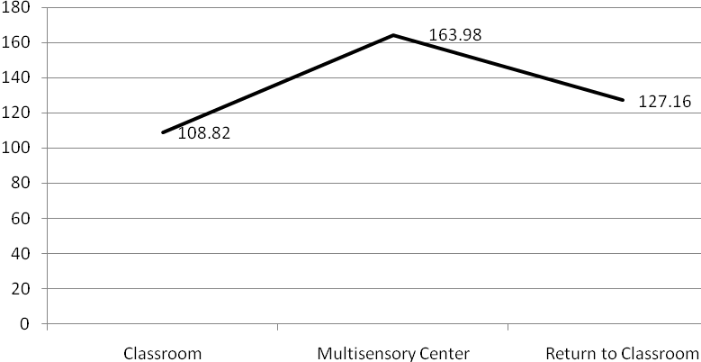
Mean = 108.82 Mean = 163.9 Mean = 127.16
S. D. = 31.42 S. D. = 41.93 S. D. = 32.17

Figure 4.
Mean Changes in Sustained Focus over Three Observational Environments

Significant increase (14%, p<.001) in sustained focus was found when students return to regular classroom activities after experiencing the multi-sensory center. This finding corroborates previous studies that demonstrated improvement in student attention or sustained focus patterns relative to the intervention of a multisensory environment (Ashley et al, 1995; Lindsey et al, 1997; Houghton et al, 1998; Kaplan et al, 2007; Lotan & Gold, 2009).

Research question two: Is there a difference in the average self-injurious behaviors before, during, and after experiencing a multi-sensory environment? The results of research question two are depicted in Figure 5.

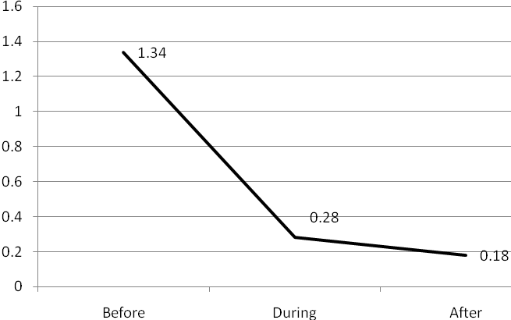
Mean = 1.34 Mean = .28 Mean = .18
S. D. = 3.47 S. D. = 1. 98 S. D. = 1.27

Figure 5.
Mean Changes in Self-Injurious Behaviors over Three Time Periods

Mean self-injurious behaviors decreased by over 98% after experiencing a multi-sensory environment. This finding corroborates the results of Smith, Press, Koenig, and Kinnealey (2005) and Shapiro, Sgan-Cohen, Parush, & Melmed, (2009) that suggest that a sensory integration approach is effective in reducing self-stimulating and self-injurious behaviors that interfere with daily functional activities and extends previous findings since the current study utilized a large sample size (N=50) as suggested by Smith et al (2007).

Research question three: Is there a difference in the average student relaxation level, happiness level, or engagement level before, during, and after experiencing a multi-sensory environment? The mean changes over time resulting from the repeated measures ANOVA procedure are depicted in Figure 6.

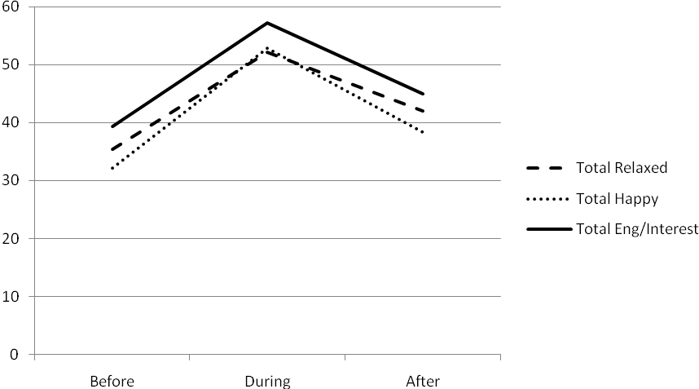
 | Before | During | After
Total Relaxed | Mean = 35.35  S. D. = 14.18 | Mean = 52.10  S. D. = 12.88 | Mean = 42.00  S. D. = 12. 97
Total Happy | Mean = 32.14  S. D. = 13.86 | Mean = 52.78  S. D. = 13.54 | Mean = 38.38  S. D. = 14.84
Total Eng/Interest | Mean = 39.32  S. D. = 13.76 | Mean = 57.14  S. D. = 12.07 | Mean = 44.96  S. D. = 12.77

Figure 6.
Mean Changes in Relaxation, Happiness, and Engagement over Three Time Periods

Findings of the analyses for research question three indicate significant (p<.05) increases in each of the areas that characterize positive student attention or sustained focus, that is, observed student relaxation ratings revealed a 17% increase, observed student happiness ratings revealed a 16% increase, and observed student engagement ratings revealed a 13% increase from the before to after time period on the average for the N=50 students in the study. These results provide some evidence in support of the effectiveness of the multisensory center environment on those factors that comprise the construct identified as sustained focus, i.e., happiness, relaxation, and engagement/interest. Bera (2008) corroborates these findings for elderly clients in nursing home environments and Slevin and McClelland (1999) findings support the current study results that relaxation and comfort are provided to individuals with disabilities through a multi-sensory environment approach to therapy.
Additional Results
Additional data analyses were performed for determining mean differences in sustained focus across the three time periods relative to gender, ethnicity, and types of classifications of students with special needs using repeated measures MANOVA. Results of these analyses are depicted in Figures 7, 8, and 9. (next pages)

Impact of the multi-sensory center experience on African American students’ average sustained focus levels reveals a significant increase that substantially surpasses the significant impact of the multi-sensory center on white students’ average sustained focus increases. Selected results of the study include the following summary statements: (a) The observed sustained focus of students with special needs after experiencing a multisensory environment increased by 14% in the regular classroom; (b) The observed self-injurious behaviors of students with special needs after experiencing a multisensory environment decreased by 98%; (c) The observed sustained focus of both boys and girls with special needs increased substantially after experiencing a multisensory environment; (d) The observed sustained focus of all ethnic groups of students with special needs increased substantially with the

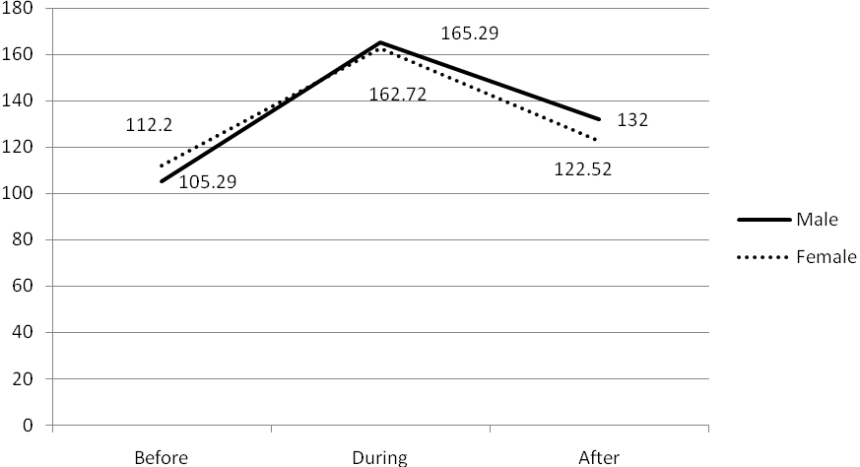
Gender | Before | During | After
Male | Mean = 105.29  S.D. = 46.28 | Mean = 165.29  S. D. = 40.19 | Mean = 132.00  S. D. = 39.87
Female | Mean = 112.20  S. D. = 29.28 | Mean = 162.72  S. D. = 37.16 | Mean = 122.52  S. D. = 33.69
Figure 7.
Mean Changes in Sustained Focus over Three Time Periods Relative to Gender

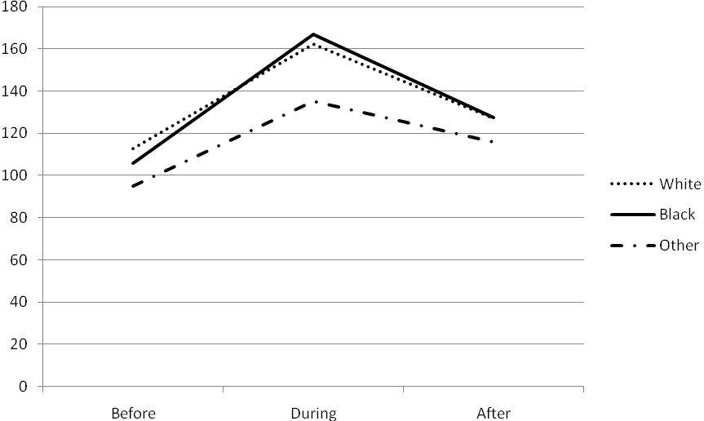

Ethnicity | Before | During | After
White | Mean = 112.57  S. D. = 28.22 | Mean = 162.17  S. D. = 37.16 | Mean = 127.22  S. D. = 34.49
Black | Mean = 105.92  S. D. = 46.23 | Mean = 166.80  S. D. = 37.30 | Mean = 127.56  S. D. = 40.10
Other | Mean = 95  S. D. = 21.19 | Mean = 135  S. D. = 42.31 | Mean = 116  S. D. = 22.37
Figure 8.
Mean Changes in Sustained Focus over Three Time Periods Relative to Ethnicity
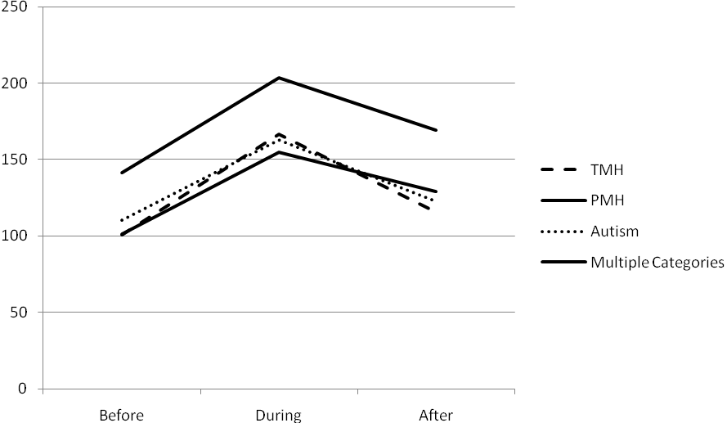
Disability | Before | During | After
TMH (N=18) | Mean = 100.83  S. D. = 33.21 | Mean = 166.72  S. D. = 38.77 | Mean = 115.44  S. D. = 39.49
PMH (N=14) | Mean = 101.29  S. D. = 47.16 | Mean = 154.79  S. D. = 33.61 | Mean = 129.29  S. D. = 36.52
Autism (N=10) | Mean = 110.20  S. D. = 26.73 | Mean = 162.60  S. D. = 42.08 | Mean = 122.60  S. D. = 26.97
Multiple Categories (N=8) | Mean = 141.33  S. D. = 16.26 | Mean = 203.67  S. D. = 25.11 | Mean = 169.33  S. D. = 22.03
Figure 9.
Mean Changes in Sustained Focus over Three Time Periods Relative to Four Special Needs Categories

greatest increases recorded for African American students with special needs after experiencing a multisensory environment; (e) The observed sustained focus of all types of students with special needs increased substantially after experiencing a multisensory environment; and (f) The observed student engagement, happiness, and relaxation levels of all students increased on the average after experiencing a multi-sensory environment. These results corroborate Houghton, Douglas, Brigg et al (1998) findings relative to the positive effects of the multi-sensory environment on students representing various classifications of disability and various demographic groups.

Implications of the Findings
Implications of these findings for teaching and learning environments involving students with special needs empirically support the use of a multi-sensory center and the incorporation of multi-sensory experiences for students. These results provide a strong baseline for future research studies involving specific multi-sensory activities and materials. Study findings have implications based in three perspectives: (a) theoretical implications; (b) behavioral research implications, and educational applications. The empirical evidence generated by the study provides a sound foundation for supporting sensory integration theory as a viable approach for assisting students with special needs. Likewise, the empirical findings of significant mean changes in sustained focus across time periods provide solid settings and sound practices for behavioral researchers. Implications of the findings for teaching and learning for students with special needs align with current response-to-intervention practices and outcomes. The utility of the implications of the findings for furthering research efforts is evidenced in the sub groupings for analyses that were employed (gender, ethnicity, and types of classifications of students with special needs). The need for researchers to continue to explore the use of interventions for students with special needs is demonstrated by the study results.

Limitations
Limitations of the study parallel some of the weaknesses evidenced in previous research efforts focused on the effectiveness of using multi-sensory interventions with special needs students identified in a meta-analysis of twenty-eight research studies conducted by Lotan and Gold (2009): (a) the small number of research projects available on the topic; (b) the small number of participants in each research effort; and (c) the lack of use of control groups and robust research designs. This study utilized a one group repeated measures design rather than a quasi-experimental research design and is therefore limited to little or no consideration of controls for threats to internal and external validity. Although generalizing results of the study to specific populations is inappropriate, the implications of the findings for generating new research design efforts focused on multi-sensory interventions for students with special needs is a plausible outcome of the study. In addition, the study includes a large number of participants (N=50) who represent four classifications of students with special needs, thereby addressing one of the criticisms or weaknesses of previous multisensory intervention research efforts, that is, the small number of participants within a research project. However, limitations of the research design and the inability to generalize results must be considered relative to study findings.

Conclusions
The study results provide a strong baseline for future research studies involving specific multi-sensory activities and materials. The need for high quality response-to-intervention research efforts involving multi-sensory interventions for students with special needs is supported by the empirical evidence obtained in the study. In addition, the study demonstrates high quality instrument fidelity in sensory integration intervention research efforts that have the potential for improving not only the sustained focus of the student but the quality of life of the student. The multiple potential of multi-sensory interventions has only just begun to be examined by researchers. Future efforts will provide a rich technological perspective to the world for students with special needs.

References
Allington, R. L. (2008). What really matters in response to intervention: Research-based designs (what really matters series). NY: Allyn & Bacon.
Ashby, M., Lindsay, W. R. , Pitcaithly, D. et al (1995). Snoezelen: its effects on concentration and responsiveness in people with profound multiple handicaps. British Journal of Occupational Therapy, 58, 303-307.
Ayres, A. J. (1972). Improving academic scores through sensory integration. Journal of Learning Disabilities, 5, 338-343.
Ayres, A. J. (1979). Sensory integration and the child. Los Angeles: Western Psychological Services.
Ayres, A. J. (1986 and 1989). Sensory integration and Praxis Tests. Los Angeles: Western Psychological Services.
Ayres, A. J. (2005). Sensory integration and the child. Los Angeles: Western Psychological Services.
Bera, D. R. (2008). Multisensory room and specialized dementia programming. Nursing Homes, 1-6.
Botts, B. (2006). Snoezelen: Empirical review of product representation. Unpublished dissertation.
Bundy, A. C., Lane, S. J., Fisher, A. G. , & Murray, E. A. (2002). Sensory integration: Theory and practice (2nd ed.). Philadelphia: F. A. Davis.
Collier, L. & Truman, J. (2008). Exploring the multi-sensory environment as a leisure resource for people with complex neurological disabilities. Neuro-Rehabilitation.23(4), 361-367.
Chan, S.C. & Chien, W. T. (2007). An evaluation of the clinical effectiveness of a multisensory therapy on individuals with learning disability. Hong Kong Medical Journal, 13(1), 28-31.
Hager, J. C. & Ekman, P. (1995). Essential behavioral science of the face and gesture that computer scientists need to know. International workshop on automatic face-and gesture recognition proceedings. Retrieved August 15, 2006, from http://www.face-and-emotion.com/dataface/misctext/iwafgr.html
Houghton, S., Douglas, G., Brigg, J., et al (1998). An empirical evaluation of an interactive multi-sensory environment for children with disability. Journal of Intellectual and Developmental Disability, 23(4), 267-278.
Humphries, T. , Wright, M., Snider, L. & McDougall, B. (1992). A comparison of the effectiveness of sensory integrative therapy and perceptual-motor training in treating children with learning disabilities. Developmental and Behavioral Pediatrics, 13, 31-40.
Humphries, T. , Wright, M., Snider, L. & McDougall, B. (1993). Clinical evaluation of the effectiveness of sensory integrative and perceptual motor therapy in improving sensory integrative function in children with learning disabilities. Occupational Therapy Journal of Research, 13, 163-183.
Kaplan, H., Clopton. M., Kaplan, M.,Messbauer, L., & McPherson, K. (2007). Snoezelen multi-sensory environments: Tasks engagement and generalization. Research in Developmental Disabilities. 27(4), 443-455.
Lancioni, G. E., Cuvo, A. J., & O’Reilly, M. F. (2002). Snoezelen: An overview of research with people with developmental disabilities and dementia. Disability & Rehabilitation, 24(4), 175-184.
Lindsay, W. R. , Pitcaithly, D., Geelan, N., et al (1997). A comparison of the effects of four therapy procedures on concentration and responsiveness in people with profound learning disabilities. Journal of Intellectual Disability Research, 41, 201-207.
Lotan, M. & Gold, C. (2009). Meta-analysis of the effectiveness of individual intervention in the controlled multisensory environment (Snoezelen) for individuals with intellectual disability. Journal of Intellectual and Developmental Disability, 34(3), 201-215.
Parham, L. D., Cohn, E. S., Spitzer, S., Koomar, J. A., Miller, L. J., Burke, J. P., et al. (2007). Fidelity in sensory integration intervention research. American Journal of Occupational Therapy, 61, 216-227.
Runyon, C. (2007). An introduction to special needs. Southeast Regional Clearinghouse, College of Charleston. Retrieved September 25, 2010 from http://serch.cofc.edu/special/IntroductionToSpecialNeeds.doc
Shapiro, M. , Sgan-Cohen, H., Parush, S., & Melmed, R. (2009). Influence of adapted environment on the anxiety of medically treated children with developmental disability. The Journal of Pediatrics. 154(4), 546-550.
Slevin, E. & McClelland, A. (1999). Multisensory environments: are they therapeutic? A single-subject evaluation of the clinical effectiveness of a multisensory environment. Journal of Clinical Nursing, 8, 48-56.
Slotnick, S. (2010). A multisensory integration activity across visual, vestibular, auditory, temporal, and proprioceptive senses: “The Slotnick Scramble”. Poster session presentation for the International Congress of Behavioral Optometry (ICBO). Retrieved September 21, 2010 from http://www.oepf.org/ICBOFlash/Handouts/Posters%201CBO%202010.pdf
Smith, S. A., Press, B., Koenig, K. P., & Kinnealey, M. (2005). Effects of sensory integration intervention on self-stimulating and self-injurious behaviors. American Journal of Occupational Therapy, 59(4), 418-425.
Stadele, N. D., & Malaney, L. A. (2001). The effects of a multisensory environment on negative behavior and functional performance on individuals with autism. Journal of Undergraduate Research, IV, 211-218. Retrieved September 28, 2010 from
http://murphylibrary.uwlax.edu/digital/jur/2001/stadele-malaney.pdf

