CORRECTIVE FEEDBACK OF ORAL DECODING ERRORS FOR DIVERSE LEARNERS WITH READING DISABILITIES:

THE EFFECTS OF TWO METHODS ON READING FLUENCY

Morgan Watson
Cecil Fore III
Richard T. Boon
The University of Georgia

The purpose of this study was to compare the effects of two corrective feedback methods, word-supply and phonics-based, on the oral reading fluency of students with mild disabilities. The participants included three students in the fourth grade who were diagnosed with a Specific Learning Disability (SLD) or Emotional and/or Behavioral Disorder (EBD). A single subject modified parallel treatments design (Alberto & Troutman, 2008) was used to evaluate the effectiveness of the two types of feedback methods (e.g., word-supply and phonics-based) on the students oral reading fluency skills. In the word-supply condition, students were provided the whole word upon a miscue, while in the phonics-based condition students were provided the word phoneme-by-phoneme in a sounded-out fashion. Feedback procedures were implemented upon the occurrence of word miscues during the oral reading. Dependent measures included the number of correct words per minute, recorded as a rate on individual passages taken from leveled readers. Results of the fluency data collected on the errors corrected using either the word-supply or phonics-based feedback method revealed that the word-supply feedback condition was slightly superior for two of the three students.

Reading achievement has long been an issue of high priority in American schools for students with and without disabilities. Students must learn to read fluently to obtain meaning from written text in order to succeed in comprehending a variety of content areas in school and in their professional and social lives beyond school (Mastropieri, Scruggs, & Graetz, 2003; Therrien, 2004). For students with specific learning disabilities (SLD), mild intellectual disabilities (MID), and emotional and/or behavioral disorders (EBD), the task of learning to read is an exceptionally pressing concern. More than 80% of students with SLD have some sort of reading difficulty (Gersten, Fuchs, Williams, & Baker, 2001) and have reading objectives identified for instructional focus in their Individual Education Plans (IEPs) more than any other academic skill (Bos & Vaughn, 2008). Similarly, according to Vaughn, Levy, Coleman, & Box (2002) many students with emotional and/or behavioral disorders (EBD) often have reading skill deficits and function one or more years below grade level in reading, math, writing, and spelling (Spencer, Scruggs, & Mastropieri, 2003) and show underachievement in reading when compared with their intellectual capabilities. Epstein, Kinder, & Barsuck (1989) reported that students with EBD have more difficulty in reading and mathematics instruction than other students of the same age and these students were more likely to fail courses than students without disabilities (Wagner, Blackorby & Hebbeler, 1993).

Imperative to the ultimate goal of reading comprehension is the skill of fluency, or reading with both accuracy and speed. Though there are a variety of reasons students with disabilities may have difficulty achieving reading comprehension commensurate with their grade level peers, studies have linked improved reading fluency with improved reading comprehension (Chard, Vaughn, & Tyler, 2002; Fuchs, Fuchs, Hosp, & Jenkins, 2001; Mastropieri & Scruggs, 1997; Mastropieri, Leinart, & Scruggs, 1999; Reutzel & Hollingsworth, 1993). Students who read slowly and/or inaccurately often expend too much cognitive effort in the decoding process to allow for comprehension to take place (see Gersten, Fuchs, Williams, & Baker, 2001; Mastropieri, Scruggs, Bakken, & Whedon, 1996; Talbott, Llyoyd, & Tankersely, 1994, for reviews).

Fortunately, there is the potential for reading fluency to be developed using several evidence-based methods, such as repeated readings, taped readings, and choral reading, but only individual student oral reading allows teachers to provide feedback to students on their errors and assess specific areas of skill deficit on which to focus for each student (Heubusch & Lloyd, 1998). Thus, it is imperative that word identification errors, or miscues, made during oral reading be corrected with the most effective method available. For that reason, the purpose of this study is to determine the most effective means of providing feedback of miscues during oral reading for elementary students with high-incidence disabilities.

A major tenet of special education reading instruction guiding this study is the direct instruction model set forth by Carnine, Silbert, and Kame’enui (1997) in Direct Instruction Reading. Here, it is proposed that struggling readers, who cannot afford to risk practicing miscues, be given explicit, code-based instruction that includes modeling, or word-supply immediately following the student’s oral reading miscue. The Corrective Reading Program (Engelmann et al., 1999) is based on the direct instruction model of Carnine et al. (1997). The scripted reading program instructs teachers to stop students immediately upon miscue, provide the word (the word is_____), prompt the student to say the word (what word?) and then prompt the student to reread the sentence.

Recent studies on oral reading feedback methods have targeted their effects on varying components of students’ overall reading ability. Results have strongly favored corrective feedback, in which some decoding strategy or the actual word is given, to either general feedback, in which students are simply told to try again, or receive no feedback. However, results have been mixed as to which type of corrective feedback is superior for improving reading fluency. Types of corrective error feedback studied have included meaning-based, in which the student is prompted in various ways to think about whether the miscued word makes sense in the context of the sentence, phonics-based, in which the student is prompted to sound-out or otherwise analyze the miscued word, and modeling, or word-supply feedback, in which the word is simply supplied after a designated amount of time following the miscue.

In the first study, Pany and McCoy (1988) compared the effects of two feedback methods- total feedback and meaning change feedback with a control group of a no feedback condition with 16 third graders with LD. In the total and meaning change conditions, the feedback was held constant and utilized a succession of prompts that ranged from asking the student to try again to providing phonemic cues to supplying the word. The independent variable was the selection of miscued words chosen to receive feedback rather than the type of feedback. In the total feedback condition, all miscues were followed by the succession of feedback prompts, whereas, in the meaning change feedback condition, only those miscues that affected the meaning of the passage were followed by the succession of prompts. Each student read a different one of three passages under each treatment condition in a varying pattern of passage-to-intervention. Following each passage reading session, comprehension and word recognition was measured by a passage-based assessment including a story retell, comprehension questions, word list reading, and delayed word list reading. Results indicated the total feedback condition showed results that were significantly superior to both the meaning change condition and the no feedback condition on all measures of word recognition and comprehension. There were no pretest scores to determine overall reading improvement as a result of the interventions.

In the second study, using a pretest/posttest multiple treatment design, Perkins (1988) compared four feedback treatments on 48 elementary boys with LD, who were in the acquisition stage of learning. He concluded that word-supply feedback was superior to two other forms of feedback and to no feedback on word recognition of ten CVC nonsense words, or trigrams. Students were pretested on a transfer list of ten words that were comparable to the experimental word list. The treatment conditions included: (a) general feedback, in which the experimenter responded to errors by simply prompting the student to try again; (b) modeling feedback, in which the experimenter supplied the word; and (c) phonics-based feedback, in which the experimenter prompted the student to sound-out the word, paying particular attention to the beginning, middle, and/or ending sound, depending on the location(s) of the error. The fourth condition was a no-feedback condition. A posttest of the transfer word list was given immediately following treatment and one week later to test for maintenance effects. A comparison of mean posttest scores reflecting the number of words read correctly for each treatment group revealed the modeling condition to be superior to all other conditions on the immediate posttest. However, the modeling treatment also showed the sharpest decline in reading scores on the delayed posttest, suggesting that modeling, or word-supply feedback may not be the most effective feedback method for promoting maintenance of word recognition skills. The study has limited utility in analyzing feedback effects on oral reading fluency, however, because, as in the Spaai et al. (1991) study, the dependant variable only included the reading of words in isolation with no timed measure, and the ability to decode words in isolation does not necessarily transfer to passage reading fluency.

In the third study, Spaai, Ellermann, and Reitsma (1991), compared the effects of word-supply feedback to segmented feedback on first grade average readers’ single word reading accuracy and time. The study utilized a pretest/posttest multiple treatment design with 66 first grade boys and girls from average reading classrooms. The students’ reading accuracy and time was compared as measured by posttest scores on isolated word lists. The students were divided into 3 groups: (a) a whole word-supply group, in which the whole word was provided to the student upon miscue; (b) a segmented word-supply group, in which the individual phonemes of the word were provided upon miscue; and (c) a control group, in which no feedback was given upon miscue. In all conditions, the words were presented individually on a computer screen, and feedback was given via a digitized voice presentation of either the segmented phonemes or the whole word. Results showed the whole word condition to be favorable to both the segmented word and no feedback conditions on measures of accuracy and speed of decoding. Because the word reading accuracy score was derived from the percentage of words read correctly from the entire list, whereas the time score was derived from averaging the time to read each word, the reader cannot glean information as to the effects of the feedback methods on the fluency of the participants.

In the fourth study, Crowe (2003), 12 students, ages 8 to 11 years-old in third, fourth, and fifth grades with various language learning disabilities were compared for reading improvements following either one of two interventions (treatment groups) or no intervention (control group). The students were divided into three groups of four students each. The first group (Group 1) received “traditional” decoding feedback during oral reading. Traditional feedback was defined by the following criteria for interventionist’s prompts: sounding out the word, rereading the word dividing the word into smaller segments, providing phonemic cues, and providing the word. Conversely, the second group (Group 2) received meaning-based feedback, referred to as Communicative Reading Strategies (CRS), in which the interventionist provided preparatory sets, prompted students to summarize, explained word usage, and provided pronoun referencing and cohesive ties, while (Group 3) served as the control group and received no intervention. Pretest and posttest scores were compared from two standardized measures of reading ability including: (a) the Gray Oral Reading Test-Revised (GORT-R); and (b) the Comprehensive Receptive and Expressive Vocabulary Test (CREVT, Form A), including measures of reading comprehension, passage reading (fluency), overall oral reading, receptive vocabulary, expressive vocabulary, and general vocabulary. Results revealed that Group 2 showed significantly higher gain scores than the Group 1 and the control group in all areas except receptive and general vocabulary. Because the values for the independent variables were so broad (each treatment group had multiple defining criteria), it is difficult to discern whether one or more values for each variable was responsible for each treatment’s success or failure. Additionally, the Group 1 intervention features appeared to focus on feedback after miscues, whereas the Group 2 intervention features focused on prompting before the occurrence of miscues.

Finally, in the fifth study, Crowe (2005) examined the effects of two types of oral reading feedback strategies with 8 third, fourth, and fifth grade students with low reading abilities and reading comprehension skills. The study used a pretest/posttest treatment comparison design to compare the effectiveness of the two oral reading feedback techniques, which lasted in duration from one hour of intervention twice a week over a period of 5 weeks. The students were divided into one of two groups, either the (Intervention 1) group, which used a traditional decoding type feedback procedure or the (Intervention 2) group, which employed Communicative Reading Strategies (CRS) or a meaning-based feedback approach. Pretest and posttest scores were compared from three standardized measures of reading ability: (a) the Gray Oral Reading Test-Revised (GORT-R); (b) the Comprehensive Receptive and Expressive Vocabulary Test (CREVT, Form A), including measures of reading comprehension, passage reading (fluency), overall oral reading, receptive vocabulary, expressive vocabulary, and general vocabulary; and (c) a subtest of the Assessment of Sound Awareness and Production. Results indicated that the students in the Communicative Reading Strategies (CRS) condition or meaning-based feedback approach was more effective and showed significantly greater gains on posttest measures than the traditional decoding approach to facilitating the students oral reading comprehension skills, as measured by formal assessment measures of reading comprehension and story-related comprehension questions.
Each of the studies reviewed used varying operational definitions for its feedback conditions, making comparisons across studies is somewhat difficult. For example, in the Crowe (2003) and Hernandez (1989) studies, the traditional feedback condition included both word-supply and the prompt to sound-out the word, whereas the Rose et al. (1982), Perkins (1988), and Spaai et al. (1991) studies defined word-supply and phonemic segmentation as two separate conditions. Additionally, studies that have measured the decoding of words in isolation provide limited information as to the effectiveness of each feedback intervention on passage reading fluency.

Given the importance of learning to read words in the context of whole passages, or texts, and the established connection between oral reading passage fluency and comprehension, this study sought to compare the effectiveness of two feedback conditions: (a) words-supply and (b) phonics-based, during passage reading on the oral reading fluency of fourth grade students with specific learning disabilities and emotional and/or behavioral disorders. This study, then, sought to answer the following two research questions:
- Are the word-supply and phonics-based feedback methods effective at increasing the oral reading fluency (ORF) of students with disabilities?
- Is one method, word-supply or phonics-based, superior to the other in its ability to increase the oral reading fluency of students with disabilities?
For the purpose of measurement, oral reading fluency (ORF) was defined in this study as the number of correct words per minute (CWPM) during passage reading under each treatment condition.

Method

Participants
The study involved three students in the fourth grade from one elementary school in the southeastern United States in a middle class urban neighborhood. The students were identified at the time of the study for Special Education services based on state eligibility requirements and all had reading objectives stipulated on their current Individualized Education Plans. All three students were receiving reading instruction from the investigator/ teacher during the same 45 minute class period, an interrelated resource class designed to serve students with high-incidence disabilities. All participants had previous experience with the word-supply feedback method and at least one component of the phonics-based feedback method (either they have been prompted to sound-out miscued words, or a teacher has modeled the segmented sounds of miscued words).

Prerequisite skills necessary for inclusion in the study were hearing and vision within normal limits with or without the aid of corrective devices, the ability to decode at least 40 words in a passage of at least first grade level, to comprehend and verbally respond to verbal feedback, to comprehend and follow multi-step instructions, to have shown previous positive response to reinforcement systems, and to have shown sufficient levels of motivation to participate. All students had been previously assessed for and had been found to possess the prerequisite skills based on daily observations during the preceding one month period that the investigator was the reading instructor for the participants, or based upon IEP reports stating such criteria had been met. Of the 7 students available to the investigator at the start of the study, 4 students were excluded; one was excluded for irregular school attendance; two were excluded based on behavioral observations indicating insufficient motivation and/or inconsistent response to reinforcement systems; and one was excluded because of inability to read at least 40 words at the first grade reading level. Therefore, three students were chosen to participate in the study.

Tiara is a 10 year, 7 month-old, fourth grade female of low SES served for an Emotional and/or Behavioral Disorder. She also received services for a Language Impairment in the area of receptive language comprehension. Her General Cognitive Ability, as measured by the Stanford-Binet intelligence test is SS 102. Overall Achievement score (Total Test on the PIAT-R was SS 87. Specific scores in the area of reading include: KABC Reading- SS 72. She has been in special education for 2 years, 6 months).

Samantha is an 11 year, 3 month-old, fourth grade Hispanic female of low SES served for a Specific Learning Disability in the areas of reading and written expression. She also receives services for a Speech and Language Impairment in the area of an articulation disorder. Her General Cognitive Ability, as measured by the Differential Ability Scale (DAS) is SS 91. Her overall achievement score (Total Test) on the PIAT-R was SS 90. Specific scores in the area of reading include: PIAT-R- Reading Recognition SS 69; Reading Comprehension SS 71; DAS Word Reading- SS 55. She has been in special education for 4 years, 8 months.

Alana is an 11 year, 5 month-old, fourth grade African American female of medium SES served for an Emotional and/or Behavioral Disorder. Her general cognitive ability, as measured by the Reynolds Intellectual Ability Scale (RIAS) is 87. Overall achievement scores include: Peabody Individual Achievement Test-Revised (PIAT-R) - Total Test SS 80; Specific scores in the area of reading include: Wide Range Achievement Test, Third Edition (WRAT-3) Reading- SS 71; Reading Recognition- SS 67; Reading Comprehension- SS 79. She has been in special education for 3 years, 1 month.
Table 1
Students’ Demographic Data

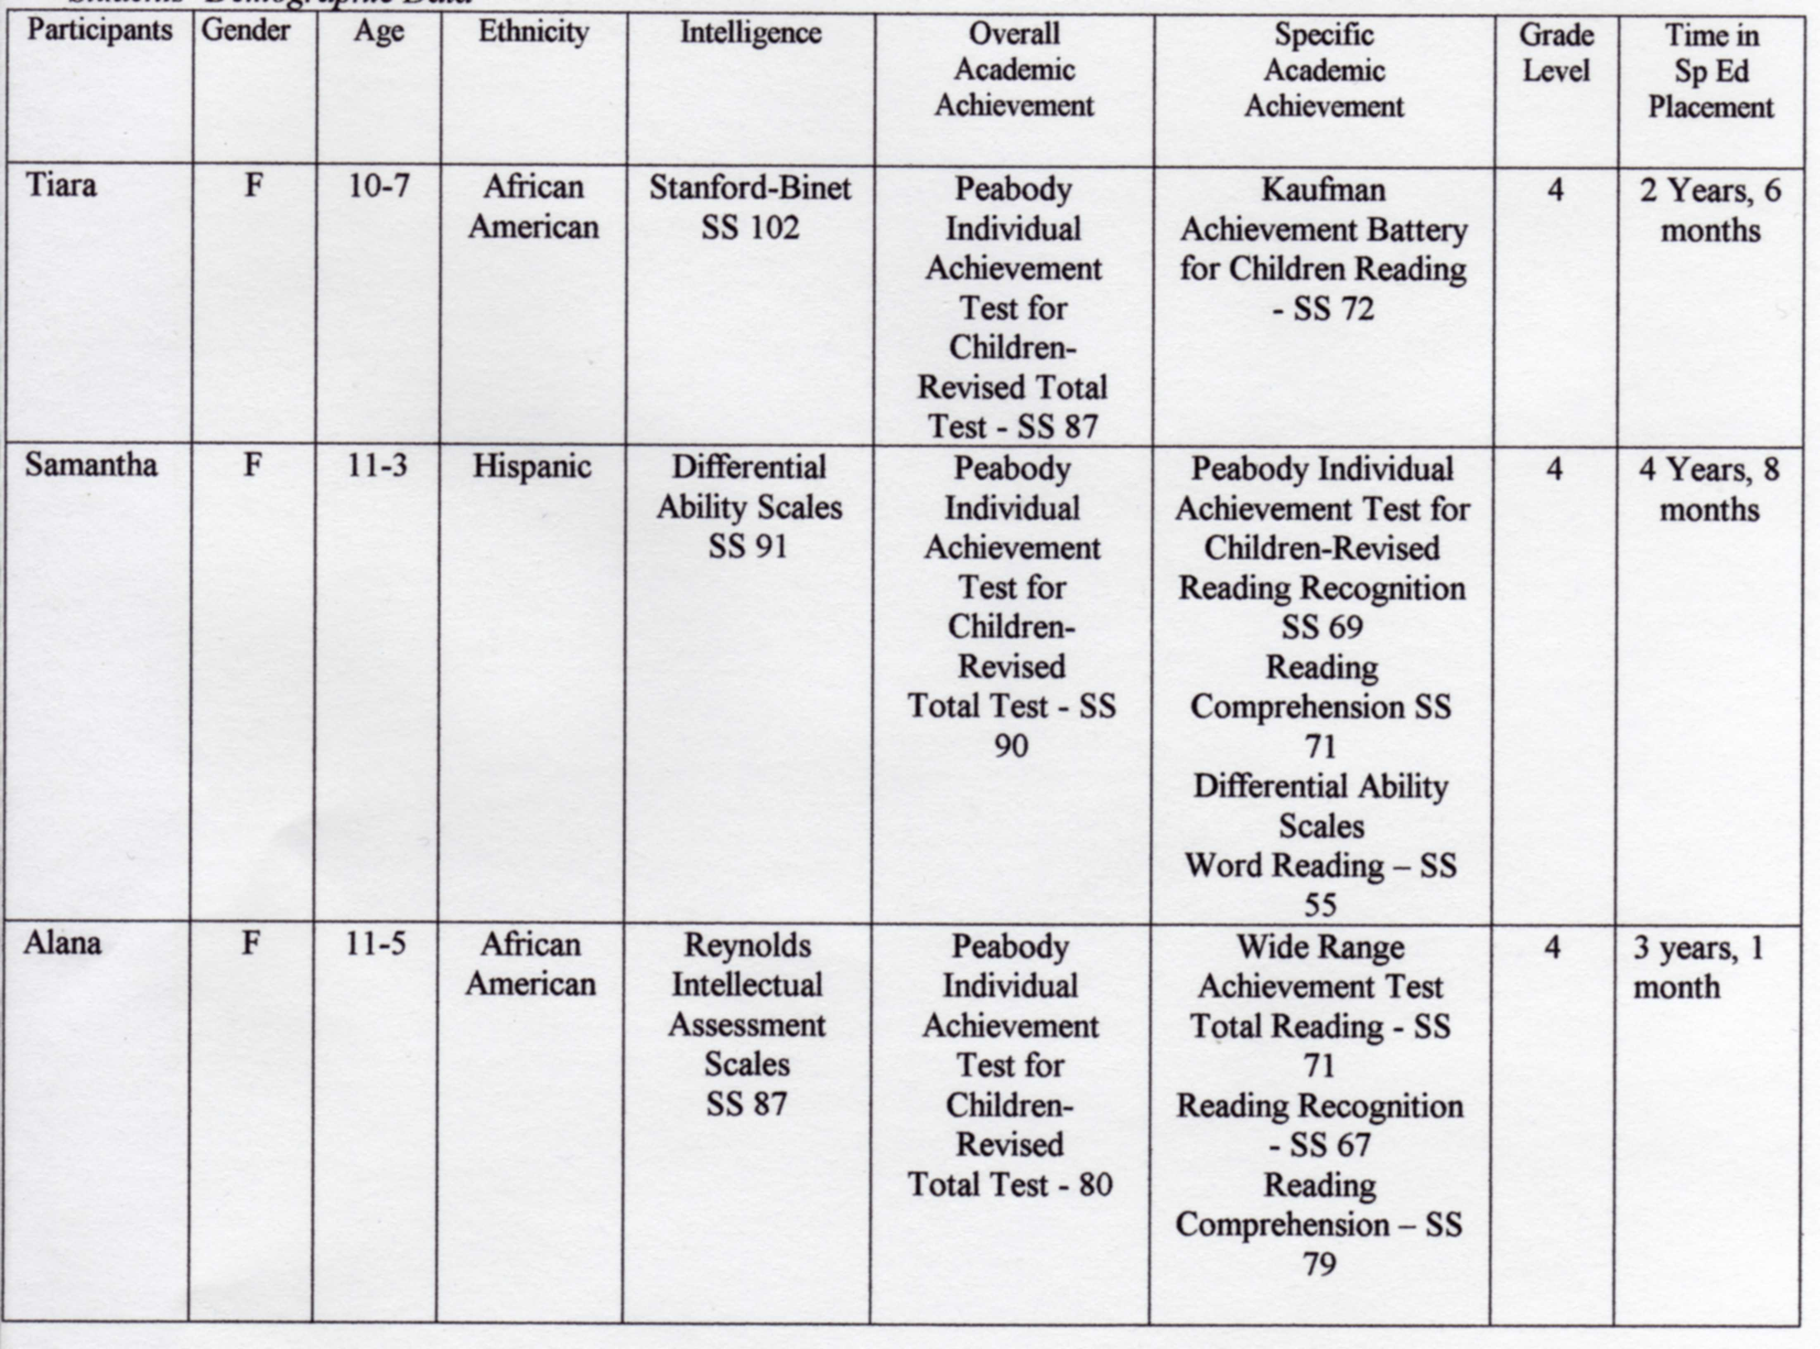Setting and Arrangements
Instruction was conducted in the participants’ existing interrelated resource classroom, a 15’ x 30’ trailer placed just outside the school building of a small urban public elementary school for pre-kindergarten through fifth grade. Instruction was conducted by the students’ resource teacher, who was also the investigator for this study. During each session with an individual participant, the two other participants were present in the room and were assigned independent work activities or participated in direct instruction with either the teacher’s assigned paraprofessional or a practicum student assigned to the teacher during the investigation period. Sessions were conducted in a 1:1 arrangement, with the student and investigator seated facing from each other at the investigator’s desk placed at one end of the classroom. Reading materials were placed on a 12” x 18” pull-out desk section between the participant and the investigator.

Materials
Each participant was instructed in reading 4 reading passages. Each reading passage consisted of just over 100 words typed in 12 point black Arial font and double spaced on standard white paper. Reading passages were selected from leveled readers not currently used in the classroom to reduce the possibility of prior experience with the passage. Reinforcement materials included red tickets typical of the type used in movie theaters and carnivals which are ripped from perforated rolls. The students earned a ticket for appropriate participation after each session and were given the opportunity to exchange them for various reinforcers such as pencils, notepads, erasers, puzzles, and small toys when they had accumulated 10 tickets. Passage reading was timed using a digital timer.

Procedures
Screening Procedure. Participants were screened during 6 sessions across 6 consecutive days to determine which reading passages they were able to read below instructional level. Instructional reading level is defined as that level of difficulty at which the student can successfully read a passage with teacher support. Typically, instructional level is determined by the reading level at which the student can identify words within the passage with 94-96% accuracy (Bos & Vaughn, 2008). Based on data already collected during instructional time which provided evidence as to each student’s instructional reading level, the investigator began presenting passages to each student at his or her instructional level, increasing the level of difficulty of passages presented until the investigator identified 4 passages which the student was able to read at 80-85% accuracy. This accuracy level was set at a level commonly considered frustrational level to allow for the measurement of feedback affects. During the screening sessions, each student worked individually with the investigator. Passages were presented one at time, with the instruction to do your best reading. The student read from one copy of the passage, while the investigator marked miscues on an identical copy. The investigator positioned the recording copy of the passage out of the line of sight of the student, taking care to avoid allowing the student to see marks in order to avoid distraction or feedback affects. Words that were omitted after 3 seconds, mispronounced, or substituted were marked as miscues, and the investigator placed a slash mark through that word. No feedback was given during the screening phase with the exception of general praise following the reading of each passage along with any necessary behavioral corrections. If the student paused or struggled for more than 3 seconds over a word, however, the investigator said skip it, prompting the student to move on.

Response Definitions and Data Collection. During all sessions, oral reading fluency, defined as the number of correct words read per minute, was tallied and recorded as the number of correct words per minute (CWPM). An error, or miscue, was defined as any word that was omitted after 3 seconds, substituted with another word or form of the word, or mispronounced. Any error in word pronunciation that was deemed to be due to an articulation problem (e.g. difficulty pronouncing r’s) or due to the participant’s dialectical patterns (he walk, rather than he walks) were not counted as a miscue if the response is known to be a reflection of the student’s typical oral language patterns. All miscues were recorded as a slash mark on the investigator’s copy through the word read incorrectly or not read. Miscues were tallied to arrive at a reading rate, which were then recorded on a graph for that session. The same recording procedure was used for all phases of the experiment.

General Procedures. The 4 reading passages selected during the screening phase were matched by similar baseline fluency scores and assigned one of the two treatment conditions, with 2 passages being taught in the word-supply condition and 2 passages taught in the phonics-based condition. One passage was taught during each treatment condition, with two treatments conducted simultaneously during one phase. Two sessions were conducted per day, one in the morning and one in the afternoon, with treatment conditions alternating and counterbalanced between morning and afternoon sessions to control for order or time of day affects. In one session, word-supply feedback was used, and in the other session, phonics-based feedback was used. A total of 10 sessions were conducted per intervention phase including 5 word-supply sessions and 5 phonics-based sessions for each participant. Maximum session length for treatment conditions was 3 minutes per session. During the first session of each condition, participants were told, I am timing your reading to see how many words you can read correctly in one minute. Students were then prompted to sit up straight and focus on the material, and they were told that when they finish reading for one minute with focused attention on the passage, they would receive one ticket to be exchanged for a prize when 10 tickets are earned. Reminders to this affect were made periodically throughout the study, with equal prompting time given to each intervention. During each session, the selected passage was placed in front of the student, and the title of the passage was read to the student. The investigator then gave the instruction to do your best reading. You may start now. The investigator began timing at the moment the student began the first word, and stopped timing after one minute. During all sessions, if a student lost her place, the investigator pointed to the word from which the student should continue reading. During error correction for both treatments, the investigator stopped the timer when a correction was initiated by the investigator, and the stopwatch was restarted when the participant began reading again. At the end of each session, the total number of errors and total number of words read correctly were tallied and recorded. All errors, or miscues, were coded in the same manner across all conditions. Total number of words read correctly constituted the reading rate, since a one minute time period was used. When a student read the passage in less that one minute, the timer was stopped and the accuracy score was multiplied by 60 seconds and divided by the total seconds to arrive at a reading rate. The method of reinforcement was the same across conditions. The student was given verbal praise, one ticket for appropriate behavior, and was shown progress in the number of words the student was able to read compared to the last session, immediately following each session. In response to inappropriate behavior during the passage reading (e.g. teeth-sucking, heavy sigh upon error correction) no ticket was given and a simple statement of the appropriate behavioral expectation was given. In this case, the student still received the reinforcers of simple verbal praise (good reading) and progress shown on words read. All procedures were held constant across all probe and treatment conditions, with the exception of the method of correcting miscues.

Before beginning the first intervention condition, a probe phase was undertaken to obtain a baseline ORF score for each of the 4 reading passages. The first baseline probe phase (P1) was conducted over 3 consecutive sessions. The first treatment condition (T1) followed the first probe, during which both treatments were implemented simultaneously on the first set of reading passages (one passage per treatment) and continued for 5 consecutive sessions. A second probe phase (P2) followed T1 and again included all 4 reading passages over 3 consecutive sessions. The second treatment condition (T2) followed the P2, during which both treatments were implemented simultaneously on the second set of reading passages. Finally, a third probe phase (P3) was implemented on all 4 passages.

Probe Procedures. A probe condition was implemented prior to the introduction of the first treatment condition and following each intervention phase. During the probe conditions, all 4 passages were tested to depict the difference between passages learned and passages not learned. Probe conditions were implemented in a 1:1 student/teacher arrangement with one 1-minute trial per reading passage. As in the screening phase, no feedback was given upon miscues, with the exception of the prompt to skip it after a 3 second hesitation or stumble. Students were given the same instructions as in all other conditions to sit up, pay attention, etc., and were given the same reinforcers of general praise, ticket, and showing of progress.

Word-Supply Procedures. In the word-supply treatment, the correct word for each miscue was supplied by the investigator, either immediately interrupting to correct if the participant continued reading without hesitation or after a 3-second wait if the student paused or made an attempt at the word. During the 3-seconds from the time the participant first attempted a word, self-corrections, or the student’s own correction of the error to the correct pronunciation of the word, were counted as correct. If the student did not read the word correctly within a 3-second time period, the investigator stated the word, prompted the student to repeat the word, and then instructed the student to begin again at the exact point where the error first occurred. E.g.: The word is ________. What word? Read again starting here (point to miscued word). To correct miscues for which the student did not pause and continued reading, the investigator immediately said, Stop, pointed to the miscued word, provided the word, and prompted for correction in the same manner as the 3-second pause error. (The word is ____. What word. Read again starting here [point].)

Phonics-Based Procedures. In the phonics-based treatment, the investigator prompted participants to sound-out any word in which a miscue was made, either immediately interrupting to correct if the participant continued reading without hesitation, or after a 3-second wait if the student pauses or makes an attempt at the word. During the 3-seconds from the time the participant first attempted a word, self-corrections, or the student’s own correction of the error to the correct pronunciation of the word, were counted as correct. If the student did not read the word correctly within a 3-second time period, the investigator prompted the participant to sound-out the word, paying attention to the beginning, middle, and/or end of the word depending on where the error(s) occurred: Sound it out-look at the beginning of that word. To correct miscues for which the student did not pause and continued reading, the investigator immediately said, Stop, pointed to the miscued word, and then continued with same instructions to sound out the word. For any type of error, if the student did not read the word correctly after initial instruction to sound it out, the investigator secured attention and modeled the sounds of the word, then prompted the student to say the word: Listen. /k/…/l/…/a/…/p/. What word? If the student did not read this word correctly after phonetic modeling, the investigator provided the word and prompted the student to begin reading exactly where he or she left off. It was only necessary to provide the word after phonetic cuing on two occasions for the same word Carter, a man’s name which proved difficult to pronounce for one participant. In both treatments, the oral reading fluency score was based on the original student miscue, regardless of whether the student made the correction after the investigator’s prompt. At the beginning of each session, students were told to sit up and do their best reading. Reinforcement schedules remained constant across conditions as verbal praise, one ticket following appropriate behavior during passage reading, and progress shown. A probe phase followed each treatment condition, in which all 4 passages were probed.

Experimental Design and Dependent Measures
A single subject parallel treatments design (Alberto & Troutman, 2008) was implemented in a modified format to test and compare the effectiveness of two feedback methods of error correction following oral reading miscues. Gast and Wolery (1988) define the design as a nested single subject experimental design that is a combination of two concurrently implemented multiple probe designs (1988, p. 270). The design evaluates experimental control by testing the two procedures on similar stimuli in a time-lagged fashion to show intervention affects across 2 different points in time. Each subject was taught 4 reading passages, 2 of which were assigned to each procedure. The experimental phases were presented in the following sequence: probe phase on all 4 passages; treatment phase to teach the first 2 passages (one taught with word-supply, one with phonics-based correction procedures); probe phase on all 4 passages after 5 sessions of each treatment condition; repeat sequence until all 4 passages were taught (2 repetitions of treatment phases and 3 probe phases). The current study was modified from Gast and Wolery’s (1988) description of the parallel treatments design in that this study is designed to include 2 intervention phases compared to the original 3 phases.

Reliability Procedures
Inter-observer reliability for the oral reading fluency measures was collected by a practicum student who was assigned to the investigator’s classroom during the time of the study. The practicum student/observer was trained in the miscue coding system and was instructed to mark and tally errors of a passage on a separate copy of the reading passage at the same time the investigator was listening to the passage. While listening to the session, the observer recorded errors, took a total error tally, and calculated and recorded the student’s CWPM. The observer’s copy was the same as the investigator’s copy except for the addition of a specified area for the observer to calculate the reading rate and for the investigator to calculate the inter-observer agreement. Data collected by the investigator and observer for the sessions were compared specifically on the number of errors emitted using the point-by point method, whereby the number of agreements between errors recorded by the investigator and errors recorded by the observer were divided by the total number of agreements and disagreements, then multiplied by 100 to arrive at a percent of agreement between investigator and observer (Alberto & Troutman, 2008). Inter-observer reliability data was collected one time for each condition (one probe, one word-supply, and one phonics-based observation) across subjects. Inter-observer reliability scores ranged from 89% to 99% agreement with a mean of 96%.

Procedural reliability data was collected during one session per intervention condition (one word-supply session and one phonics-based session) by the same practicum student/ independent observer. The observer was provided with a checklist of investigator procedures that were expected to be followed and checked the occurrence or non-occurrence of the procedure while observing in the room during the intervention session. Procedures implemented correctly were tallied as occurrence, and any procedures implemented incorrectly or not implemented were tallied as non-occurrence on the checklist provided. Correctly implemented procedures were checked under a YES column, while incorrect or improperly implemented procedures were checked under a NO column for each procedure. Procedural reliability data was determined by dividing the number of procedures implemented correctly by the total number of procedures to be implemented and multiplied by 100 to arrive at a percentage of procedures correctly implemented by the investigator (Billingsley, White, & Munson, 1980). The percentage of agreement between observed procedures and expected procedures is reported for each intervention.

Results
The purpose of this study was to investigate whether the word-supply or phonics-based methods of error correction would increase the oral reading fluency of students with reading disabilities and whether one of these methods can be shown to be superior to the other in its effects on reading fluency. The sequence of conditions and the number of correct words read per minute for Tiara, Samantha, and Alana are shown in Figures 1, 2, and 3, respectively. The effectiveness of two interventions, word-supply and phonics-based were analyzed in two different ways. In the first comparison, mean scores of each treatment phase were subtracted by mean scores of the probe phase immediately preceding the treatment to show effects of the treatment when compared to the probe.

For the word-supply method, effect sizes for Tiara, Samantha, and Alana were 15.5, 24.5, and 23 CWPM, while in the phonics-based method, effect sizes for the three students’ fluency scores were 21, 4.5, and 16 CWPM, respectively. Tiara made a greater increase in fluency during the phonics-based feedback, while Samantha and Alana made greater gains during the word-supply feedback. The total across-phases gain for all word-supply interventions taught across students was 125 CWPM compared to 83 CWPM for the total phonics gains. It was noted that among all 12 passages taught across the three students, greater probe-to-intervention fluency gains occurred during in the first intervention phase for both phonics and word-supply methods, with the exception of Samantha, who made slightly greater fluency gains during the second phonics intervention phase (mean gain- 6 CWPM) than in the first phonics phase (mean gain-3 CWPM). One possible reason for this pattern may be that at approximately the same time that the study was entering the second intervention phase, the paraprofessional previously assigned to the reading class was reassigned to another class, which caused some change to the daily routine. This may have presented a distraction that resulted in lesser gains across both treatments and across students.

The second comparison of fluency scores was a within-treatments analysis. In this comparison, the fluency score obtained during the first session was subtracted from the fluency score of the last session in each intervention phase, resulting in a within-treatments gain score. Tiara showed superior gains during the phonics intervention for the first pair of reading passages (Word-Supply- 22 CWPM gain; Phonics-Based - 32 CWPM gain), but she showed superior gains during the word-supply intervention in the second pair (Word-Supply- 18 CWPM gain; Phonics-Based - 9 CWPM gain). Samantha and Alana showed superior gains during the word-supply interventions for both pairs of passages. Word-supply gains were 8 CWPM and 55 CWPM for pair 1 and 14 CWPM and 21 CWPM for pair 2 for Samantha and Alana respectively, while phonics gains were 5 CWPM and 30 CWPM for pair 1 and 8 CWPM and 14 CWPM, respectively. The total fluency gain score within all word-supply treatment phases taught across students was 138 CWPM, while the total within-treatment phonics gain was 100 CWPM. For Samantha and Alana, gain scores from both comparisons showed slightly higher scores for the word-supply treatment across pairs than for the phonics treatment. Results were mixed for Tiara, with higher phonics gains in pair 1 and higher word-supply gains in pair 2.

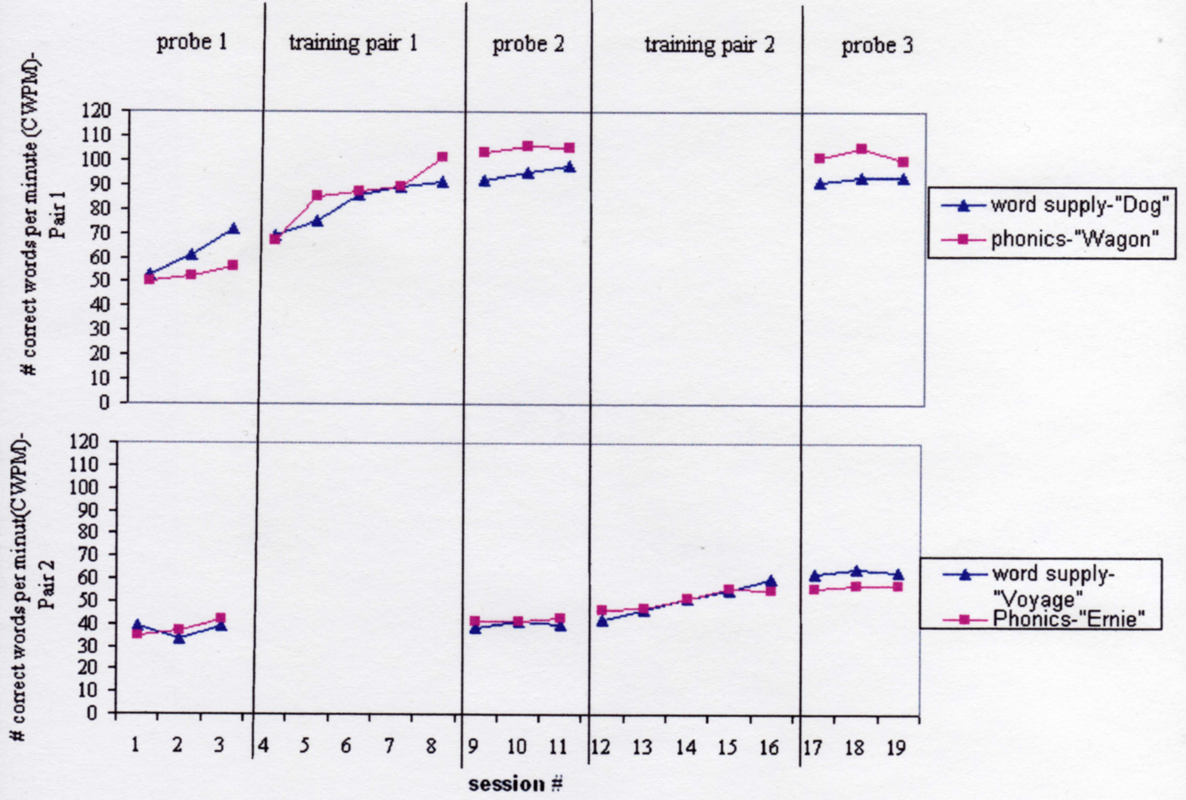

Figure 1
Number of correct words per minute for Tiara across pairs of reading passages taught and word-supply and phonics-based feedback

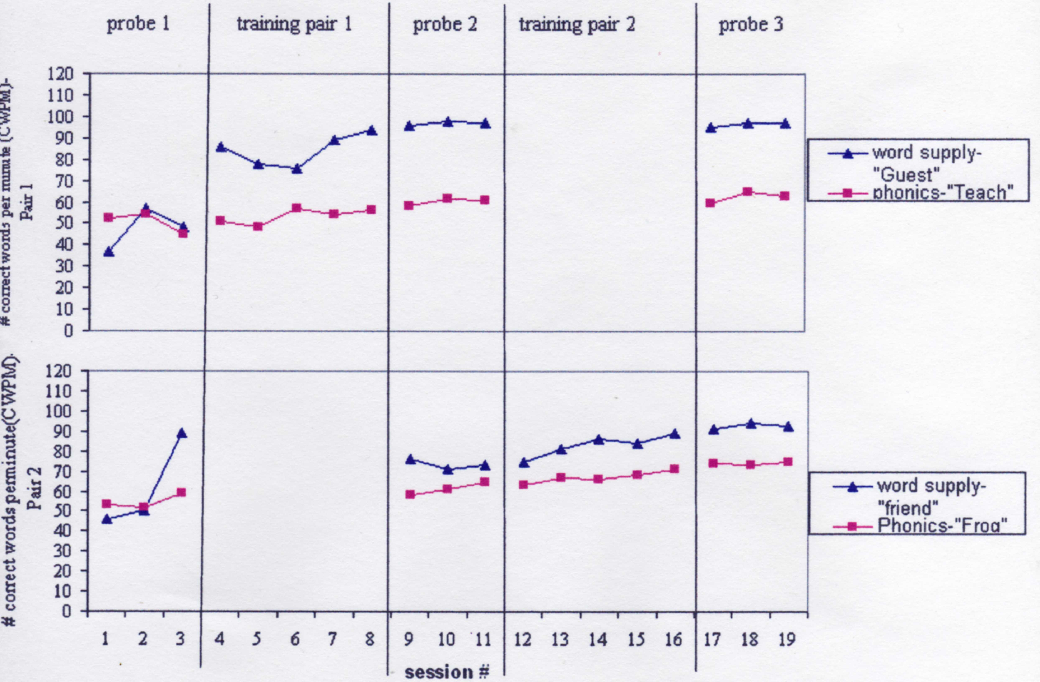
Figure 2

Number of correct words per minute for Samantha across pairs of reading passages taught and word-supply and phonics-based feedback

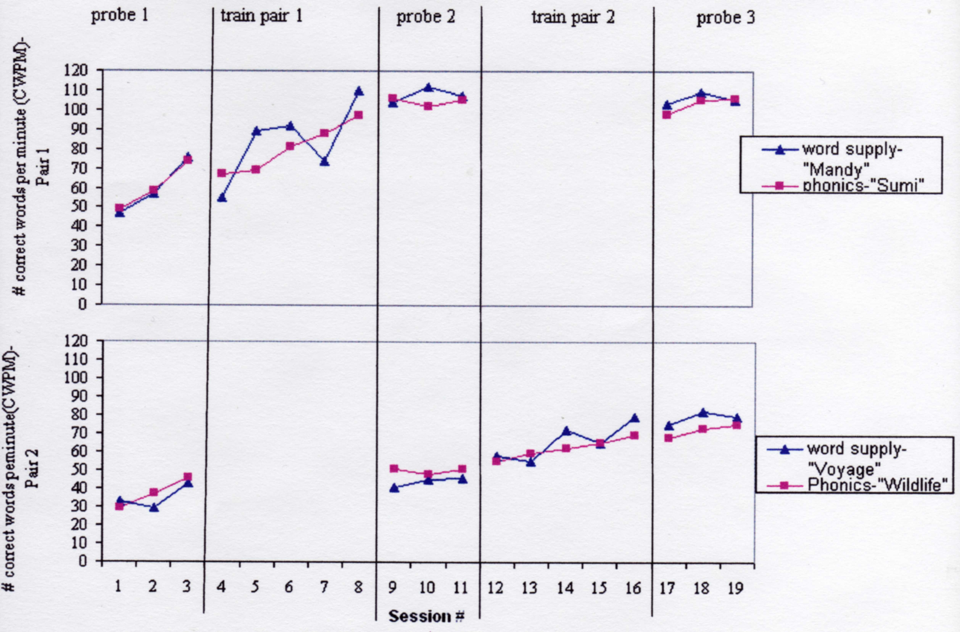
Figure 3

Number of correct words per minute for Alana across pairs of reading passages taught and word-supply and phonics-based feedback

Discussion
Findings from this study contribute to the limited body of evidence for the best method of correcting student miscues made during oral passage reading. Because oral reading is a common practice in classrooms for both instructional, assessment, and diagnostic purposes and because previous studies have linked the ability to read fluently with the ability to comprehend what is read, it is imperative for teachers to utilize the most effective feedback procedure available for promoting reading fluency.

Results indicated that both the word-supply feedback and the phonics-based feedback methods of correcting errors during oral reading improve the reading rate for students with reading disabilities. However, the effects are minimal and appear to be difficult to distinguish from the affects that occurred during the probe sessions. When analyzing trend lines between probe phases and intervention phases, it was evident that fluency increases were occurring that were similar to the treatment effects. A possible reason is that the students were repeatedly reading the same passage, which may have served as an intervention in itself during the probe phases. Recent studies have shown repeated reading of the same passage has the potential to increase student’s oral reading fluency, even when used with no other feedback (O’Shea, Sindelar & O’Shea, 1985; Sindelar, Monda & O’Shea, 1990; Homan, Klesius, & Hite, 1993; Stoddard, Valcante, Sindelar, O’Shea & Algozzine, 1993; Strong, Wehby, Falk, & Lane, 2004; Valleley & Shriver, 2003; Vandenberg, Boon, Fore, & Bender, 2008).

Therefore, future studies of the effects of feedback methods on oral reading fluency might benefit from a design which incorporates the use of separate but equally difficult passages. Overall, findings suggest that while both the word-supply and phonics-based procedures showed increases in oral reading fluency, the word-supply method is slightly superior to the phonics-based approach.

Limitations
A major limitation to the study is the fact that only two feedback methods were employed. The study did not include a treatment condition designed to study the effects of meaning-based feedback, or feedback that prompts students to pay attention to how the word fits into the context of the sentence, on fluency. Nor did this study attempt to differentiate the type of feedback based on the type of error. All errors in this study were corrected, whether they changed the meaning of the passage or not and regardless of whether the miscue appeared to be phonemic, contextual, or visual in nature.

Future Research
Further research questions for feedback effects on oral reading fluency of students with disabilities should include the following:
- Are meaning-based feedback procedures more effective than either word-supply or phonics-based feedback procedures for improving oral reading fluency?
- Are certain feedback methods more effective at improving fluency than other methods for each specific type of error made during oral passage reading? Would it be better to utilize a range of feedback procedures, depending on the type of error made?
Considering the prevalence and necessity of oral reading for students with reading disabilities, these research questions are imperative for laying a broader empirical basis of procedures for correcting students’ errors toward promoting the essential skill of reading fluency.

References
Alberto, P. A., & Troutman, A. C. (2008). Applied behavior analysis for teachers (8th ed.). Upper
Saddle River, NJ: Pearson Education, Inc.
Bos, C. S., & Vaughn, S. (2008). Strategies for teaching students with learning and behavioral
problems (7th ed.). Boston: Allyn & Bacon.
Billingsley, F., White, O.R., & Munson, R. (1980). Procedural reliability: A rationale and an
example. Behavioral Assessment, 2, 229-241.
Carnine, D., Silbert, J., & Kame'enui, E.J. (1997). Direct instruction reading (3rd ed.).
Columbus, OH: Merrill.
Chard, D.J., Vaughn, S, & Tyler, B. (2002). A synthesis of research on effective interventions for
building reading fluency with elementary students with learning disabilities. Journal of Learning Disabilities, 35(5), 386-406.
Crowe, L.K. (2003). Comparison of two reading feedback strategies in improving the oral and
written language performance of children with language-learning disabilities. American Journal of Speech-Language Pathology, 12, 16-27.
Crowe, L.K. (2005). Comparison of two oral reading feedback strategies in improving reading
comprehension of school-age children with low reading ability. Remedial and Special Education, 26(1), 32-42.
Engelmann, S., Meyer, L., Carnine, L., Becker, W., Eisele, J., & Johnson, G. (1999). Corrective
reading program. Columbus, OH: SRA/McGraw-Hill.
Epstein, M. H., Kinder, D., & Barsuck, B. (1989). The academic status of adolescents with behavioral disorders. Behavioral Disorders, 14(3), 157-165.
Fuchs, L.S., Fuchs, D., Hosp, M.K., & Jenkins, J.R., (2001). Oral reading fluency as an indicator
of reading competence: A theoretical, empirical, and historical analysis. Scientific Studies Reading, 5(3), 239-256.
Gast, D.L., and Wolery, M. (1988). Parallel treatments design: A nested single subject design for
comparing instructional procedures. Education and Treatment of Children, 11(3), 270-
285.
Gersten, R., Fuchs, L.S., Williams, J.P., & Baker, S. (2001). Teaching reading comprehension
strategies to students with learning disabilities: A review of research. Review of Educational Research, 71, 279-320.
Hernandez, S.N. (1989). Effects of communicative reading strategies on the literacy behaviors of
third grade poor readers. Unpublished doctoral dissertation, Louisiana State University, Baton Rouge.
Heubusch, J.D., & Lloyd, J.W. (1998). Corrective feedback in oral reading. Journal of
Behavioral Education, 8(1), 63-79.
O’Shea, L. J., Sindelar, P. T., & O’Shea, D. J. (1985). The effects of repeated readings and
attentional cues on reading fluency and comprehension. Journal of Reading Behavior, 17(2), 129-142.
Mastropieri, M.A., & Scruggs, T. E. (1997). Best practices in promoting reading comprehension
in students with learning disabilities. Remedial and Special Education, 18(4), 197-213.
Mastropieri, M. A., Scruggs, T. E., Bakken, J. P., & Whedon, C. (1996). Reading
comprehension: A synthesis of research in learning disabilities. In T. E. Scruggs & M. A. Mastropieri (Eds.), Advances in learning and behavioral disabilities: Intervention research (vol. 10, Part B, pp. 201-227). Greenwich, CT: JAI.
Mastropieri, M., Scruggs, T., & Graetz, J. (2003). Reading comprehension instruction for
secondary students: Challenges for struggling students and teachers. Learning Disability Quarterly, 26, 103-116.
Mastropieri, M.A., Leinart, A., & Scruggs, T.E. (1999). Strategies to increase reading fluency.
Intervention in School and Clinic, 34(5), 278-284.
Pany, D., & McCoy, K.M. (1988). Effects of corrective feedback on word accuracy and reading
comprehension of readers with learning disabilities. Journal of Learning Disabilities, 21(9), 546-550.
Perkins, V.L., (1988). Feedback effects on oral reading errors of children with learning
disabilities. Journal of Learning Disabilities, 21(4), 244-248.
Reutzel, D.L., & Hollingsworth, P.M. (1993). Effects of fluency training on second graders’
reading comprehension. Journal of Educational Research, 86(6), 325-331.
Rose, T.L., McEntire, E., & Dowdy, C. (1982). Effects of two error-correction procedures on
oral reading. Learning Disability Quarterly, 5, 100-105.
Sindelar, P. T., Monda, L. E., & O’Shea, L. J. (1990). Effects of repeated readings on
instructional and mastery-level readers. Journal of Educational Research, 83(4), 220-226.
Stoddard, K., Valcante, G., Sindelar, P., O’Shea, L., & Algozzine, B. (1993). Increasing reading
rate and comprehension: The effects of repeated readings, sentence segmentation, and intonation training. Reading Research and Instruction, 32(4), 53-65.
Strong, A., Wehby, J., Falk, K., & Lane, K. (2004). The impact of a structured reading
curriculum and repeated reading on the performance of junior high students with emotional and behavioral disorders. School Psychology Review, 33(4), 561-581.
Spaai, G. W., Ellermann, H. H., & Reitsma, P. (1991). Effects of segmented and whole-word
sound feedback on learning to read single words. Journal of Educational Research, 84(4), 204-213.
Talbott, E., Lloyd, J.W., & Tankersley, M. (1994). Effects of reading comprehension
interventions with students with learning disabilities. Learning Disability Quarterly, 17, 223-232.
Therrien, W. (2004). Fluency and comprehension gains as a result of repeated reading: A meta-
analysis. Remedial and Special Education, 25(4), 252-261.
Valleley, R. & Shriver, M. (2003). An examination of the effects of repeated readings with
secondary students. Journal of Behavioral Education, 12(1), 55-76.
Vandenberg, A., Boon, R., Fore, C., & Bender, W. (2008). The effects of repeated readings on
the fluency and comprehension for high school students with learning disabilities. Learning Disabilities: A Multidisciplinary Journal, 15(1), 11-20.
Vaughn, S., Levi, S., Coleman, M., & Bos, C.S. (2002). Reading instruction for students with LD
and EBD: A synthesis of observation studies. Journal of Special Education, 36(4), 2-14.
Wagner, M., Blackorby, J., & Hebbeler, K. (1993). Beyond the report card: The multiple dimensions of secondary school performance for students with disabilities. Menlo Park, CA:

