A SPECIAL EDUCATION TEACHER’S NETWORKS: A FINNISH CASE

Jenna Tuomainen

University of Helsinki

Tuire Palonen

University of Turku

and

Kai Hakkarainen
University of Helsinki

This case study analyzed a special education (SE) teacher’s activity within his workplace community and external professional network in a Finnish special education context. The nature of the SE teacher’s networks and his networking role were examined using an interview and a questionnaire, completed by the teachers working in the community investigated; the methods of social network analysis (SNA) were employed. In addition, the SE teacher’s social embeddedness to his new workplace community was investigated, using event sampling and three interviews. The data were analyzed by qualitative content analysis. The results indicated that the principal participant utilized an SE-related multi-professional network and had very significant roles both as a knowledge source and collaborator. The results also revealed various challenges and obstacles related to his professional portrait, the new workplace and his position within the teacher community. It was concluded that this SE teacher may be characterized as a networked expert, who appears to work at boundary zones between school communities and the outside world, and to rely on hybridized expertise. The study also presents an innovative methodology that can facilitate researchers’ collection of data from SE teachers’ professional communities and complex environments.

Special education (SE) teachers work in multi-professional collaboration across organizational boundaries. They instruct students who have diverse needs regarding educational activity, behavior, and instructional arrangements (Fuchs & Fuchs, 1994); simultaneously, they consult other teachers on pedagogical issues regarding special education (Sugai & Tindal, 1993). Because of the SE teachers’ multifaceted actions, the problem addressed in present study is to examine the networked activity and expertise of an SE teacher, who is called the principal participant. There are, of course, many studies concerning collaboration between SE teachers and various domain experts. For instance, there have been investigations concerning collaboration between an SE teacher and a school psychologist (Arivett, Rust, Brissie, & Dansby, 2007), SE teachers and parents whose children need SE services (Croll, 2001), and relations of parallel SE and regular teaching (Weiss & Lloyd, 2002). The purpose of the present case study, in contrast, is to explicitly address a SE teacher’s expertise and professional activity from a multilevel perspective that integrates quantitative, qualitative, and visual analysis. The present investigators’ aim is to analyze the principal participant’s professional networking connections across three complementary levels by examining his network position in the teacher community, his personal professional network of special education and corresponding pedagogues, and his social embeddedness in a new school community.

Networked expertise and network environments
Expertise is been examined more and more as socially distributed and networked (Hakkarainen, Palonen, Paavola, & Lehtinen, 2004; see also Hakkarainen, Palonen, & Paavola, 2002). The present investigation analyzes the workings of the principal participant’s networked expertise (Hakkarainen et al., 2004) from a socially distributed viewpoint, i.e., we examine his demonstrated, high-level of professional competence as a special educator merging in a suitable environment as evidenced in sustained collaborative efforts to solve problems and build knowledge together with colleagues. An SE teacher’s expertise as we said earlier, involves multi-layered actions; it can be seen in social interaction, knowledge sharing, and shared problem solving in interaction between individuals, communities, and broader networks (Hakkarainen et al., 2004). Experts have typically diverse network relations that elicit successful solutions to challenging problems (Nardi, Whittaker, & Schwarz, 2000). Therefore, to obtain expert knowledge concerning their own domain, SE teachers have to create, keep up, strengthen, and dynamically develop multi-faceted network relations.

In the present paper, the network environment created by the selected SE teacher is examined in terms of personal social network (or intentional network; Nardi et al., 2000). Access to knowledge and novel ideas takes place through creating personal networks that cross-organizational boundaries (Nardi et al., 2000). Intentional networks are formed interactively through remembering and communicating, so that individual actors create, strengthen and activate the set of potential relations according to problems and questions they are trying to solve. Even if personal networks are egocentric in nature, they are often partially overlapping; hence a participant often gets access to network connections and resources provided by another agent (Nardi et al., 2000).

Methods of social network analysis (SNA) enable one to examine networked expertise and experts’ environments; these methods model the structures of social interactions, which permit analysis of both the community and individual level and, integrate data on individual attributes with data on interpersonal relations (Palonen & Lehtinen, 2001, 495). A social network consists of a limited number of actors and their mutual relations (see e.g., Marsden, 2005; Wasserman & Faust, 1994). Interacting individual actors can be, e.g., persons or groups; within the present study, actors are persons working in a teacher community, which refers, in this report of the present investigators, to the staff of a school organization responsible for instruction, i.e., teachers and principal. The community members’ mutual networking ties, such as providing advice and pursuing collaboration constitute the teacher community’s social structures. In present study, networked expertise will be examined by analyzing social networks within and outside of the SE teacher’s school. The analysis relies on a who can you reach approach (Lin, 1982, 2003), i.e., who are the actors and resources that the participant is reaching through his or her networks. Besides knowledge resources, people search through social ties for belongingness and collective experiences (Lin, 1982).

Social embeddedness
In the present context, social embeddedness is approached, from our viewpoint, as a socialization process, which enables the actor’s embedding in community’s social relationships, in its networks. The principal participant is a newcomer in his school organization and, therefore, his socialization in school’s social environments is a one of the main processes during the first semester. In an effort to gain an understanding of the relevant features of the organization, the newcomer is an active agent and turns to available information sources, including interpersonal sources, such as supervisor and co-workers (Miller & Jablin, 1991; Reichers, 1987).

As a newcomer spends time getting information from sources, he or she may establish a social support network or become integrated into the informal social network (Ostroff & Kozlowski, 1992). Usually the social support network is formed by certain network participants that a worker usually, more or less deliberately, selects and is able to identify (Shah, 1998). In the present investigation, the process, whereby the principal participant socializes himself in the school and its networks, provides him resources for integrating to the culture of the organization, developing his own professional role, and participating in various collaborative professional activities.

Method

Research questions
The purpose of the present study is to analyze the networked expertise of a selected SE teacher, whom we call the principal participant. In more detail, the present investigator’s aim is to answer the following research questions:
- What is the SE teacher’s position in his teacher community’s internal networks of knowledge sharing, collaboration and informal interaction?
- Who are the experts of the SE teacher’s professional network and what are the resources provided by the professional networking connections?
- What kinds of issues does the SE teacher consider during the socializing process and what kind of support network does he rely on?

Setting and participants
The principal participant was a 46-year-old male SE teacher, who carried out professional duties with a very broad professional scope, i.e., he was an SE teacher in part-time special education; he worked in several schools and with changing student groups. He had functioned as an SE teacher and an SE teacher with a broad work description both in lower and upper primary education and in the vocational sector. He had a total of eight years of professional experience in his professional domain. Before becoming a teacher, he had been working in another occupation.

The SE teacher was a new member in his main school’s teacher community, which included a school principal and 13 teachers (ten females). He functioned part-time also as an SE teacher in two smaller lower- primary schools; in one of them, one day per week, and in another, one day in every two weeks. A detailed description of Finnish special education is provided, for instance, by Kivirauma, Klemelä, and Rinne (2006).

Data collection

Networking questionnaire
Data concerning the teacher community’s internal networking relations were collected by a networking questionnaire based on a name list of the members of the teacher community. This was performed at the end of the spring semester when the SE teacher had participated in the teacher community across eight and half months. The participants were asked to assess, in relation to each other member, the following networking dimensions and mark by x those community members from whom: 1) they ask advice concerning practices of school activity; 2) they ask advice or guidance concerning pedagogical issues; and 3) they get new information or ideas (concerning instructional issues). We further asked: with whom they are in collaboration; and if they have informal interaction (concerning those relationships that include discussions not directly related to their work or school but personal issues, such as family and hobbies). The instructions guided the participants to consider the networking interactions over the preceding six months. The networking dimensions were determined according to earlier studies by the present investigators and their collaborators (Palonen, Hakkarainen, Talvitie, & Lehtinen, 2004).

Beyond the SE teacher, the network questionnaire elicited responses from 12 members of the teacher community; the response rate was 87 %, and eight of the teacher community’s participants were females. Two teachers did not answer the questionnaire, and their data were removed before analysis, because the response rate was at an adequately high level. Five matrices were created to describe the internal relations between participants of the teacher community. These five networks corresponded to the five columns of the network questionnaire and were interpreted as partially overlapping dimensions. Columns 1–3 represent networks of knowledge sharing, and columns 4–5, respectively, networks of collaboration and informal interaction. In the present investigation, the networking relations concerning knowledge sharing are directional in character because they need not be reciprocal in nature. Collaboration and informal interaction are assumed to be reciprocal in character, i.e., acknowledged by both participants, and therefore, symmetric.

Interview of the principal participant regarding his egocentric network
Beyond analyzing the teacher community’s overall social network, we carried out an interview of the SE teacher, regarding his personal, i.e. egocentric, professional network. An egocentric network is one that emerges around a single actor (ego) and often extends beyond the immediate professional community (Marsden, 2005; Wasserman & Faust, 1994). The interview focused on two themes. The first theme includes the names of the professional experts who belonged to the principal participant’s network across the main school’s teacher community and external organizations. The second theme consists of the resources provided by the networking connections. The objective was not to examine the structure of the egocentric network, such as depth and strengths of network connections, but to analyze the existence and content of networking linkages. The interview produced 11 transcribed pages of data. The SE teacher’s egocentric network was also examined visually by paper-and-pencil technique (Hogan, Carrasco, & Wellman, 2007), and the visualization was reconstructed with a computer. A map-like picture was generated without proper names or the ego; it involved only the expert bodies (alters) to which the SE teacher was in a network relation.

Event sampling
We collected data concerning the SE teacher’s social embeddedness in the teacher community through event sampling (Ecological Momentary Assessment, Shiffman, 2000) based on reflective audio notes on an MP3 player. The chosen time sample was eight months, the first and major segment of his first year upon entering the new environment. Rather than asking a participant to remember or retrospectively generalize past experiences, the idea of event sampling is to record naturally occurring situations or contexts longitudinally in tens of snapshots of personal experiences and observations concerning the phenomenon of interest (Reis & Gable, 2000). The instructions of event sampling, in the present case, guided the participant to reflect on the following two open questions: 1) What kinds of issues you are considering related to your workplace community, teaching, and the new school? and 2) From whom are you seeking advice concerning the problematic issues? The SE teacher was instructed to make notes whenever issues corresponding the instruction emerge. The first author of this study made monthly visits to the SE teacher’s school and moved the audio files for further analysis. Altogether the principal participant created 47 audio recordings of event sampling across the period. The material corresponded to 41 transcribed pages. The advantage of using an MP3 player was that audio files were given accurate recording dates and times, which made systematic analysis possible.

Complementary interviews
Collecting information about the SE teacher’s first year in the teacher community by three, theme interviews with him complemented the event sampling. In two interviews, in the first and the third, and which took place in the beginning of the fall semester and in the end of the spring semester, the principal of the school was also present. This was because the interviews focused on socialization and initiation processes in which both worker as well as his or her supervisor has an essential role. The second interview, which took place at the end of spring semester, the SE teacher was interviewed of two topics, i.e. his adaptation to workplace community as well as his professional work description and role in the main school’s teacher community. The transcribed data consisted of 27 pages.

Data analysis

Social network analysis
Analysis among teacher colleagues was focused on the teacher community’s knowledge sharing and reciprocal interaction, and the SE teacher’s position in the associated network structures. The teacher community’s internal networks were analyzed with UCINET6 program (Borgatti, Everett, & Freeman, 2002). The analysis had two foci: 1) analyzing the cohesion of the networks that represent density and centralization of their networking relations; and 2) examining centrality of the participation (Borgatti et al., 2002; Wasserman & Faust, 1994, 167-215).

In order to simplify data analysis, we performed an analysis of QAP correlations (Borgatti et al., 2002) concerning the three matrices of knowledge sharing. The results indicated that the matrices correlated with one another (correlations varied between 0.38 (p < .05) and 0.50 (p < .05)), and we constructed one matrix for knowledge sharing in which the values of cells varied 0–3, by summing up the matrices. In addition, networks of collaboration and informal interaction were symmetrized in such a way that only those networking linkages that were confirmed by both parties were included in analyses.

In the first approach to data analysis, we examined network cohesion from two complementary perspectives. Density characterizes the general cohesion of network, i.e. how large a proportion of all possible ties between the community members are present in the data, whereas centralization indicates cohesion around certain central actors (Scott, 1991, 85).

In the second approach to data analysis, centrality was examined according to Freeman’s degree (Borgatti et al., 2002), which describes the amount of knowledge and interaction that an actor received or provides from other actors (Scott, 1991, 88). Freeman’s degree can be used to assess participants’ socio-cognitive centrality, i.e., how significant a role his or her expertise has within the social network (Burt, 1999). Another measure of centrality used in the context of knowledge sharing networks, was Freeman’s betweenness value, which assists in examining the participants’ activities as socio-cognitive brokers. This value is based on path distance; actors who are often at the shortest path between two other actors who are not directly interacting with one another have high betweenness values (Borgatti et al., 2002).

Further, networking relations were examined using multi-dimensional scaling (MDS). Scaling methods, such as MDS, are used to transform network graphs to metric distance measures that make visible complex network patterns providing visual representations of the networks investigated (Borgatti et al., 2002; Wasserman & Faust, 1994). In analysis, a non-metric analysis that keeps principal components in rank-order (Torsca) was used (Borgatti et al., 2002). The MDS -analysis concerning knowledge sharing was counted on the valued matrices, where three matrices were combined (symmetrizing method Sum), and collaboration was counted on a matrix (symmetrizing method Minimum). Due to limited data, it was not reasonable to calculate a MDS map for informal interaction, as the SE teacher was not connected to any other worker with a reciprocated tie. Thus, he was socially isolated from the informal teacher community. By considering stress value, one can assess the quality of a MDS map; a low stress value indicates that path distances of the network can be presented in three-dimensional space. However, the value is dependent on the data: the number of actors and the scale of measures. Stress values are represented in Figures 2–3, which were constructed employing M3D program and MDS coordinates, and those values are at an adequately low level (for Figure 2 (0.110) and for Figure 3 (0.000)). There are differences in standards regarding the amount of stress to tolerate in MDS maps; we use here criterion close to the criterion of Borgatti (1997); anything under 0.1 is excellent and anything over 0.15 is unacceptable. The stress value of Figure 2 is acceptable and the stress value of Figure 2 (0.000) indicates that the three dimensions used in MDS analysis give better representations of the collaboration matrix data. The best possible presentation of the data can be achieved by increasing the numbers of dimensions that bring the stress value down to zero. Therefore, zero stress values are possible in three dimensional MDS configurations; as the number of dimensions used goes up, the stress must either come down or stay the same (Borgatti, 1997). With one dimension the stress value of the Figure 3 is 0.145 and with two dimensions the value is 0.007.
The analysis of the principal participant’s professional network, in contrast, was intended to depict more deeply resources provided by expert connections i.e., who can you reach knowledge. The interview data concerning egocentric networks were analyzed by listing the experts’ networking, his or her background organization and resources provided by the contact.

Qualitative content analysis
Transcribed data from event sampling and interviews were analyzed according to qualitative content analysis. In the first stage, we analyzed event-sampling data. In practice, this meant that all transcribed data were gone through; we sought to find answers to the research questions concerning the third level of analysis, forming subcategories and grouping those categories under themes and those themes under main dimensions. The resulting dimensions were an SE teacher’s professional identity, socialization and practical concerns. These dimensions (bolded) and main themes are below in Figure 1, which depicts a time line describing the SE teacher’s central reflections and practical needs for assistance across the eight-month period. Furthermore, the support network and its actors were analyzed by listing support persons from whom the principal participant had searched for help and advice. The nature of the connections was also determined.
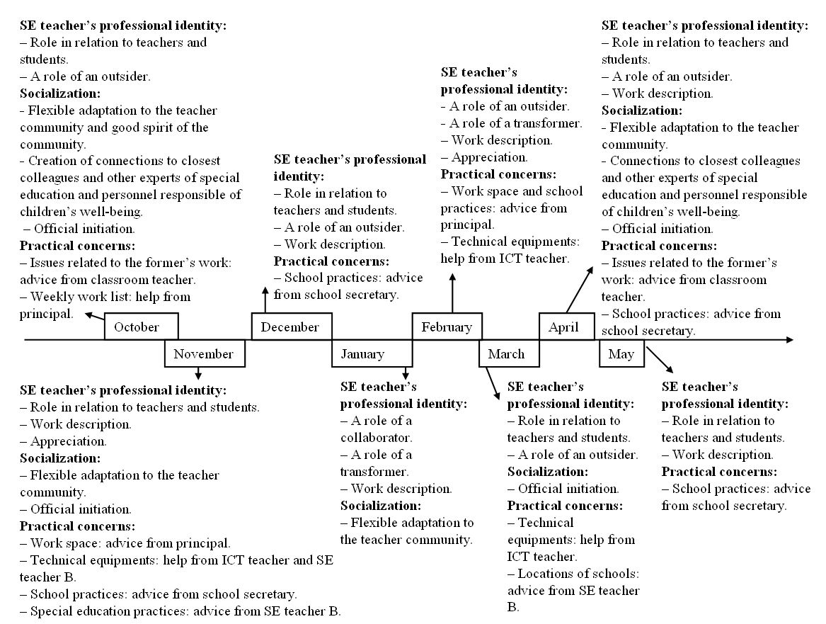
Figure 1.
The figure depicts a timeline, which presents the main themes and practical concerns that the SE teacher reflected on during the eight-month event-sampling period.
In the second stage, the interview data were analyzed using those three dimensions. Analysis revealed that the interview data and event-sampling data included very similar content and complemented one another (the analysis table formed while analyzing interviews is presented in Appendix A). It was decided that the event sampling data were to be taken as our hard data. In results section, transcriptions, translated from Finnish to English, are used to illustrate the analysis.

Results

Level 1: Social networks of the teacher community and the SE teacher’s position
At the first level, we will present the results from the overall teacher community’s networks describing both actor and network level measurements and especially concentrate on SE teacher’s position. It should be mentioned, in the Table 1 concerning knowledge-sharing network, both an actor’s own estimation (out degree) and that of the alters (in degree) are presented. The results rely; however, only on in degrees that represent the centrality of the actor estimated according to incoming ties that the other community members reported. In the cases of collaboration and informal interaction the networks, and consequently the degree values, are symmetrized. It is typical for SNA that some respondents assess the number of their own network ties as relatively large, which consequently overemphasizes their network centrality. Apparently, in degree values and symmetrized degrees provide a more reliable estimate of a person’s centrality.
Table 1
Density and centrality measures of the teacher community’s social networks (N=13)
Teacher  (Code of participant) | Knowledge sharing |  |  | Collaboration | Informal  Interaction
Teacher  (Code of participant) | Out degree  (self-report) | In degree  (peer report) | Betweenness | Degree  (reciprocal ties) | Degree  (reciprocal ties)
F1 | 5 | 4 | 0.4 | 4 | 1
F2 | 10 | 11 | 7.5 | 10 | 5
F3 | 9 | 3 | 0.1 | 6 | 4
F4 | 4 | 7 | 0.0 | 4 | 0
F5 | 5 | 12 | 6.4 | 11 | 3
F6 | 9 | 10 | 5.2 | 8 | 3
F7 | 10 | 9 | 6.8 | 10 | 3
F8 | 7 | 4 | 0.0 | 6 | 4
M9 | 10 | 8 | 8.5 | 7 | 4
M10 | 11 | 9 | 7.4 | 7 | 1
M11(SE) | 12 | 10 | 11.0 | 11 | 0
M12 | 8 | 9 | 1.5 | 10 | 6
M13 | 2 | 6 | 0.1 | 6 | 2
Network level measures
M | 7.8 | 7.8 | 4.2 | 7.7 | 2.8
SD | 2.9 | 2.7 | 3.8 | 2.4 | 1.8
Centralization % | 38 |  |  | 33 | 32
 | Knowledge sharing |  |  | Collaboration | Informal  Interaction
Density % | 65 |  |  | 64 | 23
SD | 0.48 |  |  | 0.48 | 0.42

Table 1 indicates that the networks of knowledge sharing (65 %) and reciprocal collaboration (64 %) were the most dense network dimensions. In contrast, the network of reciprocal informal interaction was the least dense (23 %). Moreover, the results of the other cohesion analysis indicated that the network dimensions were not very centralized. In the case of the knowledge-sharing network, network centralization was highest (38%). Networks of collaboration (33%) and informal interaction (32%) were even less centralized in that only one third of networking linkages were concentrated around certain actors. It may be concluded that the participants of the teacher community were actively utilizing each other as knowledge sources and committed to reciprocal collaboration, but the informal teacher community did not include many mutual relationships. A summary of density and centrality values of the social networks is presented in Table 1. The SE teacher’s network values are bolded.

In Figures 2–3 closely located actors are engaged in more intensive interaction than actors who are farther away from one another. Color of the node indicates the gender of the actor. Grey indicates females; white, males; and black indicates the SE teacher. For each node, we provided gender code (M=male, F=female), participant number, and centrality value (indicating how many other actors reported using the teacher in question as a knowledge resource or a collaborator).
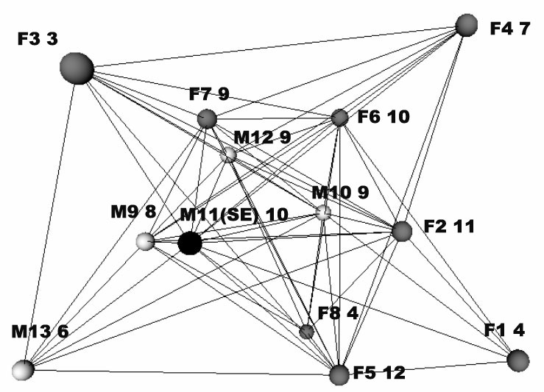
Figure 2.
This is a visualization of the teacher community’s network of knowledge sharing (M= 7.8). The matrix has been symmetrized for this analysis. The stress value of MDS analysis is 0.110.

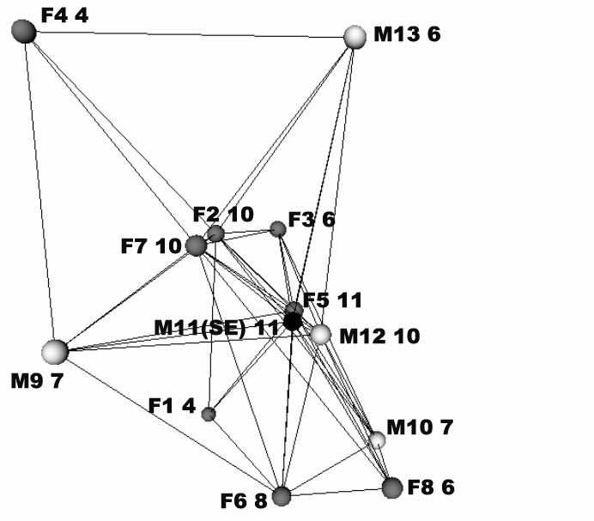
Figure 3.
This figure shows the teacher community’s network of reciprocal collaboration (M= 7.7). The stress value of MDS analysis was 0.000.

Table 1 and Figures 2–3, representing the knowledge sharing and collaboration networks, reveal that there are some actors, such as the principal participant (M11 (SE)), who had significant positions in formal interaction actions; those actors are located in a central position in the graphs, indicating that they carried out the main responsibility for knowledge sharing and collaboration within the community. The SE teacher’s Freeman’s centrality values were relatively high in the cases of knowledge-sharing (10) and collaboration (11) networks. Moreover, the Freeman’s betweenness value provided by Table 1 indicates that the principal participant also had the position of knowledge broker in the knowledge-sharing network. His betweenness measure is the highest of all community members, and it is about two standard deviations higher than the mean. Figures 2–3 demonstrate clearly and visually these central positions of the SE teacher.
In the informal-interaction network the SE teacher is an isolate (centrality value 0, see Table 1). Isolated persons are members of an organization who have very little or no networkings contacts with other members and, consequently, are at the periphery of the network (Rogers & Agarwala-Rogers, 1976). From Table 1, it can be inferred that there is another teacher who did not have any reciprocal relations regarding informal interaction. This actor (F4) had one similarity with the SE teacher; they both taught the other teacher’s students and therefore had no class of their own. However, the SE teacher had a central position in knowledge-sharing and collaboration networks, whereas teacher F4 was also at the periphery in both corresponding networks.

Level 2: Egocentric professional network
At the level of analysis of the professional network, we will present the results by describing the experts and expert bodies included in the SE teacher’s professional network according to the resources provided by the professional interactions. Figure 4 presents the SE teacher’s egocentric professional network. Within the visual presentation, the same shade of gray is used to identify expert contacts similar in content: dark gray indicates connections to colleagues and comprehensive sharing of special pedagogical information, gray indicates administration of special education related resources, and the lightest gray indicates students and their support-related resources. The ego (the SE teacher) itself is not represented in the figure and the technique does not consider depth or strength of the connections, only existence and contents of the network connections.
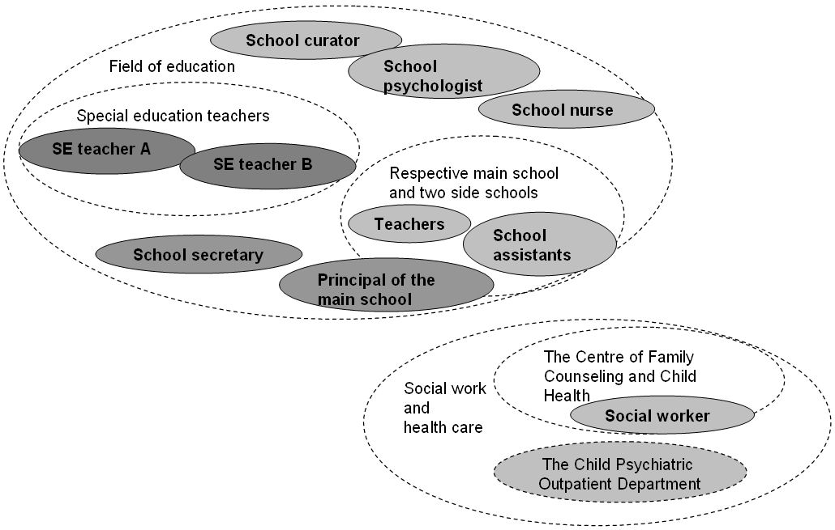

Figure 4.
The figure presents the egocentric professional network of the SE teacher in a visual form

In the field of education within the principal participant’s school, the other teachers and school assistants functioned as experts regarding particular students he was working with. This student-related information affected the planning and providing of special education. In addition, the school nurse, school curator, and school psychologist were part of the principal participant’s professional network, and were consulted according to their very specialized expert areas. The curator had specific student-, group-, and classroom-related knowledge and expertise whereas the school psychologist carried information from assessments and investigations concerning students. Moreover, the SE teacher considered the school nurse to be an especially important expert on student-related issues, because of the nurse’s long history in the school. The SE teacher’s within-school network also involved the principal and school secretary as experts of administrative issues. The school secretary, especially, was a link to the provincial department of education.

Further, in the field of social work and health care the Centre of Family Counseling and Child Health as well as the Child Psychiatric Outpatient Department represented bodies external to the school organization that had significant expertise concerning student-related issues. In the case of assessing and investigating students, the Child Psychiatric Outpatient department played an essential role. The social worker of the Centre for Family Counseling and Child Health was an expert with whom the SE teacher kept contact according to the problems concerning students in special education.

The SE teacher named as his experts two colleagues (the SE teachers A and B) in the same town representing the same domain of expertise. While addressing their collaboration, the SE teacher highlighted both professional and social dimensions on those collegial connections. On the one hand, the principal participant revised knowledge, materials and experiences of special education, and on other hand the collegial connections provided support and encouragement to do his duties.

Level 3: The SE teacher’s central reflections and social support network
We will begin description of the results from the third analysis level by presenting the main themes that the SE teacher reflected on during the event-sampling period. Those can be roughly divided to two categories; the first involves reflections regarding the SE teacher’s professional identity and the nature of special-education teaching. The principal participant contemplated his professional role and content of his work from various perspectives, and we will show that some these reflections are related to SNA results. The second category involved a new employee’s perspective; the SE teacher reflected on his own socialization process and factors that affected the process. After addressing these two main categories of content, we describe practical concerns that emerged during the first semester, while analyzing the content of linkages of the emerging support network.

Event sampling revealed that while reflecting on his professional identity and description, the SE teacher thought of his role in relation to various perspectives. One the one hand, reflected on his role in relation to other teachers:
I’ve been pleasantly elated when I’ve realized that in this work community the special education teacher is relied upon a lot and considered to be important. They do seem to consider me a kind of an expert in my field, special education that is.

These reflections and SNA results of the principal participant’s central roles as collaborator and knowledge source corroborate each other. Moreover, the principal participant brought up, in his reflections, the multi-faceted collaborative dimension of his work, which also became visible in SNA results of the overall and particularly in professional networks.

On the other hand, the SE teacher reflected on domains of challenges regarding his professional role and activity. He experienced that his role involved a great many expectations, firstly from parents, and secondly those from other teachers. Furthermore, the principal participant reflected on his own role as an outsider, transformer as well as his professional appreciation from a negative viewpoint. We start with the feeling of being an outsider; this is an intriguing issue if one takes the results of SNA into consideration, which showed that the principal participant was an outsider in the informal teacher community. He truly felt, correctly, rather isolated from other activities of the school:
That is one problem with special education; the special education teacher might be kind of estranged from the school’s other action, so he easily turns into a kind of freak.

Feelings of being an outsider were revealed in his reflections concerning organizing and participating in various school-wide events. The SE teacher did not know his own place and role in diverse events, such as Christmas and spring celebrations:
For example when you go to a celebration or prepare a program, it always happens in a class, and because I don’t have a class, then I’m in a slightly different position compared to the other teachers in the school. I kind of feel like well, where do I belong? Should I go with this class to see the presentation, or should I be part of designed the program and such...

The SE teacher also saw himself as a transformer. He had noticed that in his profession, there are unexpected and surprising situations, and one has to be flexible and get used to quick and transforming changes, especially in situations, when the principal participant was asked to be a substitute teacher. Consequently, he considered where the limit should be established so that his main task – special education – would not suffer from assisting the others.

Further, the SE teacher considered to what extent his work is valued. The principal participant experienced that his and other SE teachers’ work is highly regarded at the primary level, which can be seen from his central networking roles. He stated, however, that the appreciation was not necessarily present while organizing certain practical things. On the one hand, he reflected that while classroom teachers are provided a classroom substitute for the duration of their sick leave, it does not usually happen in the case of SE teachers. Secondly, the principal participant had problems with his workspace, i.e., the location of his workspace and sharing it, and he brought up a dark side concerning appreciation of special education, because according to him there are many SE teachers who do not have proper work spaces.
The SE teacher reflected on his socialization across the eight months from the perspectives of school community, creation of networking connections required by SE, and official initiation. We start with school community; the principal participant considered, especially, the importance of informal interaction while entering to a new school community and becoming acquainted with its teachers. However, according SNA results, mutual informal interaction between the principal participant and other members of the community was not visible even the end of the semester.

He also reflected on the significance of the creation of his professional network as a new professional in the town and as a representative of expertise in special education:
Yeah, they (the closest colleagues SE teachers A and B) contacted me and we agreed that we’d start to hold regular meetings. And so these have been very important in terms of knowledge acquisition and getting to know people.

Moreover, the SE teacher reflected on various aspects of his initiation to the new school. Firstly, he was thinking about a missing tutor. According to his assessment, initiation would have been more effective if he had been provided a tutor or a mentor teacher who would have assisted in facing those novel issues and challenges related to school practices.

Secondly, he mentioned that, due to the initial information flow, many of the issues introduced during the first weeks were forgotten. According to his reflections, the most important issues in which he needed assistance were related to physical spaces of the school and social practices enacted in the school community.

Here we will take a closer look to those practical concerns mentioned above, regarding the social support network, which involves the main school’s principal, the school secretary, a classroom teacher, a classroom teacher who functioned as ICT support person and another SE teacher who worked in other schools. Three out of these actors (the principal, the school secretary, and the other SE teacher) were also part of the present SE teacher’s egocentric professional network.

From the members of his support network within the main school, the principal was the main initiator of the SE teacher. The contacts involved initiation activities in the beginning of the school year. Besides the main initiator, the SE teacher asked practical help from the school secretary, whom he characterized as his personal counselor regarding practical school-related issues. Also, one of the classroom teachers was an important contact person. From him, the principal participant had obtained assistance and guidance in various issues related to the former’s work. Furthermore, the main school’s ICT support teacher played a crucial role. The SE teacher had, over the event-sampling period, problems and needs for assistance concerning various pieces of technical equipment; consequently, he asked assistance of the ICT support teacher frequently.

From outside of the main school, the SE teacher working in other schools functioned as an important support person. Assistance concerned issues related to special education (investigating how special education services can be funded within the municipality in question) as well as general and practical issues (such as buying a new computer).

Discussion
The present study analyzed the selected SE teacher’s networked activity and expertise within his main school and its internal teacher community, and across his external professional network. The results indicated that the principal participant was socially embedded in his new formal teacher community and functioned in the role of expert while having highly regarded positions as a source and a broker of knowledge, and collaborator. Practically all members of the teacher community recognized and utilized the SE teacher’s epistemic resources. The results of event sampling confirmed these findings by providing evidence of the SE teacher’s everyday functioning at school and his collaborative relations with the rest of teachers. Nevertheless, the SE teacher did not have any reciprocal informal interactions within the teacher community of his main school, and, thus, was not embedded in the informal teacher community.

The socialization process does not appear to completely account for the SE teacher’s peripheral position in the network of informal interaction. The reason for being considered as an outsider may be the SE teacher’s relational activity at the boundary zones of schools and the external world, or his professional (McLeod, 1988) as well as physical isolation (Hargreaves, 1992). Such isolation is a serious problem of SE teachers, and one of the reasons behind this state of affairs is that a SE teacher’s role diverges from those of all other teachers (McLeod, 1988, 248–249). In addition, SE teachers’ isolation may frequently result from the physical environments of schools; SE teachers often have remote work spaces (Hargreaves, 1992, 224–225). Both McLeod’s and Hargreaves’ reports are supported by the present data; event sampling indicated that the SE teacher had problems with the work space, and his role as outsider was especially in evidence when one considers differences in classroom teachers’ and SE teachers’ work descriptions. In this regard, it is relevant that, unlike classroom teachers, SE teachers work in numerous environments with changing student groups.

The SE teacher’s naturally occurring reflections on an expert’s daily activities allowed the present investigators to extend an examination of his professional role beyond his structural position within the social networks. The results of the study suggest, on the one hand, that a great part of the SE teachers’ challenges encountered during the semester was related to clarifying his work description and professional identity. On the other hand, challenges related to practical matters also had a great role. For instance, the present investigation revealed that the SE teacher would have wanted to have a person who assisted in his initiation to the school community and its practices. We propose that, because SE teachers’ work descriptions diverge from those of other teachers, there should be special attention to designing their initiation. For instance, Rollag, Parise, and Cross (2005) have proposed that, rather than asking what a new employee should know, it may be more productive to ask who a new employee should know? Such a question reveals those experts and knowledge brokers with whom the employee has to interact so as the blend into a new workplace community. Nevertheless, for solving his practical problems, the principal participant had selected a few co-workers and the supervisor, who formed his social support network.

In describing the SE teacher’s professional network, we have deliberately examined from whom the SE teacher got professional resources needed for successfully carrying out his work. The results revealed that the SE teacher was mainly engaged in student-centered collaboration and networked with experts representing diverse domains of knowledge. In addition, the event sampling revealed that a part of the SE teacher’s social embeddedness was to build a special-education-related network and create contacts with colleagues working in the same domain of expertise. Overall, experts in workplace communities not only have an extensive knowledge base but also a network that they can personally access or direct other people to when necessary (Lesser & Prusak, 1999). The SE teacher’s position as a central broker (Nardi et al., 2000) in knowledge-sharing activities made it possible for him, presumably, to guide the flow of relevant expert and knowledge resources to his workplace community by relying on diverse contacts outside his immediate social network. Overall, the results indicate that this SE teacher with a broad professional scope may be characterized as a networked expert who is a collaborator dependent on his work community; he identifies resources from the environment according to the evolving needs of the student and appears to rely on hybridized expertise concerning individual students, school practices, pedagogy of special education, administration, psychology, health care, and social work.

In conclusion, we believe this study contributes by presenting an innovative methodology. SNA and event sampling complemented each other; the one analyzed networked expertise at a relational level whereas the other described its contents in everyday practices. However, it is important to find ways to collect data on the relational nature of networked expertise in more detail; for instance, to analyze experts’, such as SE teachers’, professional connections around a specific student case. In addition, one possibility is to use more regular sampling methods and collect such contextual data, which would enable one to revealing experts’ daily practices and networking. Therefore, in the future it is important to investigate how these kinds of complementary methodologies and multi-layered data can be utilized more effectively, for example, in detailed descriptions in analyzing dimensions of an SE teacher’s networked expertise.

References
Arivett, D.C., Rust, J.O., Brissie, J.S., & Dansby,V.S. (2007). Special education teachers’ perceptions of school psychologists in the context of individualized education program meetings. Education 127(3), 378–338.
Borgatti, S.P. (1997). Multidimensional Scaling [On-line]. Available:
http://www.analytictech.com/borgatti/mds.htm.
Borgatti, S.P., Everett, M.G., & Freeman, L.C. (2002). Ucinet for windows: Software for social network analysis. Harvard, MA: Analytic Technologies.
Burt, R.S. (1999). Entrepreneurs, distrust, and third parties: A strategic look at the dark side of dense networks. In L.L. Thompson, J.M. Levine, & D.M. Messick (Eds.), Shared cognition in organizations: The management of knowledge (pp. 213–243). Mahwah, NJ: Erlbaum.
Croll, P. (2001). Teacher contact with parents of children with special educational needs: A comparison over two decades. Journal of Research in Special Educational Needs [On-line], 1(2). Available: http://www3.interscience.wiley.com/journal/120188608/issue.
Fuchs, D., & Fuchs, L.S. (1994). Inclusive school movement and the radicalization of special education reform. Exceptional Children 60, 294–309.
Hakkarainen, K., Palonen, T., & Paavola, S. (2002). Three perspectives on studying expertise. In P. Bell, R. Stevens, & T. Satwicz (Eds.), Keeping learning complex: The proceedings of the fifth conference of the learning sciences (ICLS) (pp. 131–138). Mahwah, NJ: Erlbaum.
Hakkarainen, K., Palonen, T., Paavola, S., & Lehtinen, E. (2004). Communities of networked expertise. Professional and educational perspectives. Amsterdam: Elsevier.
Hargreaves, A. (1992). Cultures of teaching: A focus for change. In A. Hargreaves, & M.G. Fullan (Eds.), Understanding teacher development (pp. 216-240). Teacher College Press, Columbia University New York.
Hogan, B., Carrasco, J.A., & Wellman, B. (2007). Visualizing personal networks: Working with participant-aided sosiograms. Field Method 19(2), 116–144.
Kivirauma, J., Klemelä, K., & Rinne, R. (2006). Segregation, integration, inclusion – The ideology and reality in Finland. European Journal of Special Needs Education 21(2), 117–133.
Lesser, E., & Prusak, L. (1999). Communities of practice, social capital and organizational knowledge [On-line]. Cambridge: Institute for Knowledge Management. Available: http://www.clab.edc.uoc.gr/ hy302/papers/communities%20of%20practice.pdf.
Lin, N. (1982). Social resources and instrumental action. In P. Marsden, & N. Lin (Eds.), Social structure and network analysis (pp. 131–145). London: Sage.
Lin, N. (2003). Social capital: A theory of social structure and action. Cambridge, MA: University Press.
Marsden, P.V. (2005). Recent development in network measurement. In P.J. Carringon, J. Scott, & S. Wasserman (Eds.), Models and methods in social network analysis (pp. 8–30). Cambridge, MA: University Press.
McLeod, J.L. (1988). One professional perspective. In D.P. Hallahan, & J.M. Kauffam (Eds.), Exceptional Children (pp. 240–260). New Jersey: Prentice Hall.
Miller, V.D., & Jablin, F.M. (1991). Information seeking during organizational entry: Influences, tactics, and a model of the process. Academy of Management Review 16(1), 92–120.
Nardi, B., Whittaker, S., & Schwarz, H. 2000. It's not what you know, it's who you know: Work in the information age. First Monday [On-line], 5, 5. Available: http://firstmonday.org/ issues/ issue5_5/ nardi/index.html.
Ostroff, C., & Kozlowski, S.W.J. (1992). Organizational socialization as a learning process: The role of information acquisition. Personnel Psychology 45(4), 849-874.
Palonen, T., Hakkarainen, K., Talvitie, J., & Lehtinen, E. (2004). Network ties, cognitive centrality, and team interaction within a telecommunication company. In H. Gruber, E. Boshuizen, & R. Bromme (Eds.), Professional learning: Gaps and transitions on the way from novice to expert (pp. 273-294). Dordrecht: Kluwer Academic Press.
Palonen, T., & Lehtinen, E. (2001). Exploring invisible scientific communities: Studying networking relations within an educational research community. A Finnish case. Higher Education 42(4), 493–513.
Reichers, A.E. (1987). An interactionist perspective on newcomer socialization rates. Academy of Management Review 12(2), 278–287.
Reis, H.T., & Gable, S.L. (2000). Event-sampling and other methods for studying everyday experience. In H.T. Reis, & C.M. Judd (Eds.), Handbook of research methods in social and personality psychology (pp. 190–222). Cambridge, MA: University Press.
Rogers, E., & Agarwala-Rogers, R. (1976). Communication in organizations. New York: Free Press.
Rollag, K., Parise, S., & Cross, R. (2005). Getting new hires up to speed quickly. MIT Sloan Management Review 46(2), 35–41.
Scott, J. (1991). Social network analysis. A handbook. London: Sage.
Shah, P.P. (1998). Who are employees’ social referents? Using a network perspective to determine referent others. Academy of Management Journal 41(3), 249–268.
Shiffman, S. (2000). Real-time self-report of momentary states in the natural environment: Computerized ecological momentary assessment. In A.A. Stone, J.S. Turkkan, C.A. Bachrach, J.B. Jobe, H.S. Kurtzman, & V.S. Cain (Eds.), The science of self-report. Implications for research and practice (pp. 277–296). New Jersey: Erlbaum.
Sugai, G.M., & Tindal, G.A. (1993). Effective school consultation. Pacific Grove, CA: Brooks/Cole.
Wasserman, S., & Faust, K. (1994). Social network analysis. Methods and applications. Cambridge, MA: University Press.
Weiss, M.P., & Lloyd, J.W. (2002). Congruence between roles and actions of secondary special educators in co-taught and special education settings. The Journal of Special Education 36(2), 58–68.

Appendix A.
Analysis table concerning complementary interviews
Dimensions | Main themes | Subcategories
An SE teacher’s professional identity | Work description | Being a part of school’s every day life
An SE teacher’s professional identity | Work description | Wide collaboration field
An SE teacher’s professional identity | Work description | Challenge areas in special education
An SE teacher’s professional identity | Role and position in school | Relied collaborator
An SE teacher’s professional identity | Role and position in school | Outsider and isolated
An SE teacher’s professional identity | Role and position in school | Transformer
An SE teacher’s professional identity | Role and position in school | Appreciation according to experience and in practical matters
Socialization | School community | Teacher community’s warm and welcoming atmosphere
Socialization | School community | Meeting student community in informal situations
Socialization | Official initation | Lacks in initiation arrangements
Socialization | Creation of SE –related connections | Meetings with SE –related professionals
Practical concerns | Equipments and materials | Problems with computer and printer
Practical concerns | Equipments and materials | Finding materials and using equipments
Practical concerns | Participation | Teachers’ professional development training
Practical concerns | Former’s work | The content of work duties
Practical concerns | Special education budget | Financing practices

