ENHANCING ORTHOGRAPHIC COMPETENCIES AND REDUCING DOMAIN-SPECIFIC TEST ANXIETY: THE SYSTEMATIC USE OF ALGORITHMIC AND SELF-INSTRUCTIONAL TASK FORMATS IN REMEDIAL SPELLING TRAINING

Günter Faber
Leibniz University Hannover

In this study the effects of a remedial spelling training approach were evaluated, which systematically combines certain visualization and verbalization methods to foster students' spelling knowledge and strategy use. Several achievement and test anxiety data from three measurement times were analyzed. All students displayed severe spelling disorders at the beginning of the treatment. It was administered in single-case sessions and took about 80 hours. Empirical results could demonstrate statistically significant increases in students' general and error-specific spelling test performance, also reaching a considerable overall effect size. Furthermore, a statistically significant decrease in their spelling-specific test anxiety scores appeared at the end of the treatment. Finally, these findings were discussed in terms of conceptual and methodological issues concerning both the evaluation of remedial treatments in natural training settings and the need for evidence-based treatment practice.

Since many dyslexic students display poor knowledge of the important orthographic rules and remain unfamiliar with its implications, they often resort to existing phonological spelling skills and try in vain to master the critical word items in terms of phonological correctness (Bailet, 1990; Carlisle, 1987; Darch, Kim, Johnson & James, 2000; Klicpera & Schabmann, 1993; Steffler, 2004). Because of repeated errors, these students may become irritated and disappointed over their unsuccessful spelling efforts, as they have, from their viewpoint, genuinely pondered over the words and could even come up with an explanation for deciding on the spelling that they used. Therefore, remedial spelling interventions should enhance, round off, or catch up on their orthographic skills, the acquisition of which had been unsuccessful for them thus far, so as to avoid, last but not the least, the motivational and socioemotional long-term effects of cumulative failure experiences (Carroll, Maughan, Goodman & Meltzer, 2005; Faber, 2007; Ridsdale, 2004). The development and persistence of these learning difficulties can essentially be traced back to fundamental knowledge and strategy deficiencies: the students concerned lack relevant knowledge with regard to critical demands; in addition, they do not possess suitable metacognitive skills for the acquisition of appropriate learning strategies, or they are unable to adequately apply solution approaches (Borkowski, Johnston & Reid, 1987). So remedial spelling instruction has to teach students the knowledge of relevant rules in a much more comprehensible way, and useful behavioral patterns with regard to the instruction strategy have to be worked out to bring this knowledge to effective application (Larkin & Ellis, 2004; Swanson & Deshler, 2003).

In particular, sociocultural theories concerning the nature and the development of academic learning activities point to the necessity of an instructional approach which enables the students to understand the underlying logic of a certain spelling rule and to form a cognitive concept or tool for further problem-solving in that given spelling domain (Arievitch & Haenen, 2005; Gal’perin, 1989a,b). In this sense, the training must include systematic orientation clues for the presentation of the object of learning, as well as effective structuring remedies for a proper skills acquisition. Accordingly, the task of gradually developing relevant skills requires, first of all, finding effective ways of conveying orthographic rules which guarantee that the issues at hand can be followed and understood. Most of all, this requires some consideration in resolving the verbal, abstract complexity of orthographic rules by subdividing them into concrete, problem-solving steps which, when taken from the students’ view, seem logically consistent, reliable, and mentally controllable. To that degree, an orientation basis that significantly enhances the learning process can be achieved by implementing visualization and verbalization methods that present orthographic rules in a methodical sequence of relevant decision criteria – in symbolic-graphic form and as descriptive as possible (Clarke, 1991; Englert, Raphael, Anderson, Anthony & Stevens, 1991). In this way, the students receive materialized, quasi-prototypic patterns of orthographic problem solving which are supposed to help them attain knowledge and certainty of the relevant rules in clearly structured steps. Adequate strategies can then be implemented, making it possible for the students to carry out their acquired knowledge of the orthographic rules to the corresponding spelling routines, and apply it autonomously to meet orthographic demands. Thus, the acquisition of skills and strategies is supposed to take place by educationally initiated and monitored internalization processes. To achieve this, it seems to be absolutely essential, from the sociocultural view of learning activity, to carry over the action from the exterior to the interior speech by putting the orthographic rule processing completely into language (Bodrova & Leong, 1998; Galperin, 1989b). This involves having the students comment on their rule application aloud until they master it so well that they gradually need less and less time for the operation and are finally able to do it without teacher assistance. In this way, they can approach the orthographic solution without materialized structuring or overt self-instructions, and successfully automatize it as a continuous spelling strategy.

The successful acquisition and application of orthographic rules may be facilitated significantly if one can manage subdividing the complex meaning of the rules into clearly structured intermediate algorithmic steps that can easily be visualized, and if one can also successfully support the acquisition of these intermediate algorithmic steps with consistent verbalizing methods. The acquisition of orthographic spelling skills may predominantly depend upon the implementation of suitable visualizing methods, the development of relevant solution strategies, and most of all, the use of effective verbalizing, especially self-instructional, methods (Harris, 1990; Miller & Brewster, 1992; Schunk, 1986). To ensure the success of the remedial process it may be crucial to combine both instruction approaches (and thus the implementation of visualizing and verbalizing methods) as closely as possible (Ellis, Deshler, Lens, Schumaker & Clark, 1991; Scott, 1999; Zimmerman, 2000).

Algorithmic and self-instructional task spelling training
The systematic use of visualizing and verbalizing methods has to be demonstrated by the teacher by thinking aloud. In the course of this, the teacher also informs the students in detail about the meaning of a problem-solving algorithm and the benefits of the thinking aloud technique for enhancing one’s own orthographic skills (Pressley, 1986; Schunk & Rice, 1987; Schunk & Zimmerman, 2007). The students can test and practice the problem-solving plan with the teacher’s guidance. At first, they apply the plan by thinking aloud, without exception. In doing so, they follow the algorithmic plan determined by them on a respective work sheet step by step with a colored pencil (Figure 1). In the case of errors or uncertainties, the teacher discontinues the ongoing activity and determines the correct solution approach together with the students, repetitively modeling the correct step if needed. In this way, each target word is analyzed by itself before a decision is made. Both the self-instructions and the colored marking of the solution approach should contribute to enabling students toward becoming more thoughtful in their solution behavior, thus replacing impulsive guessing with reflexive decision patterns. At the same time, they should be able to perceive their progress more consciously and control it more precisely, as the combination of visualized algorithms and verbal self-instruction renders their own success/failure experience more comprehensible. The flow chart shall help to precisely locate and promptly eliminate any difficulties in executing a certain problem-solving step. In a remedial spelling training with algorithmic flow charts of this nature, methodically adequate task formats and training materials must play a central role (Faber, 2006a). They have to depict the orthographic demands using algorithmically formatted exercise types consistently enabling the students to convert the orthographic skills that they have acquired into a strategically adequate behavior. They should always optionally combine the handling of the critical word material with the verbalization of self-instructive comments, and provide suitable assistance along with it, so that the mental representation of spelling rule application is supported in a targeted manner through the task structure according to the students’ skill level, and thus facilitating the habit of pertinent thinking routines. Based on the students’ skill level, respective memory aids can be abridged and finally faded out altogether, but they may still be reused when difficulties arise (Figure 2).

Overall, the use of visualized algorithms and verbalized self-instructions can open up many possibilities for scaffolding the development of dyslexic students’ orthographic knowledge and strategy use (Englert & Mariage, 2003; Hogan & Pressley, 1997; Palincsar & Brown, 1984). With respect to its concrete layout and presentation, this approach offers enough scope to develop a mode of adoption geared to the students’ level of skill, and guarantee the highest degree of structured, transparent and individualized learning, e.g., by the targeted variation of the number and complexity of individual solution steps and by introduction of alternative concepts and self-instructions.
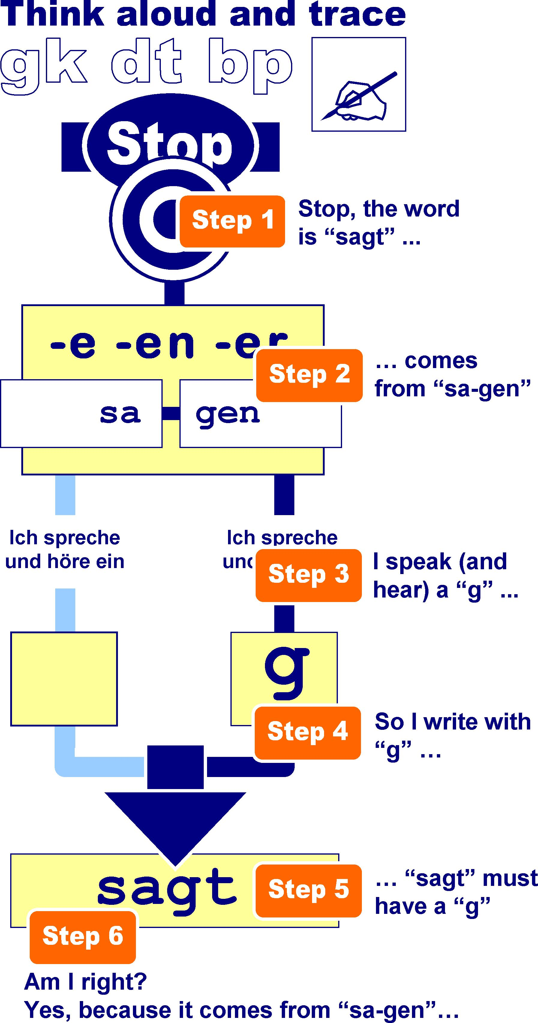
Figure 1.
Visualizing the application of spelling rules: An algorithmic flow chart

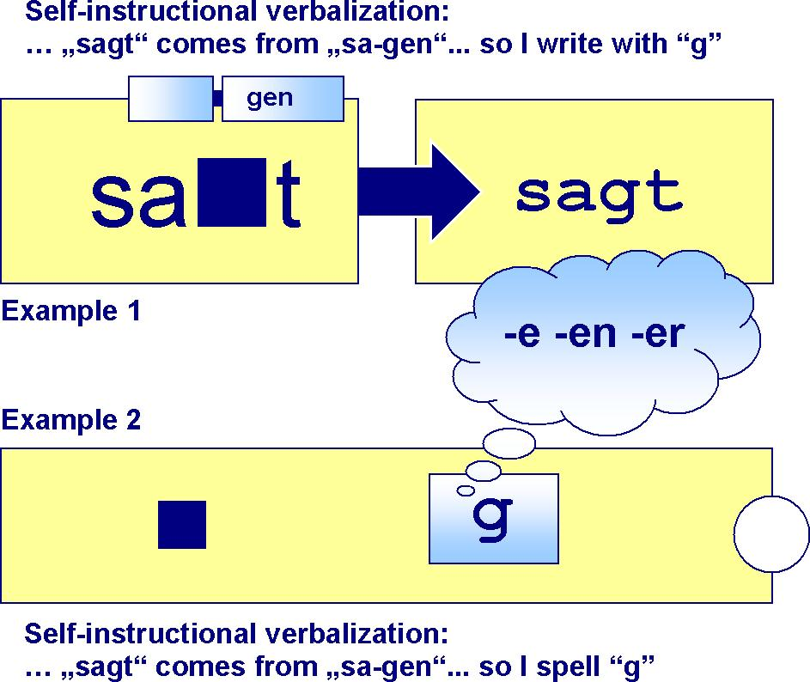
Figure 2.
Algorithmic and self-instructional task format: An example.

The results of evaluation studies in the field of systematic remedial training using visualizing and verbalizing methods could establish and prove significant performance gains on the part of four training cohorts whose intervention was completed after nearly two years in each case. In the meantime, the relevant analyses encompass an evaluation period of about eight years, and they are based on data compiled from an N = 109 dyslexic children and adolescents. Overall, it was possible to replicate and to gradually specify the results (Faber, 2006a). On the basis of relevant norm test scores, students trained over a longer period of time were able inter-individually and intra-individually to achieve highly significant gains in spelling performance. This result is maintained even when empirically taking into consideration regression-dependent performance increases prior to the treatment. At the same time, the students trained over a longer period of time were able to achieve, particularly in statistical and practical terms, significant improvements in the systematically trained spelling skill areas. To a slightly lesser but still significant extent, this also holds good for the spelling skill areas only incidentally considered. In this respect, strategic transfer effects must have taken place in the course of the training. The analyses could also establish significant improvements in the untrained spelling skill areas, which indicate the possibility of strategic transfer effects. The performance gains achieved in each case and cohort were not significantly correlated to gender, age, or regular school training conditions. Some first empirical evidence suggest that advances in the students’ performance, with the proviso of conceptually adequate approaches, procedures, and training conditions, can be achieved largely independent of any teacher effects. Furthermore, another study could prove significant gains in spelling performance for an experimental group of conceptually trained students after 40 hours. In comparison, a control group of dyslexic students without any spelling treatment could reach only marginal and statistically insignificant performance gains. These preliminary findings, however, have to be replicated again, by all means, with additional evaluation studies, and they have to be specified further with regard to a comprehensive series of conceptual and/or methodical questions of detail.

The analysis presented here is therefore supposed to once again control corresponding effects on the students’ spelling performances. In the case of the trained students, significant increases in performance in the spelling domains explicitly dealt with, and to a lesser degree, in the spelling domains implicitly considered, are expected. However, as such possible transfer effects are conceivable not only directly at the performance level but indirectly at the level of the students’ cognitive-motivational orientations, the analysis at hand is also supposed to clarify whether the systematic use of visualizing and verbalizing methods in remedial spelling training can bring about unspecific, yet relevant changes in certain cognitive-motivational variables, which, in turn, should favorably influence the course of the training in its entirety.

Therefore, as a relevant key criterion, the students’ spelling-specific test anxiety is supposed to be analyzed. Over time, students with severe spelling difficulties in particular form may develop negative competence and control cognitions. For this reason, they may perceive critical academic tasks as hardly manageable anymore, and thus as a threat (to their self-esteem). Consequently, they increasingly react with worry and emotionality cognitions in the spelling domain (Deffenbacher, 1980; Tobias, 1992), which can contribute to far-reaching impairments in their learning behavior and even to a stabilization of existing difficulties (Martin, 2002). In the light of all this, the subjectively predominant experience of lowered competence and control beliefs turns out to play a crucial role in the formation and habitualization of students’ test-anxious behavior patterns (Faber, 2007; Skaalvik, 1997). It could be expected from a systematic training of spelling skills that, owing to its structured and descriptive approach, it would ensure manageable learning settings and allow the targeted training of strategic spelling competencies with this prerequisite. This in turn, should result in more positive competence and control experiences, and eventually, a reduction of test anxiety reactions. In this regard, it should be particularly favorable if the training would present the critical learning object in a way that allows the students from the very start to approach the task with a high level of self-efficacy as possible. This may be achieved by individually tailored and understandable requirements as well as algorithmic and self-instructional task formats, stepwise split up decision routines, strategy-related outcome attributions, error-specific feedback techniques, as well as cooperative controlling and planning phases (Faber, 1989; Matthes, 1994; Naveh-Benjamin, 1991; Suppon, 2004; Van Oudenhoven, Siero, Veen & Siero, 1982; Zimmerman, 2000). The central assumption of such a skill development approach, which aims to achieve favorable changes in the students’ academic self-beliefs primarily via the development of their relevant competencies, appears to be sufficiently supported by empirical findings (O’Mara, Marsh, Craven & Debus, 2006). With regard to the reduction of spelling-specific test anxiety, the study by Berger (2001) also could deliver more precise insights and findings: After a 40-hour extracurricular training period with different cohorts, a significant reduction of spelling-specific test anxiety could be demonstrated. Owing to some methodological limitations, a careful interpretation of these findings is certainly recommended. In particular, the conceptual and instructional features of the various spelling treatment conditions have not been controlled. The results at least tend to confirm the possibility of reducing, over the long-term, the degree of test anxiety by continually advancing the students’ spelling competencies.

Therefore, the objective of the present analysis also was to examine this result in the context of uniform and consistent treatment conditions. With this as background, the following hypotheses seek to be clarified with the present evaluation study:
- After a training period of 80 hours the students’ orthographic performance appears to be significantly and substantially improved.
- In the process, the students’ mean error rates in four spelling skill areas explicitly worked on can be significantly and substantially reduced.
- In addition, significant and substantial error reductions in two spelling skill areas only implicitly worked on can be proven as well.
- And finally, the degree of students’ spelling-specific test anxiety can be significantly reduced.

Method

Subjects.

The training cohort comprised of 21 (twelve female and nine male) students from different grade levels (Table 1) who displayed normal cognitive abilities but had extensive orthographic difficulties, which, in most cases, had already been accumulated over a longer period of time. Descriptive spelling error analyses revealed clear evidence that the students’ orthographic difficulties could be traced back to a lack of rule-dependent competencies and strategies in most cases. Phonologically based misspellings were relatively rare overall (Figure 5).

Basic Training Conditions.

In all cases studied, the spelling training consisted of an individually compiled training sequence addressing different orthographic problems employing extensive visualized problem-solving algorithms and verbal self-instructions. This concerned spelling skill areas on explosive consonant graphemes (gk+), i-graphemes (ieih), as well as doubling of consonants (II+) and s-graphemes (ssß). In contrast, the incidentally considered spelling skill area capitalization (grokl) was only picked out as a central theme in cases of individual uncertainties or errors; the students were then supposed to show the critical front part of the word with the aid of a corresponding signal card and by thinking aloud (Faber, 2006a). Similarly, the incidentally considered skill area of phonologically based spelling (lautg) was picked out as a central theme as required, by also focusing the students’ attention on the critical work part with signal cards, getting them to think aloud about their spelling activities and then to write, control and correct the word (Nies & Belfiore, 2006). Often this concerned problems around the subjects of differentiating phoneme sounds and, in particular, structuring or segmenting words, the mastery of which, along with elaborate syllabification exercises – is already a central component part of the spelling strategies imparted in the training units dealing with explosive sounds and doubling of consonants. The intervention took place once a week for 60 minutes.

Measurements.
The students’ spelling achievement were first assessed in pre-test one six months prior, on an average, towards the start of the training, again in pre-test two directly at the beginning of the training, in subsequent follow-up tests after 40 hours into the training and in post-tests after 80 hours at the end of the training. According to grade level, this applied to all students with the WRT 3+ (Birkel, 1994), the DRT 4, and the DRT 5 (Grund, Haug & Naumann, 1994, 2003), the RST 4-7 (Grund, 2003), or with the HSP 5-9 (May, 1998). In pre-test two, it was possible to administer parallel forms of the instruments used in pre-test one. As follow-up and post-test measures, instruments with norms for the next higher grade level were administered in each case. Evaluation of test results was carried out quantitatively on the basis of grade-related T-score norms, as well as qualitatively using descriptive error categories. For this purpose, individual error rates were generated from an especially developed spelling word list (Faber, 2004). It promises, as to content and psychometry, more adequate results with regard to the students’ individual error ratio, as these are no longer directly dependent on the item pool of a certain spelling test. The internal consistency of the word list was α = .93 (Cronbach’s alpha). The sum total of list words correctly written correlated with the T-score norms of the spelling test procedures by r = .55 (p < .001) and turned out to be significantly influenced by the grade level (r = .66, p < .001) but not by gender (r = .02, p > .05). Owing to the previous course of the training, the corresponding error rates in the learning skill areas (explosive consonant graphemes, i-graphemes, doubling of consonants, s-graphemes, capitalization, and phonologically-based spelling) were used for the study at hand. As children and adolescents with severe spelling difficulties tend to commit several misspellings in one single word, the ordinary test sum scores cannot be expected to fully reflect the extent of their individual problems. Therefore, their individual error frequency in each word was used as an additional performance measure. With the test norm scores, the error frequency of all students at measurement time two correlated to r = -.72 (p < .001). Students’ spelling-specific worry and emotionality cognitions were measured by an especially developed scale at measurement time two (pre-test two) and measurement time four (post-test). It consisted of 13 four-point self-ratings. Sample item: Prior to class dictations, I am often worried to forget everything I have been practicing. As earlier studies have repeatedly shown that spelling-specific worry and emotionality cognitions could not be separated by factor analyses, an overall scale format has been devised (Faber, 2007). Students with high sum scores report a strong degree of spelling-specific test anxiety. In a longitudinal analysis of a sample of elementary fourth graders, the psychometric properties of this scale turned out well (Cronbach’s alpha α = .87 and .90, retest reliability over a period of 12 months r_{tt} = .74). At measurement time two (pre-test two) its sum scores appear not to be significantly correlated with students’ gender (r = .11, p > .05) and grade level (r = .25, p > .05).

Statistical analyses.
Since the error rates in some spelling skill areas at measurement time three seemed not to be normally distributed, all statistical analyses of differences between pre- and post-test measures were therefore driven by nonparametric methods (Siegel & Castellan, 1988). All evaluation hypotheses were tested one-tailored with an error ratio of p ≤ .05. For spelling-specific test norms and test anxiety scores which appeared to be normally distributed at each measurement time, standardized effect sizes could be calculated (Cohen, 1988).

Results
For the spelling test performances in this training cohort, no significant changes could be established between the two measurement times before the start of the spelling training (pre-test one through pre-test two). But from the beginning of the training (pre-test two) to its completion after 80 hours (post-test), the level of the students’ performance obviously increased on the basis of corresponding test norms (Figure 3).
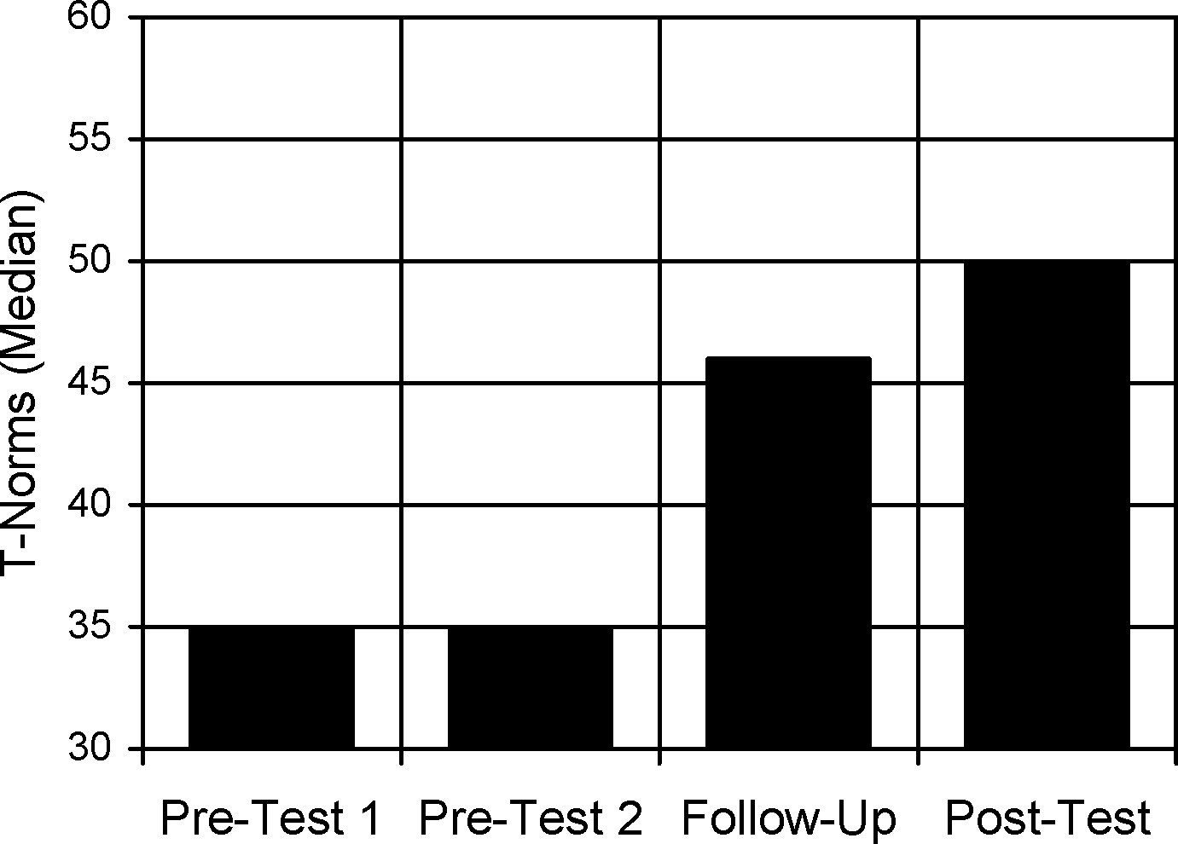
Figure 3.
Students’ spelling test performance before, during, and at the end of the training.

The results of a Friedman two-way analysis of variance (by ranks) show that the degree of changes in spelling test performance appears also to be statistically significant. With an effect size of d = 3.56, it turns out to be very strong. According to inter-individually referenced test norms, the increments in the T-scores amount, on an average, to 1.5 standard deviations – i.e., a significant approximation to the mean spelling test outcomes at the individually relevant grade-level has been achieved (Table 1).
Table 1
Spelling test norms (T), total error rates, and specific error rates (SPER) in pre-test two measures before the training, follow-up measures after 40 training hours and post-test measures after 80 training hours (ST = systematically trained, IC = incidentally trained spelling skill areas, SPWLIST = sum of correct items in spelling word list).
Pre-Test 2 Follow-Up Post-Test Chi² p
Spelling Test T 35 46 50 36.22 < .001
Total Error Rate 95 43 23 36.86 < .001
SPER gk+ ST 28 5 5 30.87 < .001
SPER ieih ST 22 4 2 23.41 < .001
SPER II+ ST 28 16 6 36.60 < .001
SPER ssß ST 50 33 7 22.22 < .001
SPER grokl IC 12 4 3 22.21 < .001
SPER lautg IC 10 3 0 23.46 < .001
SPWLIST Sum 28 43 56 22.00 < .001

In the course of this, the degree of students’ spelling improvement seems not to be dependent on their grade level (r_{s} = -.28, p > .05). Thus, their individual duration of school learning should not have played a critical role for the training effects. But their biological age, however, turns out to be significantly negatively correlated with the pre-post-test differences in the T-scores (r_{s} = -.38, p < .05). According to this, the older students in their particular grade level, as well as overage children and adolescents, tend to achieve only slight improvements. The pre- and post-test differences in students’ total error rates also present themselves analogous to the changes in the test norms: The students of the training cohort were able to reduce their relative error rate in a considerable manner. These changes achieved are highly significant in terms of the Friedman two-way variance analysis (Table 1).
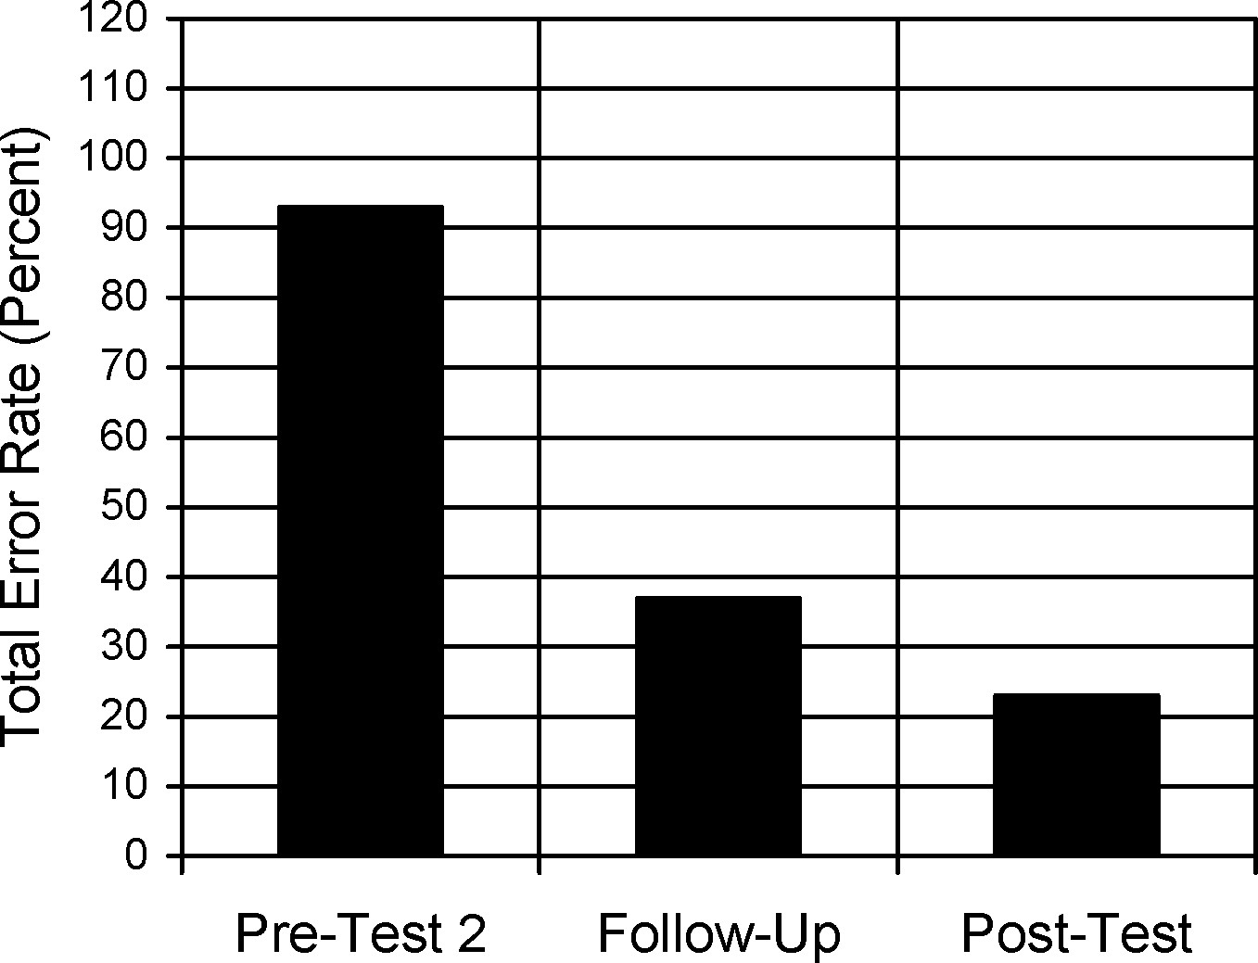

Figure 4.

Students’ total error rates in spelling tests before, during, and at the end of the training.

The results of the error-specific improvements draw a very similar picture (Figure 5). The students of the training cohort show substantial, statistically very significant and consistent error reductions in all the four spelling skill areas that they had systematically worked on over a period of 80 hours. Corresponding performance improvements can also be found in the spelling skill areas only incidentally thematized. Partially very high error rates at the outset decreased considerably after 40 hours, particularly in the systematically trained skill areas (Table 1).
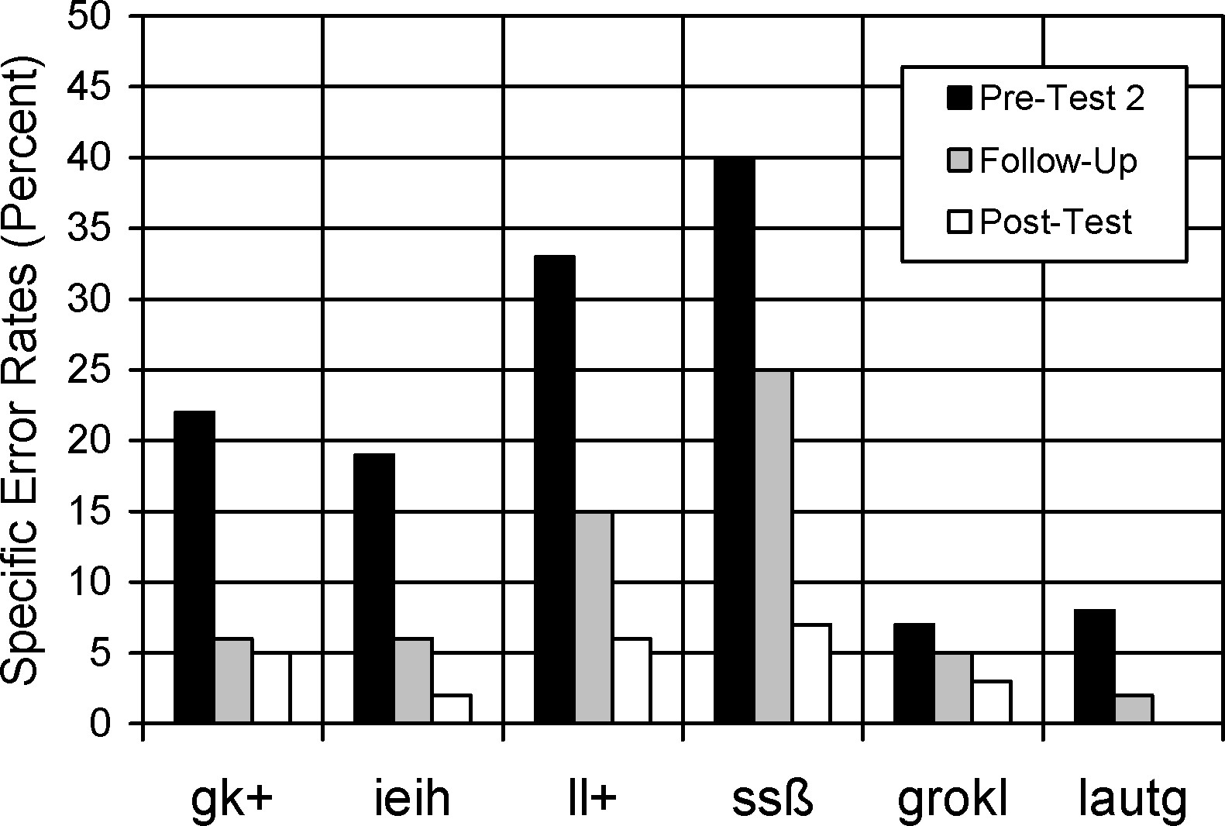

Figure 5.

Students’ error rates in various spelling skill areas before, during, and at the end of the training.

A notable reduction of worry and emotionality cognitions in the spelling domain can also be established (Figure 6). The average cumulative scores of the spelling-specific test anxiety scale have decreased, on an average, by 11 raw score points from measuring time two (prior to the beginning of the training) to measuring time four (after completion of the training). This difference turns out to be highly significant (Wilcoxon test: Z = -3.87, p < .001), and with a relative effect size of d = 1.93 it can be considered very momentous.
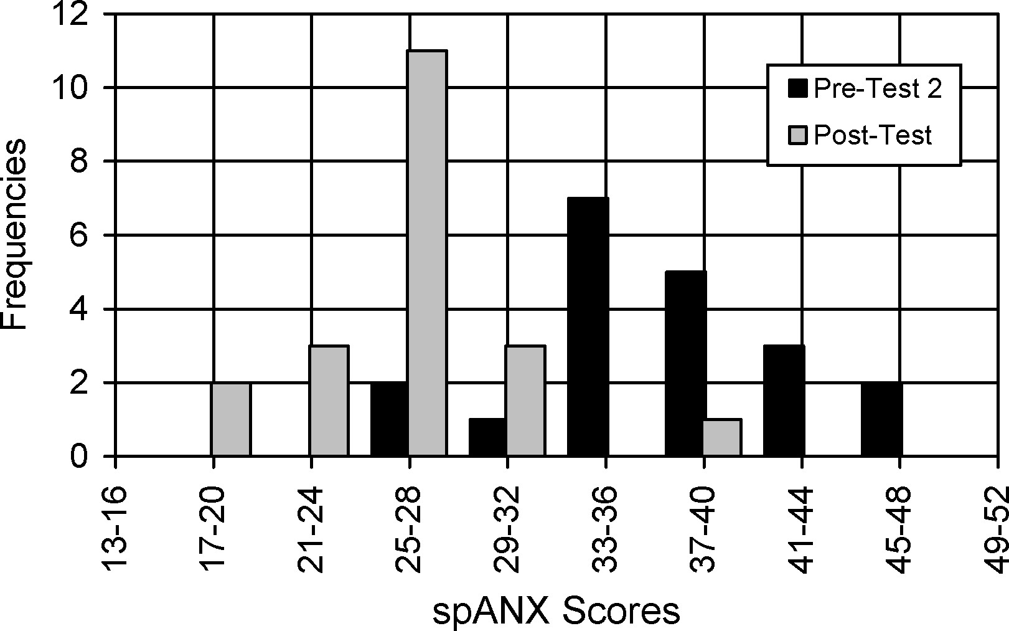

Figure 6.

Students’ sum scores on the spelling-specific test anxiety scale (spANX) before and at the end of the training.

Discussion
After a training time spanning of nearly two years (80 hours) the systematic use of algorithmic and self-instructional methods lead to consistent substantial performance gains in a cohort of 21 dyslexic children and adolescents, and thus once more confirms existing findings (Faber, 2006a,b). Overall, the level of the students’ orthographic competencies significantly increased, both in the systematically trained and the incidentally considered spelling skill areas. Again, this result points out the possibility of corresponding transfer effects. So a certain orthographic skill initially acquired in one error-specific training sequence can affect the learning in other error-specific training sequences. For example, the well-directed development of syllable segmentation in the skill area final sounds has a favorable effect on phonologically correct spelling altogether. However, more general strategic transfer effects are also conceivable. In this way, the solution behavior gradually acquired and sustained on a self-instructive basis in a specific spelling skill area might have stabilized with each additional skill area (quasi cumulative) and contributed, on a long-term basis, to significantly improved and controlled writing activities (Klauer, 2000).

Additional unspecific transfer effects may also have occurred on the level of the students’ academic self-beliefs. In agreement with the findings of Berger (2001), the students in this training cohort report an overall lower level of spelling-specific test anxiety at the end of the training. This decrease in test-anxious worry and emotionality cognitions might have crucially come about through the systematic scaffolding of competence development which has contributed to reinforced individual experiences of self-efficacy and thus ultimately to increased competence and control experiences over the long-term. Further orthographic and strategic learning processes might have benefited from that.

Under the aspect of the best entry into training (in the sense of a suitable initial concept), the possibility of such reciprocal effects supports the implementation of the skills development approach. In principle, this did not necessarily exclude possible treatment orientations from a self-enhancement perspective in an individual case. Thus, these results can support and complement the findings of rule- and/or strategy-oriented intervention approaches in the spelling domain (Graham, Harris & Chorzempa, 2002; Mäki, Vauras & Vainio, 2002; Nunes, Bryant & Olsson, 2003; Scheerer-Neumann, 1993; Tijms & Hoeks, 2005).

While the students’ performance increased overall up to the first measuring time, this trend was not continue on to the third measuring time and flattened observably. At first glance, an impression might therefore arise that the corresponding performance effects can be achieved, for the most part, in the first 40 hours of the treatment, and that insofar perhaps a shorter period of training should be sufficiently purposeful and rewarding. However, if one considers that the relevant test norms at the individual measuring times reflect the increased classroom demands in each case, then the students’ performance in the second half of the training did not stagnate at all (eg a test norm score of T = 50 at sixth grade should indicate an individually higher achievement level than at fifth grade).

In the face of this, the results have to be viewed in the context of the empirical approach selected. Evaluation studies in the natural training setting consider the given stipulations of the existing educational context and thus allow statements with respect to the everyday practical proof of an intervention. However, they were at the same time subject to the basic dilemma of being unable to completely and sufficiently control certain confounding variables in the sense of the experimental paradigm. Therefore, their results commonly claim a high degree of external validity, yet only limited internal validity. This restriction must, in any case, be applied to short-term interventions. For training effects examined on a long-term basis however, as they have been reported here, the question about relevant confounding variables gradually poses itself differently: the significance of possible treatment-independent variables that might have per se affected the registered improvements in the students’ orthographic performance seems to be relativized over the two-year evaluation period. As such, socioemotional nature of student-teacher-relations nor a mere learning time factor might have independently contributed to the substantial differences between pre- and post-test results. And the observed degree of gains in spelling performance could hardly be traced back to possible spontaneous regressions or unspecific development and/or maturation effects, either. Thus it should be possible to attribute the reported findings to the treatment conducted at least in the sense of a global and local (and thus, always preliminary) evaluation. The validity of their results extends, for a start, to comparable extracurricular learning settings with dyslexic children and adolescents.

A replication of these results in other educational settings and with other student samples would be a desirable next step in the evaluation process. In this sense, evaluation studies conducted in the natural setting can yield important clues for an evidence-based evaluation of spelling-related interventions. They should not be contrastively related to other methodical approaches but rather understood as a sensible and indispensable part of an optionally more embracive evaluation concept. Viewed from that perspective, the findings of the evaluation studies accompanying the remedial practice might constitute a useful contribution toward more evidence-based treatment decisions in relevant training settings.

The findings of these studies, however, have to be specified further with regard to additional conceptual and practical issues. So it still seems to be worth analyzing, whether the systematic use of algorithmic and self-instructional tasks would generate differential effects for students with behavioral and/or attention deficit problems. Such studies should also plumb the possible limitations of algorithmic graphs and verbal self-instructions for certain sub samples of students (eg whether students with severe speech problems could be enabled to use verbal self-instructions, and to which extent they would need additional assistance or modified training conditions).

Furthermore, it might be interesting to explore whether the visualizing and verbalizing methods can be successfully transferred to rule-specific spelling trainings in other regular orthographies (Lyytinen, Aro & Holopainen, 2004; Mäki, Vauras & Vainio, 2002; Tijms & Hoeks, 2005), and whether they can be also integrated into other training approaches more phonologically oriented (Faber, 2006a; Lovett, Lacerenza, Borden, Frijters, Steinbach & De Palma, 2000; Mannhaupt, 1997).

References
Arievitch, I.M. & Haenen, J.P.P. (2005). Connecting sociocultural theory and educational practice: Galperin’s approach. Educational Psychologist, 40, 155-165.
Bailet, L.L. (1990). Spelling rule usage among students with learning disabilities and normally achieving students. Journal of Learning Disabilities, 23, 121-128.
Berger, C. (2001). Reduzierung von psychischen Störungen bei lese-rechtschreibschwachen Kindern durch Legasthenietherapie. Leopold-Franzens-Universität Innsbruck, Naturwissenschaftliche Fakultät (Studienrichtung Psychologie): unveröffentlichte Dissertation.
Birkel, P. (1994). Weingartener Grundwortschatz Rechtschreib-Test für dritte und vierte Klassen WRT 3+. Göttingen: Hogrefe.
Bodrova, E. & Leong, D.J. (1998). Scaffolding emergent writing in the zone of proximal development. Literacy Teaching and Learning, 3(2), 1-18.
Borkowski, J.G., Johnston, M.B. & Reid, M.K. (1987). Metacognition, motivation, and controlled performance. In S.J. Ceci (Ed.), Handbook of cognitive, social, and neuropsychological aspects of learning disabilities (vol. 2, pp. 147-173). Hillsdale: Erlbaum.
Carlisle, J. (1987). The use of morphological knowledge in spelling derived forms by LD and normal students. Annals of Dyslexia, 37, 90-108.
Carroll, J.M., Maughan, B., Goodman, R. & Meltzer, H. (2005). Literacy difficulties and psychiatric disorders: evidence for comorbidity. Journal of Child Psychology and Psychiatry, 46, 524-532.
Clarke, J.H. (1991). Using visual organizers to focus on thinking. Journal of Reading, 34, 526-534.
Cohen, J. (1988). Statistical power analysis for the behavioral sciences (2nd ed.). Hillsdale: Erlbaum.
Darch, C., Kim, S., Johnson, S. & James, H. (2000). The strategic spelling skills of students with learning disabilities: The results of two studies. Journal of Instructional Psychology, 27, 15-26.
Deffenbacher, J.L. (1980). Worry and emotionality in test anxiety. In I.G. Sarason (Ed.), Test anxiety: Theory, research and applications (pp. 111-128). Hillsdale: Erlbaum.
Ellis, E.S., Deshler, D.D., Lens, B.K., Schumaker, J.B. & Clark, F.L. (1991). An instructional model for teaching learning strategies. Focus on Exceptional Children, 23(6), 1-24.
Englert, C.S. & Mariage, T. (2003). The sociocultural model in special education interventions: Apprenticing students in higher-order thinking. In H.L. Swanson, K.R. Harris & S. Graham (Eds.), Handbook of learning disabilities (pp. 450-467). New York: Guilford Press.
Englert, C.S., Raphael, T.E., Anderson, L.M., Anthony, H.M. & Stevens, D.D. (1991). Making strategies and self-talk visible: Writing instruction in regular and special education classrooms. American Educational Research Journal, 28, 337-372.
Faber, G. (1989). Kurzzeiteffekte schülerorientierender Leistungsrückmeldungen im Rechtschreiben. Empirische Pädagogik, 3, 161-176.
Faber, G. (2004). Lernhilfen. Kopiervorlagen zur systematischen Rechtschreibförderung: 45 kommentierte Arbeitsblätter auf CD-ROM (pdf-Datei). Goslar: Arbeitsstelle für pädagogische Entwicklung und Förderung.
Faber, G. (2006a). The systematic use of visualizing and verbalizing methods in remedial spelling training: Conceptual issues, practical applications and empirical findings. In C.B. Hayes (Ed.), Dyslexia in children: New research (pp. 1-45). New York: Nova Science Publishers.
Faber, G. (2006b). The effects of visualizing and verbalizing methods in remedial spelling training: Individual changes in dyslexic students’ spelling test performance. International Journal of Special Education, 21(3), 85-95.
Faber, G. (2007). Academic self-beliefs in the spelling domain: Empirical research findings on elementary school students’ subject-specific self-concept, causal attributions, and test anxiety. In E.M. Vargios (Ed.), Educational psychology research focus (pp. 65-120). New York: Nova Science Publishers.
Gal’perin, P.Ya. (1989a). Mental actions as a basis for the formation of thoughts and images. Soviet Psychology, 27(3), 45-64.
Gal’perin, P.Ya. (1989b). Organization of mental activity and the effectiveness of learning. Soviet Psychology, 27(3), 65-82.
Graham, S., Harris, K.R. & Chorzempa, B.F. (2002). Contribution of spelling instruction to the spelling, writing, and reading of poor spellers. Journal of Educational Psychology, 94, 669-686.
Grund, M. (2003). RST 4-7. Rechtschreibtest für 4.-7. Klassen. Baden-Baden: Computer & Lernen.
Grund, M., Haug, G. & Naumann, C.L. (1994). DRT 4. Diagnostischer Rechtschreibtest für 4. Klassen. Weinheim: Beltz.
Grund, M., Haug, G. & Naumann, C.L. (2003). DRT 5. Diagnostischer Rechtschreibtest für 5. Klassen (2. Aufl.). Göttingen: Beltz Test.
Harris, K.R. (1990). Developing self-regulated learners: The role of private speech and self-instructions. Educational Psychologist, 25, 35-49.
Hogan, K. & Pressley, M. (1997). Becoming a scaffolder of students’ learning. In K. Hogan & M. Pressley (Eds), Scaffolding student learning. Instructional approaches and issues (pp. 185-191). Cambridge: Brookline Books.
Klauer, K.J. (2000). Das Huckepack-Theorem asymmetrischen Strategietransfers. Ein Beitrag zur Trainings- und Transfertheorie. Zeitschrift für Entwicklungspsychologie und Pädagogische Psychologie, 32, 153-165.
Klicpera, C. & Schabmann, A. (1993). Do German-speaking children have a chance to overcome reading and spelling difficulties? A longitudinal survey from the second until the eighth grade. European Journal of Psychology of Education, 8, 307-323.
Larkin, M.J. & Ellis, E.S. (2004). Strategic academic interventions for adolescents with learning disabilities. In B.Y.L. Wong (Ed.), Learning about learning disabilities (3rd ed., pp. 375-414). San Diego: Elsevier.
Lovett, M.W., Lacerenza, L., Borden, S.L., Frijters, J.C., Steinbach, K.A. & De Palma, M. (2000). Components of effective remediation for developmental reading disabilities: Combining phonological and strategy-based instruction to improve outcomes. Journal of Educational Psychology, 92, 263-283.
Lyytinen, H., Aro, M. & Holopainen, L. (2004). Dyslexia in highly orthographically regular Finnish. In I. Smythe, J. Everatt & R. Salter (Eds.), International book of dyslexia. A cross-language comparison and practice guide (pp. 81-91). Chichester: Wiley.
Mäki, H.S., Vauras, M.M.S. & Vainio, S. (2002). Reflective spelling strategies for elementary school students with severe writing difficulties: A case study. Learning Disability Quarterly, 25, 189-207.
Mannhaupt, G. (1997). Teaching monitoring strategies in early literacy acquisition. In J.H.M. Hamers & M. T. Overtoom (Eds.), Teaching thinking in Europe (pp. 213-218). Utrecht: Sardes.
Martin, A.J. (2002). The lethal cocktail: Low self-belief, low control, and high fear of failure. Australian Journal of Guidance and Counselling, 12, 74-85.
Matthes, G. (1994). Vermittlung positiver Lernerfahrungen bei extremen Rechtschreibschwierigkeiten. Heilpädagogische Forschung, 20, 56-65.
May, P. (1998). HSP 5-9. Hamburger Schreibprobe für die Klassen 5 bis 9. Hamburg: Verlag für pädagogische Medien.
Miller, G.E. & Brewster, M.E. (1992). Developing self-sufficient learners in reading and mathematics through self-instructional training. In M. Pressley, K.R. Harris & J.T. Guthrie (Eds.), Promoting academic competence and literacy in schools (pp. 169-222). San Diego: Academic Press.
Naveh-Benjamin, M. (1991). A comparison of training programs intended for different types of test-anxious students: Further support for an information-processing model. Journal of Educational Psychology, 83, 134-139.
Nies, K.A. & Belfiore, P.J. (2006). Enhancing spelling performance in students with learning disabilities. Journal of Behavioral Education, 15, 163-170.
Nunes, T., Bryant, P. & Olsson, J. (2003). Learning morphological and phonological spelling rules: An intervention study. Scientific Studies of Reading, 7, 289-307.
O’Mara, A.J., Marsh, H.W., Craven, R.G. & Debus, R.L. (2006). Do self-concept interventions make a difference? A synergistic blend of construct validation and meta-analysis. Educational Psychologist, 41, 181-206.
Palincsar, A.S. & Brown, A.L. (1984). Reciprocal teaching of comprehension-fostering and comprehension-monitoring activities. Instructional Science, 1, 117-175.
Pressley, M. (1986). The relevance of the good strategy user model to the teaching of mathematics. Educational Psychologist, 21, 139-161.
Ridsdale, J. (2004). Dyslexia and self-esteem. In M. Turner & J. Rack (Eds.), The study of dyslexia (pp. 249-279). New York: Kluwer Academic Publishers.
Scheerer-Neumann, G. (1993). Interventions in developmental reading and spelling disorders. In H. Grimm & H. Skowronek (Eds.), Language acquisition problems and reading disorders: Aspects of diagnosis and intervention (pp. 319-352). Berlin: de Gruyter.
Schunk, D.H. (1986). Verbalization and children’s self-regulated learning. Contemporary Educational Psychology, 11, 347-369.
Schunk, D.H. & Rice, J.M. (1987). Enhancing comprehension skill and self-efficacy with strategy value information. Journal of Reading Behavior, 19, 285-302.
Schunk, D.H. & Zimmerman, B.J. (2007). Influencing children’s self-efficacy and self-regulation of reading and writing through modeling. Reading and Writing Quarterly, 23, 7-25.
Scott, K.S. (1999). Cognitive instructional strategies. In W.N. Bender (Ed.), Professional issues in learning disabilities. Practical strategies and relevant research findings (pp. 55-82). Austin: Pro-Ed.
Siegel, S. & Castellan, N.J. (1988). Nonparametric statistics for the behavioral sciences (2nd ed.). New York: McGraw-Hill.
Skaalvik, E.M. (1997). Self-enhancing and self-defeating ego orientation: Relations with task and avoidance orientations, achievement, self-perceptions, and anxiety. Journal of Educational Psychology, 89, 71-81.
Steffler, D.J. (2004). An investigation of grade 5 children’s knowledge of the doubling rule in spelling. Journal of Research in Reading, 27, 248-264.
Suppon, V. (2004). Implementing strategies to assist test-anxious students. Journal of Instructional Psychology, 31, 292-296.
Swanson, H.L. & Deshler, D. (2003). Instructing adolescents with learning disabilities: Converting a meta-analysis into practice. Journal of Learning Disabilities, 36, 124-134.
Tijms, J. & Hoeks, J. (2005). A computerized treatment of dyslexia: Benefits from treating lexico-phonological processing problems. Dyslexia, 11, 22-40.
Tobias, S. (1992). The impact of test anxiety on cognition in school learning. In K.A. Hagtvet & T.B. Johnson (Eds.), Advances in test anxiety research (vol. 7, pp. 18-31). Lisse: Swets & Zeitlinger.
Van Oudenhoven, J.P., Siero, F., Veen, P. & Siero, S. (1982). Effects of positive feedback on self-evaluations and spelling achievement in a real educational setting. European Journal of Social Psychology, 12, 321-325.
Zimmerman, B.J. (2000). Attaining self-regulation: A social-cognitive perspective. In M. Boekaerts, P.R. Pintrich & M. Zeidner (Eds.), Handbook of self-regulation (pp. 13-39). San Diego: Academic Press.

