PLAY THERAPY-REACHING THE CHILD WITH AUTISM

Natasha Parker

and

Patrick O’Brien

University of Southern Queensland

This paper proposes that play therapy can be an appropriate intervention in working with children with autism in schools especially when working with children who have little in the way of social skills and poor communication. It proposes that play therapy may offer school counsellors opportunities that the more cognitive therapies do not. Through the use of case study research, the paper discusses and illustrates an intervention with a seven year old boy with autism across 12 sessions of sandplay in a school in Queensland, Australia.
This paper draws our attention to the legitimate use of case study research in counselling. It also advocates for the use of sandplay, (an expressive therapy intervention) with a child who is autistic and who at first plays chaotically. This paper draws the counsellor’s attention to the developmental stages that will follow when the child feels secure enough to proceed. The lack of well researched longitudinal quantitative or mixed method research in play therapy is also noted.

Introduction
In the special education setting, it is vital to have a repertoire of interventions to best meet the needs of all children. Geldard and Geldard (1997) stated that the skilled counsellor is one who can take advantage of opportunities that occur through play and intervenes in a purposeful way. According to some researchers, autism is an increasing disability area within our schools (Mesibov, Adams, & Klinger, 1997) and recent estimates of the prevalence of autism are higher than ever before. However, there is little research on the most appropriate techniques to use with students with autism and this paper aims to explore how play therapy can be seen to be effective through the use of a single case study.

Case studies have been used extensively in the social science because they can provide the scientific rigour and the type of detail that practitioners require in implementing strategies effectively (Hartley, 2004).Case studies are particularly suited to research that seeks to explain the processes that individuals are involved in during the research period. They are usually undertaken over time and in this case the subject was observed in the counselling process for one hour a week over a twelve week period. During this time independent measures of behaviours were being recorded by his class teacher who had not experienced the behaviours that are often associated with autism.

Schools in Queensland are still undergoing a push for inclusive education with the implementation of the Inclusive Education Statement – 2005. As more students with special needs occupy caseloads, it is important for practitioners to obtain appropriate communication strategies for students with special needs. Mesibov, Adams, and Klinger (1997, p. 65), acknowledge that students on the autism spectrum are renowned for having difficulties with communication, stating that, one of the most striking characteristics of autism is the uneven profile of language and cognitive abilities. This paper looks at ways that school counsellors could work with students on the autism spectrum who are experiencing communication difficulties. Much of the current research in school counselling is about mainstream students using the traditional methods of counselling which involves using verbal interactions (O’Brien & Burnett, 2000) and it is the lack of these skills that often differentiates the child on the autistic spectrum.

In recent times, the mental health of students with special needs has attracted considerable attention (Rose, Howley, Fergussen, & Jament, 2009). However, a hurdle has been experienced in distinguishing whether displayed behaviours are a mental health issue or part of a disability diagnosis. The challenge of defining and diagnosing a mental health issue in a student who has a disability is often difficult. According to Rose, et al (2009) some studies have indicated a high occurrence of depression and anxiety among people with autism and Asperger syndrome. Finding an accurate assessment tool to assist in the attribution of behaviour would be beneficial in the area of treating students with special needs who also have mental health issues. One of the ways to assess whether children with special needs have mental health issues is by observing changes in behaviour such as disturbances in sleep, changes in appetite and energy level (Rose, et al.).

Given that students with special needs are often identified and referred to psychologists and psychiatrists for mental health issues but no diagnosis is forthcoming, a challenge arises in how to successfully communicate with and work with students in schools who often have limited language and deficits in overall communication. This paper will suggest that one effective way could be the use of play therapy and will demonstrate through a case study method and outcomes, how a therapeutic intervention with one child resulted in dramatic changes to their play and to their school and classroom behaviour.

A literature review: play therapy and therapy with children with autism
Landreth, Ray, and Bratton (2009) stated that school counsellors are gravitating towards play therapy because children express themselves more naturally through play. It is a way that the professionals can enter into the child’s world.

Other research shows that play has been linked to many areas of development including intellectual, social and emotional growth (Hughes, 1999; Rubin & Coplan, 1998; Sullivan, 1953 in Holmes & Willoughby, 2005). Children communicate best through play and it allows the child to problem solve, express feelings, and use toys to transfer fears, anxieties, fantasies, and guilt to objects rather than people.

Implementing play therapy successfully requires the school practitioner to be specifically trained in that area. There are techniques to use and theoretical models to follow. An extensive review of the research related to the use of play as a therapy indicates that a client centred approach is considered to be foundational to most introductory processes (Allen, Folger, & Pehrsson, 2004). Another therapy that has been heavily researched in recent years is the use of cognitive behavioural play therapy. The use of Cognitive Behaviour Therapy (CBT) has been verified by many research experiments but it has been argued as early as 1990 by Campbell (1990) that CBT is beyond the grasp of most preschoolers and remarked upon again by Knell (1998, p. 29). One could therefore expect that children with autism will also have difficulty with cognitive behavior therapy because of the nature of the condition. Autism occurs along a spectrum and no two students with Autism are the same. Autism as defined by Landa (2007, p. 16) is a neurodevelopmental disorder defined by impairments in social and communication development, accompanied by stereotyped patterns of behaviour and interests.

Autism is usually diagnosed when three common characteristic are present. These fall into a triad of deficits in the areas of communication, socialisation and interests or activities (Heflin & Aliamo, 2007). Communication and social interaction skills are usually needed for effective traditional verbal counselling sessions.

Given that children with autism usually have a deficit in communication, traditional cognitive counselling methods may not be appropriate. There has been some research in this area beginning with Axline (1947), but a review of the literature reveals that there there is currently no published quantitative research which looks specifically at children on the autism spectrum and a therapeutic intervention involving play to improve emotional well-being. A problem with the research so far has been the debate around whether children with autism do play effectively. Much of the existing research has been conducted in laboratory settings, not mainstream school settings (Landa, 2007) and Landa has emphasised that young children with autism often have difficulty in social play and with developing the appropriate word symbols into language. Landa (2007 p. 19) suggest that, …through early intervention, communication and social development may be improved. Considering that traditional counselling requires the ability of the child to communicate with a counsellor, play and in particular sandplay may be a more appropriate medium to express their thoughts and feelings, and in a safe place develop problem solving skills. Mastrangelo (2009, p. 35) says children with ASD do exhibit play, although the type and quality of their play varies from those children who appear to be following a typical developmental trajectory. This research also goes on to say that given children with ASD usually have strengths in the visual domain, using visually based approaches will generally yield excellent play skills. Through play it is suggested that children with autism can express their needs, share attention with another person while both people are paying attention to the same object. Children also learn strategies for solving problems through symbolic play. Symbolic play seems to be the most useful play therapy approach as children use language to make and manipulate stories related to their lives, make inferences about causes and predictions about future events and express mental experiences.

The main benefit of symbolic play is best described by Sigman and Mundy, (1987, p. 44) who state that, the autistic child may not understand other people because people are more difficult to fathom than non-social objects, which operate by simpler rules. It may therefore be easier for a child with autism to use objects to communicate than communicate verbally with another person. It is particularly important that the use of play in the counselling situation utilises the visual strengths of children with autism and involves the use of objects to which some symbolic meaning can be attached.

A particularly useful form of play therapy that involves high sensory stimulation is sandplay. Sensory stimulation is experienced through shaping and moulding the sand and through the selection and placement of a variety of objects into the Sandtray. The senses are further stimulated by soft soothing music being played in the background. Sandplay is one of the Expressive therapies (Pearson & Wilson, 2009). It has also been linked to Howard Gardner’s theory of Multiple Intelligence (O’Brien & Burnett, 2000). Given that students who have ASD have difficulties within the communication area, sand play (according to both Pearson and Wilson & O’Brien and Burnett) may provide an additional dimension to the counsellor’s work by forming a highly stimulating visual bridge between verbal and expressive therapies and that this is increased through the use of the multiple intelligences throughout the play session.

Another advantage of using sandplay therapy within a counselling session is that students are likely to reveal inner thoughts and feelings through projection of thoughts and feelings onto the toys and symbols that they choose (Landreth, 2009). The type of symbols selected for play therapy can be significant. Toys for students with ASD should be chosen carefully to make sure they are suitable. According to Holmes & Willougby (2005. p. 156), it is common for children with Autism to choose play objects based on the sensory stimulation they provide and as such may lead to overstimulation with some children.

Sandplay uses a form of symbolic play and the process of sandplay is defined as, a psychotherapeutic technique that enables clients to arrange miniature figures in a sandbox or sand tray to create a sand world corresponding to various dimension of his/her social reality (Dale & Wagner, 2003 as cited in Goss & Campbell, 2004. p. 211). There are discrepancies within the sandplay research around how and whether or not therapists should interpret the sand pictures. This is widely debated and interpretative techniques are currently lacking the empirical support provided by scientific validation (Goss & Campbell, 2009). More studies need to be conducted around this aspect sandplay. Another positive factor about the use of sand play is that it was reported by Pearson (2003) as being the technique most favoured by child clients in his study of Queensland Guidance Officers.

As with any play based intervention there may be some negative views such as Siehl (2001) (cited in Goss & Campbell, 2004. p. 216) who stated that the term play is often associated with time wasting and is frequently considered to be inappropriate in a school setting where children should be learning and working. Training in sandplay is also another factor to consider and training opportunities are fairly limited and expensive within Australia (Goss & Campbell, 2004). However, the biggest challenge is the lack of scientific research available to support its effectiveness in schools.

A Case Study Methodology
The methodology selected was that of case study research. This methodology was selected because of the acceptance of the work of Flyvbjerg (2006, p. 219) who argued that case study research suffered from five basic misunderstandings which were largely undeserved. These five misunderstandings were that theoretical knowledge can be more valuable than practical knowledge, and that one cannot generalize from a single case, therefore, the single-case study cannot contribute to scientific development. Another misunderstanding, he posited was that the case study can be most useful for generating hypotheses, whereas other methods are more suitable for hypotheses testing and theory building. The belief that case studies contain a bias toward verification also limits their acceptance as a research methodology. The fifth assumption is that it often difficult to summarize specific case studies. Flyvbjerg also argued (p. 222) In a teaching situation, well-chosen case studies can help the student achieve competence, whereas context-independent facts and rules will bring the student just to the beginner’s level. It is in the achievement of competence by counselling practitioners who read this article that the authors are most interested.

The subject for this case study was selected by use of information-oriented sampling, as opposed to random sampling as the child attended a school visited by one of the researchers in a country town in regional Queensland and the data obtained was found to be rich. Twelve counselling sessions of 45 minutes per session were conducted with a seven year old boy diagnosed as being on the autistic spectrum. The boy had been referred to the guidance officer because of the number of incidents involving classroom tantrums, hitting and biting of other children in the playground and refusal to participate in classroom activities. These behaviours were targeted in discussion with the classroom teacher and data collected on a daily basis over the twelve weeks. Previous attempts to shape his behaviour had been made though referral and discussion with support teachers on the school’s social justice and support committee and through the individual intervention of the school’s special needs teachers, the guidance officer, and collaborative work with the parents and the visiting teacher (autistic spectrum disorder).

Pearson and Wilson (2001, p.51) suggest that Often chaotic pictures or stories appear. In children’s plays battles are common. Death, opposition, threats, isolation, danger and relationships are some themes in the early stages and …in discussion with the counsellor the client may make links between the story and their current life problems. The sandplay scene may suggest helpful strategies. What is interesting in this case study is how the stages of the sandplay mirrored the stages suggested by Pearson and Wilson and the data collected shows a noticeable reduction in targeted behaviours in both the classroom and the playground?

Results
During the research period the client’s play is seen to move through four stages common in sandplay therapy, which have been labelled chaos, battles, and the rise of a hero figure and finally play with an apparently secondary or deeper meaning. At the same time significant differences in his classroom and playground behaviour were noted by his teachers and were evident in school behaviour records.

In the first three sessions, the boy was encouraged to play in a Sandtray. The photograph (Figure 1) depicts what was common in his play: disorganisation, chaos and a lack of order.
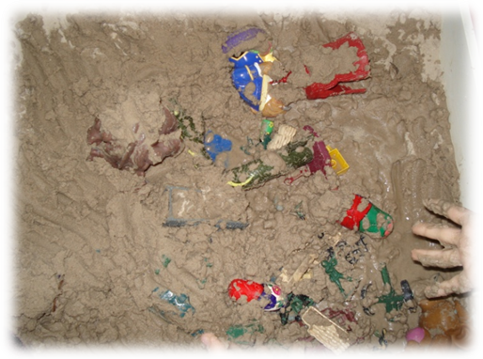
Figure1. Early chaotic play
At first the client was reluctant to enter the room but having been introduced to the sand and the symbols and having created the scene of chaos, he became reluctant to leave as if not knowing how to change what he had created or able to find alternatives to the scene that he had created. Each session the child was asked Is there anything you would like to change any extra symbols you would like to include or any symbols you would like remove from the tray? It was at the end of the third session that the client actually made a change by using a second tray into which he simply placed more objects. To overcome the reluctance to leave the therapist decided to set a time limit showing the client what the clock would look like when it was time to leave and introduced prompts that the client was approaching the time to conclude for the day.

In Session 4 the client experimented with a number of symbols, did not ask for water and selected common symbols from a range of symbols that depicted television characters such as Gumby and some superheros. By the fifth session some order was evident in the play and the young boy began regular play each week that involved battles sometimes between animals, sometimes animals against forest clearers, and sometimes between characters trying to storm a castle. The play usually started as disorganised affairs and usually resulted in a chaotic victory by one side but gradually by week seven evolved into more of a strategic set of manoeuvres that showed a clear strategy and a clear victor.
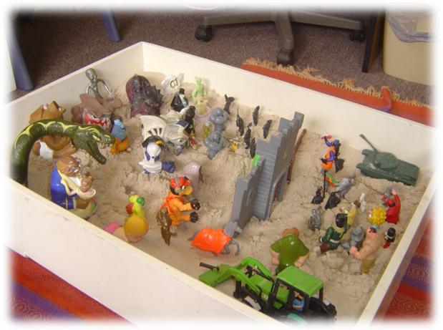
Figure 2. Battles
The seventh session saw the emergence of hero figures in the battle lines. Around this time teachers began to report that he seemed much happier in class and was cooperating with the teacher but still had problems with other children.
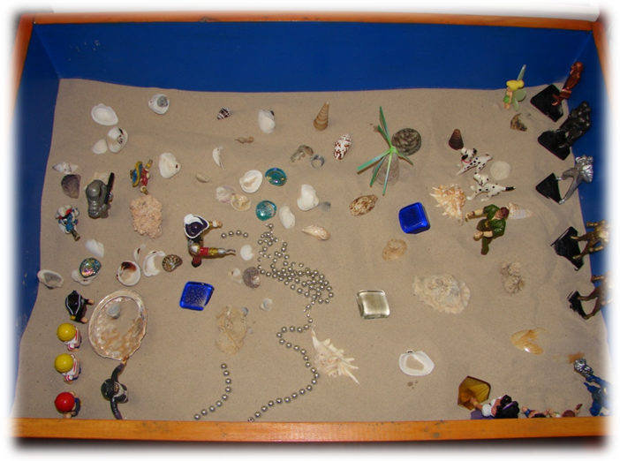
Figures 3 & 4. The rise of the hero figure
In these photographs one can see Spiderman but in the second box notice the beginnings of play with Peter Pan, with whom the young boy seemed to identify heavily. The client used Peter Pan each week for the next few weeks. Note how organised the play is now as his world seems to reflect an abundance of beauty and riches rather than chaos and disorganisation. His class teacher said that his behaviour was now much better and he seemed a little too friendly with another boy in the class. She said that both classroom outbursts and playground incidents had decreased dramatically.

In the last pictures we see two plays that seem to have a deeper meaning. Tray 5 involved a story much like Noah and the Arc where all the animals filed into the ship to start a new life. The client told the therapist that the animals were leaving behind the way that they did things in the past and were going to a new world. Figure 6 depicted the new world which was a place of great beauty and full of treasure. These plays could be a symbolic representations of the client’s new changing view of his world as his personal view of the world became more organised he may have felt more in control, more able to manipulate the symbols and the sand to achieve a result with which he was satisfied.
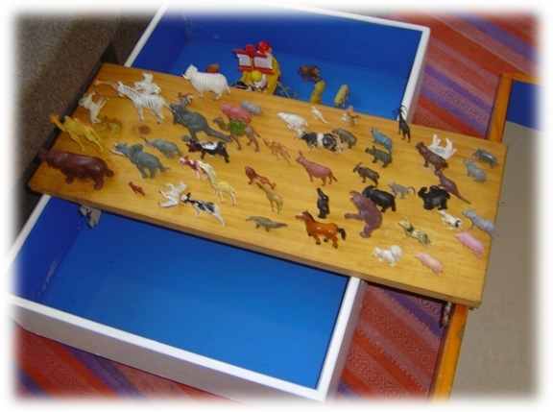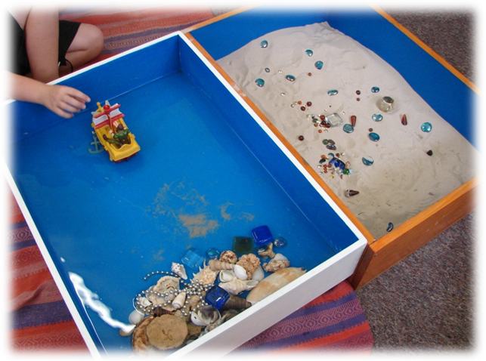
Figures 5 & 6. Organised play with deeper meaning.
The graph below has been constructed from data held by the class teacher and from the schools lunchtime detention program. The X axis represents the 4 stages noticed in the play. The Y axis represents the average number of negative behaviours per week. It can be seen that over the research period there is a decline in all behaviours.
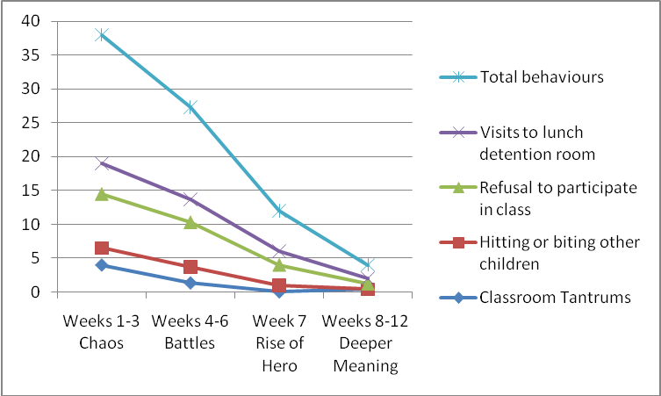

Figure 7: Average weekly behaviours recorded over the research period
Visits to the school lunchtime detention centre may have been influenced by other behaviours than those targeted in the research period and may have been over one or two days depending on the severity of the behaviour that resulted in detention. Data has been presented in table 1, as weeks 1-3, weeks 4-6, week 7 and weeks 8-12 as the stage changes were noticed in these periods the photographs were taken in these periods.

Discussion
Research to date has never indicated that play therapy is ineffective, rather that its effectiveness is difficult to scientifically validate. The literature over many years abounds with case studies where changes in behaviour are noted as a result of an intervention using play therapy. Literature reviewed by the author included the use of play with children who had a history of reading problems (Bills, 1950; Fisher, 1953), learning disabilities (Axline, 1949; Guerney, 1979, 1983; Landreth, Jacquot & Allen, 1969) speech difficulties (Axline & Rogers, 1945; Dupent, Landsmen & Valentine, 1953), mental disabilities (Bernhardt & Mackler, 1975; Li, 1981; Mundy, 1957; Newcomer & Morrison 1974; Sywulak, 1984), separation anxiety (Milos & Reiss, 1982), child abuse (In & McDermott, 1976), dysfunctional families (Eaker, 1986) and with traumatised children (Kuhli, 1979). These studies all demonstrated the effectiveness of play therapy. Not one mentioned its use with children with autism. The exception over the years has been the novel Dibs: In search of self by Virginia Axline (1971) but this was never presented as a scientific study.

It would seem that in sandplay the child at first perceives their world to be chaotic and plays in a chaotic way. As children change their view of the world through experimentation in play within the supportive non judgemental counselling environment, they learn to become more organised and in doing this begin to see the world in a new and different way. In the use of the figurines children begin to experiment with battles and often a favoured character, a hero is seen to arise. This hero moves from one situation to another as the child experiments with different stories constructed in the sand. The child consistently uses the hero’s strengths and talents in these different contexts in what has become a predictable world controlled by the child within the sandtray. A skilful counsellor is able to assist the child to find these same strengths and talents within themselves and then take these skills into the school and classroom environment.

The literature around autism and educational intervention promotes the use of developmentally appropriate strategies (Smith, Polloway, Patton & Dowdy, 2006). Play as an intervention is developmentally appropriate for children. Intervention strategies for children with autism have been many and varied ranging from Berard’s (1993) auditory integration training to self management (Koegel & Koegel, 1990), and applied behavioural analysis (Lovaas, 1987). Generally there is consensus in the literature that because children with autism are seen as on a spectrum, many and varied strategies are required when intervening. It is interesting in the intervention strategies reviewed, that not one recommended ongoing counselling for students with autism. This is in spite of recognition that many of the behaviours associated with autism are the result of anxiety. A renowned autism expert in Australia Tony Atwood, is fond of saying Autism is anxiety looking for a target. (T. Atwood, personal communication, January 2010). It has been well documented that counselling can assist clients to externalise anxiety such that individuals see themselves as troubled by anxiety rather than being overwhelming and finding it difficult to control (Geldard & Geldard, 2009). Even though the work of Flyvbjerg (2006) in respect to the usefulness of case study research has been cited, there has been limited research in the area of ongoing counselling and its effectiveness with children with autism.

More research is needed in the area of the effectiveness of the expressive therapies in schools and in particular the effectiveness of sandplay. Effectiveness is a best studied through longitudinal quantitative or mixed method studies that can then be generalised to indicate the likelihood of effectiveness with larger populations. Given that students with autism have deficits in verbal language and social interactions, a traditional verbal counselling session may not be the best counselling method available. Play therapy may be one of the many ways that educators could reach the child with autism.

References
Allen, V., Folger, W., & Pehrsson, D. E. (2004). Reflective Process in Play Therapy: A Practical Model for Supervising Counselling Students. Education, 127 (4), 472-479. Retrieved, 12, October, 2009, from, http://lib5.usq.edu.au/zportal /
Axline, V.M. (1947). Play Therapy. Cambridge: Houghton Mifflin.
Axline, V. M. (1949). Play therapy: A way of understanding and helping reading problems. Childhood Education, 26, 156-161.
Axline, V. M. (1971). Dibs: In search of self. Middlesex, England: Penguin.
Axline, V. M. & Rogers, C. R. (1945). A teacher therapist deals with a handicapped child. Journal of Abnormal and Social Psychology, 40, 119-142.
Berard, G. (1993) Hearing equals behaviour. London: Keats Publishing.
Bernhardt, M., & Mackler, B. (1975). The use of play therapy with the mentally retarded. Journal of Special Education, 9(4), 409-414.
Bills, R. C. (1950). Nondirective play therapy with retarded readers. Journal of Consulting Psychology, 14, 140-149.
Campbell, S. (1990) Behaviour problems in pre-school children. New York: Guilford
Dempsey, I., & Foreman, P. (2001). A Review of Educational Approaches for Individuals with Autism. International Journal of Disability, Development and Education, 48(1), 103-116.
Department Education Training and the Arts (2005) Inclusive Education Statement – 2005 accessed 20/10/09 and available at
http://www.education.qld.gov.au/studentservices/learning/docs/inclusedstatement2005.pdf
Dupent, J. J., Landsmen, T., & Valentine, M. (1953). The treatment of delayed speech by client centered play therapy. Journal of Consulting Psychology, 18, 122-125.
Eaker, B. (1986). Unlocking the family secret in family play therapy. Child and Adolescent Social Work, 3(4), 235-253.
Fisher, B. (1953). Group therapy with retarded readers. Journal of Educational Psychology, 44, 356-360.
Flyvbjerg, B. (2006). Five Misunderstandings About Case-Study Research, Qualitative Inquiry, 12 (2), 219-245
Geldard, K. & Geldard, D. (1997) Counselling children : A practical introduction. Thousand Oaks, Calf: Sage.
Geldard, D. & Geldard, K. (2009) Basic personal counselling. (6th Edition) Frenchs Forest, N.S.W. Aust.: Pearson
Guerney, L. (1979). Play therapy with learning disabled children. Journal of Clinical Child Psychology, 9, 242-244.
Guerney, L. (1983). Play therapy with learning disabled children. In C. E. Schaefer & K. L. O’Connor (Eds.), Handbook of play therapy (pp. 419-435). New York: Wiley.
Goss, S. & Campbell, M. (2004). The Value of Sandplay as a Therapeutic Tool for School Guidance Counsellors. Australian Journal of Guidance & Counselling, 14 (2), 211-220.
Hartley, J. (2004) In C. Cassell, & G. Symon, ( Eds.) Essential guide to qualitative methods in organisational research (pp 323-333). London: Sage.
Heflin, L. J. & Alaimo, D. F. (2007) Students with autistic spectrum disorders:Effective instructional practices. Upper Saddle River , N. J. : Pearson
Holmes, E., & Willoughby, T. (2005). Play behaviour of children with autism spectrum disorders. Journal of Intellectual & Developmental Disability, 30 (3), 156-164.
In, P. A., & McDermott, J. F. (1976). Treatment of child abuse. Journal of American Academy of Child Psychiatry, 15(3), 430-440.
Knell, S. (1998). Cognitive-Behavioural Play Therapy. Journal of Clinical Child Psychology, 27 (1), 28-33.
Koegel ,R. L.,& Koegel, L. K. (1990). Extended reductions in stereotypic behavior of students with autism through a self-management treatment package. Journal of Applied Behavior Analysis 23 (1), 119–127.
Kuhli, L. (1979). The use of two houses in play therapy. American Journal of Orthopsychiatry, 49(3), 431-435.
Landa, R. (2007). Early Communication Development And Intervention For Children With Autism. Mental Retardation And Developmental Disabilities Research Reviews, 13, 16-25.
Landreth, G., Jacquot, W., & Allen, J. (1969). A team approach to learning disabilities. Journal of Learning Disabilities, 2(1), 24-29.
Landreth, L., Ray, D.E., & Bratton, S. (2009). Play Therapy In Elementary Schools. Psychology in the Schools, 46 (3), 281-289.
Li, A. (1981). Play and the mentally retarded child. Mental Retardation, 19(3), 121-126.
Lovaas, O. I. (1987). Behavioral treatment and normal educational and intellectual functioning in young autistic children. Journal of Consulting and Clinical Psychology, 55, 3-9.
Mastrangelo, S. (2009). Harnessing the Power of Play-Opportunities for Children with Autism Spectrum Disorders. Teaching Exceptional Children, 42 (1), 34-44.
Mesibov, G., Adams, L., & Klinger, L. (1997). Autism: Understanding the Disorder. Plenum Press: New York.
Milos, M. E., & Reiss, S. (1982). Effects of three play conditions on separation anxiety in young children. Journal of Consultation and Clinical Psychology, 50, 389-395.
Mundy, L. (1957). Therapy with physically and mentally handicapped children in a mentally deficient hospital. Journal of Clinical Psychology, 13, 3-9.
Newcomer, B. L., & Morrison, T. L. (1974). Play therapy with institutionalised mentally retarded children. American Journal of Mental Deficiency, 78(6), 727-733.
O’Brien, P. J. & Burnett P. C. (2000) Counselling children using a multiple intelligences framework. British Journal of Guidance and Counselling. 28 (3),. 353-371.
Pearson, M. & Wilson, H. (2001) Sandplay and symbolwork: Emotional healing & personal development with children, adolescents and adults. Melbourne, Vic: ACER
Pearson, M. & Wilson, H. (2009) Using expressive arts to work with mind body and emotions: Theory and practice. London: Jessica Kingsley.
Rose, R., Howley, M., Fergusson, A. & Jament, J. (2009) British Journal of Special Education, 36 (1), 3-8
Smith, T. E. C., Polloway, E. A., Patton, J. R., & Dowdy, C. A. (2006) Teaching students with special needs in inclusive settings. Boston: Pearson.
Sywulak, A. (1984). Creating a whole atmosphere in a group home for retarded adolescents. Academic Psychology Bulletin, 6, 325-327.
Vinturella, L. & James, R. (1987). Sandplay: A therapeutic medium with children. Elementary School Guidance and Counselling, 21 (3), 229-238.

