A Statewide Survey of Special Education Directors
on Teacher Preparation and Licentiate in Autism Spectrum Disorders:
A Model for University and State Collaboration

Juliet E. Hart
Ida Malian
Arizona State University

The sustained increase in prevalence rates of students with autism spectrum disorders (ASD) has led to a corresponding growth in interest among teacher educators on how to prepare teachers to work effectively with this student population. However, current research efforts on effective preparation in the area of ASD are only emerging and have not included targeted collaboration with state departments of education. In this study, a statewide survey of special education directors in the southwest United States was conducted to determine which competencies and licensure requirements would be necessary to prepare educators teaching students with ASD. Findings suggest that the majority of the 124 respondents indicated a preference for an autism endorsement added on to a special education certificate and described knowledge of characteristics of ASD, behavior management, and communication skills development as competencies as most essential for teachers working with students on the autism spectrum. As a model for university and state collaboration, implications for teacher preparation programs are described.

Considered the most rapidly growing developmental disability and ranked as the 6th most commonly classified disability in the U.S. (National Center on Birth Defects and Developmental Disabilities, 2011) autism spectrum disorder (ASD) occurs in all social, racial, and ethnic groups and is estimated to currently affect 1 in 110 children (Center for Disease Control and Prevention, 2011). Although exact prevalence statistics internationally are variable, a meta-analytic review of sixty-one studies worldwide reported that prevalence rates have increased in most countries and are attributable to changes in definition, public awareness, service availability, and new policies governing service provision (Saracino, Noseworthy, Steiman, Reisinger, & Fombonne, 2010). Concurrent with this increase in prevalence is the trend to serve greater numbers of students with disabilities in inclusive settings, and children with Autism Spectrum Disorder (ASD) are no exception (US DOE, 2009). Consequently, as the number of children diagnosed with ASD increases, a pressing educational challenges facing school officials in the U.S. and globally is to ensure educators not only are prepared to include these students, but also are trained to teach them effectively and according to grade level standards (Loiacono & Valenti, 2010).

State Certification and Licentiate Requirements for ASD
The increase in prevalence of students identified on the spectrum, along with current special education legislation mandating that all students have access to the general education curriculum through highly qualified teachers employing evidence-based practices (Individuals with Disabilities Education Improvement Act, [IDEIA] 2004; No Child Left Behind, [NCLB] 2002) signals growing and focused attention on effective teacher education programming for teachers working with students with ASD (Morrier, Hess, & Heflin, 2011). However, both within the U.S. and internationally, there is still a paucity in the research regarding the status of personnel preparation for teachers of this population of student (Scheueremann, Webber, Boutot, & Goodwin, 2003) Although Daley (2004) reported that over 80 different countries globally have organizations seeking to address autism and autism spectrum disorder, specific international certification or licentiate requirements are not readily available and are difficult to ascertain due to varying educational oversight agencies for children with autism around the world. Moreover, lack of relevant instruction in ASD at the pre-service level as well as limited post-graduate training opportunities have also been reported in China and elsewhere (McCabe, 2008). With respect to the U.S., the National Comprehensive Center for Teacher Quality (2007) reported that only a handful of states currently have a policy or specific licentiate requirements for teachers serving students with ASD. Connecticut, Illinois, Indiana, Kansas, Oklahoma, and Nebraska include autism among their cross-categorical or multi-categorical teacher preparation certification options, with autism included in the mild/moderate or severe/profound disability categories. Delaware requires a standard certificate with a major in special education and a concentration in autism, while the state of Florida requires an endorsement in autism to include twelve semester hours of specialization in ASD. States with specific autism licentiate programs are in the minority and include Kentucky, Michigan, Nevada, and West Virginia.

Although it is highly probable that both general and special educators will encounter students with ASD in their classrooms, consistent with the findings from the state analysis above and of the National Research Council [NRC] (2001), most teacher graduates receive minimal to no preparation in evidence-based practices for students diagnosed with ASD, being prepared through a single introductory course as general education majors or other courses centered on strategies and accommodations to address a variety of disabilities as special education majors (Morrier, Hess, & Heflin, 2011). The NRC (2001) further concluded personnel preparation remains one of the weakest elements of effective programming for children with autism spectrum disorders and their families (p. 225). It is therefore not surprising to find that teachers rarely employ evidence-based instructional strategies with students with ASD (Hess, Morrier, Heflin, & Ivey, 2008).

Research on Teacher Preparation in ASD and the Need for Collaboration
Emerging research on teacher preparation in the area of autism has focused on several lines of inquiry related to teachers’ extent and type of training as well as perceptions of their preparedness to meet student needs. For example, Loiacono and Allen (2008) and Loiacono and Valenti (2010) investigated the increase in autism prevalence in the state of New York over a five-year period as well the extent of teacher training in Applied Behavior Analysis [ABA] methodologies among general educators working with students with ASD in inclusive settings. Their findings showed increased prevalence rates consistent with the Center for Disease Control and Prevention [CDC] (i.e., 10-17% yearly) and educators largely untrained in and unfamiliar with ABA approaches. In the state of Connecticut, general education teachers’ feelings of confidence and competence to teach children with ASD who were included in their classrooms were reported on by Teffs and Whitbread (2009), who determined that the teachers in their survey had little training to meet the needs of students with ASD, and once students with ASD were placed in the classroom, teachers lacked the support they needed to provide appropriate instruction for their students. In a statewide study, Morrier, Hess, and Heflin (2011) reported on the nature and type of training current teachers of students with ASD received. Morrier et al., found that the most frequently reported type of training was attendance at a full or half-day workshop, with fewer than 15% of teachers reporting training via their university preparation
program; moreover, the type of training did not predict use of evidence-based practices.

Barnhill, Polloway, and Sumutka (2011) surveyed teacher educators at 87 institutes of higher education [IHEs] across 43 states to determine prevalence of teacher training programs in ASD, the nature of autism-specific coursework, and the specific topics addressed through that coursework. Their findings indicated an apparent increase in the development and implementation of personnel preparation programs in ASD, but wide variation in the nature of these programs, due in large part to the fact that only a small number of states offer a licensure program in ASD. In conclusion, IHEs are working within a comparative void regarding guidelines for the development of their preparation programs. Barnhill et al., recommended increased guidance from state departments of education with regard to program development for teacher preparation in ASD. Loiacono and Allen (2008) and Loiacono and Valenti (2010) made similar calls for IHEs to work in collaboration with their state departments of education to determine pedagogical criteria for teaching students with ASD, which would require a significant collaborative effort among colleges and universities, Local Education Agencies [LEAs], and other state department stakeholders (including parents). The present study reports the findings of one state’s statewide survey of special education directors on teacher preparation in ASD, accomplished through targeted collaboration among university faculty and state special education department stakeholders in the southwest.
Methods
Responding to the call for IHEs to collaborate with their respective state education departments and stakeholders in the preparation of teachers serving students with ASD, the purpose of this study was to 1) determine if a single special education certificate should be offered for teachers of students with ASD; 2) prioritize competencies essential in teaching students with ASD; 3) prioritize academic and behavioral needs of students with ASD; 4) determine the role of para-educators in the education of students with ASD; 5) determine the types of professional development opportunities focused on ASD offered by districts; and 6) determine the role of higher education in preparing teachers with skills in ASD.

State and local special education directors and university faculty targeting these questions collaboratively developed a survey. The survey was piloted through the State Special Education Advisory Panel [SEAP] consisting of: parents with disabilities, individuals with disabilities, special education teachers, state and local education officials, administrators of programs for children with disabilities, representatives of state agencies involved with related services to students with disabilities, representatives of public charter and private schools, representatives of vocational, community or business organizations concerned with transition services to students with disabilities, and representatives from state juvenile detention and adult corrections agencies. Following suggested refinements the survey was created through an electronic survey engine and sent electronically through the state department to all local directors of special education in the state. A 3-week time line was established for responses to be completed and returned. Responses were entered electronically with no identifiable information. Responses were collated and reported electronically. Two open-ended questions were qualitatively analyzed for predominant themes regarding the research questions.

Results
Directors of special education programs (or a special education designated the state
answered an online survey questionnaire targeting the research questions as related to students
with ASD and their teachers within their district. A total of 18 items were administered including two open-ended response questions. Results are presented herein in terms of the major research questions (in text and table format) using descriptive statistics. A total of 124 special education directors that reported serving students with ASD responded, representing 20% of the total number of directors. In order to advise the State Department of Education, SEAP directed that the survey be administered within a three-week time-line for completion in order to address this item at their following meeting. Consequently, any follow up efforts to increase the response rate were not possible due to the time constraints imposed by the SEAP schedule.

Location and Nature of Services for Students with ASD
The first section of the survey related to demographics of the district such as overall Local Education Agency (LEA) enrollment, type of LEA, and location (e.g., urban, rural, or suburban). Of the LEAs, 90% were general education and 10% were special education.

Table 1: Participants' Demographics: LEA Location
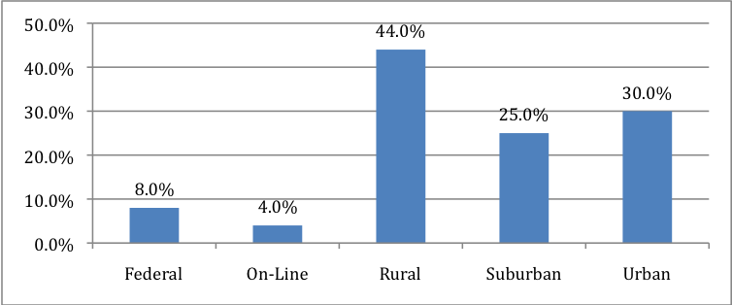

Fifty-nine percent of respondents classified their school as a district school, while 41% classified their school as a charter school. Forty-four percent of the respondent’s district schools were located in rural communities, 30% in urban areas, and 25% in suburban areas. Eight percent were considered federal and 4% were online.

An item surveyed respondents on the percentage of time students with ASDs were served in certain environments in their LEA. It was reported that 49% of the time students were served in the general education classroom, 20% in the self-contained classroom, and 18% in the resource classroom. The least served areas were home program (3%), itinerant (4%), and special school (7%).

Eighty percent of respondents reported serving students with ASD in their home school as opposed to a separate or special day school. In order to serve students with ASD in the future, respondents collectively reported a projected need of 967 full-time special education teachers, and 1,243 other full-time personnel, specifically in the related service areas.

Respondents were asked to project future related services needs for students with ASDs. Projected, related services needs registered by respondents were: speech therapists (85%), occupational therapists (70%), behavior specialists (57%), and psychologists (52%). Services least needed were: board certified behavior analysts (14%), consultant (32%), and physical therapists (34%).

Table 2: Related Services Needs for Students with ASD
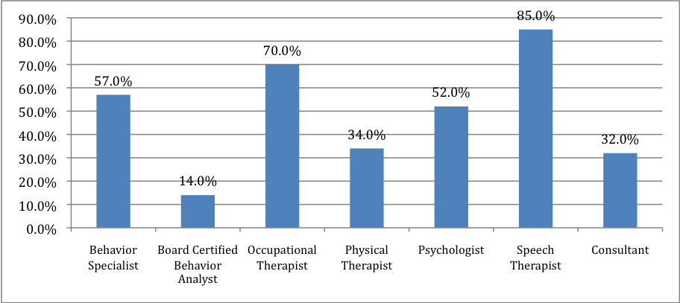

State Licentiate
With respect to the type of credential most supported by special education directors, twenty-eight percent of respondents suggested that a dedicated autism certificate should be required by the state to teach children with ASD. Conversely, 72% did not support a separate special education certificate for teaching students with ASD.

When asked which credential they would most like to see available as an option, 71% chose an autism endorsement added to an existing special education certificate. Fifty percent answered that they would like to see an autism certificate offered by the state department of education while 35% indicated a preference for an autism certificate offered by an institution of higher learning. Twenty percent would like to see an autism endorsement added to an elementary or secondary general education certificate. Fifteen percent indicated a preference for a specialized ASD master’s degree while another 15% supported including ASD within cross-categorical special education.

Respondents were asked which credentials special education teachers serving students with ASD typically hold. Ninety-four percent of special education directors reported that special education teachers typically hold cross-categorical special education endorsements added to a special education certificate; moreover, 42% of the current teachers in the director’s respective districts were reported to hold a master’s degree in special education. Fewer respondents reported their teachers holding the following credentials: categorical severe and profound mental retardation (9%), and autism certificate offered by an institution of higher education (11%).

Table 3: Preferred Credential/Certification Options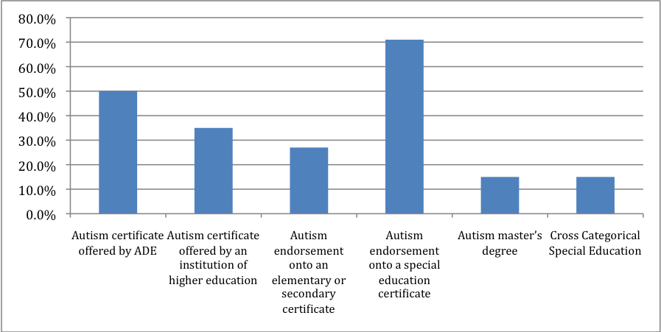

Table 4: Typical Credentials of Special Education Teachers Who Serve Students with ASD
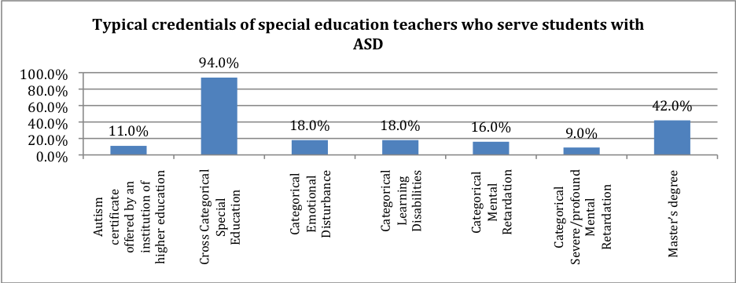

Teacher Education and Curricular Competencies
Special education directors were asked to rank, on a scale of 1 (most essential) through 14 (least essential), the competencies essential for working with students with ASD. Respondents reported that knowledge of the characteristics of autism was the most essential skill, followed by behavior management and communication skills development. Skills regarded the least essential were consultation, transition, and curriculum.

Respondents prioritized academic needs of students with ASDs on a scale of 1 (most
essential) through 6 (least essential). Ability to communicate what they know, functional or adaptive skills, and ability to work independently were considered the most essential academic needs (in that order). Ability to organize for class work, overall academic achievement, and K-12 state standards achievement were the least essential academic needs.

Behavioral needs of students with ASDs were prioritized from 1 (most essential) through 6 (least essential). Communication skills for personal and classroom interactions, acceptable classroom behavior, and adaptations for socio-emotional over and under-responsiveness were deemed the most essential needs. Adaptations for sensory over and under-responsiveness, attending skills, and friendship making skills were the least essential.

Several areas related to professional development were emphasized. These areas included preparing teachers of students with ASDs through group efforts such as training events held at a district-paid conference (87%) and individual efforts such as research and collaboration with others (80%). University programs paid or supported by the district (30%), and university programs supported by the individual teacher (31%) were deemed as less necessary.

Table 5. Professional Development Needs for Teachers of Students with ASD
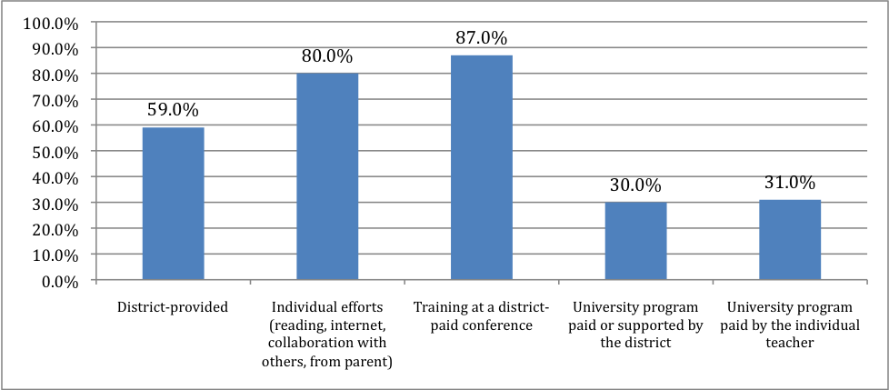

Role of Para-Educators
In serving students with autism spectrum disorders, respondents reported that roles most assumed by para-educators are: skill reinforcement (95%), behavioral direction (91%), attention to task (86%), charting and documenting (82%). Roles less assumed are reporting to parents (18%), skill teaching (42%), reporting to teacher (81%). In terms of professional development opportunities for para-educators, 75% of directors of special education reported training at a district-paid conference.

Table 6: Para-educator Roles in Serving Students with ASD
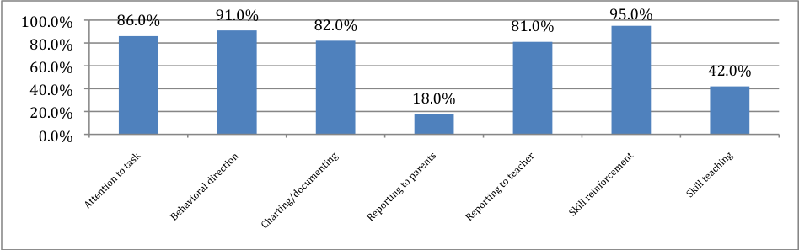

Role of Universities and Colleges of Teacher Education
Respondents were asked what role institutions of higher education played in facilitating competencies for teachers and para-educators of students with ASDs. Respondents felt the most important role of institutions was conducting and disseminating cutting-edge research into the characteristics of autism, which could guide the development of professional training courses for special education teachers. Respondents also suggested that state or district make such training affordable.

Respondents were asked to offer suggestions and comments through an open-ended format. Respondents appreciated a survey that sought their input in the certification process. The qualitative analysis yielded the following themes:
- Teacher Preparation should provide more coursework and practical internships for all teachers preparing to work with students.
- School-based program involvement should occur for professors and teacher candidates.
- Content of course work should focus on behavior management, advocacy, parent relationships and curricular adaptation and modification specific to students with ASD.
- Teacher in-service support should include options such as in-class consultation and on-line, web-cast and ITV support. More respondents suggested the need for continued research and training in the field of ASD.

According to the directors, the population of children with ASD is ever growing, hence the need to provide more training and to make training an integral, affordable part of higher education. Additionally, comments reflect the concept that since autism is a spectrum disorder, the more diverse credentials teachers have, the better equipped they are to teach students in a less restrictive environment.

Discussion
The survey results revealed that the participating Directors of Special Education in the state do not support the creation of a separate autism certificate. However, they do support an endorsement added to a cross-categorical Special Education certificate. Further there was clear support for additional competency development through university-delivered degrees (Masters) and other forms of credentialing (State Department offered certificate). Currently, special education directors reported that teachers with cross-categorical endorsements (94%) are serving student with ASD. Typically the cross categorical certificate allows for teaching mild and moderate disabilities, which also includes children with ASD. The survey suggests that this certification is sufficient with additional focused competencies. To be certain, institutions of higher education do offer university certificates that provide a concentration of courses in autism-but are not necessarily acknowledged or required by the state credentials office.

State directors were clear on the competencies needed to address the educational needs of ASD. Fundamentally, teachers of students with ASD need to have a comprehensive knowledge of the disability and be able to manage the manifested overt behaviors. The focus on development of communication skills for the students was also essential to advancing the academic and behavioral development of students with ASD. A parallel consistency was found between essential teacher competencies and student needs regarding communication skill development. That is to say, special education directors prioritized the importance of teachers’ ability to develop their students’ communication skills as well as identifying communication as a critical area for students. This is also consistent with 85% of the special education directors reporting a high projected need for speech therapists to collaborate in providing communication-based related services to students with ASD. The data also suggested that the competencies that were deemed less essential--consultation, transition, and curriculum-- seemed to be skills that are provided by other professionals in collaboration with the special education teacher.

Professional development was seen as a necessary element to advancing skills of all teachers and para-educators serving students with ASD, with collaboration as a core theme underscoring the service delivery process. Additionally, directors of special education indicated that students with ASD were served in general education 53% of the time and resource rooms 23% of the time. Thus, professional development and collaboration with related service professionals were seen as necessary and provided.

The data suggest that professional development opportunities offered by institutions of higher education were the least available option. This may be due to the university credit-cost structure, distance to a campus and scheduled class offerings, and perhaps the expressed belief that university faculty was divorced from the realities of the classroom. Training at district-paid conferences was reported by 87% of the special education directors. Special education directors commented that newly certified teachers did not necessarily possess the depth and breadth of skills necessary to meet the needs of students with ASD. Consequently, the data suggest that districts are providing this training themselves to supplement the skills of the novice teacher.

Para-educators were reported to be assuming a greater role in serving students with ASD. This is consistent with findings of national studies on para-educators in a variety of classroom settings (French, 2001; Liston, Nevin & Malian, 2009). Specific tasks for para-educators were skill reinforcement, behavioral redirection, charting and communicating achievement and behavior. These functions again highlight the necessary collaboration between teachers and para-educators to meet the range of needs of students with ASD. Thus, referring back to professional development, it is logical that teachers and para-educators have been identified as needing much the same skill set for classroom implementation.

Moreover, special education directors voiced their opinions about teacher preparation. They admonished the universities to include courses on ASD for general as well as special education teachers. The rationale for this admonishment was clearly illustrated by the inclusive classes that are serving students with ASD. Additionally, opportunities to intern with mentor teachers in classes with students with ASD were highlighted. The special education directors went on to state further that those instructing future teachers of students with ASD should have recent classroom experience to appropriately inform their instructional content with the realities of the classroom.

Implications for Teacher Education
There are limitations in this research. We were unable to survey a majority of the special education directors and designates within the state but instead worked with a relatively low response rate that could not be redressed with additional efforts at survey administration given the time constraints. A higher response rate would have provided a fuller picture of the needs and recommendations from the state stakeholders regarding students with ASD and their teachers. The low response rate also limits the generalizability of the findings. These challenges notwithstanding, this study provides a model for convening a collaborative endeavor among colleges, universities, and LEAs that includes the voices of multiple stakeholders in the determination of the most effective ways to prepare teachers to meet the challenges of working with students with ASD in the U.S. and globally.

Examining the Council for Exceptional Children’s Competencies in ASD
Directors reported a clear prioritizing of competencies needed to effectively educate and work with students with ASD. The Council for Exceptional Children [CEC] has also identified initial and advanced core knowledge and skill competencies (CEC, 2009). Of CEC's 173 componrntss of specified knowledge and skills for initial licentiate in the area of Teachers of Individuals with Developmental Disabilities/Autism less than 14% are directed at autism spectrum disorders. Further, of the 103 Advanced Knowledge and Skills for Developmental Disabilities/Autism Spectrum Specialist, less than 24% target ASD. Moreover, both sets of competencies pair autism with developmental disabilities. While there are similarities between the disabilities and common core teaching competencies required for each of them, there are no unique skills for educators identified with respect to ASD. Lastly, standard 3: Individual Learning Differences, Standard 5: Learning Environment/Social interactions, and Standard 9-Professional and Ethical Practice for the initial knowledge and skills set and Advanced Standard 6-Collaboration do not list a single targeted competency for autism nor developmental disabilities specifically. While it could be argued that all of CEC’s competencies implicitly include autism as well as developmental disabilities, naming and making these explicit within the competencies (as the directors of special education in this state have suggested) would provide a more accurate template to transition to teacher education programs. Additionally, the inquiry model of canvassing the special education directors in the state regarding suggestions for specific competencies could also facilitate the mapping of the field requirements to the teacher education programs.

Teacher Preparation Programming
Previous research has suggested that there exists significant variation in the nature of preparation programs in ASD, which reflects not only that a small number of states and countries globally currently offer licensure programs but also that the IHE’s within most of these are operating from a relative void in terms of guidelines for development of their programs (Barnhill, et al., 2010). The present research directly responds to the call for increased guidance from and collaboration with state departments of education and stakeholders with respect to goals and objectives for program development in teacher preparation for ASD (Loiacono & Valenti, 2010), particularly since it is state departments of education who ultimately determine criteria for licentiate certification. While it is important to begin by linking course work with national CEC standards, it is also critical for teacher educators to align preparation programs with what our state agencies indicate that students need in terms of interventions (e.g., research-based practices such as ABA intervention methodologies, pivotal response and discrete trial training), what their teachers need in terms of training areas to effectively work with students (e.g., characteristics, functional behavioral assessments, and social skills development), and the types of field-based experiences to promote direct work with students with the unique features associated with ASD (Barnhill, et al., 2010).

The findings of this study also underscore the need for comprehensive professional development for teachers and para-educators in the field who are working with students on the autism spectrum, beyond the typical single day training, half-day workshop, and self-teaching reported by many teachers of students with ASD (Morrier, et al., 2011). Comprehensive professional development for teachers and para-educators should be spearheaded by expert faculty who can provide in-depth and substantive content knowledge as well as hands-on-training so that teachers are able to understand the range of learning, social, and behavioral features each student with ASD brings into the instructional setting and to subsequently respond effectively (McGee & Morrier, 2005). With direct access to the most up-to-date research, those faculty experts in the area of ASD must engage in more classroom-based supervision and on-site training in order to directly impact students with ASD and their teachers in our schools through the delivery of models of evidence-based practices. This preparation should also involve continued supervision, ongoing feedback, and consultation (NRC, 2001) as part of rigorous on-the-job training during the school year as well as summer institutes and seminars for practicing educators (Barnhill, et al., 2010). Professional development opportunities at the university level should be provided for faculty who are not yet expert in ASD (e.g., colloquia by internal and external consultants, actively participating in webinars); correspondingly, faculty should engage in volunteer, supervision, and observation opportunities in school settings to increase their knowledge and expertise in ASD characteristics and strategies.

Technical Support
Professional development is a critical component to updating skills for teachers of students with ASD and the teacher educators responsible for their effective preparation. Professional development can be offered through a variety of venues, including virtual. For teachers in the field, a connection to an expert who can provide perspective as well as effective classroom practice recommendations is critical to teacher development. A consultant hot-line that dedicates a bracketed time-frame for calls or computer chats with SKYPE capabilities can facilitate this type of professional connection. At the end of a school day, teachers can connect with others teachers and university faculty within the state or nationally to discuss curricular, behavior management or problem-solving successes and soon-to-be success inquiries. Interactive television can also provide a forensic meta-analysis of the broadcast session. Existing students in the teacher education program would benefit from the type of questions and the expert responses.

Aligned with the study, in-class expert consultation would also provide a type of professional development. A triad of content coaches, with expertise, for example, in behavior management, curricular modifications, and/or social skills and communication can engage in a clinical supervision session. Following a pre-conference to set forth the lesson objectives and areas to observe, the observation can be recorded or scripted. The post-conference would then focus on objective achievement and focused observation feedback. Finally, web - casts are not only available through professional organizations but can also be developed by the content coaches and classroom teachers for further analysis with current students at institutions of higher education’s teacher education programs.

References
Barnhill, G. P., Polloway, E. A., & Sumutka, B. M. (2011) A survey of personnel practices in
autism spectrum disorders. Focus on Autism and Other Developmental Disabilities, 26(2), 75-86.
Center for Disease Control and Prevention. Prevalence of autism spectrum disorders: Autism and Developmental Disabilities Monitoring Network, United States, 2011. MMWR Surveillance Summaries 2011 April 1; 60: 365-369.
Council for Exceptional Children. (2009). What every special educator must know: Ethics, standards, and guidelines (6th ed. Rev.). Arlington, VA: Author.
French, N. K. (2001). Supervising paraprofessionals: A survey of teacher practices. The Journal of Special Education, 31(1), 41-53.
Hess, K. L., Morrier, M. J., Heflin, L. J., & Ivey, M. L. (2008). Autism treatment survey: Services received by children with autism spectrum disorders in public school classrooms. Journal of Autism and Developmental Disorders, 38, 961-971.
Individuals with Disabilities Education Improvement Act, Pub. L. No. 108-446, 118 Stat. 2647 (2004).
Liston, A. G., Nevin, A. & Malian, I. (2009). What do para-educators in inclusive classrooms say about their work? Analysis of national survey data and follow-up interviews in California. Teaching Exceptional Children Plus, 5(5), 2-17.
Loiacono, V., & Allen, B. (2008). Are special education teachers prepared to teach the Increasing number of students diagnosed with autism? International Journal of Special Education, 23(2), 120-127.
Loiacono, V., & Valenti, V. (2010). General education teachers need to be prepared to co-teach the increasing number of children with autism in inclusive settings. International Journal of Special Education, 25(3), 24-32.
McCabe, H. (2008). Effective teacher training at the Autism Institute in the people’s republic of China. Teacher Education and Special Education, 31(2), 103-117.
McGee, G. G., & Morrier, M. J. (2005). Preparation of autism specialists. In F. R. Volkmar, R. Paul, A. Klin, & D. Cohen (Eds.), Handbook of autism and pervasive developmental
disorders. Volume II: Assessment, interventions, and policy (3rd ed., pp. 1123-1160).
Hoboken, NJ: John Wiley.
Morrier, M. J., Hess, K. L., & Heflin, L. J. (2011). Teacher training for implementation of teaching strategies for students with autism spectrum disorders. Teacher Education and Special Education, 34(2), 119-132.
National Research Council. (2001). Educating children with autism. Committee on Educational Interventions for Children with Autism. Division of Behavioral and Social Sciences and Education. Washington, DC: National Academy Press.
National Center on Teacher Quality (2007). Special Education Teacher Certification and Licensure. Retrieved from http://mb2.ecs.org/reports/Reporttq.aspx?id+1542&map=0
No Child Left Behind Act, Pub. L. No. 107-110, 115 Stat. 1425 (2002).
Saracino, J., Noseworthy, J., Steiman, M., Reisinger, L., & Fombonne, E. (2010). Diagnostic and assessment issues in autism surveillance and prevalence. Journal of Developmental and Physical Disabilities, 22(4), 317-330.
Scheueremann, B., Webber, J., Boutot, E. A., & Goodwin, M. (2003). Problems with personnel
preparation in autism spectrum disorders. Focus on Autism and Other Developmental Disabilities, 18, 197-206.
Teffs, E. & Whitbread, K. (2009). Level of preparation of general education teachers to include students with autism spectrum disorders. Current Issues in Education, 12(10).
United States Department of Education. (2009). Twenty-eighth annual report to Congress on the implementation of the Individuals with Disabilities Education Act. Washington, DC: Author.

