Attributions of the educational outcomes of students with learning disabilities in China

Stuart Woodcock
Han Jiang
University of Wollongong

This paper aims to raise awareness of the importance of attributional beliefs in relation to the educational outcomes of students with a learning disability (LD) in China. The study presented in this paper examined the attributional beliefs that Chinese pre-service teachers had developed towards students with LD, in comparison to students without LD. The findings show that Chinese pre-service teachers did not differ in their attributional beliefs between students with and without LD. Implications from the findings, and future research recommendations are also presented.

Students with learning disabilities (LD), or learning difficulties, form a large significant group in China. Research has shown that the prevalence rate in young people up to the age of 18 ranges from a low of 4.86% to a high of 31.62% (He, 2005; Liu, 2000; Wang, 2003; Yao, 2009). A major reason for such a wide discrepancy is the plethora of definitions and diagnostic criterion, none of which have been widely adopted across China. The more simplified the criterion used, the higher the rate of identified students. However, no matter which rate is referred, given such a large country, the population of students with LD will always be large. For the purpose of this paper, LD will be used referring to the World Health Organization (WHO) definition that there is a significant disability of learning that cannot be solely accounted for by mental retardation, visual acuity problems, or inadequate schooling (2010, p196).

In China over the past two decades, LD has increasingly received attention from many research fields such as education, psychology and medicine. The current research LD follows two basic tracks: one is to explore the cognitive development, and the mechanisms of information processing of students with LD, as well as to design effective interventions to solve problems and disabilities that occurred during their cognitive development; the other is to explore their social development, including mind and behaviour, emotional development, social competence, and social cognition, and so on (Yu, 2005). The latter is more recent, but has become a hot topic, in which the research on attribution and motivation of students with LD is a new focus (Chen, 2007; Li, Liu & Dong, 2006; Zhao, 2010). Among the various theories of attribution, Weiner’s (1979, 1985, 1986) Attribution Theory is one of the most popular and has been commonly applied by Chinese researchers on LD among different populations (e.g., Luo, 2000; Zhao, Zhang, Geng & Shen, 2005) and in different subjects (e.g., Chang, 2010; Hu, 2009).

Weiner’s Attribution Theory
Attribution theorists assume that individuals seek to understand why events have occurred (Schuster, Forsterlung, & Weiner, 1989, p. 192). Weiner and his colleagues originally developed the research on the causes of success and failure. Guided by Heider’s causal structure (1958), they initially assumed that ability, effort, task difficulty, and luck were perceived as the most responsible causes for success and failure in achievement-related contexts, among which ability and effort were the most dominant determiners (Weiner, 1985). Later, they put forward that factors such as mood, fatigue, illness, biases of others, and unique factors to specific situations were necessary causes (Weiner, Russell,& Lerman, 1978).

In the centre of Weiner’s Attribution Theory, are two related models. First, the theory categorized the perceived causes into three dimensions: locus of causality, stability, and controllability (Weiner, 1979, 1986). Locus of causality is concerned as a backward-looking belief, thus, it focuses on whether the cause is internal or external to the individual (Linnenbrink & Pintrich, 2002). For example, among the four most important causes, ability and effort are internal to the individual, whereas task difficulty and luck are external. Stability defines the cause as either a stable (invariant) trait or an unstable (variant) trait. Based on the general agreement, ability and task difficulty are stable causes, whereas causes such as effort, luck, mood, and fatigue are unstable causes. Controllability is concerned with whether an individual has control over the cause, such as, can they increase or decrease the effort expenditure (which is perceived as controllable) over the cause (Weiner, 1985). Aptitude, by contrast, is typically perceived as uncontrollable (Schuster et al., 1989). According to the three dimensions, therefore, a specific cause can be located to one of eight cells, that is two levels of locus of causality by two levels of stability by two levels of control (Weiner, 1979). For example, a student who fails a test may explain it is due to the teacher’s bias (external, stable and uncontrollable).

The three dimensions of causality link to psychological consequences, respectively, which forms the second model of Weiner’s Attribution Theory (Weiner, 1979). Locus of causality has primary implications for self-esteem and affect as the secondary implication. If a failure is ascribed to internal causes, self-esteem may be lowered, and feelings of incompetent, guilt and resignation can be generated. If a failure is ascribed to external causes, self-esteem may be maintained, and feelings of aggression may be generated (Weiner et al., 1978). Stability relates to the degree of expectancy. A greater amount of expectancy might be produced if an individual ascribes a successful outcome to stable causes rather than unstable causes or unsuccessful outcomes to unstable causes. Finally, controllability may result in interpersonal judgment such as helping, evaluation and liking. Such an inference reminds of self- and other-perceptions for success and failure. Although the processes can be complex, these psychological consequences have significant influences on individual behaviours (Schunk, Pintrich, & Meece, 2008).

As indicated, attribution of success and failure happens in both the self and others. From this perspective, Weiner’s Attribution Theory relates to two achievement motivations. First, an intrapersonal theory is presented, which addresses how individuals interpret their successes or failures. Second, an interpersonal theory is presented, which addresses how individuals explain others’ success or failure (Tollefson, 2000). In school contexts, it can beteachers and students who explain the current outcomes and predict future results. It is also useful for teachers to use the theory to analyze students’ patterns of attribution, and then to enhance their motivations and efforts. This is especially so when a student fails at a task.

A negative and unexpected student outcome such as test failure may frequently result in an attributional search by teachers (Clark, 1997). They likely use their prior knowledge or antecedent cues (Graham, 1991), such as performance history and social norms, to infer the causes (Kelley & Michaela, 1980). In most cases, teachers view ability and effort as the most significant causes of success and failure in school (Graham, 1991; Tollefson, 2000). Several studies found that effort was rated more important than ability (e.g., Graham & Weiner, 1986; Rolison & Medway, 1985). Further, effort is considered to having greater significance than ability for teachers to determine punishment (as well as to reward) (Matteucci & Gosling, 2004; Matteucci, 2007). Weiner (1977) proposed two reasons to explain this discrepancy. First, effort elicits strong moral feelings that are socially valued. Second, effort is believed to be subject to volitional control whereas ability is viewed as stable and uncontrollable. Therefore, when a teacher ascribes a student’s failure to lack of ability, sympathy may be elicited toward the student, and supportive behaviors may be followed. If lack of effort is perceived as the cause of failure, feelings of frustration may be elicited, and punitive actions may be followed (Weiner, 1979; 1994). In addition, teachers do not have to elicit emotion in self-examination whether they are responsible for the student’s failure or not (Major, Kaiser,& McCoy, 2003).

In some cases, teachers ascribe students’ success as being influenced by their teaching and personality, particularly, when they perceive a student who has low ability but has a sudden success (Bennett & Bennett, 1994). A study by Rolison and Medway (1985) also concluded that teachers are prone to attribute performance increment of students with special needs to their effort rather than the students’ effort, ability or task difficulty. When such an attributional linkage establishes, teachers are more likely to be intrinsically rewarded. By carrying the belief that they are good teachers, effort expenditure will likely be put forth (Bennett & Bennett, 1994).

In general, normally achieving (NA) students tend to attribute their success to internal causes such as ability and effort, and failure to lack of effort and unstable external causes (Tollefson, 2000). Students who follow this attributional style when successful are also likely to have higher self-esteem (Yan & Li, 2008). On the other hand, students who follow the attributional style when they fail can protect their self-worth (Linnenbrink & Pintrich, 2002). However, individual differences can be existent in the perception of causality. For example, the study by Weiner and Kukla (1970) concluded distinctly that students who have high achievement motivation attribute success to internal causes more than those who have low achievement motivation.

Research on students with LD, has resulted with different findings. For example, Waheeda and Grainger (2002) found that students with LD have a negative attributional style, where they attribute success to external causes, and failure to internal and stable causes (Boersma & Chapman, 1981). Comparative studies between students with LD and NA students also have shown that the former are more likely to ascribe external causes such as task difficulty and luck to success than the latter (Jacobson, Lowery & DuCette, 1986; Pearl, Bryan & Donahue, 1980), as well as to ascribe internal causes such as lack of ability to failure more than the latter (Jacobson, Lowery & DuCette, 1986; Palmer, Drummond, Tollison & Zinkgraff, 1982). Consequently, students with LD may have lower self-esteem (Borkowski, Weyhing & Carr, 1988) and academic self-concept (Stone & May, 2002; Nunez et al., 2005) than NA students.

The Influence of Teacher Expectations
Teachers’ expectations play a vital role in students’ motivation and academic performance (Graham, 1991; Hinnant, O’Brien & Ghazarian, 2009). A teacher’s affective cues followed by a student’s success or failure may have a significant influence on a student’s perception of causality over the case (Graham, 1984). Weiner, Graham, Stem and Lawson (1982) studied affect-attribution relations and found that sympathy and ability, as well as frustration and effort are positively correlated. The study also indicated that even the five-year olds understood the affect-attribution relations. Furthermore, these affects convey teachers’ expectations to students (Clark, 1997). Consequently, a student who receives sympathy from the teacher may attribute their failure to low ability (internal, stable and uncontrollable) and interpret the affect as a low expectation from the teacher. Alternatively, a student who receives frustration from the teacher may attribute the failure to low effort (internal, unstable and controllable) and interpret the affect as a high expectation from the teacher. These in turn, can influence students’ motivation and achievement strategies (Reyna, 2000). In particular, when continual sympathy is paid by teachers, students’ long-term motivation may be negatively impacted; as they see it as a signal that teachers believe they are incapable of success (Reyna & Weiner, 2001).

Similarly, teachers’ praise can function as an attributional cue as well. Praise and blame from others can allow an individual to infer whether effort or ability is a cause for success or failure (Meyer et al., 1979). Nevertheless, the praise by a teacher following the success in easy tasks can lead the target of such feedback to infer low ability (Barker & Graham, 1987; Graham and Barker, 1990). Further, the praise or reward following a failure implies that the teacher believes the student will do no better and should not expect to improve (Clark, 1997). In contrast, an absence of praise following the success in easy tasks can lead the student to infer a higher ability (Schunk et al., 2008). To sum up, sympathetic help and generous praise has positive intentions by teachers and may be prevalent, but they are antecedents to perceptions of low ability (Graham and Barker, 1990; Woodcock & Vialle, 2010, Woodcock & Vialle, 2011). Further, although it may be seldom use in class, praise that focuses on the ability to successful situations will help to build up students’ motivation, while blame that focuses on effort in failed situations can maintain the motivation (Foote, 1999).

Teachers may likely view students with LD as internal, stable, and uncontrollable (Clark, 1997). Such a statement implies that teachers may be more generous, less stringent and hold lower expectations to these students. Clark’s research with general elementary teachers in the United States found that the teachers tended to reward students with LD more than students without LD in failed situations; expressed more sympathy and less frustration towards students with LD; and held the belief that students with LD would fail more in the future (1997). Similar findings have been reached by Tollefson and Chen’s (1988) research with K-12 teachers, Georgiou, Christou, Stavrinides and Panoura’s (2002) research with elementary teachers in Cyprus, and Woodcock and Vialle’s research with pre-service secondary school teachers (2010) and pre-service elementary school teachers (2011) in Australia. Thus, it can be generally concluded, at least in Western societies, attributional cues that teachers convey to students with LD are that they have lower ability than NA students and should expect less achievement. Certainly the signal can be harmful to the students’ motivation and future performance.

Research on cross-cultural comparisons has shown that, in Eastern societies, low achievement or failure tends to be attributed to low effort on the part of students (Georgiou et al., 2002). The difference may be due to subgroups in demographic variables such as religion and values, which further underline the need for caution in generalizing from the data (Yan & Gaier, 1994). Adapted from Clark’s (1997) research, Zhang, Zhao, Shen and Geng (2007) conducted a similar study with 167 elementary school teachers and 166 secondary school teachers in China. They found that the teachers tended to reward low ability and high effort students without LD more than low ability and low effort students with and without LD, were angrier to low effort students with and without LD than high effort students, and expected more failure to low ability and low effort students without LD than low ability and low effort students with LD. In particular, elementary school teachers believed high ability and low effort students without LD would fail more than high ability and low effort students with LD in the future. Zhang and colleagues concluded that Chinese teachers were less generous than Western teachers to students with LD. Further, they might perceive LD as an unstable cause, which can enhance students’ motivation.

With the exception of the above study, research on teachers’ interpersonal attributions of students with LD is limited in China. In particular, the research identifying pre-service teachers’ interpersonal attributions of students with LD is rare. As teachers’ efficacy beliefs are less likely to change throughout their teaching career (Woolfolk-Hoy & Spero, 2005), identifying pre-service teachers’ interpersonal attribution is necessary. Accordingly, the aim of the present study was to identify the causal dimensions of students with LD as perceived by pre-service teachers, and whether Chinese pre-service elementary school and secondary school teachers subscribe them to a positive or negative attribution pattern.

Method
The study aimed to investigate to what extent Chinese pre-service teachers’ knowledge of the presence or absence of a LD would influence: (a) the feedback given to a hypothetical boy based on his ability and the effort expended, (b) the frustration and sympathy felt towards each boy, and (c) the future expectations held for each boy. Participants were 101 pre-service teachers (17 male and 84 female) who would teach either in elementary schools or secondary schools. Among them, 81 participants were drawn from a local vocational university and were undertaking the final year of the Diploma of Elementary Education, which prepares graduates to teach students in elementary schools. The structure of program combines theoretical and practical elements of teaching, which helps students to develop professional knowledge and classroom practice. However, none of the special education content is included as an individual subject to the program. Therefore, these pre-service teachers did not have a conceptualized map of special education in their mind. Alongside their diploma studies, they had successfully completed two practicum experiences which had lasted for two weeks, and was at the end of year one and two, respectively. The other 20 participants were drawn from a short term (2-month) pre-teaching training program. Unlike the diploma program, it focuses on current issues and teaching methodology associated with secondary education in China. The pre-service teachers all held, at the minimum, a baccalaureate degree which excludes the degree in secondary education. All of them had passed the exams and an interview which was required by Teachers Law of the People’s Republic of China (Ministry of Education of the People’s Republic of China [MOE], 2009) and had their teaching license registered.

The survey instrument was adapted from Woodcock and Vialle’s (2010) study which examined comparisons between students with and without LD, and whether Australian pre-service secondary school teachers perceived them to a positive or negative attribution cycle. In their study, eight vignettes were adapted slightly from the original version created by Clark (1997), in order to fit within an Australian context. Each vignette described a hypothetical boy who had just taken a typical classroom test and failed. The vignettes did not specifically identify the cause of the hypothetical boys’ failures in order to stimulate causal explanations by the participants. The description of each vignette provided three types of information: a statement of student ability, the typical pattern of effort expended by the student in the classroom, and information on academic performance. The descriptions identified half of the boys as LD and half as NLD, half as high ability and half as low ability, and, half as expending high effort and half as expending low effort, but specific terms were not used. The boys were matched on ability (high/low), on typical effort (high/low), and the presence/absence of a LD (LD/NLD). Finally, a matrix of 2 (ability) by 2 (effort) by 2 (LD/NLD) were formed.

An example of a vignette (high ability/low effort/NLD) is:
Phillip is a student in your class. He has greater aptitude for academic tasks than most children in the class. Although he occasionally does excellent work, he is usually off task and does not participate in class often. He rarely completes class assignments and does not do much of his homework.

After respondents had read the vignettes, they were presented with four questions which asked them: (a) what feedback they would give to the child, (b) the degree of frustration that they would feel towards the child, (c) the degree of sympathy that they would feel towards the child, and, (d) their expectation of the likelihood of the boy’s future failure. Each of the four questions of that followed the vignettes was presented as a Likert-scale item.

In the present study, the instrument including eight vignettes was adapted from Woodcock and Vialle’s (2010), and following revisions were made:
1. The whole instrument was translated from English to Chinese. After the instrument had been translated to Chinese, it was assessed by experts in the field of TESOL, who were fluent in both written English and Chinese, and familiar with Australian and Chinese society which gave a bilingual check.
2. WHO’s definition of LD is adopted as the definition of LD referred by the instrument.
3. Minor revisions were made to fit Chinese context. For example, in Woodcock and Vialle’s version, boys are called by their first names such as Thomas and Andrew, which are common in Western society. In the present version, boys are called by their surnames, such as (Mǎ) and (Lǔ), which are common in Chinese society

Results
A two (N/LD) by two (ability) by two (effort) multivariate analysis of variance with repeated measures was conducted for the four dependent measures (feedback, frustration, sympathy, and expectation of future failure). The following sections report the results of the repeated measures for feedback, frustration, sympathy, and expectation of future failure. Each section reports the results of the repeated measures analysis by discussing the main effects for each variable (LD status, ability level, and effort expended) and combined two and three-way interactions. The effect sizes used and measured in this paper reflect upon Cohen’s suggested small, medium, and large effect sizes where ηp2sizes are equal to 0.10, 0.25, and 0.40 respectively (Cohen, 1969, cited in Richardson, 2011).

Overall, significant main effects, from the multivariate analysis of variance repeated measures, for LD status, F (1, 101) = 5.060, p< .001,ηp2= .177; ability, F (1, 101) = 19.802, p< .001, ηp2= .457; and, effort, F (1, 101) = 57.822, p< .001, ηp2 = .711, were found for attributional response. In particular, a three-way interaction of LD, ability and effort was significant and produced a small-medium main effect, F (1, 101) = 6.691, p< .001,ηp2= .222. Moreover, LD status and effort (F (1, 101) = 6.562, p< .001,ηp2= .218), and LD status and ability (F (1, 101) = 7.235, p< .001,ηp2= .235), also resulted in interaction small-medium effects. The following sections report the univariate analysis of variance using repeated measures for each individual attributional response.

Feedback
Table 1. Pre-service Teachers’ Feedback
 | LD |  | NLD
 | M | SE | M | SE
LD Status | 2.689 | .158 | 2.615 | .135
 | Low |  | High
 | M | SE | M | SE
Ability | 2.378 | .169 | 2.926 | .126
Effort | 1.408 | .222 | 3.895 | .092
 | LD LA |  | LD HA |  | NLD LA |  | NLD HA
 | M | SE | M | SE | M | SE | M | SE
LD*Ability | 2.168 | .208 | 3.209 | .145 | 2.587 | .164 | 2.643 | .162
 | LD LE |  | LD HE |  | NLD LE |  | NLD HE
 | M | SE | M | SE | M | SE | M | SE
LD*Effort | 1.704 | .233 | 3.673 | .139 | 1.112 | .259 | 4.117 | .083
 | LA LE |  | LA HE |  | HA LE |  | HA HE
LD*Ability*Effort | M | SE | M | SE | M | SE | M | SE
LD | 1.020 | .300 | 3.316 | .207 | 2.388 | .233 | 4.031 | .116
NLD | 0.990 | .310 | 4.184 | .107 | 1.235 | .305 | 4.051 | .104

As indicated in Table 1, there was no significant main effect for LD status (F (1, 101) = .336, p> .01, ηp2= .003), found for feedback. As Figure 1 shows, this can be noticed in theηp2 and mean score differences between feedback given to the students with and without LD.However, a significant small main effect for ability, F (1, 101) = 16.298, p< .001,ηp2 = .144, was found for feedback. This can be seen in the differences in feedback between the ηp2 and mean scores of low and high ability students (M1 – M2 = .548). Greater positive feedback was given to the high ability students. Finally, a large significant main effect for effort, F (1, 101) = 137.186, p< .001, ηp2= .586, was found for feedback. The level of effort expended was the most highly significant main effect found for feedback. This can be seen in theηp2 and mean feedback scores given to low effort students (M = 1.408) and high effort students (M = 3.895) with greater positive feedback given to students who expend high effort.

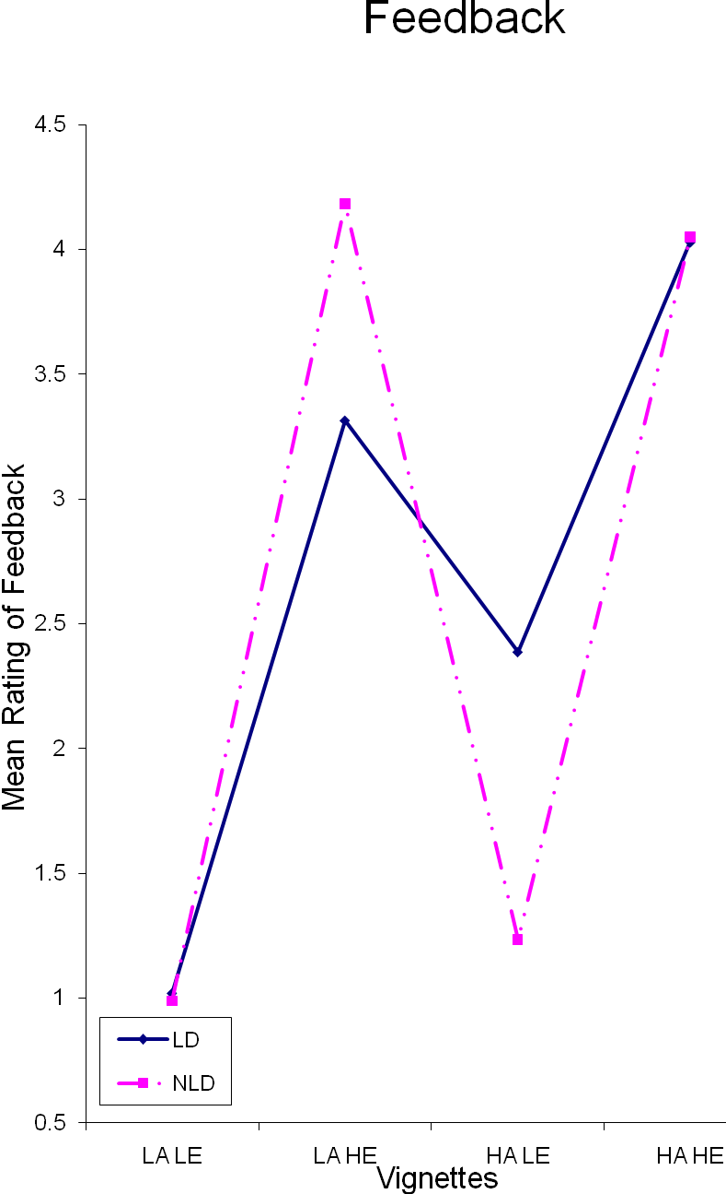
Figure 1.Pre-service Teachers’ Feedback to Students

As can be noticed in Figure 1, Chinese pre-service teachers considered a two-way interaction between a boy’s level of ability and his LD status (F (1, 101) = 19.174, p< .001,ηp2= .165) (small effect size) when giving feedback. Furthermore, Chinese pre-service teachers also considered a two-way interaction between a boy’s level of effort expended and LD status (F (1, 101) = 16.865, p< .001,ηp2= .148) (small effect size) when giving feedback.

Frustration
There was no significant main effect for LD status, (F (1, 101) = .287, p> .01, ηp2= .003), found for pre-service teacher frustration. Furthermore, there were no significant main effects for ability, F (1, 101) = 7.397, p> .01,ηp2 = .003. Thus, there were no differences in pre-service teachers’ frustrations towards high or low ability level students. Moreover, a large significant main effect found for frustration was effort, F (1, 101) = 96.883, p< .001,ηp2 = .500. This can be seen in theηp2and mean scores of frustration felt towards low effort students (M = 3.712) and high effort students (M = 2.459). Consequently, greater frustration was felt towards students who expend low effort.

Table 2 Levels of Pre-service Teachers’ Frustration
 | LD |  | NLD
 | M | SE | M | SE
LD Status | 3.107 | .091 | 3.064 | .092
 | Low |  | High
 | M | SE | M | SE
Ability | 3.224 | .097 | 2.946 | .096
Effort | 3.712 | .115 | 2.459 | 0.091
 | LD LA |  | LD HA |  | NLD LA |  | NLD HA
 | M | SE | M | SE | M | SE | M | SE
LD*Ability | 3.383 | .208 | 2.832 | .105 | 3.066 | .105 | 3.061 | .121
 | LD LE |  | LD HE |  | NLD LE |  | NLD HE
 | M | SE | M | SE | M | SE | M | SE
LD*Effort | 3.643 | .116 | 2.571 | .107 | 3.781 | .140 | 2.347 | .115
 | LA LE |  | LA HE |  | HA LE |  | HA HE
LD*Ability*Effort | M | SE | M | SE | M | SE | M | SE
LD | 3.837 | .153 | 2.929 | .138 | 3.449 | .127 | 2.214 | .128
NLD | 3.918 | .170 | 2.214 | .136 | 3.643 | .167 | 2.480 | .146

Thus, as can be seen in Figure 2, the frustration felt towards students was governed by the level of effort expended, not the LD status, nor the ability level. Pre-service teachers felt greater frustration towards students when they expend low effort, and yet less frustration towards students who expend high effort.

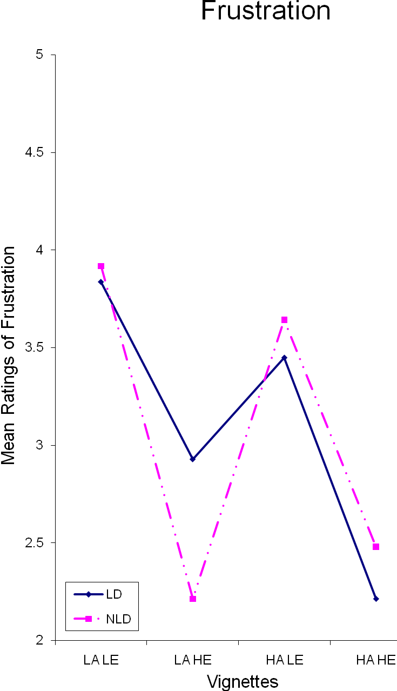
Figure 2.Pre-service Teachers’ Frustrations towards Students

There were no significant two-way or three-way interactions between LD status and ability, nor LD status and effort with regards to Chinese pre-service teachers’ feelings of frustration.

Sympathy
Table 3.Pre-service Teachers’ Sympathy
 | LD |  | NLD
 | M | SE | M | SE
LD Status | 3.622 | .123 | 3.298 | .120
 | Low |  | High
 | M | SE | M | SE
Ability | 3.640 | .123 | 3.281 | .121
Effort | 3.416 | .125 | 3.505 | .138
 | LD LA |  | LD HA |  | NLD LA |  | NLD HA
 | M | SE | M | SE | M | SE | M | SE
LD*Ability | 3.837 | .135 | 3.408 | .142 | 3.444 | .138 | 3.153 | .137
 | LD LE |  | LD HE |  | NLD LE |  | NLD HE
 | M | SE | M | SE | M | SE | M | SE
LD*Effort | 3.658 | .138 | 3.587 | .139 | 3.173 | .139 | 3.423 | .168
 | LA LE |  | LA HE |  | HA LE |  | HA HE
LD*Ability*Effort | M | SE | M | SE | M | SE | M | SE
LD | 3.592 | .163 | 4.082 | .165 | 3.724 | .150 | 3.092 | .175
NLD | 3.235 | .161 | 4.653 | .204 | 3.112 | .162 | 3.194 | .194

A significant (small) main effect for LD status, F (1, 101) = 13.974, p< .001, ηp2 = .126, was found for sympathy with mean differences in pre-service teacher sympathy towards students with and without LD (M1 – M2 = .324). Figure 3 shows that greater sympathy was felt by pre-service teachers towards students with LD than their NLD counterparts. A significant (small) main effect for ability, F (1, 101) = 15.971, p< .001,ηp2 = .141, was also found for sympathy. This can be seen in theηp2and mean differences in pre-service teacher sympathy towards low ability and high ability students (M1 – M2 = .359). Pre-service teachers felt greater sympathy for low ability students than for their high ability counterparts. There was no significant main effect for effort, F (1, 101) = 0.446, p> .01,ηp2 = .005, found for sympathy. Thus, sympathy levels did not change due to the effort expended by students.

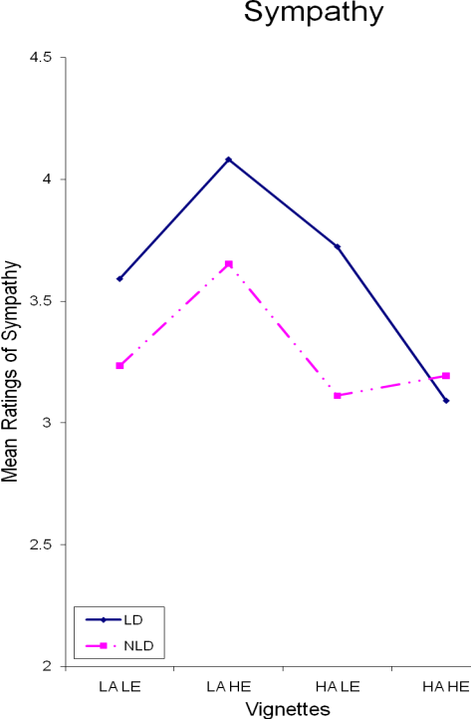

Figure 3.Pre-service Teachers’ Sympathy towards Students

There were no significant two-way or three-way interactions between LD status and ability, nor LD status and effort with regards to Chinese pre-service teachers’ sympathy.

Expectancy of Future Failure
Table 4. Pre-service Teachers’ Expectations of Future Failure
 | LD |  | NLD
 | M | SE | M | SE
LD Status | 3.776 | .088 | 3.503 | .088
 | Low |  | High
 | M | SE | M | SE
Ability | 4.026 | .088 | 3.253 | .090
Effort | 4.224 | .091 | 3.054 | .090
 | LD LA |  | LD HA |  | NLD LA |  | NLD HA
 | M | SE | M | SE | M | SE | M | SE
LD*Ability | 4.327 | .117 | 3.224 | .099 | 3.724 | .102 | 3.281 | .144
 | LD LE |  | LD HE |  | NLD LE |  | NLD HE
 | M | SE | M | SE | M | SE | M | SE
LD*Effort | 4.219 | .104 | 3.332 | .110 | 4.230 | .124 | 2.776 | .105
 | LA LE |  | LA HE |  | HA LE |  | HA HE
LD*Ability*Effort | M | SE | M | SE | M | SE | M | SE
LD | 4.612 | .141 | 4.041 | .138 | 3.827 | .119 | 2.622 | .136
NLD | 4.684 | .152 | 2.765 | .129 | 3.776 | .148 | 2.786 | .148

No significant main effect for LD status, F (1, 101) = 6.079, p> .01,ηp2= .068, was found for pre-service teachers’ expectations of a student’s future failure. However, a large significant main effect for ability, F (1, 101) = 67.806, p< .001,ηp2= .411, was found for pre-service teachers’ expectations of a student’s future failure. The differences inηp2and mean scores between the expectations of future failure for high ability and low ability students (M1 - M2 = .773) shows this. Pre-service teachers had a considerably greater expectation of future failure for students of low ability than for their high ability counterparts. A large significant main effect for effort, F (1, 101) = 140.976, p< .001, ηp2= .592, was found for pre-service teachers’ expectations of a student’s future failure. The level of effort expended was the most highly significant main effect found for expectation of future failure. This can be seen in theηp2and mean expectation scores given to students who expend low effort (M = 4.224) and students who expend high effort (M = 3.054). Thus, pre-service teachers held higher expectations of future failure for students who expend low effort than their high effort counterparts (see Figure 4).

As Figure 4 shows, there were no significant two-way or three-way interactions between LD status and ability, nor LD status and effort with regards to Chinese pre-service teachers’ expectations of future failure. Thus, although effort and ability were found to be significant in the pre-service teachers’ expectations, LD status was not significantly influential.

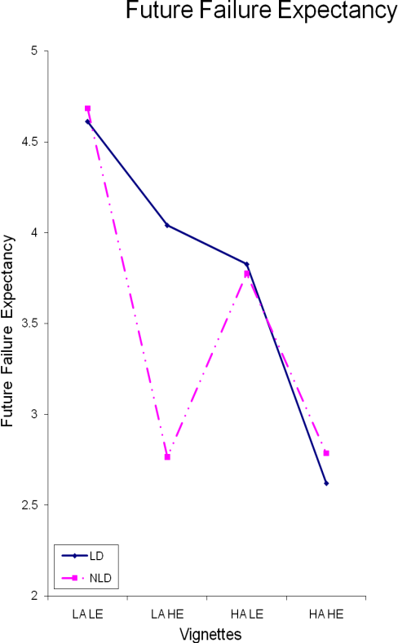

Figure 4.Pre-service Teachers’ Expectations of Future Failure of Students

Discussion
The results demonstrate that as students’ ability levels increase, the pre-service teachers’ reported feedback becomes more positive, their sympathy levels decrease, and the expectation of future failure decreases. As students’ expended efforts increase, the feedback becomes more positive, the frustration decreases, and the expectation of future failure decreases. Further, the only significant effect regarding LD status was sympathy. Pre-service teachers were more sympathetic to students with LD than their non-LD counterparts.

In summary, then, the current study suggests that, with the exception of sympathy, LD status does not generally influence Chinese pre-service school teachers’ responses to students’ test failures. As Weiner (1986) highlighted, teachers’ response to students with LD can be seen as a ‘norm to be kind’ which is often felt towards those having limitations (such as those with LD). The greatest frustration and most negative feedback were assigned to the low effort, students. Clearly, the Chinese pre-service teachers perceived the boys’ failures to be within their personal control and held them responsible. Conversely, the least frustration, and most positive feedback were given to the high effort students. It would seem that the pre-service teachers responded more positively to these students because the cause was seen to be out of their control. The findings of this study support Zhang and colleagues’ (2007) findings in that the pre-service teachers reward students who expend high effort (who are of a low and high ability) more than those who expend low effort (who are of a low and high ability), with little difference occurring as to whether students have a learning disability or not. Furthermore, The findings also show that pre-service teachers feel more frustrated towards students who expend low effort (who are of a low and high ability) more than those who expend high effort (who are of a low and high ability level), with little difference occurring as to whether students have a learning disability or not. Thus, the expectations of future failure are highest amongst students of a low ability who expend low effort, than students who expend high effort (and are of a low and high ability level) (Zhang et al., 2007).

Chinese pre-service school pre-service teachers tend to respond to the failure of students through what Jacobson, Lowery, and DuCette (1986) termed a ‘normal self-esteem attribution’. This is where failure is seen to be due to an external uncontrollable cause such as bad luck or internal controllable cause such as effort. Thus behavioural responses towards the students indirectly inform them that expectations are high and that they have the potential to achieve in the future.

Emphasizing expended effort in students with LD can increase expectations about what these students can accomplish through hard work. The beliefs that ability and LD are largely fixed can lead educators to be reluctant to demand higher levels of performance from students with LD. In regards to Chinese pre-service teachers this does not seem to be the case. The identification and label of LD does not influence their expectations of future failure, feedback that they give to students, or their level of frustration towards them. The identification and label of LD only seems to influence their level of sympathy towards these students.

In conclusion the data indicate that the attributional message that Chinese pre-service school teachers transmit to students with LD is that they have the same ability as their peers without LD, and should have the same expectations as a result. These findings suggest that Chinese teachers were less generous than Western teachers to students with LD. The only difference was the sympathy felt towards students with LD. Further, the results show that they perceive LD students’ failure as more of an unstable cause of failure, which can enhance students’ motivation; which supports previous research (Zhang et al., 2007).

Although these results suggest that pre-service school teachers respond to students with and without LD similarly, there are some limitations of the current research. The use of vignette scenarios may produce responses which differ from the responses teachers would make in natural settings (Lee, Hallahan & Herzog, 996). The responses pre-service teachers make to such scenarios may be those they feel they should make given a similar situation rather than those they might actually make. However, the current study sought to advance research built on the foundation of methods similar to that employed in numerous studies involving attribution and achievement (Clark, 1997; Weiner & Kukla, 1970; Zhang et al., 2007).

Conclusion
Perceptions, understandings, and expectations within Eastern countries of those with LD, have raised issues over the years. The greatest difficulties have been in the search for how best to understand students with LD within the education system, to meet their needs and to teach them the necessary skills for adulthood. The interpersonal attributional traits that pre-service teachers in China place on students with LD form a positive pattern to some extent, as they perceive LD as an unstable cause of failure. Therefore, it can enhance students’ motivation. Nevertheless, it can be harmful under the circumstance that pre-service teachers lack proper understanding of LD since they may hold inappropriate expectations on students. As a result, they bring these students with high pressure. Thus, it is essential that pre-service teachers be trained to understand the attributional information that they convey to students with LD, and how does it affect the students’ attitudes, motivation, expectations, etc. Further, how the aptitudes of the students can be enhanced by teaching.

Consequently, this study proposes that teacher training institutions need to prepare future teachers with perceptions, knowledge and skills to teach students with LD. By providing better training programs and practicum experiences to the teachers, the needs and opportunities within the academic arena of students with LD can be met. Secondly, the educational departments need to put more efforts to develop a clear and widely accepted definition of LD. Furthermore, they should ensure adequate policy, curriculum, personnel resource and technologies to teach students with LD.

Implications
These findings have practical implications for pre-service teacher education, and for policy makers and educational departments. Perceiving LD as an unstable cause by pre-service teachers may have some positive influences to students’ self-efficacy, so as to increase their achievement motivations (Zhang et al., 2007). On the other hand, it can be harmful to students with LD when teachers lack knowledge and instructional skills. If pre-service teachers understand these students, and then design interventions, e.g. a positive behavior support plan, such an attributional style may become an accelerant to the students’ future achievements (Zheng & Zhang, 2007). According to a study by East China Normal University, 82.6% teachers feel lacking achievability toward students with special needs (including LD), and 81.8% have some awareness of these students but feel incapable to teach them (Li, Li & Fan, 2002).

It is, therefore, essential for teacher training institutions to better prepare pre-service teachers with perceptions, knowledge and skills to teach students with LD. Most professionals identify children with LD as not intellectually impaired, not emotionally disturbed, not impaired in the modalities, and has had an opportunity to learn. LD is often referred to as a ‘hidden handicap’ (Lavoie, 1996), which could be a significant impediment to prevent pre-service teachers from recognizing problems and designing interventions. An essential first step to address the issue is to develop training and practicum programs to future teachers. How will they ascribe academic failure and success by students with LD, so as to their expectations and behaviours followed by? Understanding the direct and indirect messages that they may send to these students may then lead to attitudinal changes that will help the student with LD achieve.

The educational departments need to face squarely at LD. As indicated at the beginning of the article, LD is variously defined across China. Besides, it has been used in parallel with many other sayings such as learning difficulties, learning disabled, underachiever, and academically poor students (Han & Zhang, 2010). These conceptual confusing and misunderstandings could be an impediment to obstruct national efforts to improve the educational outcome for students with LD. Therefore, the first step is to address the definition of LD towards having a unified understanding, at least in the educational arena.

Second, educational departments need to assist teachers and schools by ensuring that students with LD is properly identified and educated. Currently, one of the top issues that impede schools and teachers to teach students with special needs are the limited support from the government (Liu, Du & Yao, 2000; Zhang & Chen, 2002). Solving the problem may require the departments providing the up-to-date technologies and devices to facilitate teaching processes at schools. However, more importantly, they need to make policy, design curriculum and provide sufficient personnel resources specifically for students with special needs (including LD). If more attention is addressed to LD by educational departments, then teachers and schools would more likely be able to increase awareness, perceptions and skills towards the students.

Future Research
The results from this research, and the previous discussion of the limitations of the research, have highlighted a number of issues which warrant further investigation. Future research might focus upon the range of data collection methods employed, and the groups examined in such studies. There needs to be a greater focus on the Western and Eastern philosophical educational view of students in general, and in particular, on students with LD. Finally, there is a need to compare responses from pre-service teachers before and after they have received a certain amount of training on how to teach students with LD. The data also can be compared to the data from Eastern countries to the Western countries.

Further studies in China could compare in-service teachers’ and pre-service teachers’ perceptions and expectations of students with LD. As a final point, the future research studies discussed here could also be carried out cross-nationally to provide comparative data.

References
Barker, G., & Graham, S. (1987). Developmental study of praise and blame as attributional cues.Journal of Educational Psychology, 79, 62–66.
Bennett, C. & Bennett, J. (1994). Teachers’ attributions and beliefs in relation to gender and success of students. Paper presented at the annual meeting of the American Educational Research Association, New Orleans, LA. (ERIC Document Reproduction Service No. ED375 127).
Boersma, F. J.& Chapman, J. W. (1981). Academic self-concept, achievement expectations, and locus of control in elementary learning-disabled children. Canadian Journal of Behavioral Science, 13(4), 349-358.
Borkowski, J. G., Weyhing, R. S. & Carr, M. (1988). Effects of attributional retraining on strategy-based reading comprehension in learning-disabled students. Journal of Educational Psychology, 80, 46-53.
Chang, Y. (2010). Research on elementary students’ attribution to success and failure in the subject of Chinese language (in translation).New Curriculum Research, 191, 126-127.
Chen, L (2007). Concept of learning disabilities and relative research (in translation). Journal of Leshan Teachers College, 22(5), 123-125.
Clark, M. (1997). Teacher response to learning disability: A test of attributional principles. Journal of Learning Disabilities, 30, 69-79.
Foote, C. (1999). Attribution feedback in the elementary classroom. Journal of Research in Childhood Education, 13(2), 155-166.
Georgiou, S., Christou, C., Stavrinides, P., & Panoura, G. (2002). Teacher attributions ofstudent failure and teacher behavior toward the failing student. Psychology in the Schools, 39(5), 583-595.
Graham, S. (1984). Communicating sympathy and anger to black and white students: The cognitive (attributional) consequences of affective cues. Journal of Personality and Social Psychology, 47, 40-54.
Graham, S. (1991). A review of attribution theory in educational contexts. Educational Psychology Review, 3, 5-39.
Graham, S.& Barker, G. P. (1990). The down-side of help: An attributional-developmental analysis of helping behavior as a low-ability cue. Journal of Educational Psychology,82, 7–14.
Graham, S.& Weiner, B. (1986). From attribution theory to developmental psychology: A round-trip ticket?Social Cognition, 4(2), 152-179.
Han, Qiu-Shi & Zhang, Guo-Jin. (2010). A research on the development of definitions of LD (in translation). Journal of JingdezhenCollege, 25, 73-75.
He, Er-Shi. (2005). Review on the researches of cognitive characteristics of children with learning disability.Chinese Journal of Special Education (Monthly), 57, 85-89.
Heider, F. (1958). The psychology of interpersonal relations. New York: Wiley.
Hinnant, B. J., O’Brien, M. & Ghazarian, S. (2009). The longitudinal relations of teacher expectations to achievement in the early school years.Journal of Educational Psychology, 101(3), 662-670.
Hu, Qiong. (2009). The Weiner’s Attribution Theory used in the ideological and political education for college student. Journal of Hefei Univeristy of Technology (Social Sciences), 23(6), 124-128.
Jacobson, B., Lowery, B., DuCette, J. (1986). Attributions of learning disabled children. Journal of Educational Psychology, 78, 59-64.
Kelley, H., Michaela, J. (1980). Attribution theory and research. Annual Review of Psychology, 31, 457-501.
Lavoie, R. (1996). When the chips are down? [video recording].Alexandria, VA: PBS Video.
Li, Chuan-Yin, Liu, Feng-Yue & Dong, Ji-He. (2006). Attribution and regulation strategies of adult learning barriers. Open Education Research, 12(6), 91-94.
Li, Jie., Li Zhi-Min. & Fan, Jing-Jing. (2002). The research on the school building environment for limb and trunk disables: An analysis causes preventing limb and trunk disables from entering schools. J.Xi’an Univ. of Arch. & Tech. (Natural Science Edition), 34:4, 313-316.
Linnenbrink, E., Pintrich, E. (2002). Motivation as an enabler for academic success. School Psychology Review, v31(3), 313-327.
Liu, Chun-Ling., Du, Xiao-Xin. &Yao, Jian. (2000). A study of regular primary school teachers’ acceptance of special needs children. Chinese Journal of Special Education (Quarterly), 34, 34-36.
Liu, Lin. (2000). Research on factors of children with learning disabilities (in translation). Chinese Journal of School Health, 21: 4, 329-330.
Luo, Li-Fang. (2000). Applying attributional theory to students with LD (in translation). Journal of Fuqing Branch of Fujian Normal University, 46, 67-69, 74.
Major, B., Kaiser, C., & McCoy, S. (2003). It’s not my fault: When and why attributions to prejudice protect self-esteem. Personality and Social Psychology, Bulleting 29, 772-781.
Matteucci, M. (2007). Teachers facing school failure: The social valorization of effort in the school context. Social Psychology of Education, 10, 29-53.
Matteucci, M., Gosling, P. (2004). Italian and French teachers faced with pupil’s academic failure: The norm of effort. European Journal of Psychology of Education, 19(2),147-166.
Meyer, W., Bachmann. M., Biermann. U., Hempelmann. M., Ploger, F. & Spiller, H. (1979). The informational value of evaluative behavior: Influence of praise and blame on perceptions of ability. Journal of Educational Psychology, 71(2), 259-268.
Ministry of Education of the People’s Republic of China. (2009). Teachers Law of the People’s Republic of China. Retrieved on 2011/2/12 from http://202.205.177.9/edoas/en/index.jsp
Nunez, J., Gonzalez-Pienda, J., Gonzalez-Pumariega, S., Roces, C., Alvarez, L., Gonzalez, P., Cabanach, R., Valle, A., Rodriguez, S. (2005). Subgroups of attributional profiles in students with learning difficulties and their relation to self-concept and academic goals. Learning Disabilities Research and Practice, v20(2), 86-97.
Palmer, D. J., Drummond, F., Tollison, P., & Zinkgraff, S. (1982). An attributional investigation of performance outcomes for learning-disabled and normal-achieving pupils. The Journal of Special Education,16, 207-219.
Pearl, R. A., Bryan, T., & Donahue, M. (1980). Learning disabled children's attributions for success and failure. Learning Disability Quarterly,3, 3-9.
Reyna, C. (2000). Lazy, dumb, or industrious: When stereotypes convey attribution information in the classroom. Educational Psychology Review, 12, 85-110.
Reyna, C., Weiner, B. (2001). Justice and utility in the classroom: An attributional analysis of the goals of teachers’ punishment and intervention strategies. Journal of Educational Psychology, 93(2), 309-319.
Richardson, J. (In Press). Eta squared and partial eta squared as measures of effect size in educational research. Educational Research Review (2011), doi:10.1016/ j.edurev.2010.12.001.
Rolison, M., Medway, F. (1985). Teachers’ expectations and attributions for student achievement: Effects of label, performance pattern and special education intervention. American Educational Research Journal, 22(4), 561-573.
Schunk, D., Pintrich, P., Meece, J. (2008). Motivation in education: Theory, research, and applications. Sydney, Pearson.
Schuster, B., Forsterlung, F. & Weiner, B. (1989). Perceiving the causes of success and failure: A cross-cultural examination of attributional concepts. Journal of Cross-Cultural Psychology, 20(2), 191-213.
Stone, C., May, A. (2002). The accuracy of academic self evaluations in adolescents with learning disabilities. Journal of Learning Disabilities, 35(4), 370-383.
Tollefson, N. (2000). Classroom applications of cognitive theories of motivation. Educational Psychology Review, 12, 63-83.
Tollefson, N., Chen, J. (1988). Consequences of teachers’ attributions for Student failure. Teaching and Teacher Education, 4(3), 259-265.
Waheeda, T., Grainger, J. (2002). Self-concept, attributional style and self-efficacy beliefs of students with learning disabilities with and without attention deficit hyperactivity disorder. Learning Disability Quarterly, 25(2), 141-151.
Wang, Shu-Quan. (2003). A study on diagnosis of learning disabilities among elementary school students (in translation). Education Exploration, 146, 91-94.
Weiner, B.(1977). Attribution and affect: Comments on Sohn's critique. Journal of Educational Psychology, 69(5), 506-511.
Weiner, B. (1979). A theory of motivation for some classroom experiences. Journal of Educational Psychology, 71, 3-25.
Weiner, B. (1985). An attributional theory of achievement motivation and emotion. Psychological Review, 92(4), 548-573.
Weiner, B. (1986). An attributional theory of motivation and emotion. New York, Sringer-Verlag.
Weiner, B. (1994). Integrating social and personal theories of achievement striving. Review of Educational Research,64(4), 557–573.
Weiner, B., & Kukla, A. (1970). An attributional analysis of achievement motivation. Journal of Personality and Social Psychology, 5, 1–20.
Weiner, B., Russell, D., & Lerman, D. (1978). Affective consequences of causal ascriptions. In J.H. Harvey, W.J. Ickes, & R.F. Kidd (Eds.), New directions for attribution research, v2.Hillsdale, N.J.: Erlbaum, 59-90.
Weiner, B., Graham, S., Stern, P., &Lawson, M. E. (1982). Using affective cues to infer causal thoughts. Developmental Psychology, 18(2), 278-286.
Woodcock, S., Vialle, W. (2010). Attributional beliefs of students with learning disabilities. The International Journal of Learning, 17(7), 177-191.
Woodcock, S., Vialle, W. (2011). Are we exacerbating students’ learning disabilities? An investigation of pre service teachers’ attributions of the educational outcomes of students with learning disabilities. Annals of Dyslexia, 61(2), 223-241.
Woolfolk-Hoy, A. & Spero, R. (2005). Changes in teacher efficacy during the early years of teaching: A comparison of four measures. Teaching and Teacher Education, 21, 343-356.
World Health Organization (2010). The ICD-10 Classification of Mental and Behavioral Disorders: Clinical Descriptions and Diagnostic Guidelines. Geneva, World Health Organization.
Yan, H., Li, X. (2008). Causal attribution and its conceptions by non-English major postgraduates in China: A case study. Canadian Center of Science and Education,4(4), 77-85.
Yan, W., & Gaier, E. (1994). Causal attributions for college success and failure: An Asian American comparison. Journalof Cross Cultural Psychology, 25, 146–158.
Yao, J. (2009). Chinese research on social development of learning disabilities: A Review.Journal of Zhejiang Normal University(Social Sciences), 160, 2-7.
Yu, G. (2005). Learning disabilities: A field waits further exploration and promotion (in translation). Advances in Psychological Science, 13(5), 545-546.
Zhao, J., Zhang, N., Geng, W,. & Shen, J. (2005). A research on the relationship between elementary school teachers’ self-efficacy and their attributional style (in translation).Journal of Educational Studies, 1(4), 71-77.
Zhao, Z. (2010). Literature review of domestic research on students with learning disabilities (in translation). Journal of MudanjiangCollege of Education, 119, 82-83.
Zhang, N., & Chen, L. (2002). A review of integration: The attitudes of primary school teacher toward students with special need learning in regular schools. Chinese Journal of Special Education (Quarterly), 34, 1-6.
Zhang, N., Zhao J., Shen J,. & Geng W. (2007). A research on response models of teachers attribution to students’ academic failure in primary schools and middle schools.Chinese Journal of Special Education (Monthly), 79, 73-78.
Zheng, Z., & Zhang J. (2007). A research on learning motivations of students with LD. Journal of Guang Xi College of Education, 92:6, 51-53.

