Comparing two story-writing mnemonic strategies: A randomized control trial study

Michael Dunn
Washington State University

Educators often use mnemonic strategies as a prime method to help children who struggle with writing. This study analyzed 12 fourth-grade students’ stories during their participation in one of three groups. The first group learned the Ask, Reflect, Text (ART) mnemonic strategy with art media in the pre-writing/planning phase. The second group used Think-Talk-Text (T3) to verbalize aloud their story ideas before encoding text. The control group participated only in general education classroom instruction. The results indicated significant differences between the ART and T3 groups for story content; T3 also was significant different for story quality. The effect size scores indicated that ART students performed better with story content and number of words written. T3 students had the largest effect size for story quality.

Writing may be one of the most challenging of the core academic tasks. Not only does a writer have to read drafts but also initially generate the text. Agatha Christie (1977), the famed novelist and playwright, described herself as having difficulties with writing as a child. Writing and spelling were always terribly difficult for me. My letters were without originality. I was . . . an extraordinarily bad speller and have remained so until this day (p. 42).Generating ideas, spelling the words, and organizing her texts were a challenge; yet, she learned to manage them. Today, we know much more about how to help struggling writers. To further explorethis issue, the author of this study investigated how 12 fourth-graders’ writing ability would change after learning and applying two mnemonic strategies for writing in a randomized control trial format over 17 forty-five minute sessions.

The Rationale For an Empirical Comparison
National Assessment of Educational Progress (2007) results documented that writing is a challenge for many students; about 40% of fourth grade students could not write at a basic level. With many students struggling with writing tasks, mnemonic strategy-instruction has renewed visibility given the implementation of response to intervention (RTI) in many schools across the United States, Canada, and other countries where teachers provide research-based, targeted programming to children who struggle with core academic skills such as writing (Gresham, 2002; Haager, Klingner& Vaughn, 2007; Jiménez-Glez& Rodrigo-López, 1994). RTI is an instructional paradigm where teachers provide research-based programming to students and at more intensive levels as children demonstrate higher levels of need. The data resulting from curriculum-based measures collected once or twice weekly can provide the basis for special education classification, if deemed warranted by the school’s multidisciplinary team. Withthis study’s two strategies (i.e., ART and T3) that focus on visual and auditory modalities, their comparative analysis would add to the existing body of writing-intervention research literature (e.g., Graham & Perrin, 2007a, 2007b).

The Challenges that Struggling Writers can Face
The underlying difficulties of struggling writers indicate a variety of characteristics about developing a schema for story structure and the physical acts of producing text(Baker, Chard, Ketterlin-Geller, Apichatabutra, &Doabler, 2009). Struggling writers do not read as much as typically achieving children (Shanahan, 2006). Having minimal exposure to reading and reviewing published texts can result in more difficulties with idea generation and how to plan ideas when struggling writers are asked to initiate composing a story. For example, a story is to have structure: a beginning (introduction), middle (main event[s]), and end (summary; Donovan &Smolkin, 2006). As struggling writers try to organizationally manage and encode their ideas, spelling and grammar becomes a challenge for expressing thoughts into phrases and sentences (Saddler, Behforooz, & Asaro, 2008). To measure progress, the number of words written in a student’s text as well as measures of story content and quality can help document change in ability following the child’s learning a mnemonic strategy; these curriculum based measures provide formative curriculum-specific data that is reflective of classroom tasks and instruction (Deno, 2003). The schema-oriented aspects of writing may be compounded by challenges that can exist within a child’s body and brain systems.

The physical process of writing is referred to as the visual-motor integration process: having a proper flow of messages from the eyes to the brain to the arm, hand, and fingers to physically manuscript print or handwrite text on the page (Polloway, Patton, & Serna, 2005). For struggling writers, these processes really tax resources from the brain and its memory functions—leaving less than what is needed for the normal writing planning, editing, and final-draft process to occur. The result is a shorter text than that of peers with minimal ideas and storyline progression (Berninger, Richards, Stock, Abbott, Trivedi, Altemeier, et al., 2008; Dockrell, Lindsay, Connelly, & Mackie, 2007; McCutchen, 2006). Given these challenges, a means to plan a story without needing to note ideas as in a traditional story web or outline would alleviate the need to spell and compose phrases. This would allow for struggling writers to devote more mental and energy resources to idea generation and story structure/progression. Two example alternative methods would be: 1) having students illustrate their story ideas before encoding them into text, or 2) verbalizing their story ideas in oral language before writing them.

Example Writing Interventions for Story Writing
Mnemonic-strategy instruction provides an effective means to help children manage story writing as a step-by-step process (Graham &Perin, 2007a, 2007b). In a single-subject design study, Mason, Kubina, and Taft (2011) offered middle school students two mnemonic strategies: the Plan, Organize and Write (POW), and Topic Sentence, Reasons (three or more), Examine, and Ending (TREE). Although the 16 participants improved their story content and quality performance during the intervention’s timeline, their number of words writtenscores were lower by the end of the study. Mason et al., attributed this to participants’ focusing on writing more topical sentences as opposed to more general phrases. However, total words and quality are not always related (Graham, Harris, & Mason, 2005; Harris, Graham, & Mason, 2006). While focusing on story content, students may pay less attention to quality, which was the case in Mason et al., study.As previously discussed, story quality can be addressed through review of published stories, analysis the texts, as well as practicing spelling, grammar and syntax (Donovan & Smolkin, 2006; Saddler et al., 2008). Story content can be improved by students’ focusing on key story ideas (e.g., location, characters, progression of events).

Graham and Harris (1989) created the WWW, W=2, H=2 cue questions to help struggling writers focus their writing on the key content of a narrative story. Each W and H specifies a story-content related question: Who is in the story? Where does the story take place? When does the story take place? What do the characters do? What do the other characters do? How does the story end? How do the characters feel? In Saddler and colleagues (2004) study, six students' use of WWW, W=2, H=2 resulted in their producing more elaborate story content; they doubled baseline performance to including all seven WWW, W=2, H-2 cue questions.Doing art can be an alternative means to help students note ideas during story planning.

Danko-McGhee and Slutsky (2007) suggest that students’ illustrating their story ideas can help them visualize and note their story’s content without needing to use words during pre-writing. This too can help provide the mental energy needed for idea generation while still noting ideas but without writing and spelling text. Offering these students the option to first illustrate their own story ideas before devoting mental energy to handwriting and spelling could help them generate more text. Students would not need to initially write; rather, they could demonstrate their ideas through visual imagery (Coleman, 2010). They would not need to read words in an outline or web as they later encode their prose. The aesthetic representation of their story would offer a visual reference, which they could use to later generate sentences for their text. Watanabe and Hall-Kenyon (2011) found that a kindergarten student who struggled with writing effectively used art as means to encode ideas although the quality of the prose was not well represented in the final product.

Strategy 1: The Ask, Reflect, Text (ART) Strategy
Author and colleague (2008) used a mnemonic strategy with typically achieving second- to seventh-grade students in a summer arts-based/integrated-curriculum program and found that they benefited from using art to initially illustrate story-component ideas. Based on the writers workshop (Calkins, 1986; Graves, 1983) and Ernst (1993) and Olshanky’s (1994) artists’ workshop, the Ask, Reflect, Text (ART) Strategy includes three steps: 1) students Asked themselves the WWW, W=2, H=2 cue questions (Graham & Harris, 1989; e.g., who is in the story? where does it take place? what happens? how does the story end?) to begin thinking of what they would like to include in their story’s topic; 2) as students Reflected on their answers, they illustrated their ideas with art media such as markers, watercolor paints, or play dough; and 3) students then used their aesthetic story plan to generate sentences for their story’s Text. Through an analysis of students’ stories, observing them while writing, and a short exit interview, the authors concluded that participants using art in the pre-writing phase could help them with the writing process and produce more elaborate stories. Author (2011; 2012a; 2012b) completed four studies with ART in a single subject design format. All studies indicated improved story content after baseline, but story quality improved little or only to some extent (1-2 points higher than baseline on a seven-point scale).

Strategy 2: The Think, Talk, Text (T3) Strategy
Initially verbalizing story ideas could help alleviate the encoding process as students plan their texts. Traweek (1993) worked to address her kindergarten students’ low literacy scores on state assessments in a low income and racially diverse neighborhood. She wanted her approach to engage all the cognitive processes of writing in the Hayes and Flower (1980) model: idea generation (expressed in oral language), translation (transforming thoughts into oral language and then, via transcription, into written language), reviewing (writer orally reading what was just written to classmates), and revising (for book published at the end of the school year; Berninger, 2009).

Traweek (1993), with Dr Ginger Berninger at a local university, developed the What I think, I can say, I can write (or Think-Talk-Text; T3) mnemonic strategy: what I think, I can tell to others (i.e., verbalize aloud), and then write as text (Katahira, 2012). Students reflected on their ideas as in the ART strategy, but there was no schema for how to organize these ideas in terms of the structure of a story (i.e., no WWW, W=2, H=2 questions; Graham & Harris, 1989). Children also illustrated their texts after writing them. Traweek (1993) observed that the children improved with writing and also reading (by the end of kindergarten, the children read at the 90th percentile or above except for one at the 70th percentile) even without formal reading instruction. Vygotsky’s (1986) theory of child development supported the idea of talking as a tool of the mind. Self-talk can help children strategize through a challenging task such as idea generation for a struggling writer.

Research Questions
To assess the efficacy of the ART and T3 mnemonic strategies in this study, the author designed a small-scale randomized control trial study with three groups: ART, T3, and a control group. The research questions were: 1) which of the three groups (ART, T3, or control) would attain higher scores on: a) story content, b) story quality, and c) number of words written (NWW)? 2) What would the comparative effect size be between the ART and T3 strategies across the three measures?

Method
The author employed randomized control trial methods. Analysis techniques included: comparing baseline and intervention story content, quality, and number of words written (NWW) probe scores (i.e., paired-samples t-tests); differences between groups (i.e., MANOVA) for each variable type (e.g., intervention story content scores between groups); and calculating effect sizes (Vogt, 2007). These quantitative methods allowed for each groups’ pre- and post-test scores to be compared within and across groups. ART and T3 participants also completed exit interviews about their assigned strategy at the end of the data collection timeline.

Setting
The study took place at a suburban elementary school in a northwestern US state during October-December of 2010. The racial demographics for the school were as follows: 0.7% American Indian/Alaskan Native, 5.0% Asian, 1.9% Pacific Islander, 6.9% Asian/Pacific Islander, 2.3% Black, 9.6% Hispanic, and 74.7% White. A total of 55.8% of the student population participated in the school's free or reduced lunch program.

The author asked the school’s principal to inquire with the fourth-grade general education teachers, who agreed to help facilitate the project by completing a universal screening. In the general-education classroom, the teacher asked all students to write a story about a simple black and white cartoon picture using any previously-learned strategies. The children could have 10 minutes to plan their story and 15 minutes to write their text. Using these story products, the teachers and author met to choose possible participants. The teachers then explained the project to the participants, attained parental consent forms, and received students’ verbal assent. The general education teachers’ professional experience ranged from 8-19 years (M=12 years). They each devoted 90 minutes per day for literacy (60 minutes specifically for writing). The teachers used Calkins, Martinelli, Kessler, and Gillette's (2006) Units of Study for Teaching Writing which included writing practices such as teacher modeling (e.g., prewriting (rehearse/brainstorm), rough draft, make revisions and edits for the publishable copy), minilessons, and student conferencing.

Participants
The 12 fourth-grade participants included 11 White and one child of Hispanic descent; all were proficient in oral English. The author, in cooperation with the general education teachers, selected these students as participants based on their universal screening assessment results of writing a story about a simple cartoon picture using any strategy(ies) that they had previously learned (see description of Phase A baseline in the next section). The general education teachers stated that the selected participants also had low-writing ability as demonstrated in classroom activities: being in the bottom 20% of their class for writing skills, needing intervention programming, and possibly in need of special education services in the future. After the project had ended, one student was later classified with a learning disability that school year.

Procedures
The author, with funding from a university campus mini-grant, hired and trained an intervention specialist, a recent university education graduate, to be the students’ instructor. Students attended 45-minute sessions across 17 school days.

Experimental groups consisted of an ART and a T3 group. Each completed four Phase A baseline sessions, four Phase B sessions of mnemonic-strategy instruction, and nine Phase C sessions for students’ application of their assigned strategy.

Control group. These students remained in their general education classroom. Writing instruction consisted of mini-lessons offered by the teacher, students working in small groups to plan and draft texts, and then individually composing a final copy at their desk. As a summative activity, the teacher asked for individual students to share their composition with the class. On selected days,this study’s control group participants met with the first author just outside their classroomto complete story probe assessments.

To help minimize diffusion of the ART and T3 strategies’ content, the author randomly assigned students as a class group to one of the experimental groups or control. In this way, no one classroom would have children learning and talking about each other’s strategy. The ART and T3 groups met with the intervention specialist in the media center in groups of two. The first 20 minutes of each Phase A and C session consisted of systematic instruction activities: meet and greet (1 minute), story reading (5 minutes), spelling (4 minutes), sentence creation about a picture (5 minutes), and combining two simple sentences into one using and/ but/or (5 minutes). During the last 25 minutes, the writing activity depended on the phase. For Phase A, participants completed either a 25-minute probe assessment of story-writing skills on designated days or did a writing activity that did not focus on a story topic such as writing a recipe or the directions from points A to B. (During Phase B, the intervention specialist used all 45 minutes for ART and T3 students to learn and practice their assigned strategy). In Phase C, students used the last 25 minutes of each session for writing more stories with ART, T3, or doing a probe assessment on designated days. These 45-minute daily sessions supplanted part of the participants’ literacy instruction in the general education classroom, which included writing.

Phase A (baseline). Using a cartoon-picture prompt (with no dialogue balloons), each student wrote a story at each session to establish pretreatment performance. The intervention specialist directed the students to write a story using any strategy(ies) that they had previously learned. The intervention specialist did not provide help with spelling or sentence creation. The author assessed control group participants in a location near their classroom but not near the media center. This prevented control-group students from hearing ART and T3 instruction. All students were given paper for planning, told the directions of 10 minutes to plan their text and up to 15 minutes to write, and provided with art media to illustrate their story if they so chose. The author aimed to keep the use of art media consistent across the timeline of the study so as to clarify that the ART and T3 mnemonic strategies’ processes were the change agents.

Phase B (training). Following each participant’s establishment of a stable baseline of writing-skills performance, the intervention specialist provided instruction in the ART/T3 mnemonic strategies, as applicable to students’ assigned group, over four sessions. The intervention specialist, during the first Phase B session, asked the students about how they managed writing and discussed any previously learned strategies. In the second session, she presented ART/T3 to the participants and discussed with them how learning this mnemonic strategy could be beneficial for them.

With the children’s affirming their commitment in the third Phase B session to learning their mnemonic strategy’s components and applying them to their story writing practices, the intervention specialist then modeled the ART/T3 strategy processes for the students. She offered them the opportunity to contribute to her story ideas to help keep them engaged in the activity. Students then tried applying ART/T3 on their own with the intervention specialist’s feedback. In the fourth session, she first modeled the strategy again and then offered feedback on students’ independent use of their assigned strategy. They ended the fourth session by discussing ideas for applying ART/T3 in other types of writing tasks.

Phase C (application of the intervention strategies). In the remaining nine of the study’s 17-sessions timeline, experimental-group students continued with the same reading, spelling, and sentence-creation activities as they had done during Phase A. This provided for consistency amongst Phases A and B as well as defining ART and T3 as the change agents in the study. In the remaining 25 minutes of each session, the participants then continued employing the ART/T3 mnemonic strategies. The intervention specialist faded her assistance from sessions nine to 17. At designated sessions (e.g., every third), children from experimental and control groups completed additional cartoon-picture probes to demonstrate their story writing ability in terms of the number of WWW, W=2, H=2 cue questions addressed in their texts, story quality, and number of words written. A table with the WWW, W=2, H=2 cue questions (Graham & Harris, 1989) was provided to the students as a reference.

Assessing participants’ writing ability over time. Students were assessed in three ways: story content, story quality, and number of words written. First, all students’ stories received a score (i.e., 0-7) for story content using Graham and Harris’ (1989) WWW, W=2, H=2 cue questions e.g., WWW: who is in the story? Where does it take place? Where does it take place? W=2: what happens? What happens next? H=2: how does the story end? How do the characters feel?). Second, students’ stories received a score for story quality (also 0-7; with a rubric crafted by the author from Harris and Graham’s [1996] rubric as well as the 6+1 Traits of Writing [Education Northwest, 2012]; see appendix). Third,WORD (2010) provided a number of words written (NWW) for each participant’s story product. For inter-rater reliability, the author trained a graduate student in scoring the story probes for story content as well as quality. After initially scoring the stories on our own, we then discussed disagreements until we attained 100% agreement.

Fidelity of implementation was addressed in two ways. First, the author and intervention specialist communicated daily about the students’ story writing and what the next lesson would entail. Second, the author observed the ART and T3 groups for eight sessions (about 33% of the overall timeline of the study) and found that the intervention specialist implemented 99% of the intervention’s components. The author’s two observations (40-60 minutes each) of general-education writing teacher’s instruction helped document that neither ART nor T3 were employed in classroom programming; the teachers had students do webbing, outlining, or free-writing (often in small groups) as a means to plan and generate texts.

Exit interviews. The intervention specialist interviewed students at the end of the project to ascertain their feedback about the strategies and what, if anything, they would change. Example questions included what did you like or not like about your strategy, and how would you change it to make it better for students to improve their story writing?

After Session 17, the end of data collection, the intervention specialist offered ART and T3 students a session to learn the other group’s strategy. Control group students also completed a session to learn the two strategies.

Results
The author analyzed participants’ baseline and intervention story content, quality, and number of words written (NWW) scores within each group using paired-samples t-tests (Vogt, 2007). Probe categories (i.e., story content and quality as well as number of words written) were analyzed using MANOVA to assess for differences amongst groups within a given measure. See Table 1. Given the small sample size (N=12), the author employed a .25 alpha level.

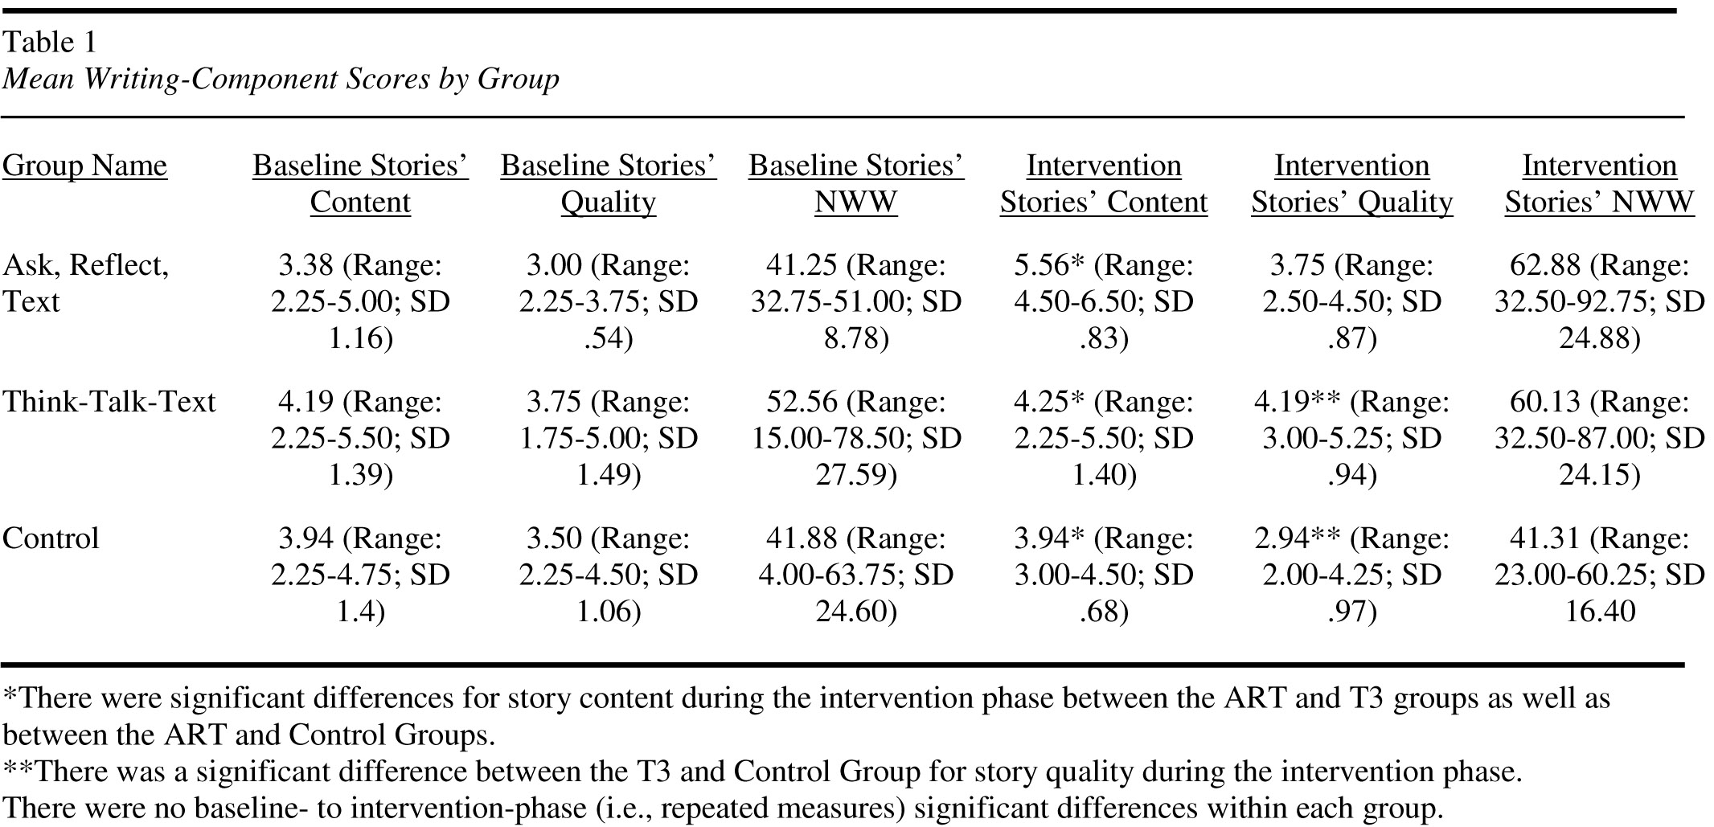

Significant differences computed amongst groups resulted between ART (Dunn & Finley, 2008) and T3 (Katahira, 2012) for intervention story content; T3 also had a significant difference for story quality.
The author computed effect sizes (Cohen’s d; Vogt, 2007; see Table 2) with the following formula: (Mean of the experimental group - Mean of the control group) / standard deviation of ART or T3 (depending on the strategy group being analyzed) and control group subjects.

Table 2. Effect Sizes

Group Name | Story Content | Story Quality | NWW
Ask, Reflect, Text | 1.46 | .85 | .95
Think-Talk-Text | .30 | 1.13 | .87

ART students achieved larger effect sizes for story content and number of words written. T3 students achieved the largest effect size for story quality.

Tables 3 and 4 offer examples of how students demonstrated their use of the ART and T3 strategies. The story prompt was a black and white cartoon picture of a boy looking at a huge pumpkin in his suburban backyard.

In the exit interviews, ART and T3 participants stated that they liked their assigned strategy. Tom, a T3 student, responded this way when asked if he thought his strategy was useful: Yes, because if other children do not think or talk about their ideas first, they would not know how to write a story (December 15, 2010). When Dave was asked if he thought ART could help other children become better writers, he said: Yes. ART would help them use art to plan for writing (December 16, 2010).

Discussion
This study’s purpose was to analyze the story-writing content and quality as well as number of words written of twelve randomly-assigned (ART, T3, and control) fourth-grade students. Significant differences amongst groups for story content and number of words written can be attributed to the ART strategy’s including the WWW, W=2, H=2 cue questions (Graham & Harris, 1989). This component of ART focused children’s attention to specific aspects of their story that needed to be included and helped some of them attain perfect content scores. Improving story quality to a score near seven, however, can pose challenges within the timeline of an intervention study even with 17 sessions.
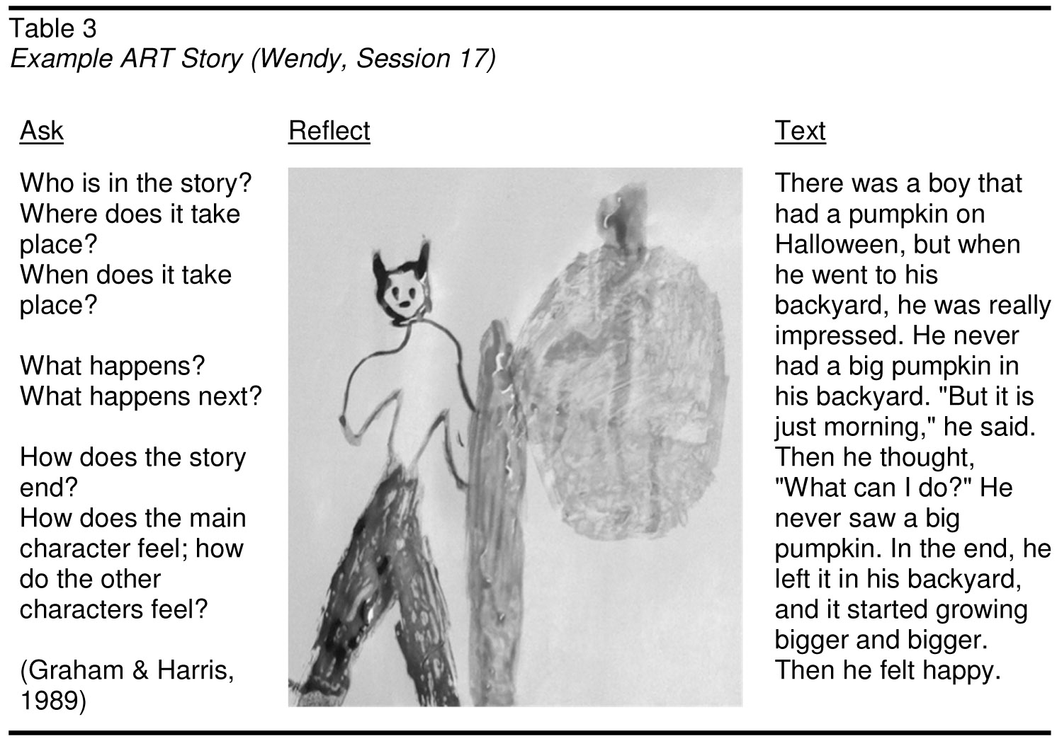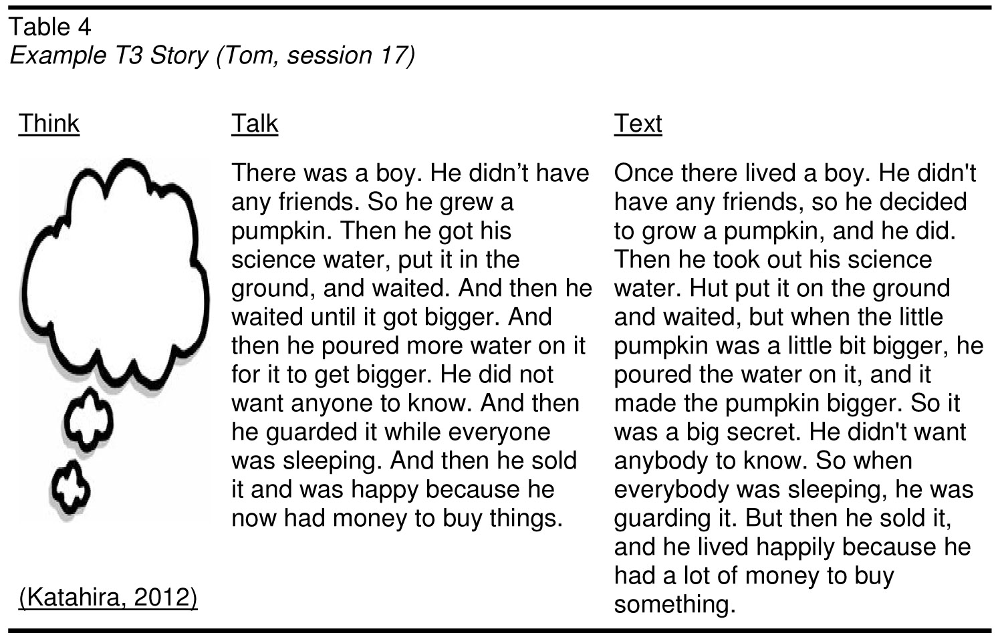

Writing quality is a challenging task which may require multiple intervention phases (such as in RTI; Gresham, 2002; Haager et al., 2007; Jiménez-Glez & Rodrigo-López, 1994) to see improvement in to that of typically-achieving peers and for this level of writing proficiency to be sustained over time.

T3’s significant difference for intervention story quality indicated that verbalizing aloud ideas during pre-writing helped the struggling writers with this aspect of writing. When a student hears a story before writing, the auditory intake can help the child finesse ideas and story structure (Donovan & Smolkin, 2006; Vygotsky, 1986), and in the process, promote story quality. In past research (Author, 2011; 2012a; 2012b), there was little or no improvement in story quality. T3’s significant difference on this measure helps provide insight as to what can help struggling writers in this area.

All of the effect sizes were large (.80 or greater) except for T3’s story content. T3 did not provide students with the specific WWW, W=2, H=2 story content cue questions (Graham & Harris, 1989). The Ask component of ART likely contributed to the larger story content and number of words written effect sizes for this group. However, T3 had a very large effect size for story quality. It would seem, then, that for struggling writers, planning in a verbal format where no visual-motor integration processes are used offer more memory and energy resources to the students to focus on idea generation, phrasing thoughts, and generating more elaborate prose.

The possibility of an alternative or combined ART and T3 mnemonic strategy’s having interaction effect between the Ask and Talk components could offer struggling writers an even stronger means for writing more elaborate sentences (Saddler et al., 2008) and overall text (Polloway et al., 2005). Ifstruggling writersfirst hadtime to verbalize with self-talk about the cue questions for text planning, they could use their mental resources more efficiently for these purposes (Berninger et al., 2008; Lindsay et al., 2007; McCutchen, 2006). This would be a logical topic for a follow-up study.

Limitations
Although students were grouped based on class membership, diffusion (i.e., one group’s learning about another’s strategy) may have occurred while students conversed in common areas or times such as recess. Having student groups at separate schools could have addressed this issue.

Given the small sample size and its having almost only White children as the participant sample, the results should be generalized with caution. The analyses of this project indicate that the strategies were effective for these participants. This does not automatically mean that a more heterogeneous sample would have the same results.

Implications for Practice
Based on the results of this study, this author would suggest two implications for teacher practice. First, both strategies can be implemented in classrooms with no real added monetary cost. This would apply to second-grade classrooms, where story writing typically begins, or older grades. The materials needed involve art media, pencils/pens, and paper, which should all be readily available in classrooms to some extent. Teachers could read about and discuss the two strategies at a grade- or division-level meeting.

Secondly, the results of the study confirm that mnemonic strategy instruction produces gains for struggling writers. They can benefit from explicit instruction as offered in RTI’s paradigm. In the process, offering students time for planning (e.g., art and verbal dialogue) can help them improve their story writing. As writing is part ofliteracy curriculum for students in many countries, a teacher’s step-by-step instruction can help children learn and self-regulate this highly complex task. The language and content of a story may vary, but the process of writing is very similar.

References
Dunn, M. W. (2012a). Response to intervention: Employing a mnemonic strategy with art media to help struggling writers. Journal of International Education and Leadership, 2(3), 1-12.
Dunn, M. W. (2012b). Illustrating story plans: Does a mnemonic strategy including art media render more elaborate text? Journal of Visual Literacy, 31(1), 93-123.
Dunn, M.W., (2011). Ask, reflect, text: Illustrating story plans with art. Journal of Research in Childhood Education, 25(4), 376-389.
Dunn, M., & Finley, S. (2008). Thirsty Thinkers: A workshop for artists and writers. Journal of Reading Education, 33(2), 28-36.
Baker, S. K., Chard, D. J., Ketterlin-Geller, L. R., Apichatabutra, C., &Doabler, C. (2009). Teaching writing to at-risk students: The quality of evidence for self-regulated strategy development. Exceptional Children, 75(3), 303-318.
Berninger, V. (2009). Highlights of programmatic, interdisciplinary research on writing. Learning Disabilities. Research and Practice, 24, 68-79. Invited.
Berninger, V., Richards, T., Stock, P., Abbott, R., Trivedi, P., Altemeier, L., & Hayes, J. R. (2008, summer). From idea generation to idea expression in written composition: Expressing thought in language by hand. British Journal of Educational Psychology Monograph.
Calkins, L. M. (1986). The art of teaching writing. Portsmouth, NH: Heinemann.
Calkins, L., &Martinelli, M., Kessler, T., & Gillette, C. (2006). Units of study for teaching writing: Grades 3-5. Portsmouth, NH: Firsthand Heinemann.
Christie, A. (1977). Agatha Christie: An autobiography. New York: Ballantine Books.
Coleman, J. (2010). Elementary teachers’ instructional practices involving graphical representations. Journal of Visual Literacy, 29(2), 198-222.
Danko-McGhee, K. &Slutsky, R. (2007). Impact of early art experiences on literacy development. Reston, VA: National Art Education Association.
Deno, S. L. (2003). Developments in curriculum-based measurement. The Journal of Special Education,37(3), 184-192.
Dockrell, J. E., Lindsay, G., Connelly, V., & Mackie, C. (2007). Constraints in the production of written text in children with specific language impairments. Exceptional Children, 73(2), 147-164.
Donovan, C. A., &Smolkin, L. B. (2006). Children’s understanding of genre and writing development. In C. A. MacArthur, S. Graham, & J. Fitzgerald (Eds.) Handbook of writing instruction (pp. 131-143). New York: The Guilford Press.
Education Northwest. (2012). 6+1 trait writing. Retrieved February 15, 2012, from http://educationnorthwest.org/traits
Ernst, K. (1993). Picturelearning.Portsmouth, NH: Heinemann.
Harris, K.R., Graham, S., & Mason, L. (2006). Improving the writing, knowledge, and motivation of struggling young writers: Effects of Self-Regulated Strategy development with and without peer support. American Educational Research Journal, 43, 295-340.
Graham, S., & Harris, K. R. (2005). Writing better: Effective strategies for teaching students with learning difficulties. Baltimore: Paul H. Brookes Publishing Co.
Graham, S., & Harris, K. R. (1989). A component analysis of cognitive strategy instruction: Effects on learning disabled students' compositions and self-efficacy. Journal of Educational Psychology, 81, 353-361.
Graham, S., and Perin, D.. (2007a). Writing next: Effective strategies to improve writing of adolescents in middle and high schools – A report to Carnegie Corporation of New York. Washington, DC: Alliance for Excellent Education.
Graham, S., &Perin, D. (2007b). A meta-analysis of writing instruction for adolescent students. Journal of Educational Psychology, 99, 445-476.
Graves, D. (1983). Writing: Teachers & children at work. Portsmouth, NH: Heinemann.
Gresham, F. (2002). Responsiveness to intervention: An alternative approach to the identification of learning disabilities. In R. Bradley, L. Danielson, & D. Hallahan (Eds.), Identification of learning disabilities: Response to treatment (pp. 467–519). Mahwah, NJ: Erlbaum.
Haager, D., Klingner, J., & Vaughn, S. (2007). Evidence-based practices for response to intervention. Baltimore, MD: Paul H. Brookes Publishing Co.
Harris, K. R., & Graham, S. (1996). Making the writing process work: Strategies for composition and self-regulation. Cambridge, MA: Brookline Books.
Hayes, J.R., & Flower, L.S. (1980). Identifying the organization of writing processes. In L.W. Gregg & E.R. Steinbert (Eds.), Cognitive processes in writing (pp. 3-30). Hillsdale, NJ: Lawrence Erlbaum Associates.
Jiménez-Glez, J. E., & Rodrigo-López, M. R. (1994). Is it true that differences in reading performance between students with and without ID cannot be explained by IQ? Journal of Learning Disabilities, 27, 155–163.
Katahira, J. (2012). Note writing in the primary classroom. Retrieved February 15, 2012, from http://www.readwritethink.org/classroom-resources/lesson-plans/note-writing-primary-classroom-285.html
Mason, L. H., Kubina, R. M., & Taft, R. J. (2011). Developing quick writing skills of middle school students with disabilities. The Journal of Special Education, 44(4), 205-220.
McCutchen, D. (2006). Cognitive factors in the development of children’s writing. In The handbook of writing research by C. A. MacArthur, S. Graham, and J. Fitzgerald (Eds.), pp. 115-130. New York: The Guilford Press.
National Assessment of Educational Progress. (2007). Retrieved February 15, 2012, from http://nces.ed.gov/nationsreportcard/
Olshansky, B. (1994). Making writing a work of art: Image-making within the writing process. Language Arts, 71, 350-357.
Polloway, E. A., Patton, J. R., & Serna, L. (2005). Strategies for teaching learners with special needs. Upper Saddle River, NJ: Pearson.
Saddler, B., Behforooz, B., &Asaro, K. (2008). The effects of sentence-combining instruction on the writing of fourth-grade students with writing difficulties. The Journal of Special Education, 42(2), 79-90.
Saddler, B., Moran, S., Graham, S., & Harris, K. R. (2004). Preventing writing difficulties: The effects of planning strategy instruction on the writing performance of struggling writers. Exceptionality, 12, 13-17.
Shanahan, T. (2006). Relations among oral language, reading, and writing development. In C. A. MacArthur, S. Graham, & J. Fitzgerald (Eds.) Handbook of writing instruction (pp. 171-183). New York: The Guilford Press.
Traweek, D. (1993) Teacher and learner variables in early literacy instruction:Treatment, evaluation and ethnographic studies. Ph.D. Dissertation, University of Washington.
Vogt, W. (2007). Quantitative research methods for professionals. Boston: Pearson.
Vygotsky, L. (1986). Thought and Language. Cambridge, MA: The M.I.T. Press.
Watanabe, L. M., & Hall-Kenyon, K. M. (2011). Improving young children's writing: The influence of story structure on kindergartners' writing complexity. Literacy Research and Instruction, 50(4), 272-29.
Word [computer software]. (2010). Redmond, WA: Microsoft Corporation.
Appendix Table
Story Quality Rubric

0 | <blank> | - No text
1 | John go fishing. Happy | - Very short or no text
2 | The egg is fit to crack. The egg is beside the tree. The grass is green. The dots is black. It is black lines. It is with stuff. People is with them. | - Simply describes the picture prompt.  - No sense of story line.  - Uses simple sentences.  - Short amount of text.
3 | There is a house. The people in the house are looking out. There is a space thing. It landed in the people’s yard. So the people are looking out. One person is looking out of the door. The other is looking out the window. They are wondering what it is doing there. They are wondering if it will go away. There are stairs and someone is coming out. It looks like there is a door too. There is a window on it too. And it was going to have to go sometime. | - Simply describes the picture prompt.  - No sense of story line.  - Uses simple sentences.
4 | Me and my friend was watching TV. Then I heard a noise. I looked out the door. My friend looked out the window. We both saw a little spaceship and the little door opened and some stairs came down. On the grass and four little aliens came down the stairs and they was making noise. They came down off the grass and on my porch. They saw someone coming. They thought I was their dad | - Provides some sense of a story line/story structure, but lacks a clear intro and conclusion.  - Grammatical and syntactical errors evident.
5 | It was winter break, and Jack, Peter, and I were having fun. We had just gotten out of school. We were headed for the hills to go sledding. We had our sleds grasped in our hands. We knew we were going to have fun. We were bundled up in scarves, sock hats, mittens, socks, and snow boots. It was really cold outside. We started sledding down the icy hill. Lucy went up the hill, but didn’t make it far. She went down the hill backwards. Carlos and Suzanne ran after her to catch her. After Lucy hits a tree she said it was fun. We ran and played in the snow for hours. | - Some evidence of an introduction, main event, and conclusion.  - No use of paragraphs.  - No use of voice.  - Grammar and punctuation mostly correct.
6 | On Saturday, while walking at the park, Paul found a strange egg. This is huge! He said.  The next day, he went back to check on the egg. Before his very eyes, the egg hatched. Out came a baby dinosaur! He fed and watered it every day. He fed it some meat scraps from dinner. Later, he found a map. It showed a buried treasure! He quickly rode his bike there. He went inside a cave. He slowly proceeded with caution. He found a spade and started to dig around. After a while, He found an iron chest plated with copper. It asked Sharp Tooth, my dinosaur, to open the chest. He did. Inside was a magnificent emerald gem. It started glowing. Suddenly, his pet dinosaur, Sharp Tooth, started growing and sprouting wings. He flew Paul and his bike back home. Then Sharp Tooth flew off to a distant land. Paul hurried home to find a magnificent sapphire gem. He grinned. He went to the local gem trader and priced the gem. It was worth millions! Of course, he sold it and became a happy rich man. | - Introduction, main event, and conclusion are evident.  - May employ some use of paragraphing.  - Some use of voice.  - Grammar and punctuation mostly correct.
7 | Jack’s Trip to the Fair  For his tenth birthday, Jack wanted to invite two of his friends, Ben and Larry, to go to the fair that coming Saturday. With his mother’s help, Jack wrote the words and made the illustrations on the cards. He took them to school the next day to give to his friends. Ben and Larry told Jack the next day that their parents were ok with them going to the fair.  On Saturday morning, Jack ran outside to check the weather and was relieved to see a bright blue sky. His mother said, Well, it looks like a perfect day for a day at the fair. After breakfast, we can drive to your friends’ homes to pick them up.  As Jack and his mother drove to the Ben and Larry’s street, Jack noticed some dark clouds forming in the sky. Oh, I hope it isn’t going to rain, he said, remembering that the fair was no fun last year when it rained.  The rain and wind began as Jack and his mom pulled into Ben’s driveway, he and Larry got in the car. By the time they arrived at the fair, it was sprinkling but the clouds were passing and sunshine was in sight.  Get your tickets to enter the fair here! a man yelled as he pointed to the entrance gate. Jack’s mother gave him a hug and said, I am so pleased that the rain has ended and the sunshine is back. I know how much you wanted t come to the fair today with Larry and Ben.  After passing through the entrance gate, Jack saw four more of his friends gathered at the ice cream tent. When they spotted Jack, they cheered and began to sing Happy Birthday. Jack, Ben, and Larry ran to greet their classmates. Jack was surprised to find a table with an ice cream cake and some presents. After eating some hot dogs and some cake, the boys began going on some of the rides and visiting the animal barns.  Jack had a great day with all of his friends! I love going to he fair, Jack told them. We do too! They all agreed that they wanted to come back another time someday. | - Clear introduction, main event, and conclusion.  - Use of paragraphs.  - Use of voice.  - Almost completely correct use of grammar and syntax.

