IMPACT OF CHESS TRAINING ON MATHEMATICS PERFORMANCE AND CONCENTRATION ABILITY OF CHILDREN WITH LEARNING DISABILITIES

Markus Scholz,

University of Leipzig
Harald Niesch,
Franz-Mehring secondary school, Leipzig
Olaf Steffen,

Centre for therapy of dyscalculia, Leipzig
Baerbel Ernst,

Psychologic centre of consulting, Leipzig

Markus Loeffler,

University of Leipzig
Evelin Witruk,

University of Leipzig
Hans Schwarz,

University of Applied Sciences of Esslingen

The aim of this study is to evaluate the benefit of chess in mathematics lessons for children with learning disabilities based on lower intelligence (IQ 70-85). School classes of four German schools for children with learning disabilities were randomly assigned to receive one hour of chess lesson instead of one hour of regular mathematics lessons per week for the duration of one school-year. Concentration and calculation abilities of children were measured before and after the year of study using standardised tests. The chess group was compared with the control group without chess lessons.
Concentration abilities and calculation abilities for written tasks and gap tasks developed equally well in both groups. Calculation abilities for simple addition tasks and counting improved significantly more in the chess classes.
We conclude that chess could be a valuable learning aid for children with learning disabilities. Transfer of chess lessons to improvement of basic mathematics skills has been observed.

Introduction
Chess is a game with a complex rule structure and the individual level of playing depends on the representation of this rule system and its anticipation and creative use during the game. The question, whether a transfer can be assumed from chess to other cognitive abilities and knowledge is discussed with opposite results (Gobet and Campitelli [in press], Saariluoma [2001]). Our investigation is based on the assumption of transfer potentials of chess on mathematics skills and concentration abilities in a group of children with learning disabilities.

Mathematics as a school subject is looked at with aversion by many school children because of abstractness and difficulties in finding applications in real life. This problem is even more fatal for children with lower intelligence, attention deficit disorder, or learning disabilities, especially dyscalculia, which often occur in combinations (Lindsay et al. [2001], Lindsay et al. [1999]). For these children, special support is necessary in the framework of special schools with adapted teaching concepts.

The target group of our investigation is integrated into schools for children with learning disabilities and represents the largest group of school people with learning difficulties in Germany (2.38% of children among a total of 6.00% of school people with learning difficulties). This group is defined by a persistent and global school failure mainly on the basis of lower intelligence (IQ between 70 and 85) (Charlton et al. [1986], B. Ernst personal communication). There is ongoing research to clarify how the approach to numbers could be facilitated for these children, how dealing with quantities and relations could become a personal need and how the rules of abstract quantities can be visualized in real life.

There is some evidence that complex games such as chess could have a positive impact on these processes. In psychology chess is investigated under different paradigms. Chess is considered as a model for cognitive processes and abilities such as perception, information management, attention, memory, logical thinking and problem solving (Gobet and Simon [1996], Grossen [1991], Horgan [1987]). These processes were measured during the game, as individual preconditions of the chess players and as learning effects of playing chess as well (Chase and Simon [1973], Charness [1992], Frank and D'Hondt [1979], Horgan [1987], Margulies [1991], Munzert [1993]).
- The question about special cognitive abilities of chess players is an old one. Doll and Mayr (Doll and Mayr [1987]) compared chess masters with a non-chess-playing control group and found that in the master group there is significantly higher general intelligence, higher information processing capacity, working speed and numerical thinking. But surprisingly, the master group did not perform better in visuo-spacial tasks. In accordance, Frydman and Lynn (Frydman and Lynn [1992]) found that in a sample of chess playing children (about 11 years) the general IQ (Wechsler Intelligence Scale) was significantly higher in comparison to the population mean, which is constituted by significantly higher performance IQ and verbal IQs of the chess players.
- Most of psychological studies are interested in the long-term effects of chess on the players in the sense of transfer. Chess playing can lead to different transfer effects. Transfer is defined as carrying over former learned reactions or knowledge to a new or changed situation or requirement. Transfer of learning occurs when learning in one context or with one set of materials impacts performance in another context or with other related materials. These transfer effects can be described on the basis of the following, not independent aspects:
Positive transfer means an advantage for a later learning process. In this sense the effects of chess have been investigated and the results are showing a different, partly opposite picture (Saariluoma [2001]).
Negative transfer implicates a disadvantage for a later learning process in the sense of proactive inhibition or interference. Chess was never discussed regarding this aspect.
Lateral transfer describes an advantage for a later learning process on the same cognitive level but in other contexts. This effect is named as low road transfer by Salomon and Perkins (Salomon and Perkins [1989]) as well as Perkins and Salomon (Perkins and Salomon [1992]) and as low-level gains by Gobet and Campitelli (Gobet and Campitelli [in press]). Low road transfer happens when stimulus conditions in the transfer context are sufficiently similar to those in a prior context of learning to trigger well-developed semi-automatic responses. These responses are not necessarily mediated by external or mental representations. Examples are learning from specific chess positions and the transfer to similar positions (Didierjean at al. [1999]). Here no abstraction is necessary. The improvement of concentration abilities through chess playing is also a lateral transfer (Gobet and Campitelli [in press]). Schneider et al. (Schneider et al. [1993]) found a very near, lateral transfer on working memory in chess playing children comparing with non-chess-playing adults for briefly presented chess positions but not for the recognition of digit lists. In general, stimulation of gaming by individual training or within groups can improve the concentration ability of children (Barchmann et al. [1991], Ortner [1991]).
Vertical or hierarchical transfer means an advantage for a later learning process on a higher level. In chess research, this phenomenon is studied as generalisation or abstraction effect. In the model of Perkins and Salomon (Perkins and Salomon [1992]) it is named “high road transfer” and depends on mindful abstraction from the context of learning or application and a deliberate search for connections: Such transfer is not automated. It requires time for exploration and the investment of mental effort. This generalisation effect has been found in several studies regarding chess. For example Marmeche and Didierjean (Marmeche and Didierjean [2001]) and Didierjean and Marmeche (Didierjean and Marmeche [2003]) showed that better chess players had a higher level of generalisation of chess rules than chess players with lower chess playing levels. Feldhusen (Feldhusen [1992]) showed a stronger transfer of chess to poetic analysis for students with intelligence above average in comparison to students with average IQ. Margulies (Margulies [1991]) reported improvement of reading skills by chess training. Gobet and Campitelli (Gobet and Campitelli [in press]) reported about so-called “high level gains of chess” in the sense of improvement of intelligence, creativity and school performance.
The sequential transfer implicates a mixture of lateral and vertical transfer effects during training or a lecture course. That is, during a sequence of lessons an advantage for later learning processes will be induced by clear principles of the time scheduling, by the stability and availability of mental representations or schemata and by the increased process of generalisation. High level gains of chess are based on this sequential transfer in most cases.
A specific transfer is based on similarities in both demands. The advantage in the second task can be explained by using the experience obtained in the first task. For chess novices, learning from examples as a case-based transfer is described by Didierjean et al. (Didierjean and Marmeche [1999]).
An unspecific transfer implicates an advantage for a different domain with no similarities between both tasks. Gobet and Campitelli (Gobet and Campitelli [in press]) reported about these unspecific transfer effects of chess on learning to lose, learning that improvement comes with learning and on the interest on school in underprivileged environments. Furthermore, chess may motivate children for independent activities and occupation with books and computers (Vail [1995]).
The explanation of the different aspects and kinds of transfer is based on the theory of identical elements in both performances (Thorndike and Woodworth [1901]), the theory of formal education, the theory of generalisation (Judd [1908]) and the transposition concept.

Positive findings of different kinds of transfer suggest that it is a question regarding the conditions of working or learning whether transfer occurs or not. One needs to ask under what conditions transfer appears. Positive conditions of transfer are described by Perkins and Salomon (Perkins and Salomon [1992]) in five main aspects of working conditions, which can be stimulated by teachers, parents, partners or trainers. These five aspects involve: Thorough and diverse practice, explicit abstraction, active self-monitoring, arousing mindfulness and using metaphor or analogy.

On the other hand, most of the findings summarized above are based on studies with selected children of normal or higher intelligence or even chess masters. Transfer studies with children of lower intelligence or learning disabilities or on the basis of mandatory teaching of chess in school classes have not yet been performed to a larger extent but there is ongoing research (e.g. Hong and Bart [2007], Pogrow [1988], Storey [2000]). Based on empirical experiences with chess teaching in mathematics lessons collected in one school for children with learning disabilities (Niesch and Schwarz [2004]), we started a study in four such schools in the city of Leipzig, Germany, and its surrounding area.

In our study we asked for relatively specific, positive, sequential and low road transfer of chess in the special group of children with learning disabilities to two domains. Firstly, chess playing needs a high level of attention. Over a chess training of one year we expected a transfer to higher concentration ability. Secondly, at the same time, we expected a positive transfer to basic mathematical skills of the children such as counting and addition of numbers with one to two digits. The latter one is assumed because of several direct mathematical aspects within chess such as elements of geometry e.g. by dealing with distances and metrics, set theory e.g. by abstraction of different pieces which belong to one group and counting with fields and pieces (Gik [1986], Soltis [1994]). Therefore, we performed standardized concentration tests and test of basic calculation abilities before and after the year of the study to quantify the effect of chess lessons for the improvement of concentration and calculation abilities of the children, and compared the results with a control group without chess lessons. Another aim of this study was to evaluate the feasibility of chess lessons in our schools, which includes the practicability of developed chess-teaching material, also for non-chess-playing teachers and the chess playing abilities of children after one school year of practising.

Method

Participants
The schools for children with learning disabilities included into this study are a part of the general educating school system in Saxony, Germany for children with learning disabilities. Children visit this school from the beginning, or switch to it later because of a persistent and global school failure mainly on the basis of lower intelligence (range of IQ 70 to 85, Charlton et al. [1986], B. Ernst personal communication).

School classes are much smaller than in regular schools (8 to 13 children), and teaching methods are specialized for the difficulties faced. The study was initiated in seven classes of four such schools in Leipzig and its surrounding area with third and forth graders (two classes in each school except for one with only one class) in the autumn of 2004. School authorities and parents of children were informed and gave consent to the study.

Study design
The study duration was one school year. In the schools with two classes, one of the classes had been selected randomly and received one hour of chess lessons instead of one hour of regular mathematics lessons per week. In the following, we denote this group as the experimental group. The other classes continued to receive the planned five regular lessons of mathematics per week so that it can be considered as a control group. In the school with only one class, the class also received chess lessons. Concentration and calculation abilities of children were measured in the beginning (pretest) and at the end of the year of study in all classes (posttest). We used the same tests as pre- and posttest in order to guarantee comparability of the results.

Content of chess lessons
The basis of the chess lessons was a method especially designed for children, and was published elsewhere (Beltz and Niesch [1995]). It starts with becoming familiar with the board and the pieces, the rules of movement, and the value of the pieces. The next steps are simple mate-tasks to be solved which are combined with mathematical relations or tasks. We illustrate this with an example: Paul has nine red, five green, three blue, and three yellow balls. Sven has nine red, five green, and four white balls. How many more balls than Sven does Paul have? In general, this is a very hard task for our children with learning disabilities because of the abstraction that the balls must be considered as equal. Visualized on the chess board (see diagram 1), the task reads as follows: Who has more material, Paul (white) or Sven (black), with the solution Paul as 9 (Queen) + 5 (Rook) + 3 (Bishop) + 3 (Knight) = 20 and Sven has 9 (Queen) + 5 (Rook) + 4 (four pawns) = 18. Paul has the lead by two.
Another task is to checkmate in one turn which can be solved by trying out all four possibilities of putting the opponent in check. Only after completion of the chess basics, the playing of real games started followed by learning the notation of a game.
Complete teaching material can be provided after request.

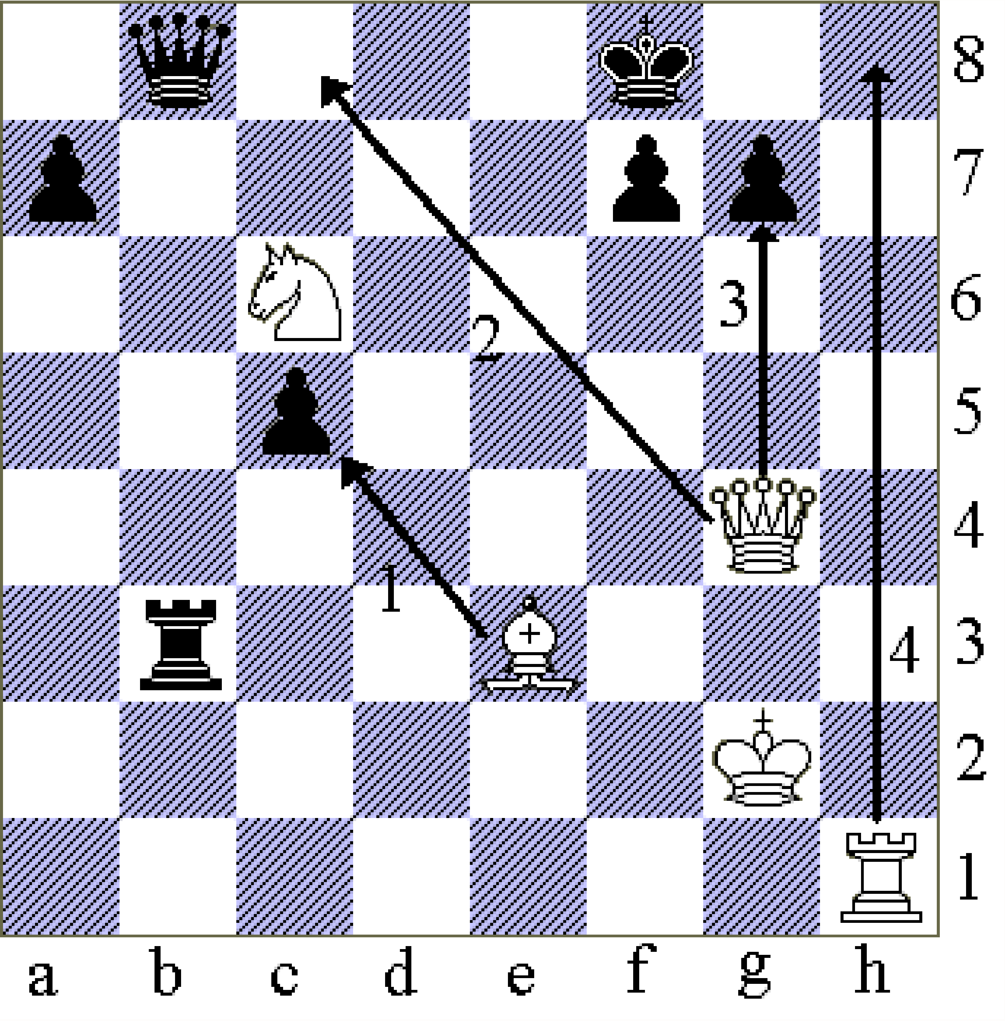
Figure 1.
Example for a mathematical task with respect to a chess position used as a training task in the experimental group: “Who has more material?” (Queen = 9 Points, Rook = 5 Points, Bishop and Knight = 3 Points, Pawn = 1 Point); Another task is to find the possible mate by testing all possible checks.

Measurement of calculation abilities in the pre- and posttest
The calculation abilities of the children were measured with a personal qualitative test for diagnostics of calculation difficulties and dyscalculia (Steffen). The test contains simple tasks with respect to comparison of sets (1 task), comparison of numbers (1 task), counting (1 task), simple calculations (addition and subtraction with numbers up to two digits – 13 tasks), tasks in written form (11 tasks, example Doris is 4 years old. How old is she in 5 years?), and gap tasks (8 tasks, example ⁪+1=5). A qualitative analysis of errors is performed using the method of loud thinking which reveals the algorithm used to solve the problem. From there, conclusions can be drawn about the understanding of mathematical contents and operations. With this method it is possible to decide whether the child has understood the underlying mathematical concepts of a task or not, or whether it uses, for example, compensation techniques such as finger or ruler counting.

For the evaluation of the calculation test, it was necessary to have children which participated in both tests, before (pretest) and after the study period (posttest). 53 children participated in both tests and were eligible for further analysis; 31 in the experimental group, and 22 in the control group. Characteristics of these children can be found in table 1.
Table 1
Characteristics of children eligible for the evaluation of the calculation test; for quantitative traits mean and standard deviation (SD) are provided
Group | Number of children | Sex  (male/  female) | Mean of Grade | Handed-ness (right/  left) | Age at pre-test in years (SD) | Age at post-test in years (SD) | Time between pre- and posttest in years (SD)
Experimental Group | 31 | 22/9 | 3.7 | 25/6 | 10.2 (0.70) | 11.2 (0.70) | 1.00 (0.05)
Control Group | 22 | 13/9 | 3.7 | 19/3 | 10.4 (0.65) | 11.4 (0.59) | 1.02 (0.12)

The age of the children at the time of the pretest was 10.2 in the experimental group and 10.4 in the control group – which is not significantly different (p=0.38, t-Test). Because of the fact that the calculation test is based on an individual talk, the tests could not be performed simultaneously, resulting in different time differences between the two tests. The experimental group had a time difference of 1.00 years between pre- and posttest and the control group of 1.02 years -- which is not significantly different (p=0.57, t-Test). The difference of the ages at the time of the posttest was also not significant (p=0.33, t-Test). Furthermore, the two populations do not significantly differ with respect to sex (p=0.39, Fisher-Test), handedness (p=0.72, Fisher-Test) and grade (p=1, Fisher-Test).

Measurement of concentration abilities in the pre- and posttest
The concentration ability was measured with the help of a standardized test (Kleber et al. [1999]) which can be traced back to Bourdon (Bourdon [1885]). It is a cross-out test where special kinds of symbols in a list must be marked in one way and other symbols must be marked in another way. Children were motivated by a fairy-tale. The duration of the test was 21 minutes. Number of symbols worked out, and number of errors (wrong marking of any symbols) relative to the number of symbols worked out, were measured as quantitative and qualitative measures of concentration ability.

Because of a fire alert, the test for concentration abilities was disturbed in one school. Although the test has been repeated, we decided to discard the results from further analysis since the children showed low compliance. Because of this accident, a total of only 30 children in three schools were eligible for comparison; 20 in the experimental group and 10 in the control group. Characteristics of children can be found in table 2. This study sample is not a subset of the sample evaluated for the calculation test but intersects with it partially.
Table 2
Characteristics of children eligible for evaluation of the concentration test; for quantitative traits mean and standard deviation (SD) are provided
Group | Number of children | Sex  (male/  female) | Mean of Grade | Handed-ness (right/  left) | Age at pre-test in years (SD) | Age at post-test in years (SD) | Time between pre- and posttest in years (SD)
Experimental Group | 20 | 15/5 | 3.7 | 15/5 | 10.0 (0.63) | 10.8 (0.63) | 0.83 (0.02)
Control Group | 10 | 6/4 | 3.3 | 8/2 | 10.0 (0.55) | 10.8 (0.54) | 0.82 (0.02)
At the time of the concentration pretest, children in the experimental group had an age of 10.0 years and in the control group of 10.0 years, which is not significantly different (p=0.96, t-Test). The time between the two tests and the age at the concentration posttest was also equal, since the tests were performed almost simultaneously in all classes. Finally, the two populations do not significantly differ with respect to sex (p=0.43, Fisher-Test), handedness (p=1, Fisher-Test) and grade (p=0.06, Fisher-Test).

Statistics
For the evaluation of the calculation tests we counted the number of right tasks in written form and right gap tasks. We determined the differences of these quantities within one year and compared it between the experimental group and the control group. Influence of the chess lessons and other covariables such as school affiliation, age, sex, time between pre- and posttest and starting performance on these quantities were evaluated univariately by ANOVA (analysis of variation). The starting performance is used as covariable in order to adjust the analysis with respect to that level, which can be assumed to be predictive for the final results. Furthermore, the effect of chess lessons has been estimated multivariately by mixed model analysis adjusting for the covariables (school affiliation considered as a random factor).

For the tasks with respect to sets, counting and simple calculations, we defined a score (“0” – answer is wrong, not compensated calculation disability, “1” – answer is right, but was generated by any disability compensating technique, compensated calculation disability, “2” – answer is right, by knowledge or calculation) before and after the year of study which results in contingency tables. We analysed the change of the score within the year of the study univariately with Fisher’s exact test and, multivariately with the help of an ordered categories logistic regression model including the observed covariables (see above). The effect of the group affiliation is measured by an odds ratio. When this ratio is greater than 1, the experimental group improved their results stronger than the control group averaged over the observed covariables.
The concentration data were evaluated in the same manner as the calculation data for written tasks and gap tasks.
Calculations were performed using the statistical software packages SPSS (© 1989-2003, SPSS Inc., Chicago IL, USA) and SAS 9.1 (© 2002-2003, SAS Institute Inc., Cary, NC, USA).

Results

Feasibility of the study
The chess lessons were performed successfully. That is non-chess-playing teachers got along well with the teaching material provided. Feedbacks from teachers were positive throughout. All children learned the rules of chess and proved their knowledge successfully in a test by achieving a so-called chess-diploma. They also were able to learn the notation of the game. Some of them took part on a chess tournament for children in the city of Leipzig which implied chess playing, notation of the game and operation of the chess clock simultaneously.

Test for calculation abilities
Results for gap tasks and tasks in written form
Before the start of the chess lessons, performance for gap tasks were not different between the experimental group and the control group (p=0.10, U-Test). But the experimental group performed weakly significantly better in tasks in written form in comparison to the control group (p=0.037, U-Test). In the posttest, children improved their results for both forms of tasks (p<0.001 for both tasks, Wilcoxon-Test), indicating an overall beneficial effect of the passed school year. By ANOVA we found that for gap tasks only starting results (p<0.001, F-Test) and for tasks in written form only school affiliation (p=0.04, F-Test) and starting results (p<0.001, F-Test) had a significant influence on the improvement of performance -- which is defined as the difference of final results and starting results. Influences of time difference between pre- and posttest, age, sex and experimental group affiliation were not significant (time difference and gap tasks p=0.11, time difference and written tasks p=0.16, age and gap tasks p=0.27, age and written tasks p=0.17, sex and gap tasks p=0.66, sex and written tasks p=0.51, group affiliation and gap tasks p=0.12, group affiliation and written tasks p=0.57, F-Test). Hence, we could not find an ameliorative effect of the chess lessons on the performance of children after the year of study. Multivariate testing adjusting for starting performance, age, sex, time difference between pre- and posttest and starting performance confirmed this finding (gap tasks p=0.40, written tasks p=0.49, F-Test).

Results for sets, counting and simple calculation tasks
The results of these tasks are summarized in two contingency tables (tables 3 and 4). Here, the achieved scores of all counting and calculation tasks of all children in the experimental group (table 3), as well as in the control group (table 4), are presented before and after the year of study. Additionally, their individual changes can be read from the tables.
Table 3
Contingency table of changes of calculation scores in experimental classes (0=wrong answer, 1=compensated non-calculation, 2=known or calculated); in the diagonal from the upper left corner to the lower right corner there are listed the corresponding number of tasks with no changes in performance; the cases above the diagonal showed improvement of score; the cases below the diagonal showed deterioration of scores after the year of study
 | 0 (posttest) | 1 (posttest) | 2 (posttest) | Total
0 (pretest) | 163 | 54 | 31 | 248
1 (pretest) | 32 | 95 | 53 | 180
2 (pretest) | 9 | 16 | 43 | 68
Total | 204 | 165 | 127 | 496

Table 4
Contingency table of changes of calculation scores in control classes (0=wrong answer, 1=compensated non-calculation, 2=known or calculated); in the diagonal from the upper left corner to the lower right corner there are listed the corresponding number of tasks with no changes in performance; the cases above the diagonal showed improvement of score; the cases below the diagonal showed deterioration of scores after the year of study
 | 0 (posttest) | 1 (posttest) | 2 (posttest) | Total
0 (pretest) | 139 | 42 | 16 | 197
1 (pretest) | 44 | 55 | 13 | 112
2 (pretest) | 3 | 16 | 24 | 43
Total | 186 | 113 | 53 | 352

In the test before the start of the chess lessons (pretest), the two groups performed equally well (p=0.23, Fisher’s exact test for comparison of the right columns of table 3 and 4). However, after the year of study the groups performed differently. The difference is highly significant (p<0.001, Fisher’s exact test for comparison of the last rows of table 3 and 4) in favour of the classes with chess lessons. This effect can be detected easily by comparing the cases below and above the diagonal of the tables 3 and 4. While the control class showed an almost perfect balance between improvements and deteriorations, the classes with chess lessons showed a clear shift towards improvements (see also figure 2-next page).

A more sophisticated analysis by a ordered categories logistic regression model confirmed the result of a strong ameliorative effect of the chess lessons -- also after adjustment to the starting values, age, sex, time difference between pre- and posttest and school affiliation. We calculated an odds ratio of 2.35 (p<0.001, Likelihood-Ratio Test), favouring the experimental group by achieving a “2” in comparison to “0” after the year of study and of 1.73 (p=0.016, Likelihood-Ratio Test) favouring the experimental group by achieving a “2” in comparison to “1” respectively. The odds for achieving a “1” in comparison to “0” are again higher for the experimental group but not significantly different to the control group (odds ratio of 1.36, p=0.09, Likelihood-Ratio Test).

Test of concentration abilities
In the pretest, children in the experimental and in the control group performed equally well with respect to the number of symbols worked out (p=0.93, U-Test) and the error rate (p=0.48, U-Test). After the year of study, children had improved their quantitative performance by working out an increased number of symbols (p<0.001, Wilcoxon-Test), but not their qualitative performance measured by the error rate (p=0.12, Wilcoxon-Test).
The difference of qualitative and quantitative performance between the first test and the second test was significantly influenced by the starting performance (qualitative p<0.001, quantitative p=0.0038, F-Test), but not by school affiliation (qualitative p=0.76, quantitative p=0.66, F-Test), age (qualitative p=0.77, quantitative p=0.84, F-Test), sex (qualitative p=0.52, quantitative p=0.32, F-Test) or the study group affiliation itself (qualitative p=0.27, quantitative p=0.53, F-Test), indicating that the chess lessons had no influence on the change of concentration abilities.
Multivariate mixed-model analysis adjusting for starting performance, age, sex and school affiliation confirmed this finding (qualitative p=0.22, quantitative p=0.96, F-Test).
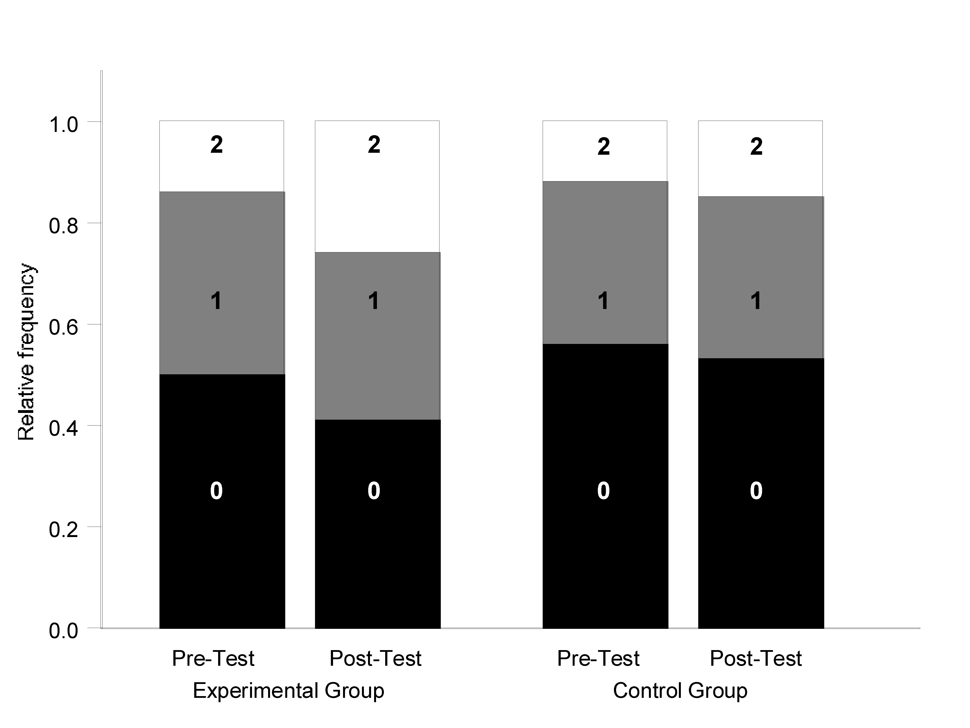
Figure 2.
Comparison of the abilities between experimental and control group with respect to sets, counting and calculation tasks (0=wrong answer, 1=compensated non-calculation, 2=known or calculated). In the pretest both groups showed equal results. In the posttest the experimental group showed clear improvements while the control group showed only small improvements.

Discussion
In the framework of a study in schools for children with learning disabilities, we introduced chess as an element of mathematics lessons in some of the classes. After the year of study we compared the improvements of calculation and concentration abilities of children between the experimental group receiving chess lessons instead of one hour of regular mathematics lessons per week and a control group receiving only regular mathematics lessons. We found a clear advantage of the experimental group with respect to improvement of basic mathematics skills such as counting and addition. To our knowledge, this is the first study which investigated the impact of chess lessons in classes of children with learning disabilities.

Experimental and control groups were selected randomly and chess lessons were mandatory for the experimental group. The aim of this comparative approach was to affirm or query the rationale for the specific teaching method of chess in mathematics lessons for children with learning disabilities. Our working hypothesis was that there is a sequential, low road transfer of chess to higher attention abilities and higher basic mathematics skills of children with learning disabilities. It was the aim of our study to investigate this transfer not on an individual level but on the class level, which in our opinion is more interesting in order to establish this new teaching concept in regular class-based education rather than in individual training of selected children.

The process of the study went without any problems and proved to be feasible for both teachers with no prior chess knowledge and children as well. We received only positive responses in accordance with other experiences with chess in schools (Vail [1995]).

We evaluated the improvements of concentration and calculation abilities of children within the year of study. For the analysis, we made the simplification that tasks are independent of each other. Furthermore, we summarised tasks of the same category (gap tasks and written tasks) in order to avoid multiple testing.

The experimental group and the control group were balanced with respect to age, sex, handedness, grade, time difference between pre- and posttest and all results in the pretests except for a slight imbalance with respect to tasks in written form favouring the experimental group. Hence, the two cohorts were comparable in general. Nevertheless, in all comparisons between the groups, we adjusted for these covariables in a multivariate analysis except for handedness because of a very small proportion of left-handers. Additionally, we adjusted for school affiliation.

We found that with respect to tasks in written form, gap tasks, and concentration the development of experimental and control group was equal within the year of study. Hence, we found no evidence for a low road transfer of chess to these skills. Reasons for these results could be that the study duration of one year was too short to discover an effect (Hong and Bart [2007], Pogrow [1988]). Furthermore, in the study of Christiaen and Verhofstadt-Deneve (Christiaen and Verhofstadt-Deneve [1981]) it has been shown that chess might improve only selected cognitive abilities in schoolchildren which possibly were not measured by the tests. Finally, performance for tasks in written form could be impaired by reading disabilities, and gap tasks require a certain degree of abstraction which possibly cannot be addressed with chess teaching. On the other hand, the loss of one regular mathematics lesson could at least be compensated by the chess lessons.

In contrast to these results, the performance for sets, counting and simple calculation tests has been significantly better improved in the experimental group, despite of the fact that the control group had more regular mathematics lessons. This observation is in agreement with previous studies in children of normal intelligence (Christiaen and Verhofstadt-Deneve [1981], Frank and D’Hondt [1979], Smith and Cage [2000]). But it is in disagreement with the results of Hong and Bart (Hong and Bart [2007]) for students at risk probably due to different measures of skills, smaller sample size or shorter follow-up.

It is interesting to discuss why chess could have the beneficial effect observed in our study. There are different opinions about the crucial points of learning mathematics. Some authors believe that conceptual and procedural knowledge is the basis of mathematics learning (Kaufmann et al. [2003]); others emphasise that the concept of numerosity is important (Butterworth [2005], Shalev [2004]). The latter fact could explain the benefit of playing chess, since sets of equal chess pieces must be summarized, evaluated and compared with sets of other pieces permanently in order to determine the material relation between White and Black as a first criterion of the evaluation of a chess position. This conception fits well in the context of positive conditions for transfer described by Perkins and Salomon (Perkins and Salomon [1992]), since the strength of the chess pieces can be used as a metaphor for numbers.

Another possibility is that learning chess supports some kind of informal handling of mathematical concepts which might be better than formal learning (Nunes [1992]). This has been illustrated within the framework of a study of Horgan (Horgan [1992]) where chess-playing children revealed excellent results in calibration tests in comparison to several control groups. Without knowledge about the concept of joint probability, chess-playing children estimated the chances of winning series better than parents or statistics students, indicating an acquired informal feeling for probabilities, which is even an advanced mathematical concept.

We conclude that chess as an element of mathematics lessons in schools for children with learning disabilities could be a valuable learning aid. Further research is necessary in order to identify skills which can be improved with chess training and to unravel the underlying mechanisms of action of chess training. The highly significant results for a better development of basic calculation abilities in the experimental group are so encouraging that we plan to extend the concept of chess lessons to a larger cohort and to classes of conventional schools as well.

Acknowledgement
We thank the initiative Aktion Mensch, 5000mal Zukunft for the funding to cover the costs of the calculation test. We thank all supporters of that study for their engagement and gratuitous work.

References

