International Journal of Special Education
2002, Vol 17, No.2.

THE USE AND EVALUATION OF COPY, COVER, AND COMPARE WITH REWARDS AND A FLASH CARDS PROCEDURE WITH REWARDS ON DIVISION MATH FACTS MASTERY WITH A FOURTH GRADE GIRL IN A HOME SETTING

Sheila Stone
T. F. McLaughlin
and
Kimberly P. Weber

Gonzaga University

An in-home comparison between the Copy, Cover, and Compare + rewards and flash cards + rewards method of teaching division facts to a fourth grade participant with difficulties in math was examined. The interventions were evaluated with a multiple baseline design across problem lists. The results indicated tha both the Copy, Cover, and Compare method and Flash Cards were successful in increasing correct rate and decreasing errors. These differences were statistically significant. Pre- and posttest data from a list of 90 division math facts revealed a large increase in participant performance. Some generalization of skill acquisition on daily tests was also noted after Copy, Cover, and Compare was introduced. The practical implications of employing these methods with in-home instruction are discussed.

Teaching of math facts is a basic element of the primary grade math curriculum. Research has shown that students with learning problems often use counting strategies (e. g., finger counting or tapping) to solve basic math problems (Lerner, 2000; Skinner, Turco, Beaty, & Rasavage, 1989; Resnick 1989). Such strategies typically result in a general lack of speed in computing math problems, which can dramatically diminish the student's performance of mathematical functions commensurate with peers and the requirements of many math related tasks (Skinner et al., 1989).

Further, math calculation skills are one of the predictors used to assessing success in general academic performance (Haring, Lovitt, Eaton, & Hansen, 1978; Lloyd, 1978). Lloyd (1978) completed several longitudinal studies that found poor academic performance as early as the third grade may later predict school failure and increased risk for eventually dropping out of school. Thus, building fluency (i. e. improving speed), as well as increasing accuracy should improve the likelihood of a student's future academic and vocational success. Immediate recall of facts is superior to using counting strategies, and allows individuals to respond with less effort and more speed across settings (Pieper, 1981; Resnick, 1989). For example, many of the math skills in everyday life in the home and community, or on the job must be performed at a certain speed in order to be considered functional (Hastings, Raymond, & McLaughlin, 1989; Johnson & Layng, 1994; Miller & Heward, 1992; Schloss, Smith, & Schloss, 1990; West, Young, & Spooner, 1990). Further, individuals with deficiencies in math skills may be excluded from certain vocational and career options (Resnick, 1989; Resnick, Wang, & Kaplan, 1973). In addition, automatically recalling basic number facts allows students to devote more attention to more complex math procedures (Binder, 1994; Johnson & Layng, 1994; Resnick, 1989).

INTERNATIONAL JOURNAL OF SPECIAL EDUCATION Vol 17, No.2.

Mastery of math facts has been taught through a variety of procedures. Three programs have been described by Silbert, Carnine, and Stein (1994) and Stein, Silbert, and Carnine (1997). In one system, students are homogeneously grouped first with students practicing new facts orally followed by writing a mixture of old and new math facts. In a second system, a large group of heterogeneous students are homogeneously paired up. One of the pair practices saying current and recent facts from a blank fact sheet, while the partner corrects any errors from an identical sheet with answers. After each student practices the current and recent facts twice, the teacher tests them on each set of old and new facts. In the third system, students are tested on 15 fact flashcards composed of 11 previously mastered facts and 4 unmastered facts. The teacher drills students for 5-10 minutes daily. If each fact and answer are stated correctly within two seconds or less the card goes to the back of the stack. If each fact is incorrect or is given after two seconds the entire math fact is modeled, repeated, and placed only two or three cards back in the pile. In all three systems advancement to new facts is based on student mastery. However, no research evidence as to effectiveness of these systems was provided.

Another procedure which has been used to practice math facts is the Copy, Cover, and Compare procedure initially developed and implemented to teach various basic skills to children with and without disabilities (Skinner, McLaughlin, & Logan, 1997). The use of the Copy, Cover, and Compare procedure has been implemented to teach basic skills to children with developmental disabilities, behavior disorders, and hearing impairments (Pratt-Struthers, Bartalamay, Bell, & McLaughlin, 1994) and to children with learning disabilities (Bolich, Kavon, Williams, McLaughlin, & Urlacher, 1995; Hubbert, Weber, & McLaughlin, 2000; McLaughlin & Skinner, 1995; Murphy, Hern, McLaughlin, & Williams, 1990; Pratt-Struthers, Bartalamay, Williams, & McLaughlin, 1989; Pratt-Struthers, Struthers, & Williams, 1983), and low achievers (McAuley & McLaughlin, 1992). The Copy, Cover, and Compare procedure has been adapted to teach math facts (Skinner et al., 1989). This adaptation requires the student to (1) Copy the problem and solution from a written model, (2) Cover the completed fact and answer and write it from memory, and (3) Compare the result to the original modeled fact. If the child's written response is correct, the student then applies the procedure to the next problem. If the written response is incorrect the entire Copy, Cover, and Compare procedure is repeated until the entire fact and answer is written correctly from memory.

The use of parents, care-providers, or siblings to provide drill and practice in the home has been advocated by several educators (Epstein, 1987; Schultz, 1987; Stading, Williams, & McLaughlin, 1996; Thurston & Dasta, 1990). The use of parents to help their children academically should be structured and organized (Schultz, 1987). One such system to do this has been the use of in-home parent tutoring procedures (Thurston & Dasta, 1990). Thurston and Dasta (1990) found that parent tutoring led to improvements in spelling performance and math flash card performance. Berger, (1981) suggested parents set a specific time and place to work with their children, visit with the teacher, and develop a home-based reward system. Copy, Cover, and Compare procedure that has been widely documented as effective in the classroom for providing drill and practice in spelling and math (Murphy et al., 1989; Pratt-Struthers et al., 1983; Skinner et al., 1989; Skinner, Bamberg, Smith, & Powell, 1993). Copy, Cover, and Compare has easily been adapted for parents and other persons in the home.

The purpose of this study was to determine the effects of a Copy, Cover, and Compare practice procedure (McLaughlin & Skinner, 1996; Murphy et al., 1990; Skinner et al., 1989, 1993) and the use of flashcards for teaching division facts. Four research questions were addressed: (a) Can the Copy, Cover, and Compare procedure be used to teach division facts to a student with learning disabilities? (b) Can the procedure be successfully implemented in a home setting which would further replicate the findings of Stading et al. (1996) with a different skill and adult tutor implementing the copy, cover, and compare procedure? (c) Which drill and practice procedure copy, cover, and compare or flash cards are the most effective in teaching division math facts, (d) Will generalization across skill sets take place? and (e) Will rewards be needed to improve student motivation and performance?

INTERNATIONAL JOURNAL OF SPECIAL EDUCATION Vol 17, No.2.

Method

Participant and Setting
The participant was a 10-year-old-girl with a three year history of difficulty in math. The participant's performance was in the low average range and she was in regular education full-time without any extra assistance for math. Her mother contacted the first author because her child was failing math.

The study was conducted in the participant's home. Sessions were held from 5 to 7 days per week. The interventions occurred in the early part of the evening during the week, or in the morning on weekends. These sessions lasted for 40 minutes.

Dependent Variable and Measurement Procedures
There were three dependent measures employed in the research. A description of each follows.
Number of corrects and errors per minute. The number of corrects and errors for division facts per minute was the primary dependent variable. Three separate lists of division facts were employed. Only basic math facts in division were used. The first list (List A) contained division facts with divisors of 0, 2, 3, and 5. List B contained problems with divisors of 4, 8, and 9. List C contained facts with divisors of 1, 6 and 7. The number of basic facts ranged from 27 to 36. The answers for each problem were single digit. Each problem consisted of a single or double digit dividend by a single digit divisor resulting in a single digit quotient with no remainders. During each session the participant wrote answers from all three lists. Corrects and errors were calculated by dividing the number of problems correct by the time in seconds that it took the participant to complete the work sheet. These data were gathered from the three targeted lists. If the participant finished the list before one-minute, the number of seconds was used to create a fraction. For example, if the participant took 50s to complete the list, the number correct and errors were divided by 0.833. Problems on various lists were presented in a random manner to prevent memorization. The materials required were a copy, cover, and compare sheet, data recording forms, 3-by 5-inch flash cards, and a digital kitchen timer.

Pre- and Posttest. To assess the participant's skills in basic division facts by single digit divisors pre and posttests were administered. The pre- and posttest contained all 90 basic division facts. The child was timed, but allowed as much time as needed to complete all 90 problems.

Experimental Design and Conditions
A single subject multiple baseline design across problem lists (Kazdin, 1982) was used to evaluate the effects of the Copy, Cover, and Compare, flash cards, and reward procedures. A description of the various conditions follows.

Baseline. During baseline, the child completed problems from lists A through C. The problem types ranged from 1/0 to 45/9 = n. No specific instruction or corrective feedback was provided during Baseline. The child was told to complete as many of the problems on the lists as she could. Completion of probe sheets lasted for 40 minutes each session. Baseline data were gathered for 3 to 31 days.

Copy, cover, and compare + rewards. At the beginning of this condition, the participant was taught to look at the modeled division fact, and read it aloud as she copied the fact. The model was then covered and she wrote the entire fact from memory. She then compared her fact to the model. If correct, she proceeded to the next fact. If incorrect, the participant repeated the process with the same fact. Again, her performance was assessed using one minute timed tests. This condition was in effect for 3 to 6 days. The child was given rewards for working hard or maintaining a high rate of performance. The rewards employed consisted of pencils, pens, and various low cost trinkets.

Flashcards + rewards During this phase, the participant had to go through a set of flashcards. The same number of problems were used as were employed during baseline or Copy, Cover, and Compare. The tutor (first author) presented the complete set of flash cards without answers three times during each session. The same problems on all three lists were presented. At the end of each practice session, a one

INTERNATIONAL JOURNAL OF SPECIAL EDUCATION Vol 17, No.2.

minute timed test for each list was given. This condition was in effect for 5 to 30 sessions. Again, the participant was provided with rewards for working hard or maintaining a high rate of performance.

Reliability of Measurement
A second independent observer was trained by the first author to assess reliability. The trained independent observer evaluated the participant's accuracy on written answers twice during baseline and four times during the intervention. The number of correct of written responses and errors were also determined using a calculator and timer by both the first author and the independent observer. Interobserver agreement was calculated by dividing the number of agreements per test by the number of agreements plus disagreements and multiplying by 100. Agreement was defined as both observers independently marking it correct or incorrect. A disagreement occurred if one observer marked an answer as correct, and the other observer marked the answer as incorrect. The mean percent of agreement was 100%. For time, the smaller number of seconds recorded was divided by the larger and multiplying by 100. Agreement for time was 99%.

Results

Correct and Error Rate
Figures 1 and 2 show the correct and errors for each set of multiplication problems during Baseline, Copy, Cover, and Compare + Reward and Flashcard + Reward procedure for Lists A through C. These outcomes are described and summarized in Table l.

Compared to baseline, the participant showed improvement during the Copy, Cover and Compare + Reward procedure. Larger increases were noted during the Flash Card procedure across all three lists. In addition, there appeared to be some generalization of material between lists.

Table 1.
The mean and standard deviations by list and experimental condition.
Conditions List Corrects SD Errors SD
Baseline
A 11.68 3.46 2.7 2.339
B 17.373 2.4 1.727 1.131
C 28.916 10.34 1.235 1.625
Copy, Cover, and Compare + Rewards
A 22.22 2.4 .967 .807
B 28.733 2.12 .667 .577
C 49.967 4.572 0.0 0.0
Flash Cards + Rewards
A 42.61 8.766 .287 .56
B 37.086 5.561 .347 .922
C 52.38 7.435 0.0 0.0

INTERNATIONAL JOURNAL OF SPECIAL EDUCATION Vol 17, No.2.
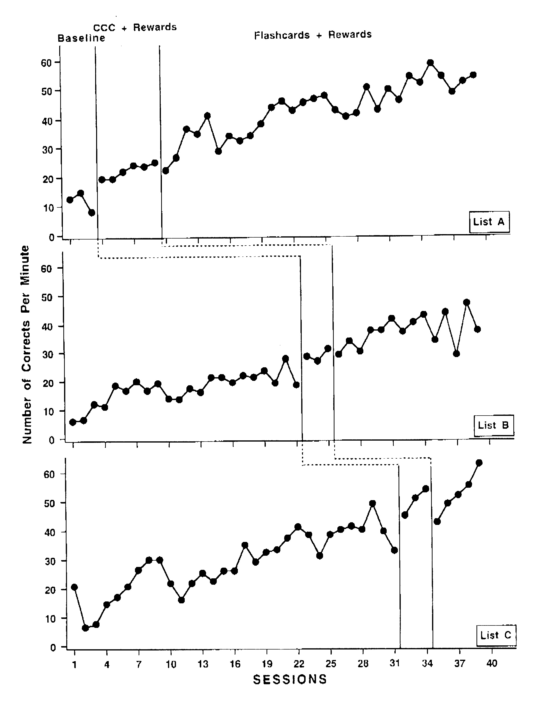

Figure 1.
Correct digits rate for the participant across Lists A, B, and C during Baseline, Copy, Cover, and Compare + Rewards, and Flash Card + Rewards. Solid horizontal lines indicate condition means.

INTERNATIONAL JOURNAL OF SPECIAL EDUCATION Vol 17, No.2.

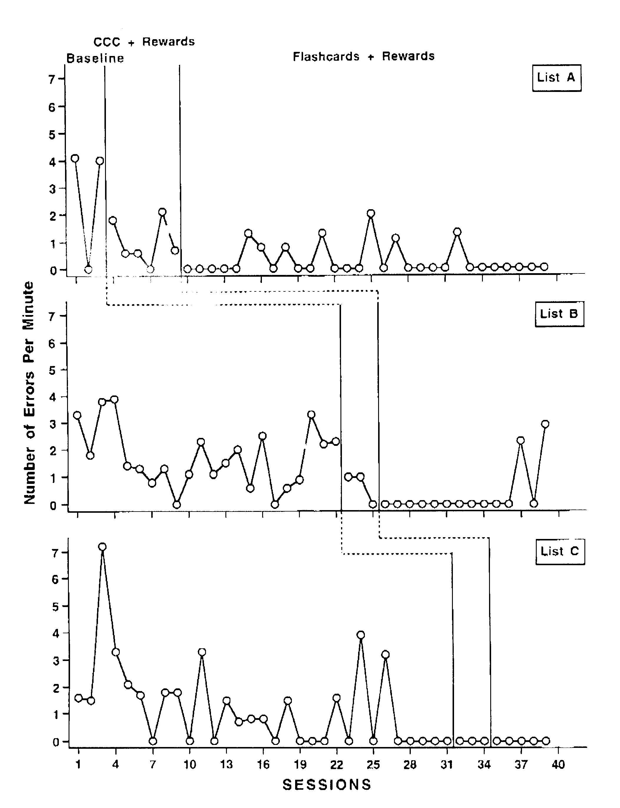
Figure 2.
Error rate for the participant across Lists A, B, and C for Baseline, Copy, Cover, and Compare + Rewards, and Flash Card + Rewards. Solid horizontal lines indicate condition means.

INTERNATIONAL JOURNAL OF SPECIAL EDUCATION Vol 17, No.2.

Baseline data for List A showed a mean of 11.8 for corrects (range 14.8 to 8.0) and 2.3 errors (range 0 to 4.1). During the Copy, Cover and Compare + Reward intervention, accuracy increased for corrects and errors declined for each list. A larger increase was found when flash cards with rewards were employed (See Table 1). A Friedman Analysis of Variance (Siegel, 1956) found a significant difference between the three conditions for corrects in List A (χr2 = 6.0, df = 2, p = .0498), but not for errors (χr2 = 3.551, NS). Follow up tests using Wilcoxon Signed Ranks found a significant difference between Copy, Cover, and Compare and Flash Cards + Rewards for corrects ( Z = -2.201; p = .028).

The baseline outcomes for List B revealed an increase over time for corrects and stable performance for errors (See Figure 2). The mean number of corrects for List B during Baseline was 17.373 and 1.727 for errors. A Friedman Analysis of Variance (Siegel, 1956) found a significant difference between the three conditions for corrects in List A (χr2 = 6.0, df = 2, p = .0498), but not for errors (χr2 = 3.551, NS). Follow up tests using Wilcoxon Signed Ranks found a significant difference between Copy, Cover, and Compare and Flash Cards + Rewards for corrects. ( Z = -2.201; p = .028).

When the Copy, Cover and Compare procedure was employed with List B, accuracy increased to over 10 digits per minute (M = 28.733). Corrects further increased when Flash Cards + Rewards were employed (M = 37.086). Errors were reduced and remained low for the duration of Copy, Cover, and Compare as well as Flash Cards + Rewards (See Table 1 above).

The baseline outcomes for List C revealed an increase over time for corrects and stable and low for errors (See Figure 3). The mean number of corrects during baseline was 28.916, with a mean of 1.235 for errors. A Friedman Analysis of Variance (Siegel, 1956) found a significant difference between the three conditions for corrects in List C (χr2 = 6.0, df = 2, p = .0224), and for errors (χr2 = 6.0; df = 2; p = .0498). Follow-up tests using Wilcoxon Signed Ranks found a significant difference between baseline and Copy, Cover, and Compare + Rewards (Z = -2.201; p = .028) and Flash Cards + Rewards for corrects. (Z = -2.023; p = .0431). With the implementation of the Copy, Cover, and Compare + Reward procedure the child's correct rate increased to a mean of 49.967. Error rate declined to 0.0. For flash cards + reward phase, correct rate increased somewhat (M = 52.38) while errors declined to 0.0 for List C. The only comparison for errors that was statistically different was between Baseline and Flash Cards + Rewards (Z = -2.,023; p = .0431).

Pre and Posttest Data
The data for pre and posttest correct rate for the 90 basic division facts increased. The participant's initial correct rate was 9.7 digits per minute and 2.48 for errors. At the completion of the study, the participant's correct rate increased to 42.9, with an error rate of 0.97 for the 90 basic math facts.

Discussion
These data indicate that the Copy, Cover, and Compare procedure was as effective as Flash Cards in increasing mastery of basic division facts. This replicates the work of several researchers (e.g., Skinner et al. 1989, 1993; Stading et al. 1996). In addition, the Copy, Cover, and Compare + Rewards and Flash Cards + Rewards techniques were shown to be procedures that could be used successfully in the home by a college student to improve the math performance of a friend's child.

The initial generalization between lists for the Copy, Cover, and Compare procedure was not replicated for the Flash Card + Reward phase. Also, little or no generalization was found for errors. This failure to find generalization may be attributed to several factors. Since errors were so low, there was little room for the data to change. The Copy, Cover, and Compare and the Flash Cards practice strategies both produced high rates of correct responding and low rates for errors. The only list where these differences were not significant was for List B. Based on this application, as well as prior studies (Skinner et al. 1989; Stading et al. 1996), both drill and practice techniques were very efficient because once the participant is trained there is little required tutor or parent time involved. The initial effort for the teacher or parent involves
INTERNATIONAL JOURNAL OF SPECIAL EDUCATION Vol 17, No.2.

copying or producing the Copy, Cover, and Compare formatted sheets and the Flash Cards (Murphy et al., 1990; Struthers et al., 1994; Silbert et al.1997). These sheets could be produced with a computer and a copy machine with minimal financial costs. The Copy, Cover, and Compare procedure thus demonstrated effectiveness in terms of time, effort, and money.

The cost of the rewards was low and well within the budget of the parents and first author. The child enjoyed the rewards and looked forward to the sessions in the home. She also earned a passing grade in arithmetic for that semester. Employing a tutor and purchasing small rewards was a small cost for the success that their child was now experiencing in math.

The findings from this study also suggest that Copy, Cover, and Compare and Flash Card procedures should be considered by teachers and parents of children with and without disabilities as a valuable technique. Both techniques can be implemented by adults as a valuable supplemental activity. Using these procedures can dramatically increase the number of opportunities for students to respond. Increased opportunities to respond has been linked to increased achievement by several researchers (Delquadri, Greenwood, Whorton, Carta, & Hall, 1986; Hall, Delquadri, Greenwood, & Thurston, 1982; Maheady, Harper, & Sacca, 1988; Maheady, Sacca, & Harper, 1987; Miller & Heward, 1992; and Thurston & Dasta, 1990) across a wide range of students, as well as subject-matter-areas.

The failure of the two procedures to be counterbalanced reduces the confidence of the differences favoring Flash Cards over Copy, Cover, and Compare. Another research project where these two procedures are either presented in an alternating treatments design or with counter balancing of condition could do much to answer the question of which procedure is superior (Kazdin, 1982).

Further areas of study might include (a) a counterbalanced comparison between Copy, Cover and Compare to a flash card procedure, (b) comparisons of these strategies to other tutorial and practice procedures (e.g., computerized drill and practice programs such as Math Blasters), (c) use of the procedure for students with disabilities and their parents, as well as in other content areas, and (d) monitoring of effects over time, with practical tasks to determine retention and potential generalization of skills at both home and school.

References
Berger, E. H. (1981). Parents as partners in education. St. Louis: C. V. Mosby.
Binder, C. (1994). Measurably superior instructional methods: Do we need sales and marketing? In R. Gardner III, D. M. Sainato, J. O. Cooper, T. E. Heron, W. L. Heward, J. W. Eshelman, & T. A. Grossi (Eds.), Behavior analysis in education: Focus on measurably superior instruction (pp. 21-41). Pacific Grove, CA: Brooks/Cole.
Bolich, B., Kavon, N., McLaughlin, T. F., Williams, R. L., & Urlacher, S. (1995). Effects of a copy, cover, compare procedure and a token economy on the retention of basic multiplication facts by two middle school students with ADD/ADHD. B. C. Journal of Special Education, 19, 1-10.
Delquadri, J., Greenwood, C. R., Whorton, D., Carta, J., & Hall, R. V. (1986). Classwide peer tutoring. Exceptional Children, 52, 535-542.
Epstein, J. (1987). Parent involvement: What the research says to administrators. Education and Urban Society, 19, 119-136.
Haring, N. G.., Lovitt, T. C., Eaton, M. D., & Hansen, C. L. (Eds.). (1978). The fourth R: Research in the classroom. Columbus, OH: Merrill Publishing Co.
Hall. R. V., Delquadri, J., Greenwood, C. R., & Thurston, L. (1982). The importance of opportunity to respond in children's academic success. In E. B. Edgar, N. G. Haring, J. R. Jenkins, & C. G. Pious (Eds.). Mentally handicapped children: Education and training (pp. 107-140). Baltimore, MD: University Park Press.
Hastings, F. L., Raymond, G., & McLaughlin, T. F. (1989). Speed money counting: The use of direct instruction to train disabled and mentally retarded adolescents to count money efficiently. B. C. Journal of Special Education, 13, 137-146.

INTERNATIONAL JOURNAL OF SPECIAL EDUCATION Vol 17, No.2.

Hubbert, E. R., Weber, K. P., & McLaughlin, T. F. (2000). The effects of copy, cover, and compare and a traditional spelling intervention with an adolescent with a conduct disorder. Child & Family Behavior Therapy, 22(3), 55-68.
Johnson, K. R., & Layng, T. V. (1994). The morning side model of generative instruction. In R. Gardner III, D. M. Sainato, J. O. Cooper, T. E. Heron, W. L. Heward, J. W. Eshelman, & T. A. Grossi (Eds.). Behavior analysis in education: Focus on measurably superior instruction (pp. 173-197). Pacific Grove, CA: Brooks/Cole.
Kazdin, A. E. (1982). Single case research designs: Methods for clinical and applied settings. New York: Oxford.
Lerner, J. (2000). Learning disabilities theories, diagnosis, and teaching strategies (6th ed.). Boston: Houghton Mifflin Co.
Lloyd, D. N. (1978). Prediction of school failure from third-grade data. Educational and Psychological Measurement, 38, 1193-1200.
McAuley, S. M., & McLaughlin, T. F. (1992). Comparison of add-a-word and compu spell programs with low-achieving students. Journal of Educational Research, 85, 362-369.
McLaughlin, T. F., & Skinner, C. H. (1996). Improving academic performance through self-management: Cover, copy, and compare. Intervention in School and Clinic, 32, 113-118.
Maheady, L., Harper, G. F., & Sacca, K. M. (1988). A classwide peer tutoring system in a secondary resource room program for the mildly handicapped. Journal of Research and Development in Education, 21, 76-83.
Maheady, L., Sacca, M. K., & Harper, G. F. (1987). Classwide student tutoring teams: The effects of peer-mediated instruction on the academic performance of secondary mainstreamed students. The Journal of Special Education, 21, 107-121.
Miller, A. D., & Heward, W. L. (1992). Do your students really know their math facts? Using daily time trials to build fluency. Intervention in School and Clinic. 28(2), 98-104.
Murphy, J., Hern, C., McLaughlin, T. F., & Williams, R. L. (1990). The Effects of the copy, cover, and compare approach to increasing spelling accuracy with learning disabled students. Contemporary Educational Psychology, 15, 378-386.
Pieper, E., (1981). A technique for discovering LD adolescents' strategies for solving multiplication facts. The Pointer, 27(2), 40-41.
Pratt-Struthers, J. P., Bartalamay, H. R., Williams, R. L., & McLaughlin, T. F. (1989). Effects of the add-a-word spelling program on spelling in creative writing: A replication across two classrooms. B. C. Journal of Special Education, 13, 151-158.
Pratt-Struthers, J. P., Struthers, T., & Williams, R. L. (1983). The effects of the add-a-word system on spelling accuracy during creative writing. Education and Treatment of Children, 6, 277-283.
Resnick, L. B. (1989). Developing mathematical knowledge. American Psychologist, 44, 162-169.
Resnick, L. B., Wang, M., & Kaplan, J. (1973). Task analysis in curriculum design: A hierarchically sequenced introductory mathematics curriculum. Journal of Applied Behavior Analysis, 6, 679-710.
Schloss, P. J., Smith, M. A., & Schloss, S. N. (1990). Instructional methods for adolescents with learning and behavior problems. Boston: Allyn and Bacon.
Schultz, J. B. (1987). Parents and professionals in special education. Boston: Allyn and Bacon.
Silbert, J., Carnine, D., & Stein, M. (1997). Direct instruction mathematics. Upper Saddleback, NJ: Prentice-Hall/Merrill.
Siegel, S. (1956). Nonparametric statistics for the behavioral sciences. New York: McGraw-Hill.
Skinner, C. H., Turco, T. L., Beatty, K. L., & Rasavage, C. (1989). Cover, copy, & compare: A method for increasing multiplication performance. School Psychology Review, 18, 412-420.
Skinner, C. H., Bamberg, H,. W., Smith, E. S., & Powell, S. S. (1993). Cognitive, cover, copy, and compare: Subvocal responding to increase rates of accuracy division responding. Remedial & Special Education, 14(1), 49-56,
Skinner, C. H., McLaughlin, T. F., & Logan, P. (1997). Cover, copy, and compare: A self-managed academic intervention across skills, students, and settings. Journal of Behavioral Education, 7, 295-306.
Stading, M., Williams, R. L., & McLaughlin, T. F. (1996). Effects of a copy, cover, and compare procedure on multiplication facts mastery with a third grade girl with learning disabilities in a home setting. Education and Treatment of Children, 19, 425-434.
INTERNATIONAL JOURNAL OF SPECIAL EDUCATION Vol 17, No.2.

Stein, M., Silbert, J., Carnine, D. (1997). Designing effective mathematics instruction: A direct instruction approach. Upper Saddle River, NJ: Merrill/Prentice Hall.
Struthers, J. P., Bartalamay, H., Bell, S., & McLaughlin, T. F. (1994). An analysis of the add-a-word spelling program and public posting across three categories of children with special needs. Reading Improvement, 31, 28-36.
Thurston, L. P., & Dasta, K. (1990). An analysis of in-home parent tutoring procedures: Effects on children's academic behavior at home and in school and on parent's tutoring behaviors. Remedial & Special Education, 11(4), 41-52.
West, R. P., Young, K. R., & Spooner, F. (1990). Precision teaching: An introduction. Teaching Exceptional Children, 22(3), 4-8.

