The Applicability of Curriculum-Based-Measurement
in Math Computation in Jordan

Bashir Abu-Hamour
Mutah University

Jihan Mattar
University of Jordan

The proper assessment of math computational skills is essential for monitoring progress, predicting achievement, and identifying students with disabilities. The current study extends previous research on assessment of curriculum-based measurement in mathematics(M-CBM) . The purpose of this research was to examine the effects of the M-CBM computation assessment on improving third-grade math achievement. This paper presents a comparison study of two classrooms; one used a M-CBM computation in addition to the summative assessment and one used summative assessment only. Each class consisted of 35 students; three who had a Specific Learning Disability in math. The results of a 15-week CBM process demonstrated the effectiveness of using the M-CBM with third- grade students. Furthermore, when compared to the traditional way of assessment, the use of the M-CBM produced significant gains in students’ achievement, specifically, for the students who were struggling with math.

The Applicability of the Curriculum-Based-Measurement in Math Computation in Jordan
Identifying appropriate ways for teachers to assess students’ skills in the critical areas of reading, spelling, and math is an important goal in helping all students succeed in school. Unfortunately, some assessments that teachers typically use (e.g., informal inventories, teacher-made tests) lack reliability and validity (Spear-Swerling & Sternberg, 1998), and many (e.g., norm-referenced tests) may lack treatment validity. Treatment validity is important because it indicates that the results of a test can be used to guide instruction and improve student performance (Hosp & Hosp, 2003).

Summative evaluation is important as a measure of accountability (i.e., to what degree are students meeting established standards), but does not offer the feedback teachers need to make day-to-day adjustments in their teaching. Unlike summative evaluation approaches where student performance is often evaluated only at one point in time during the academic year, the formative approach to assessment provides an opportunity for teachers to catch problems early and monitor progress throughout the school year (Hosp, Hosp, & Howell, 2007). Researchers have recommended curriculum-based-measurements (CBM) as an alternative assessment procedure for monitoring progress and guiding the selection of interventions (Deno, 2003; Hosp et al., 2007). CBM’s validity and reliability are well established (National Center on Response to Intervention, 2012).

The CBM is considered to be a type of formative assessment. Formative assessment is not a test per se, but instead a process by which teachers use test-elicited evidence to revise instruction for students and help students adjust their own learning strategies (Popham, 2009). The CBM has been used by teachers and school psychologists for over three decades and has been shown to provide reliable and valid indicators of students’ achievement in reading, writing, and mathematics (for reviews, see Deno, 1985; Deno, Fuchs, Marston, & Shin, 2001).
The CBM lays the foundation for profiling specific child strengths and weaknesses and for mapping and evaluating the academic skills rather than the common way of assessing (Bagnato, 2007). Teachers can design interventions that can be proactive and can prevent learning problems from occurring. The CBM used in conjunction with a problem-solving model can be used to target scarce intervention resources to those who need it the most. Moreover, the formative approach using the CBM allows for the on-going evaluation of interventions. Thus, ineffective interventions can be discarded in favor of more effective ones. The CBM and problem-solving teams are proving to be an effective and efficient way to design student interventions and to monitor student's academic progress (Hosp et al., 2007). As compared to reading, not as much is known about the use of the CBM and math performance (Monuteaux, Faraone, Herzig, Navsaria, & Biederman, 2005).

Reading and literacy are often considered the most important skills taught in schools; however, many argue that math is similarly important for life success. Just as the other CBMs, the math CBMs (M-CBMs) provide a reliable and valid way to identify students who are at risk for failure; not making adequate progress given the instruction they are receiving; need additional diagnostic evaluations; or determination of instructional levels (Hosp et al., 2007).

The M-CBMs have been developed for three areas: early numeracy, computation, and concepts and applications. Computation has been the traditional standard of the M-CBM and therefore, has the most research to support its use (Deno, 2003). The computation CBMs were developed to provide a quick and easy method to measure computation performance that would be reliable and relate to outcomes measures. For the rest of the study, when we refer to math CBM (M-CBM), we will be talking about computation only. An overview of the M-CBM use in both general and special education is presented next.

The M-CBM Computation and Students’ Achievement in General Educations
Previous research has demonstrated that teachers who use M-CBM produce greater student achievement than teachers who use other forms of assessment for developing instructional programs (see Fuchs, Butterworth, & Fuchs, 1989; Fuchs & Fuchs, 1991; Shinn, 1989). Christ and Vining (2006) suggested that stratified construction of multiple-skill M-CBM probes would be likely to yield more generalizable and dependable measurement outcomes and found that it was especially robust within the upper primary grades. Another study was conducted by Allinder, Boiling, Oats, and Gagnon (2000) on the effects of the M-CBM measures on students’ achievement. The results indicated that teachers who used the combination of self-monitoring and the M-CBM found that their students demonstrated significantly greater progress than did students whose teachers did not use the M-CBM. In addition, results indicated that the students for whom teachers made instructional adjustments, based on those students' own M-CBM data, performed significantly better on a global achievement test than did their partners whose instructional adjustments were not based on their own assessment data (Stecker & Fuchs, 2000).

Finally, some studies have reported outcomes of relationships between the M-CBM and statewide assessments in math. For example, Helwig, Anderson, and Tindal (2002) examined the effectiveness of a M-CBM concept task at predicting eighth-grade student scores on a computer adaptive test of math achievement designed to approximate a state (Oregon) standardized math achievement measure. Results indicated that the M-CBM task used in this study was effective at predicting scores on the computer adapted test of math assessment for students in general education. In fact, when the data were analyzed using discriminant function analysis, the M-CBM probes predicted with 87% accuracy the students who would meet the state math standards. Helwig et al. noted that assessments such as M-CBM that can accurately estimate progress toward statewide goals in addition to monitoring classroom progress have considerable utility for planning instruction.

The Use of M-CBM in Special Education
Approximately 5-9% of the school-age population may be identified with mathematics disability (e.g., Badian, 1983; Geary, 2004). Comparable prevalence was documented in Jordan as well (McBride, 2007). Studies indicate that students in the United States are not achieving sufficient mathematics skills to meet the demands required of them within and outside of school. Among the keys to preventing mathematics difficulties are to identify and intervene with those students who may be most at-risk for later failure, monitoring their progress as frequently as possible (Clarke & Shinn, 2004; Reese, Miller, Mazzeo, & Dossey, 1997). Continuous monitoring of individual student academic progress has long been an important component of special education (Deno, 1985; Fuchs & Fuchs, 2005).

According to the 21st Annual Report to Congress, students with disabilities have lower math skills than their general education peers. Teachers need a practical and user-friendly method to increase the math achievement of all students, including students with disabilities. One method of increasing math achievement is to monitor progress in basic skills using a method known as CBM (Hosp et al., 2007). The M-CBM represents an empirically supported system of progress monitoring that has produced demonstrated effects on student achievement.

The M-CBM is an approach for assessing the growth of students in basic skills that originated uniquely in special education. The M-CBM can be used effectively to gather student performance data to support a wide range of educational decisions, including screening to evaluate pre-referral interventions, determining eligibility for and placement in remedial and special education programs, evaluating instruction, and evaluating the reintegration and inclusion of students in general education programs (Deno, 2003).

Purposes of the Study
Although the M-CBM procedures may be more racially and culturally neutral than traditional norm-referenced tests (Galagan, 1985; Shinn, 1989), there have not been any studies in Jordan to examine the validity of the CBM procedures when used to assess math in Arabic. Schools in Jordan are in need of an empirically-based assessment tool to monitor math progress. The assessment practices among the resource room teachers in Jordan were investigated in a recent study (Al-Natour, AlKhamra, & Al-Smadi, 2008). The results indicated that most teachers rely heavily on teacher-made tests of academic achievement to make eligibility decisions. On the other hand, the M-CBM was rarely used by teachers. These findings were not surprising since resource room teachers in Jordan are not familiar with the M-CBM procedures.

The purposes of this study were to: (a) improve students’ math achievement in a third grade math class by using the M-CBM computation, (b) enhance the math achievement of students who have math disability, and (c) investigate the effectiveness of using the M-CBM in Arabic.

Three main hypothesizes were investigated in this study. First, there will be a significant difference in terms of performance on math achievement tests between students who were administered the M-CBM computation and summative assessment compared to students who were administered summative assessment only. The differences will be in favor of the M-CBM computation group. Second, students will develop a positive steady growth rate in their M-CBM computation skills as a result of using the M-CBM and making instructional adaptations. Finally, students with SLD will develop a positive increase/trend-line in their M-CBM computation skills as a result of using the M-CBM and making instructional adaptations.

Method
Participants and Setting
A total of 70 third-grade students participated in this study (37 female and 33 male). The mean age was 103 months with a range of 100 to 107 months. The participants attended a private school in the central region of Jordan. The participants were selected from a larger set of students who were assessed to meet the requirements for inclusion in the study: intelligence within the average range, native speakers of Arabic, no noted emotional/behavioral disorder, and no sensory impairments. Consent for participation was obtained from the participants and their parents/guardians.

The math class was taught by a class teacher and assisted by a resource room teacher to facilitate teaching students with SLD in math. The researchers and school’s principal coordinated to choose two comparable samples for the purpose of the study. Each one of the two samples was comprised of 35 students in two separate classes. Three students with SLD in math were identified by the resource room teacher in each class. The summative assessment was used with the first group, while progress monitoring (M-CBM computation) and summative assessment were used with the second group during one academic semester.

Measures
M-CBM computation. When giving the M-CBM computation probes, the examiner can choose to administer them individually or to groups of students. For the purpose of this study, we used the multiple-skill worksheets that covered all computational skills for the second semester of third-grade math curriculum and administered them to the entire class. The student was given the worksheet and then asked to complete as many items as possible within 2 minutes. The M-CBM assigns credit to each individual correct digit appearing in the solution to a math fact. By separately scoring each digit in the answer of a computation problem, the instructor is better able to recognize and give partial credit to a student. The probes were administered to groups of students and scored according to the correct digit system in this study.

End-of-academic semester test. A 100-point final examination included multi-digit addition without regrouping, multi-digit addition with regrouping, multi-digit subtraction without regrouping, multi-digit subtraction with regrouping, adding and subtracting, of fractions and math problem solving. Two equivalent forms of this test were created from the accredited curriculum and administered to the students in the experimental and control groups.

Procedural and inter-scorer reliabilities. To ensure consistency of testing administration across the M-CBM probes, the second author and the class teacher read from scripts and used timers. The fidelity of testing administration was tested by using a detailed checklist to ensure each test was administered as it was intended and described in the CBM manuals (Hosp et al., 2007). Procedural reliability was obtained during 100% of testing sessions with an average reliability of 100 percent.

Each M-CBM probe was scored and entered into an excel sheet. The first author randomly checked 25% of the scoring sheets. The average inter-scorer reliability of scoring fidelity data was 99% (range 98%-100%). In terms of data entry reliability, all of the excel data (100%) were checked against the paper scores and all discrepancies were resolved by examining the original protocols. In addition, we had weekly updates and discussions with the class teacher to address the crucial points of teaching the course and using the M-CBM assessment. Instructional adjustments’ were made based on the M-CBM computation data.

Results
To assure that there were no violations of assumptions in independent t-tests, a Levene’s test was administered to the last semester of second grade math scores for both groups. No violations of normality and homogeneity of variance were detected. The variances were equal for the M-CBM group and the control group, F(1, 68) = .009, p = 0.925, which is greater than 0.05. On the average, students in the control group had slightly higher scores (M = 71.57, SD = 8.43) than students in the experimental group (M = 70.4, SD = 8.97). However, this difference was not significant t(68) = -.563, p = 0.576, which is greater than 0.05.

These results were confirmed by conducting other independent t-test and Levene’s test to the median baseline M-CBM computation scores for the two groups. No violations of normality and homogeneity of variance were detected. The variances were equal for the CBM group and the control group, F(1, 68) = .056, p = 0.813, which is greater than 0.05. On average, students in the control group had slightly higher scores (M = 7.74, SD = 2.33) than students in the experimental group (M = 7.29, SD = 2.45). This difference was not significant t(68) = -.799, p = 0.427, which is greater than 0.05.

The following sections present the results for each hypothesis explored in this study.

Hypothesis 1: there will be a significant difference in terms of performance on math achievement tests between students who were administered the M-CBM computation and summative assessment compared to students who were administered summative assessment only.

All assumptions of performing independent t-tests were examined. No violations of normality and homogeneity of variance were detected. The variances were equal for the CBM computation group and the control group, F(1, 68) = .23, p = 0.629, which is greater than 0.05. On average, students who had M-CBM measure achieved higher grades in math (M = 77.43, SD = 9.11) than students who experienced summative assessment only during the academic semester (M = 70.11, SD = 8.58). This difference was significant t(68) = 3.45, p = 0.001, which is less than 0.05, and it represented a medium-sized effect r = .38.

The same conclusion was yielded when other independent t-tests and Levene’s test were administered to the median score of the last three M-CBM computation probes for the two groups. All assumptions of performing independent t-tests were examined. No violations of normality and homogeneity of variance were detected. The variances were equal for the M-CBM experimental group and the control group, F(1, 68) = .032, p = 0.859, which is greater than 0.05. On average, students who had M-CBM measures achieved higher grades in the median M-CBM computation (M = 27.4, SD = 5.82) than students who experienced summative assessment only during the academic semester (M = 18.2, SD = 5.23). This difference was significant t(68) = 6.94, p = 0.000, which is less than 0.05, and it represented a medium-sized effect r = .64.

Hypothesis 2: Students will develop a positive steady growth rate in their M-CBM computation skills as a result of using M-CBM and making instructional adaptations

The CBM results, a more sensitive measure of growth, were used to support the efficacy of using M-CBM computation with students. Students progressed on their M-CBM computation skill from 6.8 correct digits in two minutes on the first probe to 26.58 by the last week of instruction. The estimated growth rate was 1.3 correct digits per week. Graph 1 provides information on the weekly growth for M-CBM computation skill for the third-grade students.
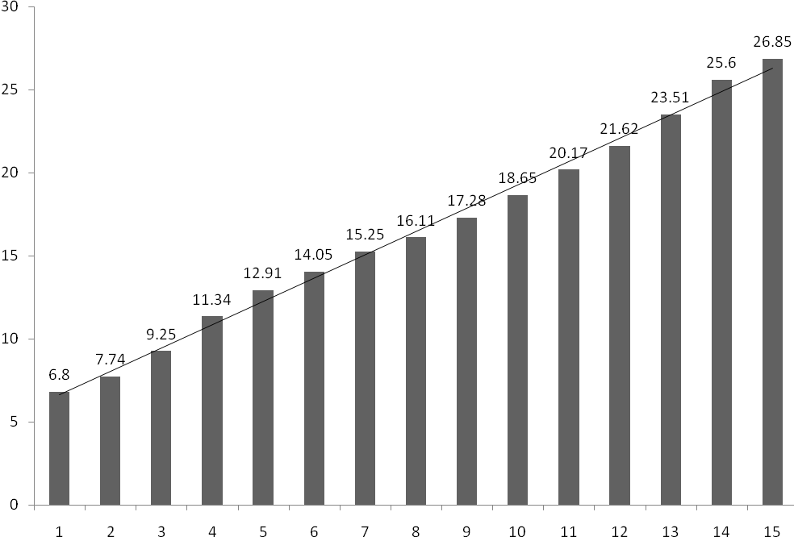Instructional Week
Correct Digits in 2 Minutes

Figure 1. Graphic display of the mean performance on the M-CBM measure reported in
Correct Digits in Two Minutes

Hypothesis 3: Students with SLD will develop a positive increase/trend-line in their M-CBM computation skills as a result of using M-CBM and making instructional adaptations

Due to the small number of students with Specific Learning Disability (SLD) in math, we decided to graph their progress. The trend line represents the student progress. Basically, a trend-line is a line of “best fit” in terms of showing the trajectory of the student’s performance. Although a student’s data may be variable (higher one day than the next day), a trend-line provides a clear picture of the overall trajectory in relationship to a student’s goal-line (Hosp et al., 2007).

As it was expected, the three students progressed on their M-CBM computation skill from (5, 2, 1) correct digits in two minutes on first probe to (15, 14, 14) respectively by the last week of instruction. Figure 2 illustrates the students’ weekly M-CBM computation progress. Even though these results are encouraging, these students are still extremely far behind their peers in computational skills, and will require additional remedial intervention with progress monitoring to continue closing the gap.

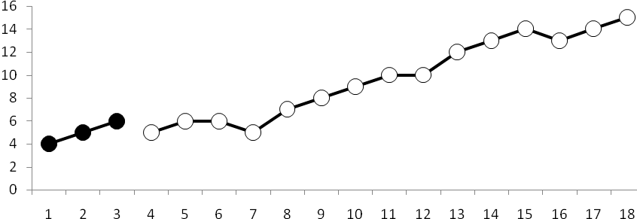
Omar
1 2 3 4 5 6 7 8 9 10 11 12 13 14 15

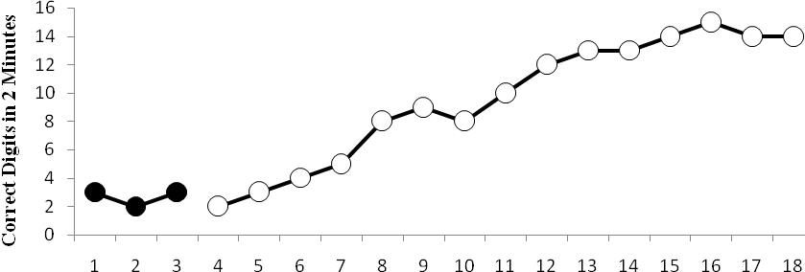
Joseph
Suzan
1 2 3 4 5 6 7 8 9 10 11 12 13 14 15

Baseline
Intervention
Tukey Slope Line
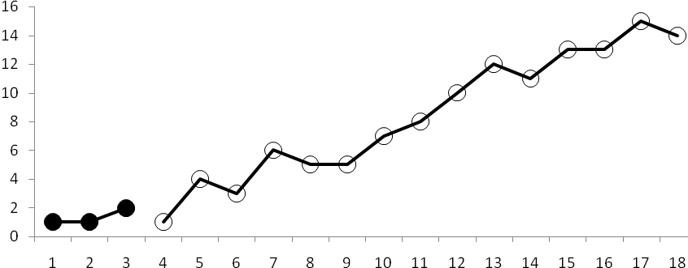
1 2 3 4 5 6 7 8 9 10 11 12 13 14 15
Figure 2. Results of students’ M-CBM reported in Correct Digits (CD) in two minutes.

Social Validity
Evaluations of social validity focus on satisfaction with the intervention's outcomes by those who use them (Clarke, Worcester, Dunlap, Murray, & Bradley-Klug, 2002). Students with SLD and the entire class were asked individually whether they felt their math computation skills improved during the M-CBM period and whether they enjoyed the instructional program. The majority of them indicated that they enjoyed doing the work and following their own progress. In addition, students stated that they like M-CBM computation probes more than formal summative tests.

Discussion
The main purpose of this study was to assess the effects of the M-CBM computation on math achievement improvement for the third-grade students in Jordan. In general, the results indicated using the M-CBM with third-grade students was effective. This discussion contains four sections. The first section discusses the effects of the M-CBM along with the instructional adjustments to improve students’ math achievement. The second section addresses the expected growth rate of the M-CBM computational skill and how this rate can be used for identifying students with SLD in math. The third section discusses the students with SLD improvement in math due to the use of the M-CBM and systematic targeted instruction. The final section discusses the limitations and points toward directions for future research.

The Effects of the M-CBM and Instructional Adjustments in Students’ Achievement
To examine the effect that M-CBM computation has on student achievement, the performance was compared between the two groups. The results indicated that students in the M-CBM computation group achieved higher grades in math compared to the control group who administered summative assessment only. Similar findings were found when post intervention M-CBM probes were administered for both groups. The difference between the two groups was significant. These findings were expected. The administration of frequent probes is a necessary component of the CBM procedures. The experimental group engaged in M-CBM computation, and therefore, participated in important instructional-level skills once every week. Consequently, students in the M-CBM group had frequent opportunities to maintain and increase their proficiency with previously acquired skills. In addition, students’ responses to the social validity oral questions suggested that the M-CBM computation graphs may have served as an adequate basis for motivating students to work hard. This finding is consistent with previous research demonstrating that CBM increases student motivation (Fuchs, Fuchs, Hamlett, & Ferguson, 1992; Stecker, Fuchs, & Fuchs, 2005). Finally, as the teacher and the researchers had a weekly meeting to discuss the students’ progress and suggest some data based adjustments to improve the quality of instruction, both learned which factors related to the intervention were crucial for increasing students’ math achievement.

These findings concur with previous work showing that the M-CBM did contribute to the students’ math achievement and can be used to predict math achievement (e.g., Baker et al., 2002; Christ & Vining, 2006). On the other hand, the results contradict the findings of Stecker and Fuchs (2000) that showed that the M-CBM did not contribute to the learning of the students. However, in that study the researchers investigated the use of M-CBM computation by itself (without data-driven instructional adjustment). Although frequent probe taking is an essential component of CBM, it does not appear to be powerful enough on its own to enhance overall student achievement.

The Expected Growth Rate of the M-CBM
The results also indicated that the M-CBM is an appropriate measure for monitoring students’ academic growth in math achievement. The third-grade students showed steady growth rate during the 15 weeks of intervention. The estimated growth rate was 1.3 correct digits per week. Some researchers indicated that the expected weekly growth rate for the M-CBM in third grade is 0.5 correct digits (see Deno, Fuchs, Marston, & Shin, 2001; Fuchs, Fuchs, Hamlet, Walz, & Germann, 1993). However, other researchers have indicated that greater progress may be possible (Hosp et al., 2007). This finding can be attributed to two factors. First, the high motivation for both teacher and students to be part of this research study made them work hard for the academic semester. Second, the study participants were from a private school. In general, Jordanian private schools provide better educational services than do public ones.

The M-CBM can be used for identifying students who are at risk of academic failure. Descriptive data make it clear that growth rate is greater among students in the general education population than for those in the special education population. The M-CBM can discriminate between those students with and without academic skills problems. Results indicated that students who had difficulties in math scored significantly lower on the M-CBM computation probes when compared with students who were not identified with math probes.

M-CBM and Students with SLD in Math
The CBM is a useful tool for both general and special educators to evaluate and improve student achievement. The most recent re-authorization of the Individuals with Disabilities Education Act (IDEA, 2004) also requires schools to show that students with disabilities are progressing at the same rate as their typically developing peers to the greatest extent possible. This accountability of academic progress of students with disabilities is relatively new.

The M-CBM can be used to find two indicators of a problem: first, low performance in a key skill area; and second, low progress in the acquisition of key skills. By low acquisition we mean learning, as seen in changes of students’ performance over time. Both progress monitoring and instructional recommendations were provided to the resource room teachers in this research. In this study, the researchers used a trend line to follow up the individual progress for students’ with SLD in math. The overall trajectory of students with SLD in math in this study indicated a significant improvement in their M-CBM computation skills. The M-CBM computation was sensitive to growth over short periods of time when used repeatedly for purposes of progress monitoring at the individual student level.

Limitations, Implications, and Future Research
As is the case with any research study, the conclusions drawn must be viewed within the context of the study’s limitations. Foremost of the limitations was external validity. Participants were third-grade students from Jordan. The generalizability of findings to other geographic areas, grades, and students should be investigated further. External validity limitations are further compounded by the sample size of the study. Further research into the M-CBM should be done with a greater sample size and other types of CBM to investigate the reliability and validity of these measures. Finally, this study was conducted in a private school in Jordan. Additional research of the M-CBM in public schools in Jordan is certainly needed.

This study provides further support for the ongoing use of the digits correct metric for measuring computation fluency. They also provide some new directions to enhance the assessment methods that are used to guide educational decisions. The study also contributes to the international knowledge base in mathematics, as it offers evidence that the M-CBM computation can be used in languages other than English. Teachers in Jordan and other countries should consider other valid and reliable assessment tool such as the CBM to be used in both general and special education systems. A particularly important aspect of the CBM for implementation in non- English speaking countries is the inexpensive and highly efficient nature of the measures.

References
Allinder, R. M., Boiling, R. M., Oats, R. G., & Gagnon, W. A. (2000). Effects of teacher self-
monitoring implementation of curriculum-based measurement and mathematics computation achievement of students with disabilities. Remedial & Special Education, 21,219-226.
Al-Natour, M., Al-Khamra, H., & Al-Smadi, Y. (2008). Assessment of learning disabled
students in Jordan: Current practices and obstacles. International Journal of Special Education, 23(2), 67-74.
Badian, N. A. (1983). Dyscalculalia and nonverbal disorders of learning. In H. R. Myklebust (Ed.), Progress in learning disabilities (pp. 235–264). New York: Stratton.
Bagnato, S. J. (2007). Authentic assessment for early childhood intervention. New York: Guilford Press.
Baker, S., Gersten, R., Flojo, J., Katz, R., Chard, D., & Clarke, B. (2002). Preventing mathematics difficulties in young children: Focus on effective screening of early number sense delays (Tech. Rep. No. 0305). Eugene, OR: Pacific Institutes for Research.
Christ, T.J., & Vining, O. (2006). Curriculum-based measurement procedures to develop multiple-skill mathematics computation probes. Evaluation of random and stratified stimulus-set arrangements. School Psychology Review, 35, 387-400.
Clarke, B. & Shinn, M. R. (2004). A preliminary investigation into the identification and development of early mathematics curriculum-based measurement. School Psychology Review, 33(2), 234–248.
Clarke, S., Worcester, J. A., Dunlap, G., Murray, M., & Bradley-Klug, K. (2002). Using multiple measures to evaluate positive behavior support: A case example. Journal of Positive Behavior Interventions, 4, 131–146.
Deno, S. L. (1985). Curriculum-based measurement: The emerging alternative. Exceptional Children, 52, 219-232.
Deno, S. L. (2003). Development in Curriculum-Based Measurement. Journal of Special Education, 37(3), 184-192.
Deno, S. L., Fuchs, L. S., Marston, D., & Shin, J. (2001). Using curriculum-based measurement to establish growth standards for students with learning disabilities. School Psychology Review, 30, 507-524.
Fuchs. L.S., Butterworth, J.R., & Fuchs, D. (1989). Effects of ongoing curriculum-based measurement on student awareness of goals and progress. Education and Treatment of Children, 12, 63-72.
Fuchs, L. S., Fuchs, D., Hamlett, C., & Ferguson, C. (1992). Effects of expert system consultation within curriculum-based measurement, using a reading maze task. Exceptional Children, 58, 436–450.
Fuchs, L.S., Fuchs, D., Hamlett, C.L., Walz, L. & Germann, G. (1993). Formative evaluation of academic progress: How much growth can we expect? School Psychology Review, 22, 27-48.
Fuchs, L.S. & Fuchs, D. (1991). Curriculum-based measurements: Current application and future directions. Preventing School Failure, 35(3), 6-11.
Fuchs, L. S., & Fuchs, D. (2005). Using curriculum-based measurement for progress monitoring in math. Available from www.progressmonitoring.org
Galagan, J. (1985). Psycho-educational testing: Turn out the lights, the party's over. Exceptional Children, 52, 288-299.
Geary, D. C. (2004). Mathematics and learning disabilities. Journal of Learning Disabilities, 37, 4–15.
Helwig, R., Anderson, L., & Tindal, G. (2002). Using a concept-grounded, curriculum-based measure in mathematics to predict statewide test scores for middle school students with LD. The Journal of Special Education, 36(2), 102-112.
Hosp, M. K., & Hosp, J. L. (2003). Curriculum-based measurement for reading, spelling, and math: How to do it and why. Preventing School Failure, 48(1), 10-17.
Hosp, M. K., Hosp, J. L., & Howell, K. W. (2007). The ABCs of CBM: A practical guide to curriculum-based measurement. New York: Guilford.
Individuals with Disabilities Education Improvement Act of 2004, PL 108-446, 20 U.S.C. §1400 (2004).
McBride, S. (2007). Review of special education –Grades 1 to 12. Summary report submitted to the Ministry of Education, Amman, Jordan.
Popham, W. J. (2009, April). A process-not a test. Educational Leadership, 85-86.
Monuteaux, M. C., Faraone, S. V., Herzig, K., Navsaria, N., & Biederman (2005). ADHD and dyscalculalia: Evidence for independent familial transmission. Journal of Learning Disabilities, 38, 86-93.
National Center on Response to Intervention. (2012). Retrieved from
http://www.rti4success.org/.
Reese, C.M., Miller, K.E., Mazzeo, J., & Dossey, J.A. (1997). NAEP 1996 Mathematics Report Card for the Nation and the States. Washington, DC: National Center for Education Statistics.
Shinn, M.R. (Ed.). (1989). Curriculum-Based Measurement: Assessing special children. New York: Guilford.
Spear-Swerling, L., & Sternberg, R.J. (1998). Off track: When poor reader become "learning disabled." Boulder, CO: Westview Press.
Stecker, P.M., & Fuchs, L.S. (2000). Effecting superior achievement using curriculum-based measurement: The importance of individual progress monitoring. Learning Disabilities Research and Practice, 15, 128–134.
Stecker, P. M., Fuchs, L. S., & Fuchs, D. (2005). Using curriculum-based measurement to improve student achievement: Review of research. Psychology in the Schools, 42, 795–819.

