The Balance Control of Children with and without Hearing Impairment in Singapore – A Case Study

Tan Sing Yee Jernice

Karen P. Nonis

Chow Jia Yi

National Institute of Education, National Technological University, Singapore

The purpose of this study is to compare the balance control of participants with and without HI and also to investigate the effect of a Balance Programme (BP) on their balance control (HI; n = 2, M age = 7 years old). The BP consisted of six practice sessions of 45 minutes each. The Balance Tasks used to assess balance control were static Balance Tasks: two-leg stand, one-leg stand and dynamic Balance Tasks: in-place jump and in-place hop. Kinetic data such as the Centre of Pressure (COP) and the Ground Reaction Force (GRF) was captured using a force plate. The results revealed differences in Balance Tasks involving static and dynamic balance control between participants with HI and without HI. Improvement in balance control of the participants is observed for some of the Balance Tasks after the introduction of the BP which indicates the inconclusive effectiveness of the BP. The authors suggest that the instructional approach and number of practice sessions may be the contributing factors affecting the effectiveness of the BP. A new BP with an alternative instructional approach together with more practice sessions is warranted to benefit both children with and without HI so as to make inclusion possible.

Balance is an integral part of many movement tasks a person may perform (Burton & Davis, 1992). Balance control thus forms the vital foundation of all movements of which the development of balance control must take place first or in tandem to support other motor abilities such as balance (state of equilibrium required in stability) and coordination to execute motor tasks (Shumway-Cook & Woollacott, 1995; Williams & Ho, 2004). As balance is needed for maintaining overall functional independence and mobility throughout life, the development of balance control is essential to the development of motor skills and is critical to the learning of complex motor skills and the execution of coordinated motor behaviour (Chen & Woollacott, 2007). Poor balance control as a result of compromised balance conditions will inevitably affect motor strategies as one cannot activate muscle response synergies with appropriate timing, force and muscle response organisation (Shumway-Cook & Woollacott, 2007). For example, a child with poor balance control will display poor motor coordination and may subsequently result in poor motor learning (Willams & Ho, 2004).

Balance control have been widely researched in many population groups such as young children below 10 years old (Clark & Watkins, 1994; Roncesvalles, Woollacott & Jensen, 2001), the elderly (Demura, Kitabayashi & Aoki, 2008) and athletes (Gautier, Thouvarecq & Larue, 2008; Matsuda, Demura & Uchiyama, 2008). As far as the populations with special needs are concerned, researchers have also investigated the balance control of populations with physical disabilities such as cerebral palsy (Chen & Woollacott, 2007; Shumway-Cook, Hutchinson, Kartin, Price & Woollacott, 2003) and developmental coordination difficulties (DCD, Sugden & Chambers, 2006), population with intellectual disabilities (Bilir, Guven, Bal, Metin & Artan, 1995; Galli, Rigoldi, Mainardi, Tenore, Onorati & Albertini, 2008) and populations with sensory disabilities such as children with hearing impairment (HI; Butterfield, 1987; Engel-Yeger, Golz & Parush, 2004). In addition, the review of literature has reported numerous movement programmes and motor intervention conducted with the intention either to enhance balance abilities or to reduce balance problems in various populations such as the elderly (Ramsbottom, Ambler, Potter, Jordan, Nevill & Williams, 2004), the children with intellectual disabilities (Wang & Ju, 2002) and children with HI (Fotiadou, Giagazoglou, Kokaridas, Angelopoulou, Tsimaras & Tsorbatzoudis, 2002).

Hearing is an important sensory ability in the psychomotor development of humans as it forms the basis of communication for cognitive, affective and behavioural development and learning to take place (Auxter, Pyfer & Huettig, 1997). Hearing impairment can be referred to as a type of sensory disability which affects the sensory inputs resulting in the inability to hear normally. Children with HI refer to children with varying degrees of hearing loss, ranging from mild to profound. Studies investigating children with HI and their motor abilities have reported delayed motor development and in particular, poor balance abilities (Bilir et al., 1995; Brunt & Broadhead, 1982; Butterfield, 1987; Craft, 1985; Dummer, Haubenstricker & Stewart, 1996; Gayle & Pohlman, 1990; Weiss & Phillips, 2006; Wiegersma & Van der Velde, 1983). Notwithstanding the fact that many studies frequently reported children with HI having poor motor proficiency traits (Bilir et al., 1995; Brunt & Broadhead, 1982; Gayle & Pohlman, 1990; Weiss & Phillips, 2006; Wiegersma & Van der Velde, 1983), studies have shown that children with HI have comparable motor skills as their hearing peers except for balance abilities although the latter is limited (Butterfield, 1987; Butterfield, Mars-Hans & Chase, 1993; Dummer et al., 1996). Children with HI, similar to their hearing peers, show a positive age effect on their motor performance as they grow older (Butterfield & Ersing, 1986; Gkouvatzi, Mantis & Kambas, 2010). However, children with HI tend to score lower than their hearing peers on motor test items requiring good control of balance such as one-foot standing (Brunt & Broadhead, 1982; Gayle & Pohlman, 1990), heel-toe walking or walking on balance beam (Butterfield, 1987; Butterfield & Ersing, 1986). Therefore, some studies have suggested specific programmes such as tumbling and gymnastics (Fotiadou et al., 2002; Pennella, 1979), basic body movements practices (Langdale, 1984), dance (Hottendorf, 1989; Reber & Sherrill, 1981) and Asian martial arts (Sherrill, 1976) to improve balance and related motor abilities of children with HI which could enhance their motor skills and physical fitness.

In Singapore, about four in every 1,000 infants born (live births) are diagnosed with hearing loss (Irving & Ruben, 1998; Low, 2005). Further, one in four of these infants are identified with significant hearing loss (SGH, 2010). Based on a conservative prediction of the average number of infants born in Singapore annually to be about 37,500 or more (singstat, 2011), it is estimated that about 1,500 of infants are born with HI per annum and about 375 of them may have significant hearing loss. Although, information on the percentages of school children with HI in Singapore is not entirely readily available, the majority of the children with HI has been successfully included or integrated into mainstream education (Ho, 2007). The number of children with HI being included in the mainstream schools was also higher as compared to other sensory disabilities. For example, sixty-one children with visual impairment are included in mainstream schools. By contrast, five hundred and two children with HI are included in mainstream schools (MOE, 2002). In 2003, the number of children with HI receiving education in the two main special schools catered for HI (Canossian School & Singapore School for the Deaf) was 250 (Quah, 2004). In 2004, about 460 children with HI were included in mainstream schools (MOE, 2004). Based on this data, we could infer the possibility that more children with HI are in regular classrooms although this possibility needs further justification. Drawing from the number of infants born with HI and as more children with HI get included in regular classrooms, understanding their balance control and comparing with the hearing children is warranted. More importantly, designing appropriate movement programmes to cater to the needs of children with and without HI in regular schools is necessary to complement inclusion.

Understanding Balance Control with Kinetic Analysis

Despite international studies investigating the motor skills of children with HI (Butterfield, 1987; Dair, Ellis & Lieberman, 2006; Dummer et al., 1996; Horak, Shumway-Cook, Crowe & Black, 1988; Stewart & Ellis, 2005), similar studies that use kinetic analysis to understand balance control remain limited. Kinetic analysis measures the internal and external forces contributing to movement (Shumway-Cook & Woollacott, 2007) and thus depicts the cause of motion quantitatively. Kinetic data collection includes the measurement of the Centre of Pressure (COP) in anterior-posterior (AP) and medial-lateral (ML) directions and Ground Reaction Force (GRF) in the AP (F_{x}), ML (F_{y}) and vertical (F_{z}) directions. The motion of the COP represents an individual’s control of body sway in static balance tasks (Cherng et al., 2007; Demura et al., 2008; Winter, 1995). Body sway is defined as the sway of the body used to maintain posture by harmonizing the function of postural muscles based on the information from visual, vestibular and somatosensory systems (Demura et al., 2008). A larger COP sway area displayed by a larger COP displacement and/or a larger COP velocity has often been used as an indicator of increased body sway and poorer balance control (Cherng et al., 2007). However, an improved balance control can also be exhibited through lesser deviation or root mean square of the mean COP displacement from the origin (RMS) and/or lesser mean distance or mean path length travelled by the COP (MPL) in both AP and ML directions (Palmieri, Ingersoll, Stone & Krause, 2002). In the task of balance with eyes closed (intentionally limiting a sensory system), one would expect the COP parameters values to increase depicting poorer balance control. Children with Developmental Coordination Disorder (DCD) were found to have greater difficulties in restoring two-leg standing balance by using vestibular and somatosensory systems with simulated absence of visual system (Cherng et al., 2007). Similarly, Clark and Watkins (1987) reported that normally developing children had poorer balance control when they closed their eyes in a single-leg standing task. Lindsey and O’Neal (1976) also observed that the balance skills of children with HI were more adversely affected than hearing children when visual cues were removed.

In addition, plotted information of F_{x}, F_{y} and F_{z} (in newton) versus time (in seconds) involving a series of movement cycles was also used to understand the balance control within the dynamic Balance Tasks. In Nonis, Parker and Larkin’s (2006) study, the authors used the information of movement cycles of repetitive hops to investigate the hopping performance of girls (N = 51; Age range: 3 – 6 years). Within the landing phase of each movement cycle, the first peak, known as the impact peak, generated the first maximum force (F₁) and the second peak, known as the propulsion peak, generated the first maximum propulsive force (F_{p}) was calculated. Normalised by body weight (BW), the authors propose that a lower value of F₁/BW indicates better performance as the body uses lesser force to prepare before the execution of actual hopping task (Nonis et al., 2006). Conversely, a higher value of F_{P}/BW will indicate better performance as the body used more force to propel the body upwards (Nonis et al., 2006). In addition, Parker, Monson and Larkin (1993) reported a significant positive age effect in repetitive jumping and hopping of girls (N = 35; Age range: 3.5 – 9.5 years) when the older girls were observed to perform significantly better than the younger ones in terms of the mean vertical force normalised by body weight (F_{z}/BW). Although F₁/BW, F_{P}/BW and F_{z}/BW can provide indicators of the performance of balance tasks involving dynamic balance, these only reflect force data in the vertical direction. Percentage distribution of force in anterior-posterior direction (%F_{x}), medial-lateral direction (%F_{y}) and vertical direction (%F_{z}) against resultant force could then also be useful indicators of underlying ability of balance control in dynamic tasks (Nonis et al., 2006; Parker et al., 1993). A decrease in either %F_{x}, %F_{y} or both and/or increase in %F_{z} would indicate that one is able to jump or hop better vertically on the same spot which could attribute to the improvement in dynamic balance control (Nonis, Parker & Larkin, 2004; Nonis et al., 2006; Parker et al., 1993).

Motor Intervention Programme using Task-Specific Approach

Albeit motor interventions delivered in the form of movement programmes to improve overall motor abilities and increase physical activity participation of children with HI are reported (Hottendorf, 1989; Langdale, 1984; Sherrill, 1976), similar programmes emphasising on improving static and dynamic balance does not seem well documented. Although Fotiadou and colleagues (2002), in the recent decade, shared how rhythm gymnastics can cause significant improvements in the dynamic balance of children with HI, little is known about the effect of a balance-focused programme that caters to both children with and without HI on their balance abilities. In addition, movement programmes based on different instructional approaches and their effects on children with and without HI are limited. However, there are many studies focusing on various instructional approaches which include activity-based, direct instruction and task-specific on other children with special education needs such as children who were found with developmental delay or at risk with developmental delay and/or with DCD (Apache, 2005; Block & Davis, 1996; Goodway, Crowe & Ward, 2003; Revie & Larkin, 1993).

The Balance Programme (BP) conducted on children with and without HI in this study aims to improve balance control in specific balance tasks using the task-specific approach. The aims of task specificity are to provide specific instructions and guidance during motor learning and give specific feedback to the motor performance of the respective motor skills introduced in the movement programme. The rationale of task specificity for developing and learning of motor skills are supported by various researchers (Larkin & Hoare, 1992; Marchiori, Wall & Bedingfield, 1987). These authors suggest that children who are poorly coordinated were able to acquire or improve some motor skills through intensive task-specific training even though they were observed to have limited ability to transfer motor learning of one skill to another (Larkin & Hoare, 1992; Marchiori et al., 1987). Revie and Larkin’s (1993) 8-week task-specific intervention on children with poorly coordinated movements (N = 21; Age range: 5 – 9 years) was also used specifically for enhancing motor learning and motor performance. In addition, task-specific approach aligns with the direct instruction approach which is teacher-directed allowing the lesson to be highly structured and task-oriented and yet able to cater to individual needs by having the teacher to give precise feedback to the child and monitor their individual progress.

Presently, the motor abilities and physical fitness of children with HI in Singapore, particularly in relation to the information on their balance control, are not known to be documented. Further, the possibility of including children with and without HI within the same balance-focused movement programme to be conducted within the regular schools locally remains unclear. Therefore, the purpose of this study is twofold. Firstly, through this case study, we hope to understand and compare the balance control of children with and without HI. Secondly, it examined the effect of the BP that uses the task-specific approach on the balance control of the children with HI and without HI. It is hoped that the conclusion of this study will give us a better understanding of the balance control of children with and without HI and the effect of BP on their balance control. This will then form the basis for the development of movement programmes to include children with HI within regular Physical Education classes involving a larger population size.

Method

Participants

Two children participated in this study (N = 2, M age = 7 years; see Table 1). Of the two participants, Participant HI was clinically diagnosed with profound hearing loss and Participant Non-HI is of normal hearing ability. Both had no pre-existing medical and health conditions during the period of study. Informed and voluntary consent was obtained from parents of the participants and the school in accordance with institutional review committee board for the ethics of human research at the National Institute of Education (NIE).

Table 1. Characteristics of the Participants
Participant | HI | Non-HI
Gender | Male | Male
Age (years) | 7 | 7
Height (cm) | 127 | 130
Weight (kg) | 21.5 | 33.0
School Type | Mainstream | Mainstream
Hearing Impairment | Profound with cochlear implant | Nil
Other Special Condition | - | -
Completed BP | Yes | Yes

Task and Apparatus

The balance control ability of the participants was measured through four motor tasks, termed as Balance Tasks. The Balance Tasks involving static balance control were two-leg stand, one-leg stand and Balance Tasks involving dynamic balance control were in-place jump and in-place hop. The sequence of the Balance Tasks was two-leg stand with eyes open (EO), two-leg stand with eyes closed (EC), one-leg stand with eyes open (EO), one-leg stand with eyes closed (EC), in-place jump and in-place hop.

The Kistler Force Platform (Model: 9287BA) measuring 60 cm by 90 cm was used to capture the position coordinates of the Centre of Pressure (COP) in the anterior-posterior (AP) and medial-lateral (ML) directions and the components of the Ground Reaction Force (GRF) in the AP (F_{x}), ML (F_{y}) and vertical (F_{z}) directions. All these variables measure the participants’ static and dynamic balance of Balance Tasks. The data was captured at a sampling rate of 200 Hz.

Procedures and Test Instructions

This study adopted a single-subject research design consisting of a pretest (45 minutes), a task-specific Balance Programme (BP: 6 sessions, 45 minutes each) and a posttest (45 minutes) to compare the balance control of Participant HI and Participant Non-HI and examine the effect of BP through selected Balance Tasks involving static and dynamic balance. The pretest and posttest were conducted in the Biomechanics Laboratory at the University.

Prior to pretest, a familiarisation session with the participants and logistics preparation of the test venue and equipment set-up was carried out. Both face-to-face and phone briefings were conducted for the participants and their parents respectively to reduce any possible anxiety prior to the tests.

During pretest and posttest, each participant was tested barefooted individually. The participants were told to look straight ahead, fixating their gaze on a picture of a flower (15-cm diameter) positioned at eye level at a distance of approximately five meters while stepping forward to perform instructed Balance Tasks on the force plate. Their foot placement was self-selected. One trained tester collected the data throughout the study. The procedure for each task in both tests began with a demonstration and followed by a standardised command – Ready, Get Set, Go! as a signal for the participant to begin the task. In addition, Participant HI received visual and tactile cues to ensure that he understood the instructions given by the trained tester. Collection of the force data was manually controlled by the tester immediately upon the command to perform the Balance Tasks. Each participant performed three trials for each Balance Task. Adequate rest periods were given to each participant between trials and tasks. All three trials with continuous data performed by the participants were used for further analysis. In the event that continuous data was not captured in the first three trials of each Balance Task, the participants were allowed to perform up to a maximum of five trials.

The Balance Programme (BP)

The Balance Programme (BP; see Appendix A) consisted of 6 sessions using the task-specific approach (Larkin & Parker, 2002; Revie & Larkin, 1993). The activities during the task-specific approach were planned to teach the participants the techniques required to enhance specific balance control ability of the Balance Tasks of this study. Each session lasted 45 minutes and was divided into four phases: warm-up (5 minutes), task-specific and related-movement activities (35 minutes) and cool-down (5 minutes). The BP was conducted at the school of both participants.

Data Collection and Reduction

Static Balance Tasks (Two-leg Stand & One-leg Stand). Within a 10 second trial, the last five seconds of continuous force data (i.e. when the participant remained on the force plate) was analysed. The first five seconds of each trial included the preparatory time to step onto the KFP was disregarded to avoid capturing data that did not reflect the actual performance of the Balance Tasks. Chen and Woollacott (2007) used similar timing of five seconds to assess their participants’ balance control. In addition, Cherng et al. (2007) did not use data related to the preparatory time.

Dynamic Balance Tasks (In-place Jump & In-place Hop). Within a 10 second trial, data of eight full and continuous movement cycles (i.e. 8 continuous jumps and hops) were analysed. The first few jumps and hops were disregarded to avoid capturing preparation performance within each trial.

As adopted from Palmieri and colleagues (2002), the COP parameters for calculating the balance control of the Balance Tasks in this study are the root mean square of the COP displacement in AP (RMS_{x}) and ML (RMS_{y}) directions and the mean path length of COP distance in AP (MPL_{x}) and ML (MPL_{y}) directions. The kinetic variables for calculating the balance control of dynamic Balance Tasks are the mean percentage distribution of GRF in each direction to the summed GRF (%F_{x}, %F_{y} & %F_{z}), the mean vertical force normalised by body weight (F_{z}/BW), the mean of first normalised maximum vertical force (F₁/BW) and the mean of normalised maximum propulsive vertical force (F_{p}/BW). The use of similar kinetic variables in this study has also been reported in various studies (Nonis et al., 2006; Parker et al., 1993).

Data Analysis

The RMS_{x}, RMS_{y}, MPL_{x} MPL_{y}. %F_{x}, %F_{y}, %F_{z}, F_{z}/BW, F₁/BW and F_{p}/BW were calculated for dynamic Balance Tasks across three trials. The means and standard deviations of three trials of COP parameters and kinetic variables of each Balance Task were used for descriptive data analysis. The pretest and posttest results were compared within and between participants.

Results

Performance of Static Balance Tasks at Pretest and Posttest

The Balance Tasks requiring static balance were two-leg stand and one-leg stand under two conditions – eyes open (EO) and eyes closed (EC). The pretest and posttest results of static Balance Tasks were compared. For two-leg stand performed under EO and EC conditions respectively, both participants experienced a decrease in MPL_{x} and MPL_{y} at posttest when compared to pretest (see Figure 1). A similar trend was not observed for RMS values (see Figure 2). Nonetheless, the RMS_{x}, RMS_{y}, MPL_{x} and MPL_{y} values of Participant HI were comparatively higher than those of Participant Non-HI as per condition and as per test (pretest – EO, pretest – EC, posttest – EO, posttest – EC; see Figures 1 & 2).

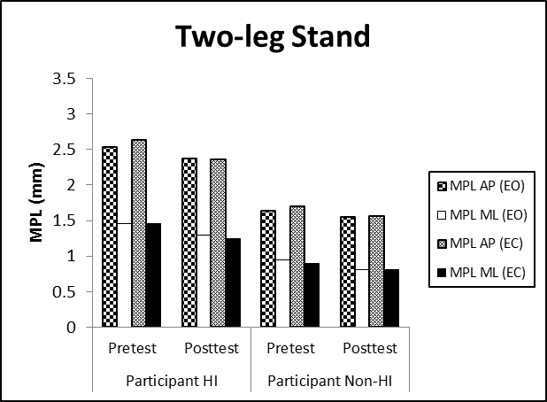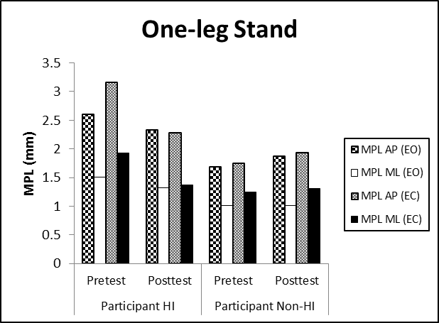

Figure 1. Mean Path Length (MPL) of Two-leg Stand and One-leg Stand (EO – eyes open, EC – eyes closed)

However, the results of one-leg stand showed different results from those of two-leg stand. Only Participant HI was observed to have lower values of RMS_{x}, RMS_{y}, MPL_{x} and MPL_{y} at posttest when compared to his pretest results under both EO and EC conditions (see Figures 1 & 2). Participant Non-HI actually experienced increased MPL and RMS values in AP and ML directions at posttest (see Figures 1 & 2). However, similar to two-leg stand results, the RMS_{x}, RMS_{y}, MPL_{x} and MPL_{y} values of Participant HI were still comparatively higher than those of Participant Non-HI under both EO and EC conditions with the exception of the RMS values at posttest (see Figures 1 & 2). Comparing between tasks, the values of RMS_{x}, RMS_{y}, MPL_{x} and MPL_{y} of one-leg stand were generally higher than those of two-leg stand under both EO and EC conditions for both participants (see Figures 1 & 2).

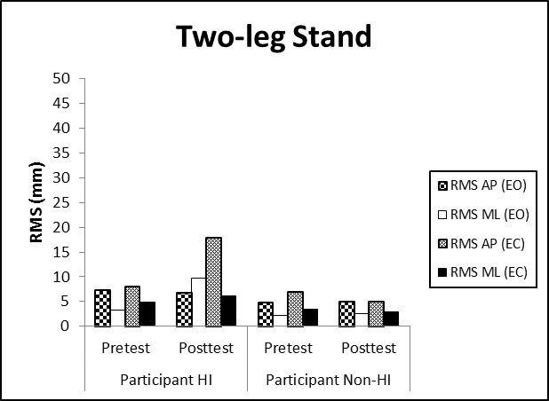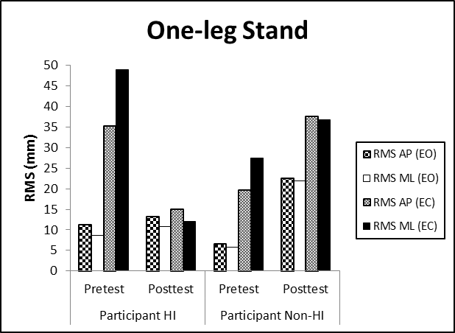

Figure 2. Root Mean Square (RMS) of Two-leg Stand and One-leg Stand (EO – eyes open, EC – eyes closed)

Performance of Static Balance Tasks under Varying Vision Conditions

Studies have documented varying difficulties of static tasks under different vision conditions where participants generally exhibited poorer balance control when vision is limited (Cherng et al., 2007; Clark & Watkins, 1984). The COP results of two-leg stand and one-leg stand of both participants under EO and EC conditions were examined to understand the role of vision on balance control and on the effectiveness of the BP. This could then be used to better differentiate the balance control between participants with and without HI. Comparing the results of two-leg stand under EO and EC condition respectively, there was no clear indicative trend to show which vision condition performed better in both participants (see Figures 1 & 2). On the contrary, with the exception of MPL posttest results of Participant HI, the results clearly showed that the values of all COP parameters (MPL_{x}, MPL_{y}, RMS_{x} & RMS_{y}) were higher in the one-leg stand task for EC condition rather than EO condition for both participants (see Figures 1 & 2).

Performance of Dynamic Balance Tasks at Pretest and Posttest

The Balance Tasks requiring dynamic balance were in-place jump and in-place hop. Similarly, the results of in-place jump and in-place hop respectively were compared between tests and between participants. For in-place jump, the posttest results revealed lower MPL_{x}, MPL_{y}, RMS_{x} and RMS_{y} values in both participants when compared to their pretest results (see Figures 3 & 4). In terms of kinetics variables, both participants had lower %F_{x} and %F_{y} but higher %F_{z} at posttest (see Table 2). Both participants also attained an increase in F_{z}/BW and a decrease in F_{p}/BW at posttest (see Table 2). However, the differences in F₁/BW between tests did not show a discernable trend in both participants.

Comparing the in-place jump results of both participants, Participant HI had higher MPL_{x} and MPL_{y} values than Participant Non-HI at pretest and posttest (see Figure. 3). The differences of RMS_{x} and RMS_{y} of both participants between tests did not show a consistent pattern (see Figure 4). In addition, Participant HI had higher %F_{x} and %F_{y} but lower %F_{z} and F_{z}/BW as compared to Participant Non-HI (see Table 2). Similar to the RMS values, the comparison of F₁/BW and F_{p}/BW between participants did not show a consistent pattern.

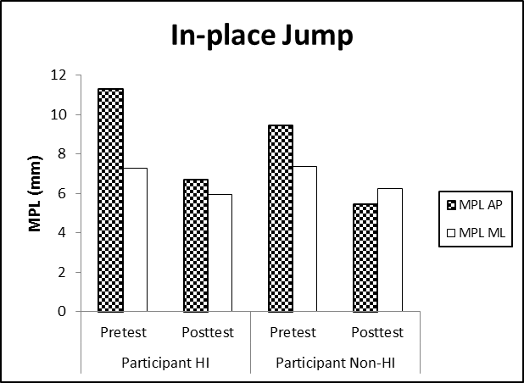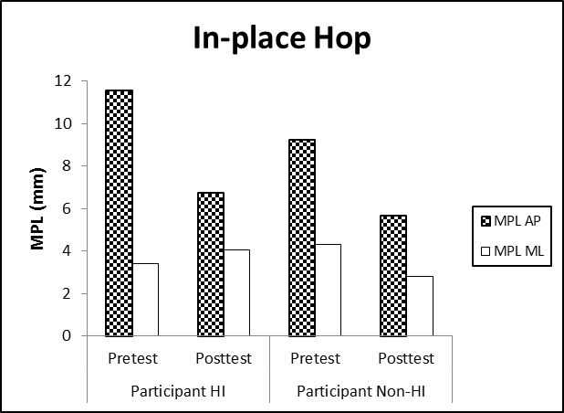

Figure 3. Mean Path Length (MPL) of In-place Jump and In-place Hop

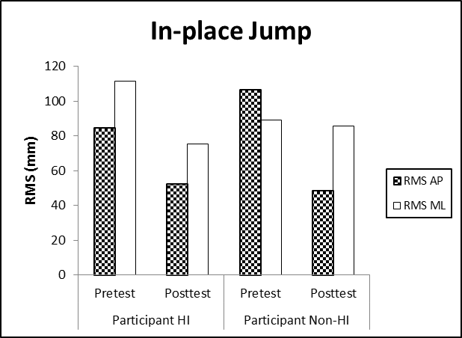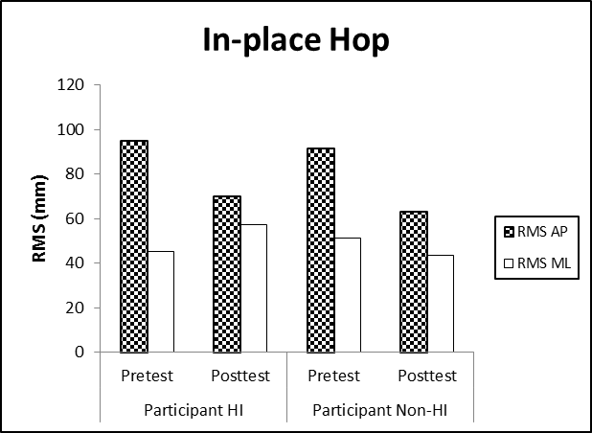

Figure 4. Root Mean Square (RMS) of In-place Jump and In-place Hop

Table 2. The Mean Values of the Kinetics Variables of In-place Jump
 | Participant HI |  | Participant Non-HI
 | Pretest | Posttest | Pretest | Posttest
%F_{x} | 15.13 | 0.444 | 3.71 | -0.030
%F_{y} | 3.34 | 1.24 | 0.127 | 0.460
%F_{z} | 81.52 | 98.3 | 96.2 | 99.6
F_{z}/BW | 0.985 | 1.04 | 1.56 | 1.67
F₁/BW | 1.11 | 0.928 | 0.93 | 1.88
F_{p}/BW | 4.54 | 2.78 | 4.45 | 3.69

From the values of the COP parameters of in-place hop, except for the MPL_{y} and RMS_{y} values of Participant HI, lower values of posttest results were observed for both participants when compared with pretest results (see Figures 3 & 4). Similar to the results of in-place jump, both participants also had lower %F_{x} and %F_{y} but higher %F_{z} for the task of in-place hop at posttest (see Table 3). Both participants also experienced increase in F_{z}/BW and decrease in F_{p}/BW at posttest.

Table 3. The Mean Values of Kinetics Variables of In-Place Hop
 | Participant HI |  | Participant Non-HI
 | Pretest | Posttest | Pretest | Posttest
%F_{x} | 20.8 | 0.983 | 3.14 | 0.242
%F_{y} | 5.82 | 1.18 | 0.402 | 0.325
%F_{z} | 73.4 | 97.8 | 96.5 | 99.4
F_{z}/BW | 0.981 | 1.06 | 1.53 | 1.64
F₁/BW | 1.99 | 1.40 | 2.89 | 2.95
F_{p}/BW | 2.72 | 1.87 | 3.37 | 2.76

With the exception of MPL_{y} and RMS_{y}, Participant HI had higher MPL and RMS values than Participant Non-HI for in-place hop at pretest and posttest. In terms of kinetics variables, participant HI also attained higher %F_{x} and %F_{y} but lower %F_{z} , F_{z}/BW, F₁/BW and F_{p}/BW as compared to Participant Non-HI (see Table 3). Comparing the pretest and posttest results between dynamic Balance Tasks in terms of MPL and RMS values in AP and ML directions, it is unclear if both participants had shown improvement in balance control (see Figures 3 & 4). However, the performance of in-place hop of both participants generally showed a higher %F_{x}, %F_{y} and F₁/BW but lower %F_{z}, F_{z}/BW and F_{p}/BW (see Tables 2 & 3) as compared to in-place jump.

Discussion

Comparison of the Balance Control between Children with and without HI

In the present study, we compared the static and dynamic balance control of a 7-year old boy with HI and his hearing peer. With the exception of the root mean square (RMS) values at posttest of one-leg stand, it was noted that Participant HI generally scored consistently higher mean path length (MPL) and RMS values in anterior-posterior (AP) and medial-lateral (ML) directions in terms of static balance control when compared to Participant Non-HI (see Figures 1 & 2). Higher MPL and/or RMS values would indicate poorer balance ability (Palmieri et al., 2002). Although we could not deduce a conclusion in comparing the results of in-place jump and in-place hop of both participants using MPL and RMS values, the results using kinetic variables suggested that Participant HI had poorer dynamic balance control than Participant Non-HI. Participant HI had higher %F_{x} and %F_{y} but lower %F_{z} and F_{z}/BW than Participant Non-HI for in-place jump and in-place hop. These finding support other studies which have reported poorer balance control in children with HI when compared with their hearing peers (Campbell, 1983; Lindsey and O’Neal, 1976; Wiegersma & Van der Velde, 1983).

Between eyes open (EO) and eyes closed (EC) conditions, in general, differences were revealed for static Balance Tasks. Specifically, both participants experienced poorer balance control for the task of one-leg stand under EC condition, especially at pretest (see Figures 1 & 2). One explanation could be related to the underlying visual system. Studies have reported that the role of visual system played an important role in controlling balance in standing tasks (Cherng et al., 2007; Clark & Watkins, 1984). However, discernable difference was observed for one-leg stand of both participants in this study and there was not much difference for the results of two-leg stand between EO and EC conditions. One could then possibly conclude that vision plays a significant part for more difficult Balance Tasks (e.g. one-leg stand) which require better balance control with a smaller base of support as compared to easier Balance Tasks (e.g. two-leg stand) of a bigger base of support.

Maintaining balance and postural control requires sensory inputs from visual, somatosensory, and vestibular systems as well as the integration of sensory systems within the environment (Shumway-Cook & Woollacott, 2007). Humans essentially rely on three main sensory systems – visual, vestibular and somatosensory systems to send sensory inputs through the CNS to generate motor outputs seen as static and/or dynamic movements. In addition, Lindsey and O’Neal (1976) observed that the balance skills of the participating children with HI were more adversely affected than those of normal hearing children when visual cues were removed. Therefore, one would suggest that humans use vision system more as compared with the auditory system although Horak and MacPherson (1995) recognized the use of auditory system in postural control. Since the children with HI have limitation in their hearing, it could be explained that they rely mainly on their visual system to make sense of the surroundings, including generating motor responses for balance control. This was further evidenced by the differences from the pre- and posttest results of Balance Tasks involving EC condition between Participant HI and Participant Non-HI. Except for the RMS values at posttest, Participant HI generally had much higher MPL and RMS values in both AP and ML directions as compared to Participant Non-HI under EC condition (see Figures 1 & 2).

Within participants, the comparison of the results between static Balance Tasks revealed that both participants performed better in two-leg stand than one-leg stand (see Figures 1 & 2). In terms of dynamic Balance Tasks, the performance of in-place jump was also better than in-place hop for both participants (see Tables 2 & 3). One would expect such findings due to the ground reaction forces generated with different bases of support at different postures (Parker et al., 1993). The tasks of one-leg stand and in-place hop require one to balance on single leg which causes lateral shift of body weight. Therefore, the execution of one-leg stand and in-place hop becomes relatively unstable when compared to two-leg stand and in-place jump which have a bigger base of support.

The Effect of BP on the Balance Control of Children with and without HI

Another aim of this study was to examine the effect of Balance Programme (BP) using the task-specific approach on the balance control of children with and without HI. The results of static Balance Tasks seemed to indicate a slightly different effect of BP between participants. Comparing the pre- and posttest results of two-leg stand and one-leg stand, Participant HI experienced an improvement in static balance control in terms of MPL_{x} and MPL_{y} (see Figure 1). Improved balance control was seen in Participant Non-HI for the task of two-leg stand only. Participant Non-HI actually performed poorer in one-leg stand at posttest (see Figures 1 & 2). On the other hand, the results of dynamic Balance Tasks revealed a more consistent pattern for both participants. In terms of COP parameters, except for the MPL_{y} and RMS_{y} values of Participant HI, both participants improved the dynamic balance control of in-place jump and in-place hop. In addition, both participants also attained lower %F_{x} and %F_{y} but higher %F_{z} and F_{z}/BW which is indicative of improved performance as reported in other studies (Nonis et al., 2006; Parker et al., 1993).

In summary, the effect of BP on the balance control of participant with and without HI, there was some indication of overall improvement for both participants. As RMS is the standard deviation of the COP displacement, a larger RMS value will then indicate a lesser stability in balance control. Although overall improvement was observed in both participants in terms of mean distance travelled from the initial point of origin (i.e. MPL), it may not necessarily reflect a stabilized improvement in balance control without a consistently reduced RMS values at posttest. Therefore, the effectiveness of BP remains unclear with the inconsistent change, particularly in RMS values in AP and ML directions, F₁/BW and F_{p}/BW of both participants.

In the attempt to have an in-depth analysis of the effect of BP as per participant, the comparison between participant with and without HI was carried out. Closer observation of the pre- and post-test results of one-leg stand of both participants suggests that the BP seemed to have a more positive effect on Participant HI experiencing improved balance control. Participant HI improved his balance control in one-leg stand from the effect of BP, unlike his hearing counterpart who was worse off at posttest. However, one needs to recall that Participant Non-HI started off with better balance control than Participant HI. Anecdotal observations also revealed that Participant Non-HI was generally able to have good balance control in one-leg stand without dropping his non-standing leg for support throughout the whole 10 seconds of data collection in this study. These findings seem to infer a higher possibility of positive BP effect on participants with poorer balance pretest result. If not, could participants experiencing performance plateau face unstable movement variability denoted by worse off balance control when they are made to unlearn familiar techniques and relearn specific techniques? Given that this is a case study, further investigation with a larger sample size is warranted.

While the effect of the 6-week BP that uses task-specific approach remains inconclusive, the authors of this study suggest for BP design review to be improved for participants with and without HI. As such, three recommendations are proposed for further investigation in future study. Firstly, the number of practice sessions may not have optimally allowed participants to make significant improvement in all COP parameters and kinetic variables of Balance Tasks especially for those requiring higher balance control ability. Therefore, a further study with more practice sessions will be able to verify it. Secondly, the task-specific approach may not be appropriate for optimal learning effectiveness especially for participants who have no balance deficits. It is suggested to explore other instructional approaches geared towards activity-based, discovery-based or game-based nature in further studies. Thirdly, in reviewing the balance control of both participants, only information of the pre- and posttest results was available. Assuming if practice sessions were to increase for optimal learning opportunities, it would be good to identify any performance plateau and unstable movement variability (if any) so as to understand the differences in balance control of children with and without HI. With these considerations in mind, it is recommended to increase the number of test sessions (i.e. before BP, within BP & after BP) to investigate the change process of balance control of all participants.

Conclusion

Researchers have reported children with HI to have comparatively poorer balance abilities especially in static balance than their normal hearing peers (Campbell, 1983; Gayle & Pohlman, 1990). The findings in this study have reached similar conclusion too. Challenges that children with HI face in motor learning could possibly inhibit timely and appropriate motor strategies to overcome disturbances to balance thus delaying normal motor development. The investigation of the balance control differences between children with and without HI is critical in understanding their motor learning and also introducing appropriate movement programme to accommodate both populations’ physical needs in order to align with the notion of inclusion. It is hoped that through balance-focused programmes such as the BP, the children with HI can improve their balance control and in turns help them develop better motor skills; but not forgetting that the children without HI can benefit too.

Inputs from the visual, somatosensory and vestibular systems must be integrated efficiently to activate appropriate motor responses in maintaining optimal balance (Shumway-Cook & Woollacott, 2007). Consequently, it is anticipated that the task-specific practices can provide good opportunities for training children with and without HI to activate their sensory systems to generate appropriate motor responses for better balance control. However, the study has revealed mixed effect of BP on the balance control of both participants. Therefore, the effect of BP that uses task-specific approach on children with and without HI remains inconclusive. Despite the descriptive analysis nature of this study and its inherent limitations with a small sample size, findings from the present case study alert the call to provide support for movement programmes to include children with and without HI.

Based on the recommendations made in this study, it is concluded that the learning of proficient movement patterns requires time and practices to attain optimum motor learning. It is proposed that future studies include an increased number of practice and test sessions in the BP. It is anticipated that the additional practice sessions will allow more time and opportunities for the children with HI to achieve more proficient movement patterns reflecting better balance control. With repeated test sessions introduced within the BP, one can then better understand the change processes of balance control of the children with HI. In addition, a further study of an alternative instructional approach moving towards participant-centered is recommended. Such participant-centered movement programmes may allow practice opportunities for children with HI to self-organise their movement and discover their own preferred balance techniques in order to optimise their ability to attain efficiency in controlling balance.

References

Apache, R. R. (2005). Activity-based intervention in motor skill development. Perceptual and Motor

Skills, 100, 1011-1020.

Auxter, D., Pyfer, J., & Huettig, C. (1997). Principles and Methods of Adapted Physical Education and

Recreation. St. Louis, MO: Mosby-Year Book, Inc.

Bilir, S., Guven, N., Bal, S., Metin, N., & Artan, I. (1995). A comparison study of gross motor

development of Normal, Hearing-Impaired and Down Syndrome children. Paper presented at the

International Congress of Education of the Deaf (July 16-20, 1995, Israel)

Block, M. E., & Davis, T. D. (1996). An Activity-Based Approach to Physical Education for Preschool

Children with Disabilities. Adapted Physical Activity Quarterly, 13, 230-246.

Brunt, D., & Broadhead, G. D. (1982). Motor proficiency traits of deaf children. Research Quarterly for

Exercise and Sport, 53(3), 236-238

Burton, A. W., & Davis, W. E. (1992). Assessing balance in adapted physical education: fundamental

concepts and applications. Adapted Physical Activity Quarterly, 9(1), 14-46.

Butterfield, S. A., (1987). The Influence of Age, Sex, Hearing Loss, Etiology, and Balance Ability on the

Fundamental Motor Skills of Deaf Children. In M. E. Berridge & G. R. Ward (Eds), International

Perspectives on Adapted Physical Activity (pp. 43-51). Champaign, IL: Human Kinematics.

Butterfield, S. A., & Ersing, W. F. (1986). Influence of Age, Sex, Etiology and Hearing Loss on Balance

Performance by Deaf Children. Perceptual and Motor Skills, 62, 659-663.

Butterfield, S. A., Mars-Hans, V., & Chase, J. (1993, Spring). Fundamental motor skills performances of

deaf and hearing impaired children age 3 to 8. Clinical Kinesiology, 2-6.

Campbell, M.E. (1983). Motor Fitness Characteristics of Hearing Impaired and Normal Hearing

Children. Unpublished Master Thesis, Northeastern University, Boston, Massachusetts.

Chen, J., & Woollacott, M. H., (2007). Lower Extremity Kinetics for Balance Control in Children With

Cerebral Palsy. Journal of Motor Behavior 39(4), 306–316.

Cherng, R. J., Hsu, Y. W., Chen, Y. J., & Chen, J. Y. (2007). Standing balance of children with

developmental coordination disorder under altered sensory conditions. Human Movement Science, 26,

913-926.

Clark, J. E. & Watkins, D. L. (1984). Static Balance in Young Children. Child Development, 55, 854-

857.

Dair, J., Ellis, M. K. & Lieberman, L. J. (2006). Prevalence of Overweight among Deaf Children.

American Annals of the Deaf, 151(3), 318-326.

Demura, S., Kitabayashi, T., Aoki, H. (2008). Body-sway characteristics during a static upright posture

in the elderly. Geriatrics & Gerontology International, 8, 188-197.

Dummer. G. M., Haubenstricker, J.L., & Stewart, D. A, (1996), Motor skill performances of children

who are deaf. Adapted Physical Activity Quarterly, 13, 400-414.

Engel-Yeger, B., Golz A., & Parush, S. (2004). Impact of middle ear effusion on balance performance in

children. Disability and Rehabilitation, 36 (2), 97-102.

Fotiadou, E. G., Giagazoglou, P., Kokaridas, D. & Angelopoulou, N., Tsimaras, V., & Tsorbatzoudis, C.

(2002). Effect of rhythmic gymnastics on the dynamic balance of children with deafness. European

Journal of Special Needs Education, 17(3), 301-309.

Galli, M., Rigoldi, C., Mainardi, L., Tenore, N., Onorati, P., & Albertini, G. (2008). Postural Control in

Patients with Down Syndrome. Disability and Rehabilitation, 30 (17), 1274-1278.

Gautier, G., Thouvarecq, R., & Larue, J. (2008). Influence of Experience on Postural Control: Effect of

Expertise in Gymnastics. Journal of Motor Behavior, 40(5), 400-408.

Gayle, G. W. & Pohlman, R. L. (1990). Comparative Study of the Dynamic, Static, and Rotary Balance

of Deaf and Hearing Children. Perceptual and Motor Skills, 70, 883-888.

Gkouvatzi, A. N., & Mantis, K., & Kambas, A. (2010). Comparative study of motor performance of deaf

and hard of hearing students in reaction time, visual-motor control and upper limb speed and dexterity

abilities. International Journal of Special Education, 25(2), 15-25.

Goodway, J. D., Crowe, H., & Ward, P. (2003). Effects of Motor Skill Instruction on Fundamental Motor

Skill Development. Adapted Physical Activity Quarterly, 20, 298-314.

Ho., L. Y. (2007). Child Development Programme in Singapore 1988 to 2007. Ann Acad Med, 36, 898-

910.

Horak, F. B., & MacPherson, J. M. (1995). Postural orientation and equilibrium. In J. Shepard & L.

Rowell (Eds.), Handbook of physiology (pp. 252-292). New York: Oxford University Press.

Horak, F. B., Shumway-Cook, A., Crowe, T. K. & Black, F. O. (1988). Vestibular function and motor

proficiency of children with impaired hearing or with learning disability and motor impairments.

Developmental Medicine and Child Neurology, 30, 64-79.

Hottendorf, E. (1989). Mainstreaming deaf and hearing children in dance classes. Journal of Physical

Education, Recreation, and Dance, 60(9), 54-55.

Irving, R.M., & Ruben, R.J. (1998). The acquired hearing losses in childhood. In: Lalwani A. K., &

Grundfast K.M. (Eds). Pediatric Otology and Neurotology (pp. 375-385). Philadelphia: Lippincott-

Raven Publishers.

Langdale, C. J. (1984). The effect of balance instruction on the balance proficiency of pre-natal and

post-natal deaf boys. Unpublished master’s thesis, California State Polytechnic University.

Larkin, D., & Hoare, D. (1992). The movement approach: A window to understanding the clumsy child.

In J. J. Summers (Ed.), Approaches to the study of motor control and learning (pp. 413-439).

Amsterdam: Elsevier Science.

Larkin, D. & Parker, H. (2002) Task-specific intervention for children with developmental coordination

disorder: a systems view. In S. A. Cermak, & D. Larkin (Ed.), Developmental Coordination Disorder

(pp. 235–247). Thompson Learning, Albany, NY, USA.

Lindsey, D., & O’Neal, J. (1976). Static and dynamic eight year old deaf and hearing children. American

Annals of the Deaf, 121, 49—55.

Low, W. K. (2005). Managing Hearing Loss in Children and Adults: Singapore Context. Annals

Academy of Medicine Singapore. Retrieved March 10, 2009 from www.annals.edu.sg/cpdMay05.html.

Marchiori, G. E., Wall, A. E., & Bedingfield, E. W. (1987). Kinematics analysis of skill acquisition in

physically awkward boys. Adapted Physical Activity Quarterly, 4, 305-315.

Matsuda, S., Demura, S., & Uchiyama, M. (2008). Centre of pressure sway characteristics during static

one-legged stance of athletes from different sports. Journal of Sports Sciences, 26(7), 775-779.

Ministry of Education. (2002). Speech by MOS on Special Education. Retrieved May 25, 2011 from

http://www.moe.gov.sg/media/speeches/2002/sp21052002f.htm. Singapore: FY2002 Committee of

Supply Debate, Ministry of Education (MOE).

Ministry of Education. (2004). Pre-School Education, Special Education, Compulsory Education and

Family. Retrieved May 25, 2011, from http://www.moe.gov.sg/media/speeches/2004/sp20040318d.htm.

Singapore: FY2004 Committee of Supply Debate, Ministry of Education (MOE).

Nonis, K. P., Parker, H. E., & Larkin, D. (2004). The development of Hopping: An Observation

Checklist for Educators. Journal of Physical Education and Recreation (Hong Kong), 10(1), 8-18.

Nonis, K. P., Parker, H. E. & Larkin, D. (2006). Using Temporal and Kinetic Variables to Understand

Performance Asymmetry in Girls’ Hopping Skill. Asian Journal of Exercise and Sports Science, 3(1),

46-54.

Palmieri, R. M., Ingersoll, C. D., Stone, M. B., & Krause, B. A., (2002). Centre-of-Pressure Parameters

used in the Assessment of Postural Control. Journal of Sport Rehabilitation, 11, 51-66.

Parker, H. E., Monson, K. P., & Larkin, D. (1993). Symmetrical and asymmetrical motor control in

children: Bipedal and unipedal hopping. Human Movement Science, 12, 179-193.

Pennella, L. (1979). Motor ability and the deaf: Research implications. American Annals of the Deaf,

124, 366-372.

Quah, M. M. (2004). Special Education in Singapore. In L. Lim & M. M. Quah. (Eds), Educating

Learners with Diverse Abilities (pp. 29-61). Singapore: McGraw-Hill Education (Asia).

Ramsbottom, R., Ambler, A., Potter, J., Jordan, B., Nevill, A., & Williams, C. (2004). The Effect of 6

Months Training on Leg Power, Balance, and Functional Mobility of Independently Living Adults over

70 years old. Journal of Aging and Physical Activity, 12, 497-510.

Reber, R., & Sherrill, C. (1981). Creative thinking and dance/movement skills of hearing impaired youth:

An experimental study. American Annals of the Deaf, 12, 1004-1009.

Revie, G., & Larkin, D. (1993). Task-Specific Intervention with Children Reduces Movement Problems.

Adapted Physical Activity Quarterly, 10, 29-41.

Roncesvalles, M. N., Woollacott, M, & Jensen, J. (2001). Development of lower extremity kinetics for

balance control in infants and young children. Journal of Motor Behavior, 33(2), 180-192.

Sherrill, C. (1976). Adapted physical education and recreation. Dubuque, IA: Wm.C Brown.

Shumway-Cook, A., Hutchinson, S., Kartin, D., Price, R., & Woollacott, M. H. (2003). Effect of balance

training on recovery of stability in children with cerebral palsy. Developmental Medicine and Child

Neurology. 45(9), 591-602.

Shumway-Cook, A. & Woollacott, M. H. (1995). Motor Control: Theory and Practical Applications.

Williams & Wilkins, Balimore, MD, USA.

Shumway-Cook, A., Woollacott, M. H. (2007). Motor Control – Translating Research into Clinical

Practice (3rd ed.). Philadelphia, Pennsylvania: Lippincott Williams & Wilkins.

Singapore Department of Statistics (2011). Key Annual Indicators. Retrieved June 01, 2011, from

http://www.singstat.gov.sg/stats/keyind.html. Singapore: Department of Statistics (singstat).

Singapore General Hospital. (2010). Hearing Tests. Retrieved May 25, 2011, from

http://www.sgh.com.sg/Patient-Services/conditionsandtreatment/Pages/HearingTests.aspx. Singapore:

Singapore General Hospital (SGH).

Stewart, D. A. & Ellis, M. K. (2005). Sports and the Deaf Children. American Annals of the Deaf,

150(1), 59-66.

Sugden, D. A., & Chambers, M. E. (2006). Stability and change in children with Developmental

Coordination Disorder. Child: Care, Health and Development, 33 (5), 520-528

Wang, W. Y. & Ju, Y. H. (2002). Promoting Balance and Jumping Skills in Children with Down

Syndrome. Perceptual and Motor Skills, 94, 443-448.

Weiss, A. H., & Phillips, J. O. (2006). Congenital and Compensated Vestibular Dysfunction in

Childhood – An Overlooked Entity. Journal of Child Neurology, 21, 572-579.

Wiegersma, P. and Van Der Velde, A. (1983). ‘Motor development of deaf children’. Journal of Child

Psychology and Psychiatry, 24, 103–111.

Williams, H. G., & Ho, L. (2004). Balance and Postural Control Across Lifespan. In D. Dewey & D. E.

Tupper (Eds), Developmental motor disorders: a neuropsychological perspective (pp. 211-234). NY:

Guilford Press.

Winter, D. A. (1995). Balance and posture in human gait. In D. A. Winter (Ed.). A.B.C. (Anatomy,

Biomechanics and Control) of balance during standing and walking (pp. 41–54). Waterloo, Ontario:

Waterloo Biomechanics, University of Waterloo.

Appendix A

Balance Programme (BP) Activity Plan
Descriptions
Warm up
Duration: 5 minutes
Purpose: increase heartbeat, warm up body temperature, stretch to increase body flexibility

Activities:
- Arm swings
- Leg Swings
- Back stretch
- Hamstring stretch
- Quadriceps stretch
- Jogging on the spot

Task-specific Activities
- Task-specific movement activities
Purpose: task specific approach applied to teaching the balance tasks with continuous monitoring and immediate feedback

- Related-movement activities (use of wall as support, beanbags, gym rings & jump ropes)
Purpose: enhance kinesthetic awareness, avoid boredom by increasing variations, practice on balance tasks that are weaker

Duration: 35 minutes (about 25-minute of static balance tasks & about 10-minute of dynamic balance tasks)

Activities:
- Static balance tasks (two-leg stand & one-leg stand) and related static balance tasks are carried out in blocks of 30 seconds x 3 trials per task
- Dynamic balance tasks (jump & hop) and related dynamic balance tasks are carried out in blocks of 10 seconds x 3 trials per task
- Rest intervals of about 10 seconds and 30 seconds are given for every trial and task respectively before moving on to the next activity
- Details of each session flow is indicated below

Session 1 | Session 2 | Session 3 | Session 4 | Session 5 | Session 6
Two-leg stand (eye open)  Two-leg stand (eye closed)  Two-leg stand with beanbag placed on head (eye closed)  One-leg stand on preferred side with wall support (eye open)  One-leg stand on preferred side (eye open)  One-leg stand on non-preferred side with wall support (eye open)  One-leg stand on preferred side with wall support (eye closed)  One-leg stand on non-preferred side with wall support (eye closed) | Two-leg stand with gym ring placed on head (eye open)  Two-leg stand (eye closed)  Two-leg stand with gym ring placed on head (eye closed)  One-leg stand on preferred side (eye open)  One-leg stand on non-preferred side (eye open)  One-leg stand on preferred side with wall support (eye closed)  One-leg stand on preferred side (eye closed)  One-leg stand on non-preferred side with wall support (eye closed) | Two-leg stand (eye open)  Two-leg stand with beanbag placed on head (eye open)  Two-leg stand (eye closed)  One-leg stand on preferred side (eye open)  One-leg stand on preferred side with gym ring placed on head (eye open)  One-leg stand on non-preferred side (eye open)  One-leg stand on preferred side (eye closed)  One-leg stand on non-preferred side with wall support (eye closed) | Two-leg stand (eye open)  Two-leg stand (eye closed)  Two-leg stand with gym ring placed on head (eye closed)  One-leg stand on preferred side with beanbag placed on head (eye open)  One-leg stand on non-preferred side (eye open)  One-leg stand on preferred side with beanbag placed on head (eye closed)  One-leg stand on non-preferred side with wall support (eye closed)  One-leg stand on non-preferred side (eye closed) | Two-leg stand (eye open)  Two-leg stand (eye closed)  Two-leg stand with beanbag placed on head (eye closed)  One-leg stand on preferred side with gym ring placed on head (eye open)  One-leg stand on non-preferred side (eye open)  One-leg stand on non-preferred side with gym ring placed on head (eye open)  One-leg stand on preferred side with gym ring placed on head (eye closed)  One-leg stand on non-preferred side (eye closed) | Two-leg stand (eye open)  Two-leg stand (eye closed)  One-leg stand on preferred side (eye open)  One-leg stand on preferred side with beanbag placed on head (eye open)  One-leg stand on non-preferred side (eye open)  One-leg stand on non-preferred side with beanbag placed on head (eye open)  One-leg stand on preferred side (eye closed)  One-leg stand on non-preferred side (eye closed)
Jump with rope turns  Jump  Hop on preferred side with rope turns  Hop on non-preferred side with rope turns | Jump  Hop on preferred side with rope turns  Hop on preferred side  Hop on non-preferred side with rope turns | Jump  Hop on preferred side with rope turns  Hop on non-preferred side with rope turns  Hop on non-preferred side | Jump with rope turns  Hop on preferred side  Hop on non-preferred side with rope turns  Hop on non-preferred side | Jump  Hop on preferred side with rope turns  Hop on preferred side  Hop on non-preferred side with rope turns | Jump with rope turns  Jump  Hop on preferred side  Hop on non-preferred side
Cool down
Duration: 5 minutes
Purpose: decrease heartbeat, cool down the body temperature, stretching to increase flexibility

Activities:
- Back stretch
- Hamstring stretch
- Quadriceps stretch
- Breathing exercises

