The role of auditory cues in the spatial knowledge of blind individuals

Konstantinos Papadopoulos
University of Macedonia

Kimon Papadimitriou
University of Thessaloniki

Athanasios Koutsoklenis
University of Macedonia

The study presented here sought to explore the role of auditory cues in the spatial knowledge of blind individuals by examining the relation between the perceived auditory cues and the landscape of a given area and by investigating how blind individuals use auditory cues to create cognitive maps. The findings reveal that several auditory cues characterize the study area and are linked to a number of its spatial features. Moreover, the results indicate that, through their sense of hearing, individuals with visual impairments create cognitive maps which include information about spatial relationships of environmental objects/attributes.

Introduction
It is widely accepted that the ability to make spatial decisions affects our quality of life to a great extent (Golledge, 1993). For individuals with visual impairments in particular, the development of spatial organization is critical for the establishment of orientation and mobility skills (Penrod & Petrosko, 2003; Wheeler, Floyd, & Griffin, 1997). Cognitive mapping of spaces and their defining features is fundamental for spatial organization (Jacobson, 1998; Kitchin, 1994). Most of the information required for cognitive mapping is gathered through the visual channel (Loomis et al., 1993; Matlin & Foley, 1992; Sholl, 1996). People, who are blind, however, do not have access to such information and as a result they use their remaining senses such as hearing, touch and smell (Jacobson, 1993).

Hearing, like vision, is a distance sense and can provide information about objects both in near and far space (Blauert, 1997). The ears collect sounds and through the movement of the head acquire information on the direction of those sounds (Gibson, 1966). The auditory system absorbs information about the nature of sounds, and their direction and duration (Gibson, 1966). Sound converges on a potential listening point from every new direction (Gaver, 1993). Such differentiations in intensity and spectrum in each direction provide a range of information which results in the formation of an auditory array. This auditory array offers important information about the size and the layout of the surrounding environment (Gaver, 1993).

Complex sound environments have been defined as soundscapes (Schafer, 1977). Soundscape is an expression that focuses on the listener’s experience of the space and therefore each listener in the surrounding area of an acoustic source experiences different soundscapes (Truax, 1984). Soundscapes are dependent upon the sound making factors that are part of an environment at any given time and may contain a wide range of sounds at the same time (Raimbault & Dubois, 2005). Since the perception of sounds ‘involves listening, not just hearing’ (Gibson, 1966, p. 75), some of these sounds may attract the listener’s attention more than others, not only owing to the physical characteristics of the signal but also to its meaning and relevance to the listener (Hirsh & Watson, 1996).
Soundscape is considered to be an auditory equivalent to landscape (Dubois, Guastavino & Raimbault, 2006). The origin and intensity of acoustic signals are a sign of the structure and spatial configuration of the landscape, since human activities, biological processes and natural phenomena produce sounds which play a role as messengers of the landscape (Truax, 1984). Moreover, given that sounds are a secondary product of the landscape, the study of landscapes should not be distinguished from spatial elements (Matsinos et al., 2008).

In view of the fact that a soundscape is shaped by both the conscious and subliminal perceptions of the listener, soundscape analysis is based on perceptual and cognitive attributes such as foreground and background, from which are derived such analytical concepts as keynote, sound signals and soundmarks (Truax, 1999). Schaffer (1977) defines background sounds as ‘keynotes’ and foreground sounds as ‘sound signals’. Additionally, Shaffer defines sounds that are particularly regarded by a community and its visitor’s as ‘sound marks’, in analogy to landmarks. As Wrightson (2000) notes, Schafer’s terminology facilitates the idea that the sound of a particular locality (its keynotes, sound signals and sound marks) can express a community’s identity to the extent that settlements can be recognized and characterized by their soundscapes.

By using auditory cues, individuals with visual impairments can gain information about landmarks and information points and can use this information to determine and maintain their orientation within an environment (Jansson, 2000; Koutsoklenis & Papadopoulos, in press). Individuals with visual impairments also use auditory cues to determine the type of an environment, to identify and localize objects, to maintain orientation, to walk in a straight line, to avoid possible hazards and to cross streets (Ashmead et al., 1998; Blumsack, 2003; Gardiner & Perkins, 2005; Koutsoklenis & Papadopoulos, in press). Several studies, however, indicate that the appraisal and perception of a sound is likely to be affected by visual attributes (Carles, Barrio & de Lucio, 1999; Pheasant, Horoshenkov & Watts, 2008; Viollon, Lavandier & Drake, 2002; Watts, Chin & Godfrey, 1999). Thus, it would be of great interest to investigate the categories of auditory cues that attract the attention of blind individuals.

The Study
The study presented here sought to explore the role of auditory cues in the spatial knowledge of blind individuals. In particular, the study aimed to investigate the nature of auditory cues that were perceived in a real environment by stationary blind individuals. It also aimed to examine how auditory cues enhance the cognitive maps of blind individuals.

Experiment
To this end, an experiment consisted of two tests was carried out. In the first test, the relation between the perceived sound cues and the landscape of a given area was examined. The first test aimed to (a) introduce a methodology for the recording and analysis of the auditory cues perceived by blind individuals in the real world, (b) record and analyze the auditory cues perceived by blind individuals, and (c) investigate how the perceived auditory cues can be linked to the spatial changes and represent the landscape. The first test concerned the recording of the perceived sound cues in six outdoor locations (L1–L6) of a university campus, in three different time periods (different days and hours) and with different participants. The second test investigated how blind individuals can use auditory cues to create cognitive maps. In particular, the second test concerned the participants’ cognitive maps for the same six locations of the first test. Participants provided verbal descriptions of the area immediately after the end of the first test.

The experiment took place in three different time periods: on three different days, at different hours of the day and with three different groups of participants. The first time it took place in the afternoon (16:30-18:30) with three participants (see Table 1, participants 1, 2 and 3). The second time it took place in the morning (10:00-12:30) with three other participants (participants 4, 5 and 6). The third time it took place in the afternoon (14:30-17:00) of a bank holiday with five participants (participants 7, 8, 9, 10 and 11). Before the start of the experiment full instructions were given to the participants, and they were given a warm-up period of five minutes to familiarize themselves with the process.

The area was selected because it offers a non-threatening urban environment (in contrast with other central parts of the city). University staff, students and visitors are continually to be found there – some on foot, others using cars or motorcycles. At the same time, since the campus forms part of the general city centre area, it is surrounded by streets with relatively heavy vehicular traffic. All the above, in combination with a few green areas (trees and small parks) and a small population of animals (birds, stray dogs), make up an urban area rich in auditory cues.

Participants
In the present study, the ethical principles of the Declaration of Helsinki have been followed. In addition, consent was obtained from the subjects on the appropriate forms and according to the procedure suggested by the World Medical Association (World Medical Association, 2010). The research sample consisted of eleven individuals with blindness (nine totally blind and two legally blind), seven men and four women, aged 21 to 40 (M = 29). Of the eleven participants, seven had lost their sight after the age of six and four by the age of six (see Table 1). Most of the participants (seven) stated that they always moved around alone (independently), whereas four stated that they sometimes went out alone, sometimes with a guide. None of the participants was familiar with the study area.

Table 1. Demographic Data of the Participants
Participant | Gender | Age | Age at onset | Vision status | Ability to move around independently
1 | Male | 35 | 21 | Blind | Alone
2 | Male | 21 | 17 | Severe V.I. | Alone
3 | Male | 24 | 15 | Blind | Alone
4 | Male | 40 | 10 | Blind | Sometimes alone, sometimes with a sighted guide
5 | Male | 28 | 1 | Blind | Alone
6 | Female | 26 | 6 | Blind | Alone
7 | female | 30 | 6 | Blind | Sometimes alone, sometimes with a sighted guide
8 | female | 40 | 12 | Blind | Alone
9 | male | 25 | 0 | Blind | Sometimes alone, sometimes with a sighted guide
10 | female | 29 | 11 | Blind | Sometimes alone, sometimes with a sighted guide
11 | male | 21 | 7 | Severe V.I. | Alone

First test
Procedures
The participants remained stationary in predetermined positions in each one of the six locations. By having stationary participants we tried to avoid informational stimuli coming from other senses. For example, if participants were walking they would have access to haptic and kinesthetic information. Each participant was asked to report, for a time period of seven minutes, the auditory cues he or she could hear. In addition, participants were asked to state in respect of each cue whether it fell within the category of foreground (a sound which was linked directly with the recording location) or background (a sound which described the auditory scenery). The participants were also expected to report each recurrence of the same auditory cue throughout the whole period. In other words, the participants were asked to report everything they could hear. Reports of each participant were recorded in a recording device (Philips Voice Tracer 7880). During this procedure, the participants (n = 2) who were legally blind and had some remaining vision were blindfolded.

In order to locate the participants in the field, two factors were taken into consideration: (a) participants had to be placed at close distance in order to avoid differences in the perceived auditory cues, (b) participants had to be at a certain distance to prevent each participant from hearing the responses of other participants. Taking into account these parameters, the participants were placed so that each participant was five meters away from the others. This is a relatively small distance which did not cause unusual differentiations in the soundscape, and at the same time did not allow the participants to listen to each other's responses.

As previously stated, the aim of the first test was to record the auditory cues that were perceived by the participants in the study area and then to link these cues with the landscape of the area. For that reason, the study was carried out in six different locations and on three different days and at three different times because the soundscape of each area changes according to time and space (Kang & Servigne, 1999). The study was conducted with different blind participants each day in order to minimize the influence of their individual characteristics. If the experiment had been carried out on only one day and with one group of participants it is very likely that some sound cues would not have been recorded or they would have been recorded with a non-representative number of occurrences. Therefore, no broad description of the auditory cues that are representative of the study area would have been obtained. Moreover, it was decided that the participants should remain stationary during the experiment to avoid receiving a wealth of proprioceptive information (Pick, 1980).
Data analysis
The authors listened to the data recorded in the field (reports of each participant) and transferred it in suitably formatted inventory form (Figure 1). Sixty six inventory forms were completed; one form per person at each recording location. In this form the auditory cues were recorded together with the time at which they were heard. As shown in Figure 1, the form wais divided into spaces of 15 seconds. Each one of these spaces was used to write down the auditory cues reported by each participant in this time period. This method was followed because it allowed the calculation of the duration of each cue so that it could be included in the calculation of the variable occurrences. For instance, say an observer identifies the sound of a bird, occurring at time-point 1’25” and lasting until time-point 2’35”. In this case, the specific auditory cue appears on the recording form in six different intervals of 15”, and thus the occurrences of the bird sound are equal to six.

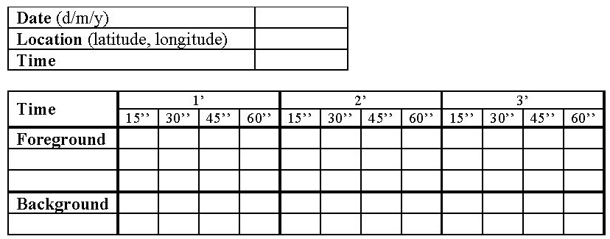
Figure 1. Inventory Form. At any particular moment the sound cues are noted, with their intensity and their classification as background or foreground.

The content of each form was transferred to digital form in MS Excel. The entire range of auditory cues recorded – by all observers, at all locations and times – was used to create a list of cues, which were those perceived by the observers forming the soundscape in the study area. To investigate how the perceived auditory cues were linked to the spatial changes and represented the landscape three parameters were calculated: (1) the total sum of occurrences of each sound cue, (2) the number of the participants who perceived each auditory cue, and (3) the total sum of occurrences of specific categories of auditory cues. These parameters were calculated separately for each location.

To calculate the third parameter, three separate categories of auditory cues were created. This categorization was based on the origin of the sound and its relation to basic spatial features (streets, parks, buildings, etc.). Auditory cues were classified into five categories: (a) anthropogenic-mechanical (car, motorbike, bus, etc.), (b) anthropogenic-human (people talking, footsteps, laughing, etc.), (c) anthropogenic-indicators (alarm, siren, bell, banging, etc.), (d) nature-biological (birds, dogs barking, etc.) and nature-geophysical (fountain, air, etc.). This categorization is based on a synthesis of the categorization of Schafer (1994) and those of other researchers such as Gage, Ummadi, Shortridge, Qi and Jella (2004), Matsinos et al. (2008) and Napoletano (2004). Anthropogenic refers to auditory cues produced by human activities and artifacts (e.g. engineering works, traffic noise), biological includes all sound-producing organisms (e.g. insects, birds, dogs) and geophysical refers to sounds emitted by any kind of natural phenomenon (Matsinos et al., 2008).

Sounds were also classified, in line with the responses of the participants, as background or foreground sounds. The foreground sounds refer to those produced instantly near the sampling site (e.g. dog, car, etc.) whereas the background sounds refer to those produced far from the sampling site and originating from the whole surrounding landscape (e.g. traffic noise). The distinction between background and foreground sounds reflects different priorities of the acoustic environment (Mazaris, Kallimanis, Hatzigiannidis, Papadimitriou, & Pantis, 2009).

Results
For each observer and location, the occurrences of each auditory cue were calculated. For example, during the seven minutes of the recording period if one observer identified the sound of a car, occurring at time-point 1’35” and lasting until time-point 2’25’’, he then identified a new car sound occurring at 4’50” and lasting until time-point 5’10’’. In this case, if the observer reports the sound of the car he hears, then on the recording form the specific sound cue appears in six (4+2) different intervals of 15”, and thus the number of occurrences of the car sound is equal to six.
Based on the variable occurrences, the variable total occurrences of each auditory cue for each location was calculated for all the participants (for all three days) from the summation of the scores of the variable occurrences of all 11 participants (see Table 2). Therefore, the score of the variable total occurrences does not represent the occurrences of each auditory cue. The variable total occurrences is an index of the frequency of appearance of each auditory cue in each location without being affected by the subjectivity of the observers. This is important since it has been well established that subjectivity affects the perception of auditory cues (Raimbault & Dubois, 2005).

Table 2. Total Occurrences of Each Sound Cue in Each Location (all participants – three days)
Sound cues | L 1 | L 2 | L 3 | L 4 | L 5 | L 6
Car | 45 | 70 | 57 | 47 | 17 | 41
Motorcycle | 32 | 23 | 37 | 54 | 16 | 42
Bus | 7 |  |  | 2 |  | 6
Car horn | 9 | 7 | 10 | 2 | 5 | 11
Car brakes |  |  |  | 4 | 1 | 4
Bicycle |  |  |  |  | 7
People talking | 40 | 77 | 37 | 65 | 83 | 63
Footsteps | 67 | 40 | 58 | 29 | 92 | 68
Coughing |  | 1 |  | 3 | 2
Sneezing |  |  |  |  |  | 1
Laughing |  | 3 | 1 | 4 | 1 | 2
Whistling |  |  | 2
Sound of door opening/closing | 1 | 2 |  | 16 | 8
Mobile phone ringing |  | 2 |  | 3 | 6
Keys | 3 | 1 | 4 | 2 |  | 1
Cart |  | 2
Lighter |  |  |  | 1
Locking/unlocking of car door |  |  |  | 1 | 1
Banging | 2 | 6 | 4 | 14 | 2 | 1
Alarm | 3 |  | 3 | 1
A metallic sound | 1 | 2 |  | 1 | 4 | 1
Something breaking | 2
Siren |  |  | 1
Music |  |  | 2 |  | 2
Engineering works |  |  | 2
Bell |  |  |  |  | 1
Car flash |  |  |  | 6
Birds | 20 | 46 | 34 | 16 | 24 | 23
Dogs (barking) | 21 | 17 | 18 | 4 | 2 | 18
Dogs (walking) |  |  |  | 1 | 1
Rustling of the leaves | 5

Furthermore, the number of participants who reported each auditory cue was separately calculated for each location. For example, we calculated how many participants reported that they heard the sound car, regardless of how many times they heard this sound. This calculation was done for the entire sample for all three days (see Table 3). This index reveals which auditory cues are dominant in each location, which are the ones reported by the majority of the participants.

The analysis revealed that a number of auditory cues (see Table 2) were perceived in all the locations (i.e. car, motorcycle, car horn, people talking, footsteps, banging, birds, dogs). This finding may indicate that these auditory cues were those which characterize the study area. They are the cues one would expect to hear at any location in the study area. Moreover, auditory cues such as car, motorcycle, footsteps, people talking, and birds were reported by many participants in each location (see Table 3). It is obvious that the specific cues are of particular value for this group of observers (blind individuals) and, moreover, are those which define the identity of the location’s soundscape.

Table 3. Number of the Participants Who Perceived Each Sound Cue of the List in Each Location (all participants – three days)
Location 1 | Location 2 | Location 3
Footsteps 11  People talking 10  Car 9  Motorcycle 9  Car horn 6  Birds 5  Dog (barking) 4  Alarm 3  Bus 3  Banging 2  A metallic sound 1  Keys 1  Rustling of the leaves1  Something breaking 1  Sound of door opening/closing1 | Car 11  People talking 11  Birds 9  Footsteps 9  Motorcycle 8  Car horn 5  Engineering works 4  Banging 3  Dog (barking) 3  Mobile phone ringing 2  A metallic sound 1  Cart 1  Coughing 1  Keys 1  Sound of door opening/closing1 | Car 10  Motorcycle 10  Footsteps 9  People talking 8  Birds 7  Car horn 3  Dog (barking) 3  Banging 2  Engineering works 2  Keys 2  Alarm 1  Laughing 1  Music 1  Siren 1  Whistling 1
Location 4 | Location 5 | Location 6
Motorcycle 11  People talking 10  Car 8  Birds 7  Footsteps 7  Sound of door  opening/closing 6  Banging 5  Car brakes 3  Car horn 3  Coughing 3  Mobile phone ringing 3  Dog (barking) 2  A metallic sound 1  Alarm 1  Bus 1  Car flash 1  Dog (walking) 1  Keys 1  Laughing 1  Lighter 1  Locking/unlocking of car door 1 | Footsteps 11  People talking 11  Car 8  Birds 7  Motorcycle 7  Bicycle 5  Car horn 4  Mobile phone ringing 4  Coughing 2  Sound of door  opening/closing 2  A metallic sound 1  Banging 1  Bell 1  Car brakes 1  Dog (barking)1  Dog (walking) 1  Engineering works 1  Keys 1  Laughing 1  Music 1 | People talking 11  Car 10  Motorcycle 10  Dog (barking) 9  Footsteps 9  Car horn 8  Birds 7  Car brakes 3  Bus 2  Laughing 2  A metallic sound 1  Banging 1  Keys 1  Sneezing 1

It is also worth looking a little more deeply at the results, attempting to link the characteristics of the area with the auditory cues which are dominant in each location. Thus, it can be said that this is an area relatively frequently traversed by pedestrians (footsteps, speech). There must be trees, green areas or small parks (birdsong and barking). In the surrounding area there must be a road or roads with heavy traffic (street noise in background). The phrase in the surrounding area was used, because if a busy road passed right through the study area itself it would be difficult to identify, easily and with high frequency, the various other isolated sounds, which would be drowned out by the noise of the road. Also, within the study area there must be some lightly used roads, which is why the participants pointed to car and motorcycle noises among the foreground sounds.

Apart from the sounds that appear in the study area and define its landscape, if sounds in each location are examined separately, additional relations between auditory cues and landscape of each location can be determined. For example, in locations 1, 4, and 6, the auditory cue bus has been reported, which means that there is a street which has bus lanes. This, together with other information and previous knowledge regarding the city’s bus lanes, can help the listener to determine which street it is. In location 4 particularly, but also in location 5, there was an increased occurrence of the auditory cue door opening/closing, which referred to the presence of buildings close to the location. In locations 2 and 3 in the park the occurrences of the auditory cue birds increased. In locations 4 and 5, where there are more buildings but no large open spaces and the occurrence of the auditory cue dogs barking increased.

Based on the categorization described above (see Data Analysis section) we found four categories of foreground auditory cues (anthropogenic-mechanical, anthropogenic-human, anthropogenic-indicators and nature-biological) and four categories of background auditory cues (anthropogenic-mechanical, anthropogenic-human, nature-biological and nature-geophysical). For each location (L1 to L6) and each of the categories the total sum of occurrences of auditory cues for foreground and background separately calculated was derived by adding the occurrences of the individual auditory cues recognized by each observer (see Table 4).

Table 4. The Total Sum of Occurrences of Sound Cues for Foreground and Background for Each Location and Each of the Categories
 | Foreground categories |  |  |  |  |  | Background categories
 | L1 | L2 | L3 | L4 | L5 | L6 | L1 | L2 | L3 | L4 | L5 | L6
Nature (geo) |  |  |  |  |  |  | 266 | 0 | 0 | 0 | 0 | 240
Nature (biol) | 46 | 63 | 52 | 21 | 27 | 41 | 130 | 123 | 200 | 145 | 123 | 81
Anthropogenic (h) | 111 | 128 | 104 | 124 | 193 | 135 | 0 | 28 | 0 | 50 | 35 | 0
Anthropogenic (m) | 93 | 100 | 104 | 109 | 46 | 104 | 136 | 172 | 211 | 196 | 255 | 238
Anthropogenic (i) | 8 | 8 | 10 | 22 | 9 | 2

Furthermore, bar-charts which represented the contribution of each category to a total soundscape of each location were created (see Figures 2 and 3). These bar-charts were created to facilitate the examination of the degree to which the perceived soundscape of blind participants is related to the landscape of the area and the spatial changes of the auditory cues in it.

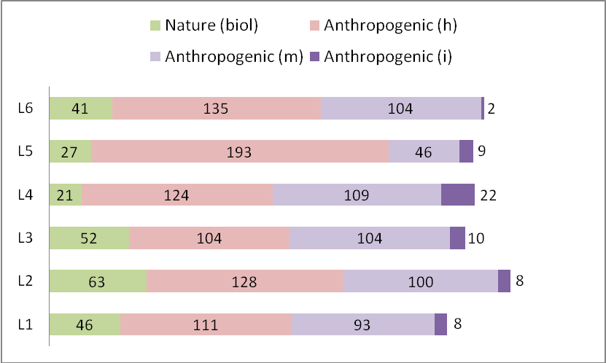
Figure 2. The Contribution of Each Category to a Total Soundscape of Each Location (foreground).

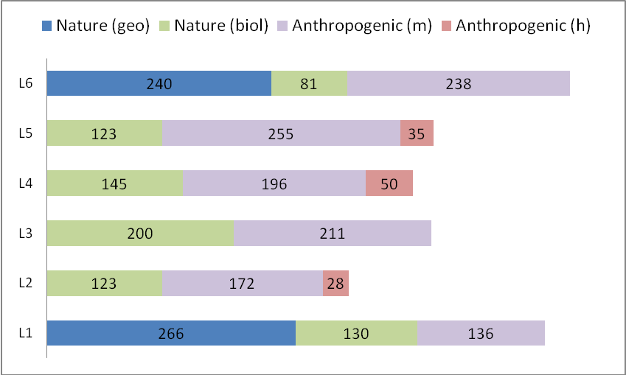
Figure 3. The Contribution of Each Category to a Total Soundscape of Each Location (background).

It is noteworthy that no nature-geophysical sounds were listed in the foreground categories and no anthropogenic-indicator sounds were listed in the background categories. In the foreground categories, anthropogenic-mechanical and anthropogenic-human auditory cues contribute more to the soundscape of each location. In the background categories, anthropogenic-mechanical sounds together with nature-biological sounds contribute more to the soundscape of the area. Interestingly, nature-geophysical sounds contribute only to the soundscape of two locations (L1 and L6). This could be directly linked to the presence of a fountain close to L1 and L6. These findings are related to the nature of the specific study area (see Experiment section). For instance, if a large park had been chosen as a setting for the experiment, or some location in the countryside, the results would obviously have been entirely different.

The examination of the bar-chart with categories of foreground auditory cues (Figure 2) shows that more nature-biological auditory cues appear in locations 2 and 3 in the park with green areas and trees. More anthropogenic-human auditory cues appear in location 5, which is close to buildings and university services (e.g. administration buildings) and it is also a central passage to other areas and buildings. Moreover, in location 5 many fewer anthropogenic-mechanical auditory cues occur, since there are no main streets nearby. In location 4 many more anthropogenic-indicators appear, since the location is close to a car park, and entrances to university buildings (e.g. administration buildings). Anthropogenic-human auditory cues are fewer in number in location 3 since this is in a park which has pathways for pedestrians. Location 2 is also in the park, but it is on the edge of the park and very close to it there are several entrances to buildings. Hence, there are more anthropogenic-human sound cues than in location 3.

The examination of the bar-chart with the categories of background auditory cues (Figure 3) reveals that more nature-biological auditory cues occur in location 3, which is in the park and is surrounded by trees (birds singing). Moreover, fewer nature-biological auditory cues occur in location 6, where nature-geophysical and anthropogenic-mechanical cues are predominant. This can be explained by the fact that there is a fountain close to location 6 and main streets in the broader area around the location. More anthropogenic-human sounds occur in locations 2, 4 and 5 which are near to areas with a number of pedestrian crossings. In location 5 more anthropogenic-mechanical auditory cues appear because there is a main street in the broader area around the location.

Second test
Procedures
In the second test the participants were asked to describe the components of the area around each location. They were asked to give descriptions based on the sounds that they could hear in each location. That is, the second test took place in each one of the six locations separately, immediately after the completion of the first test. In effect, it is a process investigating the cognitive maps created by the participants through their sense of hearing. The participants were asked to include in their descriptions basic spatial components such as streets (with light or heavy traffic), parks, squares, buildings, pathways, etc.

Data analysis
One of the authors, who had extensive experience in qualitative research, transcribed the verbal descriptions. Then a list was created containing all the relations between the auditory cues and the elements of the cognitive maps for all participants and all six locations. Examples of such relations include birds with parks, cars with streets, people talking on footpaths, etc. Furthermore, the descriptions enabled sketch maps to be created for the areas around the six locations. These sketch maps represented the cognitive maps of the participants for the areas around the six locations. Figure 4 shows an example of a sketch map. Six sketch maps were created for each participant, making 66 in total.

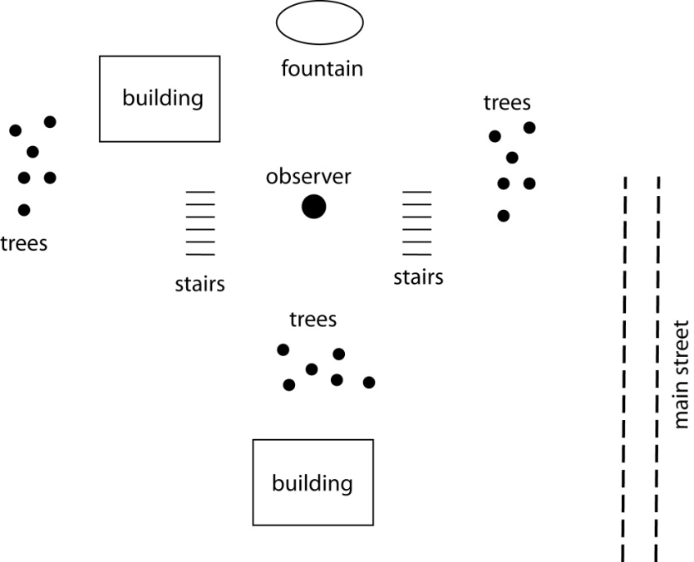
Figure 4. Example of a Sketch Map for Location 1.

The way in which the components of each sketch map fitted the actual spatial components of the area was examined. This comparison was done by using a map of the area (Figure 5) in which information provided by the authors was added during field observations.

Results
The analysis revealed that the cognitive maps of the participants contained information about principal spatial features, such as streets, buildings, parks, green areas, car parking, etc. In addition, there was more detailed spatial information on such features as footpaths, trees, steps, benches, fountains, etc. The analysis of the participants’ cognitive maps also revealed self-to-object and object-to-object spatial relationships in the study area. For example: Behind me there are steps…on the left of steps there are some trees.
Below are several examples of the relationship between auditory cues and components of the landscape.
This is a park, I can tell from the continuous bird singing. There are some people who talk and walk but the noise from the street comes from a long distance (location 2).
There should be many benches since I can hear people talking but I can’t hear any footstep (location 5).
I can hear the noise from a main street but it’s definitely quite far from here (location 5).
On the right there is probably a footpath because I heard some people who were passing by a couple of minutes age (location 3).
I think that here the area is not so ‘green’ as in the previous locations because I can’t hear birds singing (location 4).
I heard a door opening and closing. The sound came from in front of me but on so I can assume that there is a building somewhere there (location 5).
I can’t hear clearly the street traffic coming from behind me. There are probably some trees or buildings that block this sound (location 1).

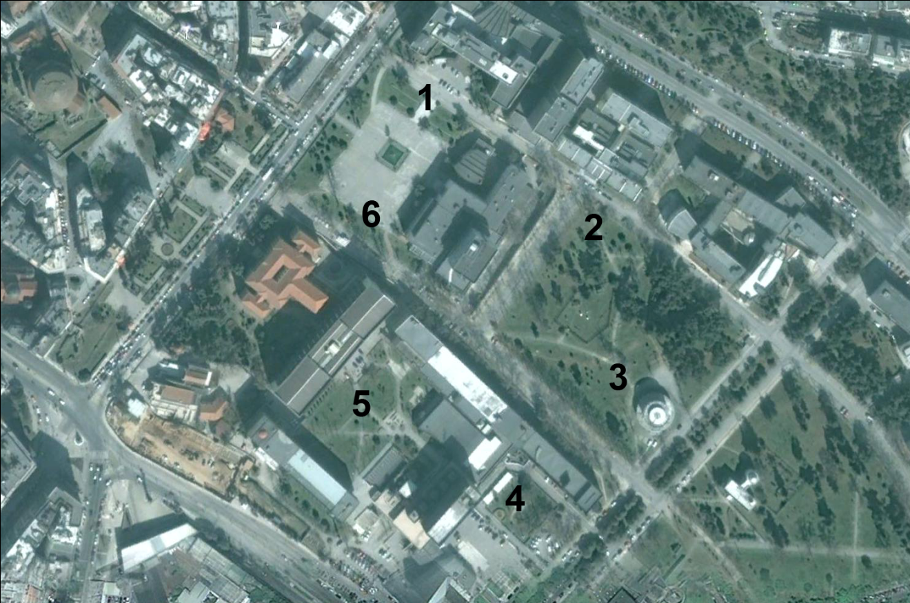
Figure 5. Map of the Study Area.

Conclusion
The study presented here sought to explore the role of auditory cues in the spatial knowledge of stationary blind individuals by examining the relation between the perceived auditory cues and the landscape of a given area and investigating how blind individuals use auditory cues to create cognitive maps. The findings of the study reveal that several auditory cues characterize the study area and are linked to spatial features. Auditory cues such as car, motorcycle, footsteps, people talking, and birds were reported by many participants in each location. These specific auditory cues are of particular value for the group of blind listeners and, moreover, are those which define the identity of the soundscape in the study area. In addition, by using auditory cues coming from different sources the participants associated the soundscape with the structural and spatial configuration of the landscape.

It is important to highlight the fact that the participants remained stationary during the testing procedure. By not moving, the participants did not have the opportunity to gather valuable information deriving from their interaction with the environment. Moreover, the results indicate that through their sense of hearing, blind individuals create cognitive maps, which include varied spatial information and spatial relationships within it. The participants linked auditory cues with specific spatial features, such as streets, buildings, parks, green areas, car parkings, and footpaths and reported an understanding of self-to- object and object-to-object relationships.

The findings of the study can be used to inform the development of orientation and mobility aids for individuals with visual impairments. It is well established that tactile maps significantly help individuals with visual impairment to gain spatial knowledge (Espinoza, Ungar, Ochaita, Blades, & Spencer, 1998; Ungar, 2000). The use of new technologies, such as the touch tablet, provides the opportunity for presenting tactile and auditory information simultaneously to individuals with visual impairments (Wells & Landau, 2003). Touch tablets also offer access to the benefits of tactile maps and auditory recordings (Papadopoulos, Koutsoklenis, & Chatzigiannakoglou, 2010). Such an application could help individuals with visual impairments to familiarize themselves with unknown areas, to learn routes on these areas and to be aware of the important spatial features such as landmarks, nodes, districts and edges. Regarding familiar areas, the combined use of tactile maps and soundscape recordings could help individuals with visual impairments to update their cognitive maps and learn new routes before deciding to navigate within these areas. The results could also enhance training in orientation and mobility skills that involves the use of recorded sounds for improving the auditory skills of individuals with visual impairments.

Limitations
One limitation of the present study is the relatively small number of participants. However, given the nature of the specific experiment, and the structure of the tests used (all participants had to be in a specific position, and relatively close to one another), it would not have been possible to make the sample used much larger. One other drawback is that the probable impact of individual differences within participants cannot be established. For example, it would be very interesting to establish the impact of a person’s age at the time of loss of sight and to identify any gender-related differentiations within the sample. Moreover, since the senses of touch and olfaction were not masked, the possible contribution of haptic cues (e.g. the feeling of wind) and olfactory cues (e.g. smell of flowers) in the cognitive maps of the participants cannot be established in the present study. Finally, given that the authors were familiar with the locales, the procedure of sketch mapping was open to unintentional bias.

References
Ashmead, D. H., Wall, R. S., Eaton, S. B., Ebinger, K. A., Snook-Hill, M. M., Guth, D. A., & Yang, X. (1998). Echolocation reconsidered: Using spatial variations in the ambient sound field to guide locomotion. Journal of Visual Impairment and Blindness, 92, 615-632.
Blauert, J. (1997). Spatial hearing: The psychophysics of human sound localization (Rev. Ed.). Cambridge: MIT Press.
Blumsack, J. T. (2003). Audiological assessment, rehabilitation, and spatial hearing considerations associated with visual impairment in adults: an overview. American Journal of Audiology, 12, 76-83.
Carles, J. L., Barrio, I. L., & de Lucio, J. V. (1999). Sound influence on landscape values. Landscape and Urban Planning, 43, 191-200.
Dubois, D., Guastavino, C., & Raimbault, M. (2006). A cognitive approach to urban soundscapes: using verbal data to access everyday life auditory categories. Acta Acustica united with Acustica, 92, 865-874.
Espinoza, M. A., Ungar, S., Ochaita, E., Blades, M., & Spencer, C. (1998). Comparing methods for introducing blind and visually impaired people to unfamiliar urban environments. Journal of Environmental Psychology, 18, 277-287.
Gage, S., Ummadi, P., Shortridge, A., Qi, J., & Jella, P. (2004). Using GIS to develop a network of acoustic environmental sensors. ESRI International Conference. 9-13 August, San Diego, CA.
Gardiner, A., & Perkins, C. (2005). ‘It’s a sort of echo. . .’: Sensory perception of the environment as an aid to tactile map design. The British Journal of Visual Impairment, 23, 84-91.
Gaver, W. W. (1993). How do we hear in the world?: Explorations in ecological acoustics. Ecological Psychology, 5, 285-313.
Gibson, J. J. (1966). The senses considered as perceptual systems. Boston: Houghton Mifflin.
Golledge, R. (1993). Geography and the disabled: a survey with special reference to vision impaired and blind populations. Transactions of the Institute of British Geographers, 18, 63-85.
Hirsh, I. J., & Watson, C. S. (1996). Auditory psychophysics and perception.
Annual Review of Psychology, 47, 461-484.
Jacobson, R. D. (1998). Cognitive mapping without sight: four preliminary studies of spatial learning. Journal of Environmental Psychology, 18, 289-305.
Jacobson, W. H. (1993). The art and science of teaching orientation and mobility to persons with visual impairments. New York, NY: American Foundation for the Blind.
Jansson, G. (2000). Spatial orientation and mobility of people with visual impairment. In B. Silverstone, M. A. Lang, B. Rosenthal, & E. E. Faye (Eds.), The Lighthouse handbook on visual impairment and vision rehabilitation (Vol. 1) (pp. 379-397). New York, NY: The Lighthouse and Oxford University Press.
Kang, M. A., & Servigne, S. (1999). Animated cartography for urban soundscape information, CM-GIS ’99. Proceedings of the 7th International Symposium on Advances in Geographic Information Systems, November 2-6, Kansas City, USA.
Kitchin, R. M. (1994). Cognitive maps: What are they and why study them? Journal of Environmental Psychology, 14, 1-19.
Koutsoklenis, A., & Papadopoulos, K. (in press). Auditory cues used for wayfinding in urban environments by individuals with visual impairments. Journal of Visual Impairment & Blindness.
Loomis, J. M., Klatzky, R. L., Golledge, R. G., Cicinelli, J. G., Pellegrino, J. W., & Fry, P. A. (1993). Nonvisual navigation by blind and sighted: Assessment of path integration ability. Journal of Experimental Psychology: General, 122, 73-91.
Matlin, M. W., & Foley, H. J. (1992). Sensation and perception. London: Allyn and Bacon.
Matsinos, Y. G., Mazaris, A. D., Papadimitriou, K. D., Mniestris, A., Hatzigiannidis, G., Maioglou, D., & Pantis, J. D. (2008). Spatio-temporal variability in human and natural sounds in a rural soundscape. Landscape Ecology, 23, 945-959.
Mazaris, A. D., Kallimanis, A., Hatzigiannidis, G., Papadimitriou, K., & Pantis, J. (2009). Spatiotemporal analysis of an acoustic environment: interactions between landscape features and sounds. Landscape Ecology, 24, 817-831.
Napoletano, B. (2004). Measurement, quantification, and interpretation of acoustic signals within an ecological context [Master's thesis]. Department of Zoology, East Lansing, Michigan State University.
Papadopoulos, K., Koutsoklenis, A., & Chatzigiannakoglou, P. (2010). Using soundscape recordings in audio-haptic maps to enhance the spatial knowledge of individuals with visual impairments. 5th ICEVI Balkan Conference, New Competencies for Future Challenges in Europe, October 20-24, 2010, Zagreb, Croatia.
Penrod, W. M., & Petrosko, J. (2003). Spatial organization skills of the blind in large outdoor places, RE:view, 34, 155-164.
Pheasant, R., Horoshenkov, K., & Watts, G. (2008). The acoustic and visual factors influencing the construction of tranquil space in urban and rural environments tranquil spaces quiet places? Journal of the Acoustic Society of America, 123, 1446–1457.
Pick, H. L. (1980). Perception, locomotion and orientation. In R. L. Welsh, & B. B. Blasch (Eds.), Foundations of orientation and mobility (pp. 73-88). New York, NY: American Foundation for the Blind.
Raimbault, M., & Dubois, D. (2005). Urban soundscapes: Experiences and knowledge. Cities, 22, 339-350.
Schafer, R. M. (1977). The tuning of the world. New York, NY: Knopf.
Schafer, R. M. (1994). The soundscape: Our sonic environment and the tuning of the world. Rochester, VT: Destiny Books.
Sholl, M. J. (1996). From visual information to cognitive maps. In J. Portugali (Ed.), The construction of cognitive maps (pp. 157-168). Dordrecht: Kluwer.
Truax, B. (1984). Acoustic communication. New Jersey: Ablex Publishing.
Truax, B. (1999). Handbook for acoustic ecology. Burnaby, B.C.: Cambridge Street Records.
Ungar, S. (2000). Cognitive mapping without visual experience. In R. Kitchin, & S. Freundschuh (Eds.), Cognitive mapping: Past, present and future (pp. 222-248). London: Routledge.
Viollon, S., Lavandier, C., & Drake, C. (2002). Influence of visual settings on sound ratings in an urban environment, Applied Acoustics, 63, 493-511.
Watts, G., Chinn, L. & Godfrey, N. (1999). The effects of vegetation on the perception of traffic noise, Applied Acoustics, 56, 39-56.
Wells, L. R., & Landau, S. (2003). Merging of tactile sensory input and audio data by means of the talking tactile tablet. Proceedings of Eurohaptics 2003, Dublin, Ireland.
Wheeler, L. C., Floyd, K., & Griffin, H. C. (1997). Spatial organization in blind children. RE:view, 28, 177-181.
World Medical Association (2010). WMA Declaration of Helsinki - Ethical principles for medical research involving human subjects. Retrieved from http://www.wma.net/en/30publications/10policies/ b3/index.html.
Wrightson, K. (2000). An introduction to acoustic ecology. Soundscape: The Journal of Acoustic Ecology, 1, 10-13.

