International Journal of Special Education
2002, Vol 17, No.2.

AN ANALYSIS OF THE ERRORS MADE BY INTELLECTUALLY DISABLED STUDENTS WHEN ATTEMPTING TO IDENTIFY NUMERALS FROM 1 TO 9

James Hanrahan
Glenda Bernstein
Erika Franz

McGill University

A set of irregularly written numerals taken from teacher-prepared handouts and a set of numerals taken from a mathematics text for children were presented to a sample of eighty-seven intellectually disabled students attending a special education school in the greater Montreal area. These subjects were required to identify each numeral in both sets. The majority of subjects made at least one error in their attempts to identify the numerals from both sources. Most of the errors occurred with the teacher-made numerals, e.g. confusing numbers for letters

An examination of teachers' written numerals, whether on a chalkboard or in their arithmetic handouts, reveals considerable variation in the way in which numerals are formed. Despite these differences in shape, teachers assume that children will be able to identify hand- written numerals correctly. Investigations into the strategies used by intellectually disabled children when adding numbers have resulted in several observations of children being confused by the way in which numerals were formed (Hanrahan, Rapagna & Poth,1993; Pupo & Hanrahan, 2000). As a consequence, it was decided to investigate the ability of intellectually disabled children to recognize handwritten numerals.

There are many reasons why children might confuse handwritten numerals. A handwritten numeral can be so poorly formed that it has little similarity to its printed form. It may not look like any numeral or it may look like another numeral or letter. In these situations, the odds of correctly identifying the numeral are reduced. Cultural differences in the way in which numerals are formed may also lead to confusion. Some teachers may form the numeral 1 with a large curved line joined to the top of the numeral that makes it look like a 7. As well, they may cross their sevens to distinguish between sevens and ones. Some teachers close the top of the numeral 4 while others leave it open. Depending on the background of the student, poorly formed numerals may also be mistaken for numerals used by other cultures such as Sanskrit .

The purpose of the present investigation was to determine if intellectually disabled children were experiencing difficulties identifying teacher-formed numerals. Our pilot work in this area suggested that some teacher-formed numerals are so poorly constructed that they would be impossible to identify by many intellectually disabled subjects. Consequently, it was hypothesized that intellectually disabled subjects would make significantly more errors when identifying poorly formed teacher-made numerals than when identifying numerals printed in a standard form.

INTERNATIONAL JOURNAL OF SPECIAL EDUCATION Vol 17, No.2.

Method

Choice of numerals
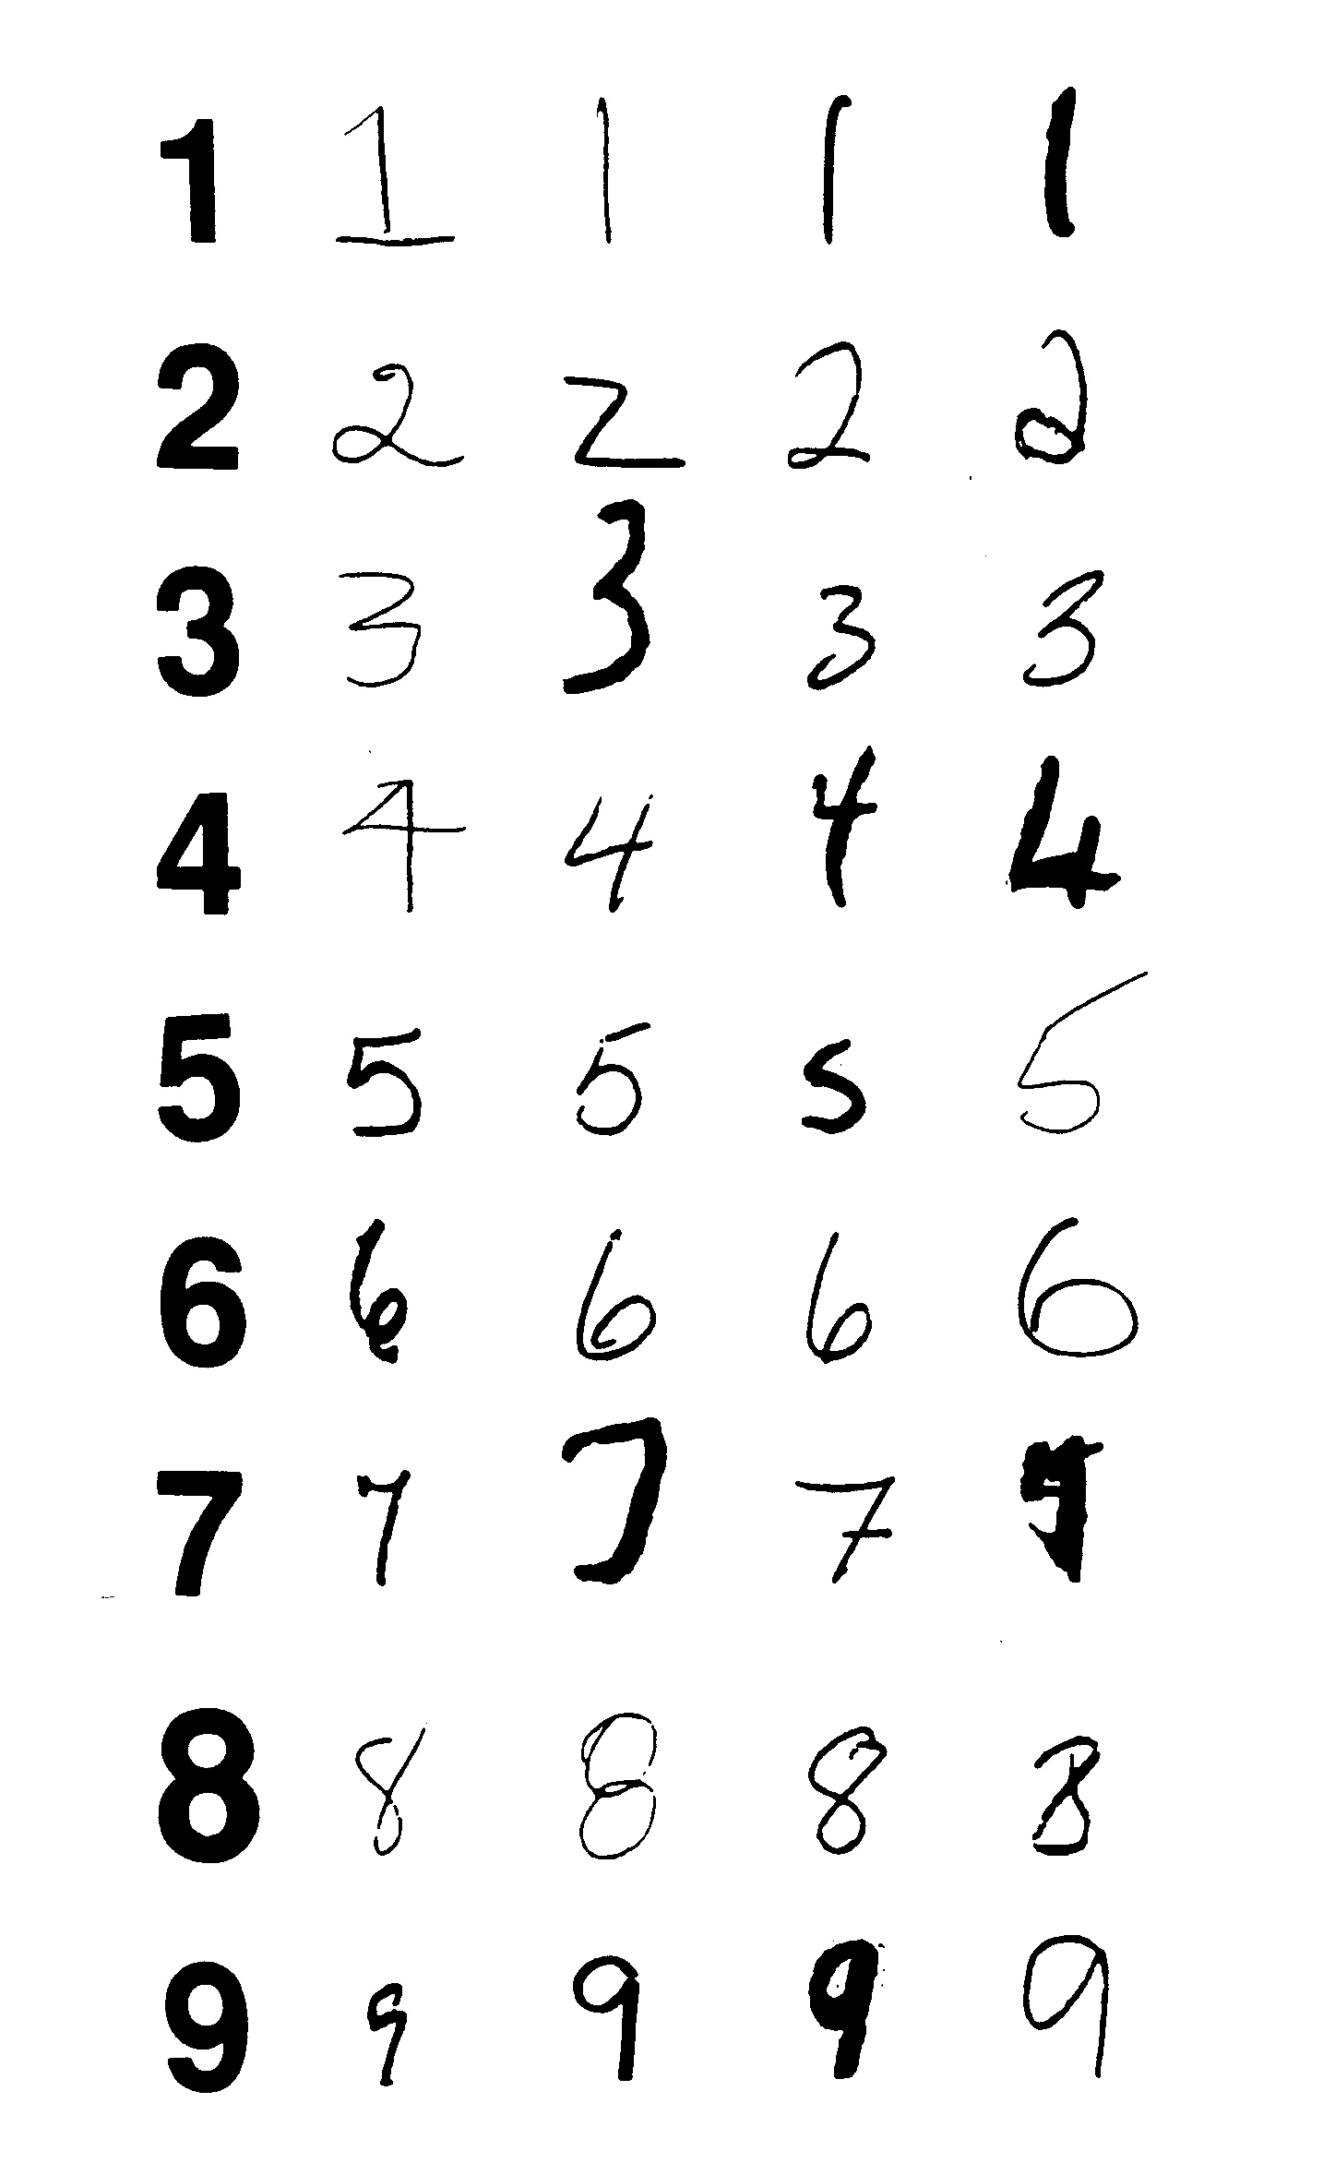
A group of four special education teachers, working at a segregated school for the intellectually disabled, gave permission for existing samples of their teacher-made arithmetic handouts to be used in this study. A group of sixteen graduate students in educational psychology compared the numerals in the teacher-made handouts with a set of numerals from 1 to 9 taken from a grade two arithmetic textbook. The graduate students were instructed to inspect each teacher's handouts separately and to choose the one example for each numeral from 1 to 9 that deviated the most from the standard set. The teacher-made handouts included fours that were closed and sevens that were crossed. As the standard set of numerals did not include these variations, the graduate students were instructed to compare the examples of closed fours and crossed sevens with what they imagined were ideal forms of numerals printed in this way. This procedure resulted in a set of nine irregularly shaped numerals for each teacher. These irregularly shaped handwritten numerals were combined with a set of nine printed numerals from 1 to 9 resulting in a total of forty-five numerals. This final set of forty-five numerals was used in the present experiment. The set of forty-five numerals is presented in Figure 1.

Figure 1: Standard and Irregularly Formed Numerals

INTERNATIONAL JOURNAL OF SPECIAL EDUCATION Vol 17, No.2.

The forty-five numerals were arranged so that numerals by the same teacher and numerals with the same value were never immediately repeated. Each numeral was enlarged so that its base was approximately one inch. Each numeral was then pasted on a standard 3 by 5 inch index card.

Subjects
A sample of eighty-seven subjects attending a special school for the intellectually disabled in the greater Montreal area participated in the study. Only subjects who, in the opinion of their classroom teacher, were able to recognize and name the numerals from 1 to 9 were chosen. Subjects ranged in age from five years seven months to twenty-one years zero months with a mean age of twelve years five months and a standard deviation of three years and nine months. Most subjects were in the moderate to mild range of intellectual ability. Sixty-five percent of the sample were male; thirty-five percent were female.

Procedure
All subjects were tested in their classrooms. Each subject was seated in a quiet part of the classroom and presented with the sequence of forty-five numerals by an experimenter. A second researcher sat parallel to the subject and recorded all responses. Responses were scored as correct or incorrect. When a response was incorrect, the substituted numeral or letter was recorded.

Results
Four of the 87 subjects were unable to identify any examples of at least one of the numerals from 1 to 9 and their results were not included in the study. Five (6%) of the remaining 83 subjects correctly identified all forty-five numerals while seventy-eight subjects (94%) made at least one error. In total, 222 of 3735 responses (5.9%) were incorrect.

The hypothesis for the study was confirmed as subjects made significantly fewer errors on the printed numerals (.022%) than on the teacher-formed numerals (.069%); chi square = 21.66, p<.0001, 1 df.

Discussion
The most important point that can be made from these results is that the errors made by intellectually disabled students on numerical operations may, at times, be due to their inability to recognize numerals rather than their inability to perform the required computation. This has important implications for everyone involved in using and preparing materials when teaching intellectually disabled children. There is less printed material available for use with these children as compared to their intellectually normal peers. Consequently, teachers of special needs children are constantly having to prepare their own handouts. It is, therefore, important that numerals be written clearly as 1 out of 15 teacher-made numerals chosen for the current study was misinterpreted by our sample of intellectually disabled students. The temptation to scratch out or reshape a numeral should be avoided. In the present study, the most confusing numeral was a 5 altered to become a 7 (see column 5, Figure 1). As well, care must be taken to prevent forming the numerals like letters. When this occurred in the present study, the following substitutions of letters for numerals were made: Z for 2; S for 5 and 9; J, T and Z for 7; and B for 8.

In this investigation, the numerals were presented individually rather than in the context of an arithmetic problem. It is expected that letter substitution would occur less frequently if the numerals were presented as a part of a computation. However, context is probably of limited value when attempting to identify numerals. While students may be able to identify a poorly formed letter by recognizing the word, with numerals, context does not provide similar cues for identification.

Future research might investigate if intellectually disabled children have difficulties transferring from the set of numerals made by their current teacher to those made by next year's teacher. It is possible that such a transfer may not be automatic for all such children and that some children will experience difficulties, particularly at the beginning of the new school year. Even with printed numerals, slight differences in typeface may make numeral recognition difficult. In his research on letter recognition using intellectually normal young adults, Sanocki (1987, 1988, 1991) found that letter recognition was not as efficient with atypical fonts as it was with typical fonts. If some intellectually disabled children cannot generalize from one standard typeface to another without making errors, then it may be necessary to agree on a single typeface when developing materials for use with such children. Many materials currently used for the instruction of intellectually disabled children such as card games have stylized numerals that may appeal to the teacher but only confuse the student.

Finally, it seems worthwhile to reemphasize the need for teachers to be aware of the confusion that may result from poorly formed numerals. The four teachers who provided examples of their arithmetic handouts believed that the numerals on these worksheets would be understood by their students. Our results indicate that, in many cases, they were not.

References
Hanrahan, J., Rapagna, S., & Poth, K. (1993). How children with learning problems learn addition. Canadian Journal of Special Education, 9, pp. 101-109.
Pupo,M., & Hanrahan, J. (2000). Teaching intellectually disabled students addition through a dot-notation approach. International Journal of Practical Approaches to Disability, 24(3). 50-55.
Sanocki, T. (1987). Visual knowledge underlying letter perception: Font-specific, schematic tuning. Journal of Experimental Psychology: Human Perception and Performance, 13, 267-278.
Sanocki, T. (1988). Font regularity constraints on the process of letter recognition. Journal of Experimental Psychology: Human Perception and Performance, 14, 472-480.
Sanocki, T. (1991). Intra- and interpattern relations in letter recognition. Journal of Experimental Psychology: Human Perception and Performance, 17, 924-941.

